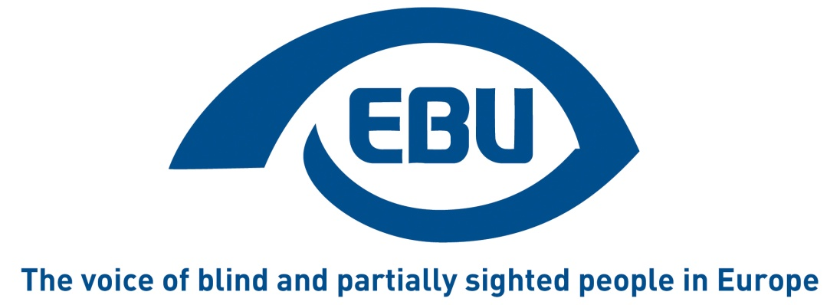

Public Consultation on reduced VAT rates for electronically supplied publications

September 2016

The European Blind Union (EBU) is a non-governmental, non profit making European organisation founded in 1984. It is one of the six regional bodies of the World Blind Union, and it promotes the interests of blind people and people with low vision in Europe. It currently operates within a network of 44 national members including organisations from 27 European Union member states, candidate nations and other major countries in geographical Europe.
We are happy for our contribution to be made public. None of the information I provide in this consultation is subject to copyright restrictions
Our Interest Representative Register ID is 42378755934-87
For further information or clarification on this consultation response, please contact the author, Carine Marzin, Chair of the EBU Campaigns Network (carine.marzin@rnib.org.uk) or get in touch with the EBU office.
European Blind Union Office: 6 rue Gager-Gabillot 75015 Paris, France
Tel : +33 1 47 05 38 20 - E-mail: ebu@euroblind.org

Books

26 out of 28 Member States apply a reduced VAT rate to printed books. These rates currently range between 0% and 12%.
E-books have to be taxed at the standard VAT rate, which lies between 17% and 27% depending on the Member State.
4.1 Should Member States be allowed to apply a reduced VAT rate to e-books?
Yes
4.2 In your view, what would be the effects of reducing VAT rates for e-books on the consumer price for those e-books?
Don’t know
4.3 If the VAT cuts are not fully passed on to final consumers, profit margins for publishers would increase. In your view, what consequences would this have on the industry? (Please check all that apply)
Don’t know
4.4 Assuming that prices for e-books were to fall by 5-10%, what would be, in your opinion, the reaction of most consumers?
Some consumers would switch from printed to e-books
4.5 In your view, what would be the impact of reduced prices for e-books for the printing industry, pulp and paper industry, and book stores?
Don’t know
Do you have further comments on the questions in this section and in particular the economic impacts from a reduced rate on e-books or other impacts such as social, cultural, or educational impacts? (optional)
A book is a book, regardless of its format.
We warmly welcome plans to reduce VAT on ebooks, as current VAT rules discriminate against blind and partially sighted people who cannot read books in standard print. However, we would like to stress the importance of ensuring that any VAT cut is actually passed on to the customer.
Currently only 5% of all published books in developed countries (and less than 1% in developing countries) are produced in accessible formats - such as braille, large print and audio – that blind and partially sighted can access. Increased affordability of ebooks would therefore provide more opportunities to access reading for more print-disabled people.

Definition of an e-book

5.1 The introduction of reduced rates might require a definition of an e-book in order to distinguish between written and audio/video content for VAT purposes. This could be done at Member State level, ensuring greater flexibility, but with the consequence of diverging definitions from one Member State to another. What is your opinion with regard to a definition of the term "e-book" for VAT purposes?
There is a need to define the term in a uniform way at EU level
You might propose a definition of the term "e-book" to be used in EU-law or justify further why no definition is needed. (optional)
We do not have a definition to suggest but are keen to ensure that the same definition applies across the EU in order to provide legal certainty.
5.2 Can you give examples of e-books that predominantly consist of video content? (optional)
N/A

Newspapers, periodicals

26 out of 28 Member States apply a reduced VAT rates to printed newspapers and periodicals. These rates currently range between 0% and 15%.
E-newspapers and e-periodicals have to be taxed at the standard VAT rate, which lies between 17% and 27% depending on the Member State.
6.1 Should Member States be allowed to apply a reduced VAT rate to e-newspapers and e-periodicals, too?
Yes
6.2 In your view, what would be the effects of reducing VAT rates on consumer price for e-newspapers and e-periodicals?
Don’t know
6.3 If the VAT cuts were not passed on (fully) to consumers, profit margins would increase. What would be the effect of this on the sector?
Don’t know
6.4 Assuming that prices for e-newspapers and e-periodicals were to fall by 5-10%, what would be, in your opinion, the reaction of most consumers?
Some consumers would switch from printed to e-newspapers/e-periodicals.
6.5 In your view, what would be the impact of reduced prices for e-newspapers/e-periodicals for the printing industry, pulp and paper industry, and newspaper stores?
Don’t know
Do you have further comments to the questions in this section and in particular the impact of a reduced rate for e-newspapers and e-periodicals? (optional)
As stated above, the e-publications, if accessible and affordable, provide more access to content and knowledge for blind and partially sighted people. However, it is important to ensure that any VAT cut is passed on to customers.

Definition of an e-newspaper or e-periodical

7.1 The introduction of reduced rates might require a definition of an e-newspaper or an e-periodical in order to distinguish between written and audio/video content for VAT purposes. This could be done at Member State level, ensuring greater flexibility, but with the consequence of diverging definitions from one Member State to another. What is your opinion with regard to a definition of the terms "e-newspaper" and "e-periodical" for VAT purposes?
There is a need to define the terms in a uniform way at EU level
In the following field, you can propose a definition of the terms "e-newspaper" and "e-periodical" to be used in EU-law or give reasons why no definition is needed. (optional)
We don’t have a definition to suggest but we believe that a unique definition will provide legal certainty, which is beneficial to all.
7.2 Can you give examples of e-newspapers and e-publications that predominantly consist of audio and video content? (optional)
N/A

Super-reduced and zero rates of VAT

For certain printed publications, 10 Member States were granted the applications of VAT rates lower than 5% (super-reduced rates) including exemptions with a deductions right of VAT at the preceding stage (so called zero rates).
Should those 10 Member States which were granted the possibility to apply VAT rates lower than 5% (super-reduced rates and zero rates) abolish them and align the rates applied to printed publications and e-publications at the level of a reduced VAT rate?
Don’t know

Final remarks

9.1 Is there anything else you would like to bring to the attention of the European Commission?
Blind and other print-disabled people are currently unable to access 95% of books as these are never published in accessible format by publishers. In addition to reducing VAT on ebooks, we would like the EU to swiftly ratify the Marrakesh Treaty, which would enable organisations of blind and partially sighted people and libraries to share their collections of accessible books with other same-language communities around the world. At the time of writing, some 22 countries have ratified the Marrakesh Treaty, which will come into force at the end of the month. Unfortunately, the EU has made little progress towards ratification since the signature of the Treaty in December 2013. We are concerned that a minority of EU member states are willing to block the ratification process and deprive blind and partially sighted people of their fundamental right to access books.
We are urging the EU and Member States to ratify the Marrakesh Treaty without further delay. This would dramatically increase access to knowledge, education and culture for millions of blind and partially sighted people, as well as other print-disabled people, in Europe and beyond. At present it is not possible to legally borrow or buy an accessible title across borders as copyright law is a national competence. This prevents organisations of blind and partially sighted people from sharing most needed accessible books with similar organisations in other countries. Organisations of blind and partially sighted people still have to duplicate the production of books in accessible formats in all countries; this is very costly and totally unnecessary.
A book is a book. We need access to books. We are urging the EU to uphold our right to read and ratify the Marrakesh Treaty now.
Ends

