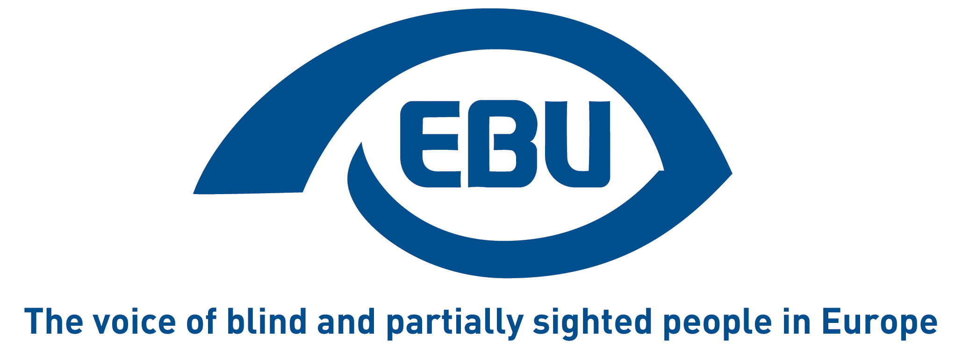

Response to the European Commission’s call for evidence for the evaluation of the Marrakesh Directive and Regulation

EBU Position Paper | May 2023

Context
The Marrakesh Treaty sets the legal frame for copyright exemptions for WIPO contracting members to enable authorized entities to produce and disseminate accessible-format copies of books and to share their accessible book collections across national borders with other entities and with visually impaired and otherwise print disabled individuals.
The European Union signed the treaty on 30 April 2014 and adopted two pieces of legislation for its implementation: the Directive (EU) 2017/1564, to be applied among EU member states, and the Regulation (EU) 2017/1563, to regulate the application of the Treaty between EU member states and non-EU countries.
This has been an important step to comply with the obligations of the United Nations Convention on the Rights of Persons with Disabilities, more specifically their right to accessibility (Article 9), freedom of expression, opinion, and access to information (Article 21), Education (Article 24) and participation in cultural life (Article 30).
Article 10 (1) of the Directive and Article 7 of the Regulation require the European Commission to evaluate their functioning so far and report on its main findings by 11 October 2023. This is the object of the Commission’s call for evidence and, eventually, its public consultation to follow.
In general, the European Blind Union (EBU) welcomes the positive impact of the EU’s Marrakesh Treaty legal framework, which largely meets its intended goals of increasing the international circulation of accessible-format printed works and, to a lesser extent, their production. Access to adapted works in foreign languages has improved considerably, especially in more internationally used languages. The costs of producing accessible-format works have been reduced, especially in countries—most—without a compensation scheme. It has also made new projects possible such as the Accessible Books Consortium (ABC). We would however like to nuance this appreciation with the following remarks.

The EAA and the Marrakesh Treaty
The EU’s legal framework is complemented by another key piece of EU legislation for persons with disabilities: the European Accessibility Act (EAA), which obliges to make certain products and services, including e-books, e-readers, reading software, accessible by default by 28 June 2025.
It is important to stress that, despite the EAA, the Marrakesh Treaty remains perfectly relevant to address the ‘book famine’ caused by the insufficient availability, in the EU as elsewhere in the world, of accessible-format printed works, still is the preferred format for many people.
Hence the importance of the ongoing evaluation of the EU’s legal framework for the implementation of the Treaty. In this respect, we would like to point out the following two issues:

Compensation schemes
Article 3 of the Marrakesh Treaty Directive allows EU Member States to opt for putting in place a compensation scheme for right holders when authorised entities make use of the Marrakesh Treaty rights.
According to the Commission’s Report on the availability of certain copyright protected works for persons with disabilities (2022) some Member States such as Austria, Belgium, Finland, Germany, the Netherlands and Sweden use that option. According to the information received from our national member organisations, this is also the case of Denmark (only for audio books), Greece (only for pedagogical books, paradoxically), not excluding others. As for Finland, we understand that the compensation scheme is only for audio books, and only if a permanent copy is given to the beneficiary.
We here refer to the responses to this call for evidence from our Austrian and German member organisations, Blinden- und Sehbehindertenverband Österreich (BSVÖ) and Deutsche Blinden- und Sehbehindertenverband (DBSV), in which they describe the negative financial impact of the compensation scheme allowed by their national legislation on their activity, and specifically on their production of accessible-format versions, but also on other potential authorised entities. Noteworthy is the fact that, in cross-border exchanges between the two countries, compensation is claimed on both sides of the border for the exercise of the same right, which is incompatible with the principle of the free movement of goods in the European Union. And in its response, our Spanish member ONCE describes how the compensations schemes are creating a “two-speed Marrakesh area” within the EU.
We argue that the possibility for Member States to provide for ‘compensation’ for rights-holders should be dropped, for the following reasons:
- As highlighted in the Electronic Information for Libraries (EFIL) Guide, authorised entities incur additional costs and use considerable resources to create accessible copies for the print-disabled.
- Authorised entities do so on a non-profit basis, without causing a loss of potential business profit for rights-holders, and in any case to remedy the fact that publishers fail to meet the demand for accessible-format works believes.
- ‘Compensation rights’ are against the spirit of the Marrakesh Treaty—remarkable precisely because it is the first intellectual property treaty that benefitting the public interest rather than the interests of rights holders.

Authorised entities
Another concern that we have is that some Member States, in their national legislation, require authorised entities, in order to benefit from the Marrakesh Treaty provisions, to be on an approved list. This, we heard from our members, is the case of Bulgaria, Cyprus, Czechia, France, Germany, Hungary, Italy, Portugal and Romania. This is contrary to the Agreed Statement on Article 9 of the Treaty and should be stopped.

Other considerations
Lastly, we fully support the view expressed by our umbrella organisation the European Disability Forum that, when carrying out the evaluation, the Commission should pay attention to the following:
- the needs of authorised entities in terms of resources and expertise to make works accessible and meet the demand, namely by launching a funding programme, even more so if compensation schemes are allowed to remain in place;
- the availability of accessible works in less common languages (as English is one of the language that can benefit the most from cross border circulation of works); and
- the level of awareness of users on where and how to find accessible material.

About EBU
The European Blind Union (EBU) – Interest Representative Register number 42378755934-87 – is a non-governmental, non-profit making European organisation founded in 1984. It is one of the six regional bodies of the World Blind Union, and it promotes the interests of blind and partially sighted people in Europe. It currently operates within a network of 41 national members including organisations from 25 European Union member states, candidate countries and other countries in geographical Europe.

European Blind Union
6 rue Gager Gabillot - 75015 Paris
+33 1 88 61 04 60 | ebu@euroblind.org | www.euroblind.org

Contact: Antoine Fobe, Head of Advocacy and Campaigning
ebucampaigning@euroblind.org | +33 1 86 61 04 64

