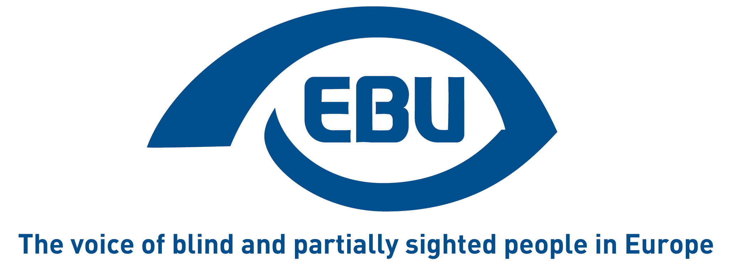

MEDIA funding to European film industry:
Promote Equal Access to Culture for Persons with Visual Impairments in the EU

EBU Position Paper | September 2020

Summary
- Cultural funding, especially for films and television programming under the MEDIA strand of the EU’s Creative Europe programme, has been a positive driver in the past.
- Despite around 820 million € of investment in the MEDIA programme between 2014 and 2020, blind and partially sighted citizens are excluded from the output of this programme.
- Innovative rules in several Member States have expanded the percentage of available accessible cultural content with audio description.
- The EU can learn from these experiences, make films more accessible and create an inclusive cultural area in Europe.
- The EU should be consistent with the revised EU Directive on audiovisual media services which requires media service providers in Europe to make their services continuously and progressively more accessible to persons with disabilities.
- EBU recommends the following:
  - The Creative Europe Programme for 2021-2027 should, at least like its predecessor, include support for audio-description of audiovisual works among support measures for the MEDIA sub-programme;
  - Audio description and audio subtitling should be included among the selection and award criteria on the basis of which proposals eligible for MEDIA funding are assessed;
  - At least 25% of films that receive MEDIA funding should have an audio description and audio subtitling.

Preliminary remark
This paper focuses on EU, i.e. Creative Europe / MEDIA funding of the European film industry. We do not ignore that MEDIA intervenes only where there is an EU added-value, and that Member States have a primary role in funding of the industry, often with larger financial capacities. In fact, EBU will coordinate representations by its member organisations at national level as well. However, we argue that MEDIA can contribute to the awareness of audio description and audio subtitling among film producers as an element of accessibility for blind and partially sighted persons.

Situation
EBU appreciates that the European Union has supported the production and distribution of fiction and documentary projects for cinema and for television with around 2.6 billion € since 1991 through the MEDIA sub-programme. Numerous awards for films funded by this action testify to their value for Europe. MEDIA supports the distribution of more than 400 films each year and the development of 200 films and series per year. It is a positive sign for the European public sphere that this funding has steadily increased until now. It is also a positive sign that the costs of audio description, like those of dubbing or subtitling, are eligible costs.
Yet, funding under MEDIA supports films that fail to include blind and partially sighted persons.
While EACEA, the agency that manages MEDIA funding, admits that costs related to audio description and/or audio subtitling are rare in supported projects, exact figures and proportions are not available. There have been some innovative MEDIA funding actions aimed at increasing audience by supporting the development of applications for accessibility, but this is very marginal.
Visually impaired persons enjoy films or documentaries as much as everyone else. But in order for them to have equal access, they need audio description and audio subtitling for what is shown on the screen. A project without these is like a project without post-editing of the sounds or without the final credits – it is an incomplete film.
The European Union (EU) acceded to the United Nations Convention on the Rights of Persons with Disabilities (CRPD) and it is responsible for its implementation to the extent of its competences. This of course includes EU funding. Article 30, paragraph 1, of the CRPD defines the right of persons with disabilities to take part on an equal basis with others in cultural life. Among other, it obliges State Parties to “take all appropriate measures to ensure that persons with disabilities (…) enjoy access to (…) films (…) in accessible formats”. The EBU Statement related to Article 30 describes the related accessibility needs for blind and partially sighted persons: “Television, film and video productions need to be audio described and audio subtitled, distributed through normal channels and made available at the same time and cost”.
Article 7 of the revised EU Directive on audiovisual media services requires media service providers in Europe to make their services continuously and progressively more accessible to persons with disabilities, including through audio description and audio subtitling. For instance, if a film is delivered in DCP Format with audio description, cinemas will need to ensure that the audio description is available, if only through a dedicated application.
However, only a fraction of television or cinema content is produced in an accessible version in the first place. This is because too few production companies are aware of the access needs of visually impaired persons and there are no incentives for them to invest in audio description and audio subtitling of their content.
A similar diagnosis has led to an innovative approach in Germany. The German Federal Film Board (Filmförderanstalt – FFA) executes the Film Funding Act (Filmförderungsgesetz – FFG). A recast of the FFG in 2013 mandated that the FFA can only fund accessible films. This has two immediate consequences:
- Film production projects are only eligible for funding, if their detailed project description budgets in an audio description;
- Film distribution projects are only eligible for funding, if the distributed film includes an audio description.
The FFA grant does not pay for the audio description but merely creates awareness among filmmakers. Therefore, there are no new costs attached for the FFA. As a result of this approach, the number of accessible films in the cinema and on television has increased significantly since 2013.
Germany is not an isolated example; other EU countries have a similar approach. For instance, in Belgium, in the Flemish and the French Communities alike, all supported films get an additional grant of 5000€ for the creation of an audio description version. In France, there is a specific scheme for the creation of audio description and subtitling files for audiences with sensory disabilities. And in Denmark, bylaws require that audio description be available for films released in cinemas, meaning that the producer needs to include the costs in the production budget and that they will be eligible for production support.
Deutsche Hörfilm gGmbH (DHG), a Berlin based company that makes arts and culture accessible for the blind and partially sighted by producing audio description, has produced audio description for more than 5.000 films since 1999. It indicates a per-minute cost to produce audio description of about 55€. For example, the audio description for an average length movie (122 minutes) like “Portrait of a Lady on Fire”, a European Film Awards 2019 award-winning, MEDIA-funded film, is 6710€; and the audio description costs for an over 3 hour movie like “Schindler’s List” is 10.670€.

Solution
Negotiations for a follow-up to the current Creative Europe programme for the period 2021-2027 are underway. The new programme by the European Commission is likely to benefit from a slight increase of the overall budget from € 1.46 billion. The MEDIA strand’s budget would go from € 820 million to € 1.081 billion, an increase of 32%.
With the budgetary perspectives for the years 2021 to 2027 and annual work programmes by the European Commission, Media already has all relevant policy tools in place. It is now necessary to leverage them for greater cultural access and participation of blind and partially sighted citizens across Europe.
At the very least like its predecessor, the Creative Europe Programme for 2021-2027 should include support for audio description and subtitling of audiovisual works among stated support measures for the MEDIA sub-programme.
We believe that eventually European film funding should be granted only to projects that will create a version with audio description and audio subtitling. But as an intermediate realistic step, we further recommend:
- That the Creative Europe Programme and the annual work programmes include audio description and audio subtitling among the selection and award criteria to be considered by the EU’s Education, Audiovisual and Culture Executive Agency (EACEA) when drawing up conditions and guidelines for funding opportunities under MEDIA and evaluating applications;
- That for the period 2021-2027, a target be set of at least 25% of films that receive MEDIA production or distribution funding have an audio description and audio subtitling in the languages of the production.
The approach we recommend is resource-neutral and without additional costs. And it is not completely new to MEDIA; already for the current funding period, proposals for the sub-branch on gaming are evaluated on their accessibility for users with disabilities.

Further reading
- European Blind Union (2016). Describing Audio Description. Link to Website.
- European Commission (2018). Proposal for a Regulation Establishing the Creative Europe Programme (2021 to 2027) and Repealing Regulation (EU) No 1295/2013. COM(2018) 366 final. Link to PDF.
- European Commission (2019). Creative Europe Projects Overview. Link to Website.
- European Disability Forum (2019). Toolkit for transposition of the Audiovisual Media Services Directive. Link to PDF.
- ISO/IEC TS 20071-21:2015 Information technology — User interface component accessibility — Part 21: Guidance on audio descriptions
- FFA (2018). Funding 2018. Link to PDF.
- FFA (2019). Förderung von Barrierefreiheit im Kino. [German] Link to Website.
- DHG. About DHG. Link to Website.
- MEDIA Films Database. “Portrait of a Lady on Fire”. Link to Website

About EBU
The European Blind Union (EBU) – Interest Representative Register number 42378755934-87 – is a non-governmental, non-profit making European organisation founded in 1984. It is one of the six regional bodies of the World Blind Union, and it promotes the interests of blind and partially sighted people in Europe. It currently operates within a network of 41 national members including organisations from 25 European Union member states, candidate countries and other countries in geographical Europe.
European Blind Union
6 rue Gager-Gabillot - 75015 Paris
+33 1 88 61 06 60 | ebu@euroblind.org | www.euroblind.org

Contacts:
Antoine Fobe, Advocacy & Campaigning, EBU
ebucampaigning@euroblind.org | +33 1 88 61 06 64

Merve Sezgin, Head of International Relations
German Federation of the Blind and Partially Sighted – DBSV
international@dbsv.org | +49 30 285 38 71 20

Source: EACEA, the Education, Audiovisual and Culture Executive Agency.
Audio description communicates important visual content with spoken information inserted as a narrative between the dialogue and other programme sounds. It is essential for the full understanding and enjoyment of films by persons with visual and intellectual disabilities.
Audio subtitling – also known as spoken subtitles – is the reading aloud of interlingual subtitles in a spoken voice. It is especially useful to the visually impaired community for access to foreign-language audiovisual products when they are subtitled rather than dubbed, particularly in countries which do not dub programmes into the national language. Moreover, subtitles have now expanded to same language subtitles; besides being useful for the deaf and hard of hearing, subtitles can be displayed amplified, e.g. on a mobile phone or intelligent glasses, to meet the needs of partially sighted persons. In any case, audio subtitling should be made available as a complement to audio description, never as a substitution.
In Germany the award criteria of the FFA are audio description for the visually impaired and subtitles (SDH) – not audio subtitling – for the hearing impaired.
Source: EFAD, the European Association of Film Agencies.

