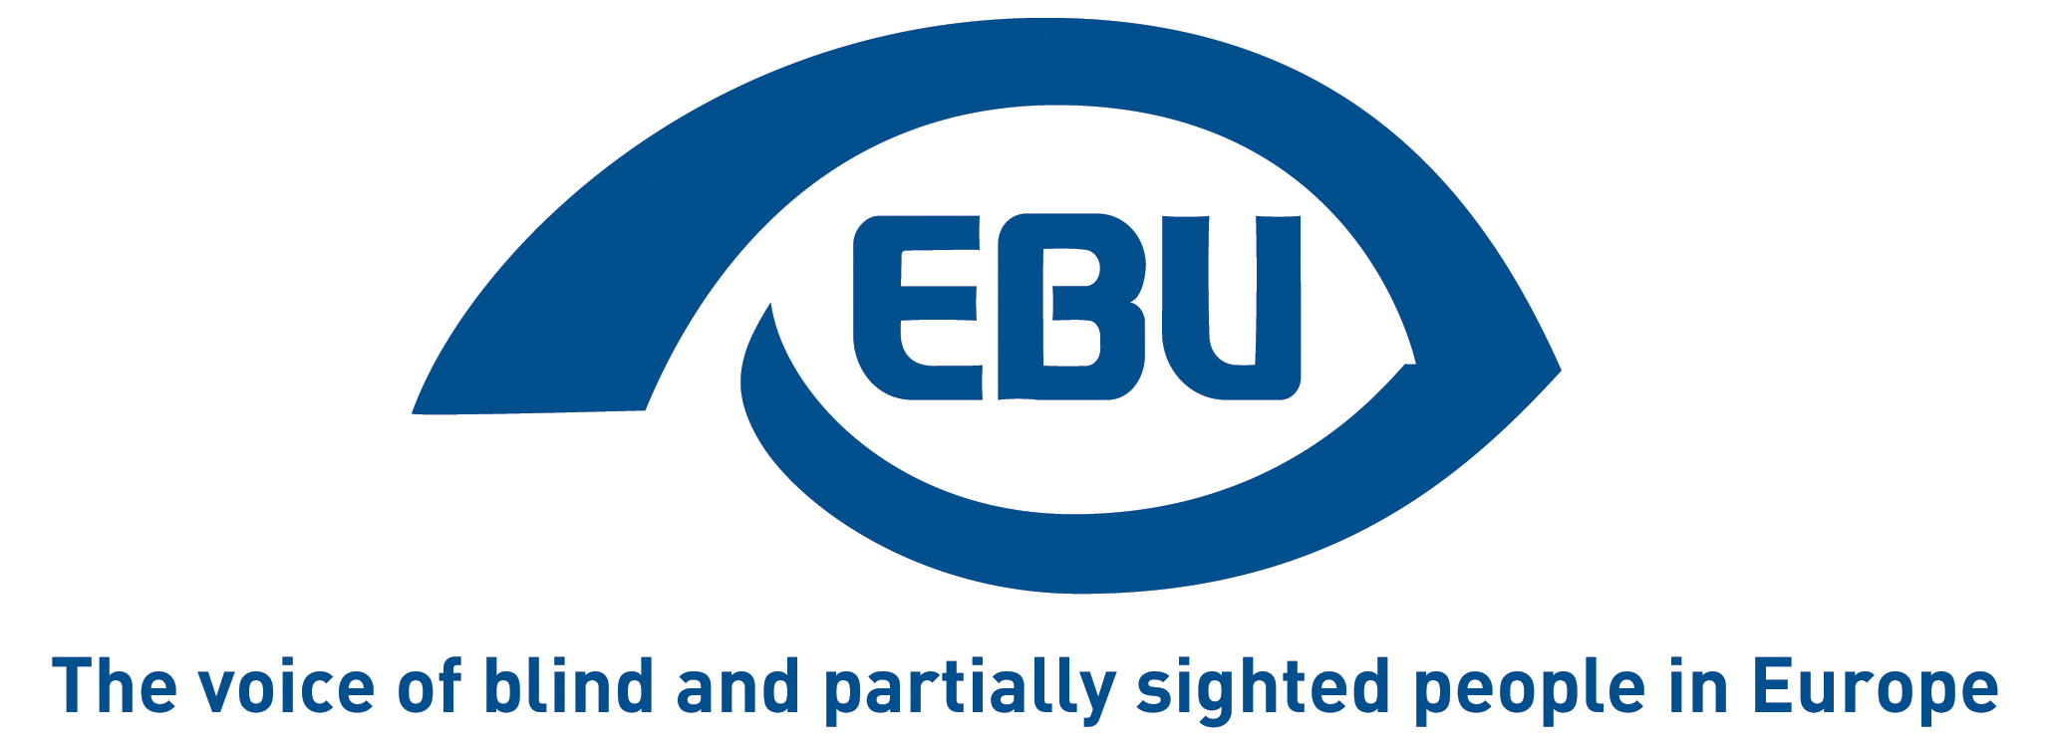

European Blind Union response to European Commission’s Public consultation on the Digital Education action plan (as updated due to COVID-19 crisis)

EBU Position Paper | July 2020

Object of the consultation

The COVID-19 crisis presents both challenges and opportunities for digital transformation in the EU. The Commission’s updated action plan will apply the lessons learnt from the crisis and set out a long-term vision for the digital transformation of education & training in the EU. It will aim to:
- increase digital literacy
- help EU countries work together to adapt their education & training systems to the digital age
- harness the internet’s potential to make online learning available to all.

EBU response

As clearly shown during the recent lockdown period related to the COVID-19 crisis, online education offers both potential for alternative forms of teaching and learning but also a number of challenges.

The European Blind Union (EBU) would like to stress the importance that all virtual platforms in use – let alone the learning resources, be it exercises, books, tests, webpages providing background reading etc. – be fully accessible to all users. In order to achieve this, the principle of universal design must be applied from the outset, meaning from the first stages of developing online tools. Otherwise, people who are blind or partially sighted, amongst many other groups of the population, are at risk of being excluded from the benefits of online education, thereby further widening the digital divide.

In addition to universal design and accessibility of tools, it is also vital to invest in the strengthening of digital skills of both learners and teachers so that all users can truly benefit from the technical platforms available. In such skills training efforts, particular attention should be paid to people who may require extra support or assistance.

Last but certainly not least, we would also underscore that online education, if run in a fully inclusive manner, is an innovative tool that constitutes a useful addition to face-to-face education. At the same time, it should always be considered as a complementary form of education and not to replace onsite learning.

The European Union, through its Digital Education Action Plan and its wider initiatives in the area of digitalisation, can play a critical role in addressing some of the above mentioned challenges and in promoting inclusive education.

About EBU

The European Blind Union (EBU) – Interest Representative Register number 42378755934-87 – is a non-governmental, non-profit making European organisation founded in 1984. It is one of the six regional bodies of the World Blind Union, and it promotes the interests of blind and partially sighted people in Europe. It currently operates within a network of 41 national members including organisations from 25 European Union member states, from candidate countries and from other countries in geographical Europe.

European Blind Union
6 rue Gager Gabillot - 75015 Paris
+33 1 88 61 06 60 | ebu@euroblind.org | www.euroblind.org

Contact: Antoine Fobe, Advocacy and Campaigning
ebucampaigning@euroblind.org | +33 1 88 61 06 64

