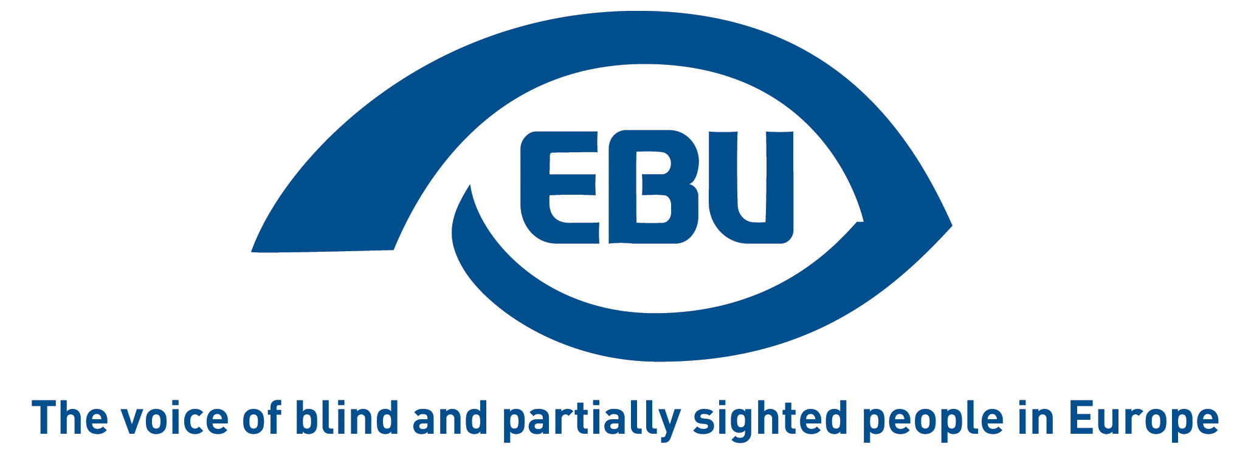

European Blind Union response to the European Commission’s public consultation on the EU strategy on rights of the child (2021-2024)

EBU Position Paper | December 2020

Background and aim of the consultation

The European Commission is currently preparing a new strategy on the rights of the child, framework for EU action to better promote and protect children’s rights. The strategy will present a list of measures (legislative, policy, funding etc.) at EU level that contribute to the protection of the rights of the child, both internally and in external action, to be implement in the course of the current Commission mandate.

We take the opportunity of the public consultation on the strategy to present our recommendations.

Preliminary remarks

The UN Convention on the Rights of Persons with Disabilities (CRPD) ratified by the EU and all its member states requires states parties to take measures to ensure the full enjoyment by children with disabilities of all human rights and fundamental freedom on an equal basis with other children (article 7), including freedom from violence (article 16), living in the community (article 16) and access to inclusive education (article 24). Children with disabilities also have the right to express their views on all matters affecting them (article 7.3).

In 2015, the UN CRPD Committee specifically recommended that EU policies on children include a comprehensive rights-based strategy for boys and girls with disabilities and safeguards to protect their rights. The Committee also recommended that the EU takes the necessary measures, including through the use of the European Structural and Investment Funds and other relevant European Union funds, to develop support services for boys and girls with disabilities and their families in local communities, foster deinstitutionalisation, prevent any new institutionalisation and promote social inclusion and access to mainstream, inclusive, quality education for boys and girls with disabilities.

As indicated by the European Disability Forum, “There are around 68 million children below the age of 15 in the EU (Eurostat, 2020) but there is no data on how many of them have disabilities. Despite the disproportionate risk they face, children with disabilities are given little to no consideration in national or European child rights legislation.
According to Eurostat, about 5% of EU families with children had a child or children with disabilities (ilc_hch13, 2017) and 9.4% of girls and young women and 7.5% of boys and young men (ages 16-24) had a disability (EU-SILC, 2017).
In most EU countries, children with disabilities are institutionalised, segregated in special schools and are victims of violence and abuse, in and outside their family setting.”

Noteworthy also is that more than 60-70% of blind and partially sighted children have one or more other disabilities.

With the above in mind, EBU welcomes the preparation of a new EU strategy on the rights of the child and makes the following recommendations.

Recommendations

The Strategy should refer to the CRPD, comply with it, advance the rights of children with disabilities and implement the recommendations of the CRPD Committee formulated in 2015.

In particular, the Strategy should:
- support Member States in collecting data on blind and partially sighted (hereafter ‘visually impaired’) children, disaggregated by gender and age, including those living in institutions, so as to inform targeted policy-making and monitor its effects;
- ensure that visually impaired children have access to inclusive education in mainstream schools with adequate human, material and technical resources without discrimination. Blind children should be guaranteed the right to learn and to use braille according to article 24 of the CRPD;
- develop support services for visually impaired children and their families in local communities, including early assessment, health care, (re-)habilitation and parent counselling, and foster de-institutionalisation so that visually impaired children with disabilities can live in the community;
- take into account, in (re-)habilitation the risk that visually impaired children develop psychosomatic disorders and other mental health problems, and the risk of suicide, as a consequence of social exclusion
- address the specific needs and issues of visually impaired children in protecting children against all forms of violence – including neglect and psychological violence – and sexual abuse – including on the internet, and including in the family, I schools, in institutions and in any other settings where they depend on other persons. Attention should be given to the training of professionals working with visually impaired children (teachers, health-care professionals, staff in institutions, social workers) on how to recognise the signs of maltreatment of children and how to talk with children about violence, as well as to access for visually impaired children to information on how to protect themselves;
- protect visually impaired children in immigration and asylum, be it with family or unaccompanied.

Moreover, visually impaired children and their representative organisations should be consulted, through accessible methods of communication, in the preparation, design, implementation and monitoring of the Strategy.

Response to the online questionnaire

We have replied to the following questions:

- GENERAL QUESTIONS

Question 4. Which of the following should be a priority for EU action? (from a closed list of possible choices)
Top priorities are:
- Education, leisure, culture
- Welfare, health and social inclusion
- Violence in all its forms

Question 5. What areas should EU action focus on, to foster the protection of children’s rights? (from a closed list of possible choices)
- Enhance the mainstreaming of children’s rights in all relevant EU policies
- Gather data on children’s rights
- Capacity-building and training for professionals

Question 6. Please further explain your choices above.
Data collection is extremely important and the EU must support Member States with tools in order to collect data on blind and partially sighted children in different settings. The lack of disaggregated data affects the possibilities to monitor or evaluate the situation for these children or to assess measures taken.
Children with disabilities and especially children who are blind and partially sighted tend to be totally invisible in international and national reports on the situation children.
The capacity building and training for professionals to ensure inclusive education and access to leisure activities, and to prevent violence, are of utmost importance.

Question 7. Covid-19 has significantly impacted children and their rights. How could child rights and child protection be better embedded in response mechanisms to the pandemic, and to emergency situations in general?
The following problems of visually impaired children need to be addressed for the present and for the future:
- They have problems to follow on line courses due to limited accessibility of the digital technology and limited availability of assistive technology, services and human support at home;
- Also due to accessibility shortcomings, they do not have equal access to information about the pandemic as other children;
- Habilitation activities have been cancelled or postponed, which has a negative impact on their development;
- They experience even more isolation than prior to the pandemic, which increases the risk of anxiety and mental health problem;
- The burden on their families increases during the pandemic, as well as the risk of domestic violence and abuse.

- PARTICIPATION IN THE EU POLITICAL AND DEMOCRATIC LIFE

Question 8. Extent to which we agree with a list of statements.
We partially agree with all statements, and fully agree with the following statements:
- The EU should become closer to its child citizens, including through adapted communication
- EU institutions should consult children directly in policy making and programming

Question 9. What are the main challenges to ensuring child participation in the political and democratic life in the EU? (from a closed list of possible choices)
- Lack of adequate expertise and know-how
- Lack of financial resources
- Difficulty to include different groups

Question 10. Which mechanism(s) should the EU develop? (from a closed list of possible choices)
- On line consultations
- Ad-hoc meetings with children
- Dedicated child-friendly information

- DIGITAL INFORMATION AND SOCIETY

Question 11. Extent to which we agree with a list of statements.
We fully agree with all statements.

Question 12. What should EU action focus on, in order to foster the protection of children’s rights in the digital environment? (from a closed list of possible choices)
- Draft or review frameworks
- Gather data on children’s use of new media
- Capacity building
- Strengthen cooperation

- VIOLENCE AGAINST CHILDREN

Question 13. Which of the following should the EU focus on to help fight violence against children? (from a closed list of possible choices)
- Further elaborate and promote the 2015 principles
- Support member states in collection of data
- Focus on online violence
By the way, in the absence of other choices or free-text field, we would like to recall here that UN Committee on the Rights of the Child urged states to expand the legal definition of violence to include neglect and psychological violence.

Question 14. Based on your professional experience, does violence particularly affect certain groups of children? (from a closed list of possible choices)
- Girls
- Children in migration
- Children with disabilities
- Children in poverty

- JUSTICE & MIGRATION

Question 15. Do you see gaps in EU legislation on child-friendly justice, or issues in its implementation? What further legislative action, if any, should the EU take in this field?
Blind and partially sighted children must have information about and access to complaint mechanism both when they are victims of and as witnesses of violence and sexual abuse.
Legal professionals must have adequate training on how to ensure that the right of the child to have his or her best interests taken as primary consideration is integrated in the legal proceedings, with special consideration on how to support blind and partially sighted children. These children must be seen as credible both as victims and as witnesses regardless their visual impairment.
Justice must be both child and disability friendly to ensure that these children are part of a legally secure process.
Different systems within Europol should be coordinated so that it is impossible for persons who have been convicted for abuse in one country to work with children or in transportation services for children in another country.

Question 16. Where should the EU act first, to contribute to child-friendly justice systems? (from a closed list of possible choices)
- Capacity building
- Information and awareness-raising campaigns
- Strengthen cooperation and coordination

Question 17. The 2017 Communication on the protection of children in migration remains the framework for EU action in this field. What parts of the Communication have not progressed enough in your opinion, and where would you suggest efforts be concentrated in the future?
States must do the utmost to protect blind and partially sighted children in migration, both in their families or as unaccompanied.
These children should be heard in the asylum process and should be given adequate support to do so.
They should have access to habilitation and eye care as soon as possible, and their families should have access to relevant and adequate support.

Question 18. Are there other priorities (which are not included in the 2017 Communication) which you would like EU action to focus on?
Blind and partially sighted children can have an increased risk to develop psychosomatic disorders and other mental health problems. This must be taken seriously and should be included in national habilitation programmes. The risk for suicide should also be taken into consideration.

About EBU
The European Blind Union (EBU) – Interest Representative Register number 42378755934-87 – is a non-governmental, non-profit making European organisation founded in 1984. It is one of the six regional bodies of the World Blind Union, and it promotes the interests of blind and partially sighted people in Europe. It currently operates within a network of 41 national members including organisations from 27 European Union member states, candidate countries and other countries in geographical Europe.

European Blind Union
6, rue Gager-Gabillot - 75015 Paris
+33 (1) 88 61 06 60 | ebu@euroblind.org | www.euroblind.org

Contact: Antoine Fobe, Head of Campaigning
ebucampaigning@euroblind.org | +33 1 81 61 06 64

http://www.edf-feph.org/newsroom/news/eu-must-protect-rights-children-disabilities

