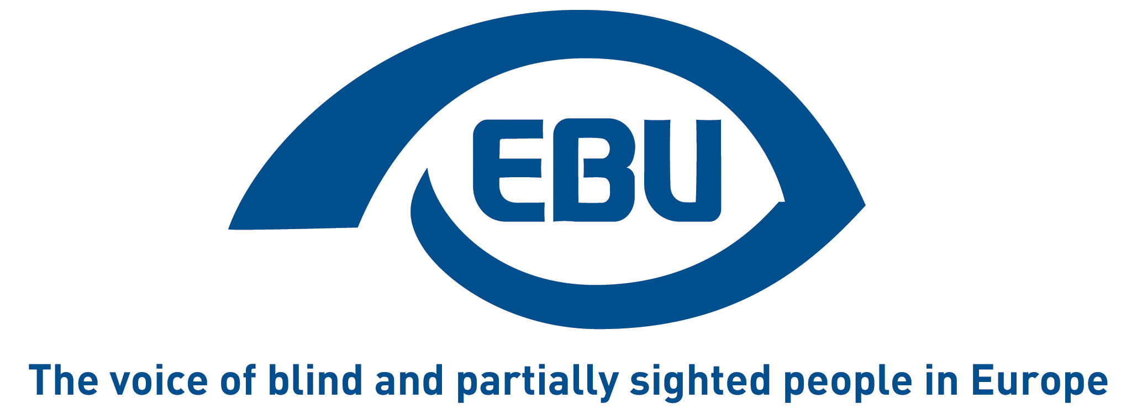

European Blind Union response to public consultation on evaluation of the European Statistical Programme 2013-2020

EBU Position Paper | July 2020

Object of the consultation

This consultation aims to evaluate the programme for the last time, focusing mostly on 2018-20, assessing:
- whether the programme is working as intended;
- progress on easier, user-friendly access to official statistics;
- progress on improving data availability;
- the benefits of statistical products and areas for simplification.
It is a consultation on the roadmap. A proper public consultation on the Commission’s evaluation is planned for the 4th quarter of 2020.

Response

Statistics are still sadly lacking at EU level to allow to monitor the situation on the ground for persons with disabilities. They are badly needed to ensure that the EU and its Member States deliver on their commitment and obligation to include disabled persons in society and in particular in the jobs market. Appropriate statistic tools are necessary for the Commission to address the situation of persons with disabilities in both the European Semester and the Joint Employment Report.

The approach taken so far is essentially surveys-based, but there needs to be a more systematic approach, with data disaggregated per type of disability, in order to bench-mark progress, identify problem areas and, where appropriate, devise fully inclusive policies.

About EBU
The European Blind Union (EBU) – Interest Representative Register number 42378755934-87 – is a non-governmental, non-profit making European organisation founded in 1984. It is one of the six regional bodies of the World Blind Union, and it promotes the interests of blind and partially sighted people in Europe. It currently operates within a network of 41 national members including organisations from 25 European Union member states, from candidate countries and other countries in geographical Europe.

European Blind Union
6 rue Gager Gabillot - 75015 Paris
+33 1 88 61 06 60 | ebu@euroblind.org | www.euroblind.org

Contact: Antoine Fobe, Advocacy and Campaigning
ebucampaigning@euroblind.org | +33 1 88 61 06 64

