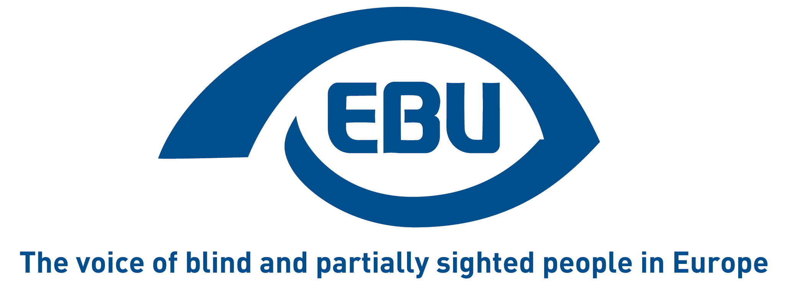

European Blind Union response to the European Commission’s public consultation on

the Eurostat SDG monitoring report

EBU Position Paper | September 2021

Object of the consultation

Context of the consultation

Sustainable development is firmly anchored in the European Treaties and has been at the heart of European policy for a long time. The 2030 Agenda for Sustainable Development and its 17 Sustainable Development Goals (SDGs), adopted by the UN General Assembly in September 2015, have given a new impetus to global efforts for achieving sustainable development. The EU is fully committed to playing an active role in helping to maximise progress towards the Sustainable Development Goals.

The annual Monitoring report on progress towards the SDGs in an EU context (5th edition) builds on the EU SDG indicator set, developed in cooperation with a large number of stakeholders. The indicator set comprises 102 indicators and is structured along the 17 SDGs. For each SDG, it focuses on aspects that are relevant from an EU perspective. The monitoring report provides a statistical presentation of trends relating to the SDGs in the EU over the past five years (‘short-term’) and, when sufficient data are available, over the past 15 years (‘long-term’). The indicator trends are described on the basis of a set of specific quantitative rules. The 2021 edition also shows some of the early impacts of the COVID-19 pandemic that are visible in Eurostat’s official statistics.

Aim of the consultation

In order to tailor its products as much as possible to users’ expectations, Eurostat seeks their advice on the quality, usefulness and versatility of the annual Monitoring report on progress towards the SDGs in an EU context and the related communication package.

Feedback

1. Please indicate for which purposes you are using the Eurostat SDG Monitoring report?
- Getting general information on the development of SDGs in the EU.
- Getting information on relevant EU policies.

1.a. If there is any other purpose for which you are using the SDG Monitoring Report, please indicate:
European Blind Union (EBU) is using the report to observe to what extent the EU and its Member States are effectively mindful of inclusion of persons with disabilities, and in particular of blind and partially sighted persons, in line with the UN Convention on the Rights of Persons with Disabilities, through the pursuit of the relevant SDGs.

2. How important/useful are the following sections of the SDG Monitoring Report 2021 for you? (1=less important – 5=essential)
Synopsis (general summary) Reply: 4
Introduction (policy background and methodological summary) Reply: 4
Cross-cutting issues: Impact of COVID-19 Reply: 4
Cross-cutting issues: Interlinkages between SDGs Reply: 4
Cross-cutting issues: Experimental indicators for estimating spillovers Reply: 3
Specific SDG chapters (1-17) Reply: 5
Analysis of decoupling in chapters 7-9 and 12-13 Reply: 3
Member State overview (chapter 18) Reply: 4

3. Are the policies relevant for achieving the SDGs in the EU described at the right level of detail in the report? Please indicate those SDGs for which you consider the level of detail is too high or too low.
The level of detail is too low for the following SDGs:
SDG1 No poverty
SDG3 Good health and well-being
SDG4 Quality education
SDG8 Decent work and economic growth
SDG10 Reduced inequalities

4. Is there any topic you would like to read more about in the next SDG Monitoring Report? If yes, please indicate what and why.
Disability is meaningfully mentioned only in relation to SDGs 1 (poverty) and 8 (employment); under SDG 3 (health) it is only addressed as a consequence of accidents (not about the healthcare needs of persons with disabilities). The section on COVID-19 and SDG 4 (education) are silent. Even more worrying, under the most relevant SDG 10 (equality) disability is only mentioned to describe the goal.

5. Is there a topic or chapter that, in your opinion, would in the future/in the next SDG Monitoring report become less important and so may be dealt with in a reduced volume or not be included at all? If yes, please indicate what and why.
No opinion.

6. Do you use other online or offline products of the SDG package? Please indicate which ones?
- Statistics Explained articles
- Online database
- Country scores
- SDG dedicated section on the Eurostat website

7. Do you have other suggestions for improving the Eurostat SDG monitoring products?
Eurostat currently does not collect data disaggregated by disability. It should start doing so, to allow a well-informed EU policy for the inclusion of persons with disabilities. To begin with, this could be only in some priority areas, e.g. employment.
The next review of the EU SDG indicator set should integrate the Washington Group Short Set of Questions into the surveys Eurostat and the national statistics offices use for SDG monitoring purposes.

About EBU
The European Blind Union (EBU) – Interest Representative Register number 42378755934-87 – is a non-governmental, non-profit making European organisation founded in 1984. It is one of the six regional bodies of the World Blind Union, and it promotes the interests of blind and partially sighted people in Europe. It currently operates within a network of 41 national members including organisations from 25 European Union member states, candidate countries and other countries in geographical Europe.

European Blind Union
6 rue Gager Gabillot - 75015 Paris
+33 1 88 61 06 60 | ebu@euroblind.org | www.euroblind.org

Contact: Antoine Fobe, Head of Advocacy & Campaigning
ebucampaigning@euroblind.org | +33 1 88 61 06 64

EBU contributed feedback to the November 2020 consultation on the EU SDG indicator set.

