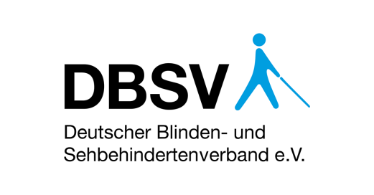

AVA – Accessible Voting Awareness-Raising

  - Report on the Accessibility of Elections for Blind and Partially Sighted Voters in Europe

Version 1.0
November 2018

EXECUTIVE SUMMARY
The United Nations Convention on the Rights of Persons with Disabilities (UNCRPD) mandates all countries in to “guarantee to persons with disabilities political rights and the opportunity to enjoy them on an equal basis with others”. This includes the act of casting a vote, which is one of the most recognisable features of political life in Europe. Yet, the standard model of elections practiced across Europe today – marking a favourite candidate or party on a paper ballot – excludes most of the 30 million European citizens with visual impairments from this core political right.

This problem has provoked a growing body of literature, mostly by international organisations. While these resources provide highly valuable input to the discussion on the political rights of persons with disabilities, they are nonetheless restricted by three shortcomings. First, they cover only sub-sections of the countries in Europe. Second, with dynamic improvements in the legal context, the reports quickly become outdated. Third, most publications are too general in scope to formulate concise action-points.

To address these gaps in the literature, this report looks at a narrow section of political participation – the act of casting a vote – only from the perspective of blind and partially sighted (BPS) voters in 45 countries of Europe. It asks how elections can be designed in an accessible way, allowing for equal participation of BPS voters. Thus, the report isolates the specific requirements of persons with visual impairment on accessibility and political participation and details their design specifications for decision-makers.

In this endeavour, the report is based on a review of the legal provisions for regular elections and referenda in 45 countries, on an Expert Survey within the European Blind Union (EBU), which yielded 24 responses, and on qualitative desk research to cover the remaining countries. For the purpose of its evaluation, the report takes a voting method to be accessible if it ensures that any given BPS person can vote equally to all other voters, independently from external help and secretly.

This report looks at seven different voting methods available in at least one European country. In all 45 surveyed European countries, the standard way of voting is with paper ballots. All except two of the surveyed countries allow voting with an assistant. 20 countries allow different methods of voting in advance for different groups of voters. Absentee voting, in the form of postal vote within the country is possible in 10 countries, while an absentee vote via mobile ballot boxes is possible in 20 countries. Voting by the means of a stencil is possible in 14 countries. Proxy voting is allowed in five countries. Electronic Voting is practiced only in four countries. The EBU Expert Survey clearly shows that there is a mismatch between the available voting methods and the desired voting methods for BPS persons. 79% prefer electronic voting, 71% prefer internet voting and 67% prefer stencil voting.

The EBU Experts further report a number of issues with existing voting methods. One hindrance to accessibility arises, when there are different rules in different electoral laws, as this makes it less likely for election officials to be aware of and appropriately apply all provisions. Further, there are issues related to the ballot paper, which is often too complicated and too spacious to allow for the accompanying usage of assistive devices. There are also issues with the practical implementation of different voting methods, for instance if not all polling stations are adequately equipped with stencils for BPS voters. In addition, EBU experts also report issues with the awareness of polling officers regarding legal rights and practical tools for BPS voters.

Regarding paper-based voting, the report notes that in itself it is not accessible to most BPS voters. A blind voter is not able to identify different elements on the ballot and independently mark the preferred option or options on the ballot. However, paper-based voting in principle can be designed accessibly for some partially sighted voters. This requires adequate font sizes and contrast values on the ballot as well as magnifying glasses in the voting booth and good lighting conditions.

Regarding assisted voting, the report notes that this is the go-to solution to make elections accessible for persons with disabilities. The implementation of assisted voting in Europe differs largely on two parameters. The first one relates to the way that the assistant is chosen, where voters should be given full discretion on whom to choose. The second one discerns the documentation requirements for assisted voting, where it is recommendable to keep these as low as possible. Nonetheless, assisted voting restricts the principle of independence and necessarily impedes the secrecy of the vote.

Regarding stencil voting, the report points out differences in the production and distribution of stencils, in the design of stencils and ballots as well as in the presentation of content on the ballots. Stencils should be produced centrally with sufficient time allocated. They should include Braille and relief large-print in sufficient contrast. There should be a unified national ballot template to simplify the production and audio-files should be made available to BPS voters online prior to the election. Stamps can be a good option for electoral systems that require the voter to write down numbers as well as for BPS voters with motor difficulties. However, the usefulness of a stencil is limited, as it does not allow striking, adding or reordering candidates. Stencil voting provides a large degree of independence and in principle guarantees the secrecy of the vote.

Regarding advance voting, the report argues that it can relieve the stress of voting on the day of the election and give BPS voters all the necessary time to make an informed decision without pressure. There should be as few additional documentation or registration requirements involved as possible. Advance voting is only a good provision if available to all voters and its accessibility depends on the availability of other tools, such as stencils.

Regarding absentee voting, the report notes two very different forms of casting a vote without being physical present at the polling station, namely postal voting and mobile ballot boxes. Regardless of this difference, options to vote outside of the polling station should be available to all voters. Difficult application procedures should be avoided. The home of a BPS person is more likely to provide appropriate surroundings for the voter, for instance regarding the lighting conditions. If coupled with other voting methods, absentee voting has the potential to increase the independence of the vote but it can also jeopardise the secrecy of the vote.

Regarding electronic voting, the least used alternative method, practical implementation differs in the prevalence of voting machines, the voting process as well as in the design of the voting machine and the electronic ballot. It is recommendable to provide voting machines everywhere in order to reach the widest number of BPS voters. The operational design of the machine and the electronic ballot needs to be accessible, including text-to-speech converter, Braille output, acoustic confirmation sounds and tactile buttons. Electronic voting also offers advantages for the countries with complex voting systems, as actions such as the striking, adding or ranking of candidates can be more easily done with an electronic interface. For this, it does not matter, whether the machine relies on a computer keyboard, a telephone keypad or a machine with multiple buttons. Electronic voting guarantees equal elections, if available to all voters. It also guarantees fully independent and secret voting, if designed accessibly.

Implementation of all these voting methods is dependent on awareness of the election officials. It is conducive for awareness, if the same rules apply to all elections, but it is in any way important to inform election officials about their responsibilities on the day of the election. This is commonly done by means of training sessions. However, 34 countries do not formulate any training requirements in their electoral legislation. Eleven countries have a training requirement, but their legislation does not mention political rights of persons with disability as a training component. Consequently, election officials often do not know how to ensure accessibility of the political process for BPS citizens. Continuous cooperation with BPS organisations in the country is a good tool to create and maintain awareness among election officials.

This report concludes with the observation that the act of voting is not fully accessible in any country in Europe. Nonetheless, the report showcases 26 good practices that can build a more equal, independent, and secret voting experience for BPS voters. While assisted voting should always remain a choice for BPS voters, it should not be the only available option as it currently is in 58% of the surveyed countries. For the full functioning of accessible alternative voting methods, it is further necessary that election officials are aware of the existing legal provisions and the needs of BPS voters. Alternative voting methods have the potential to increase the accessibility of elections. As such, they can contribute crucially to the implementation of Art 29 UNCRPD in Europe.

TABLE OF CONTENTS
EXECUTIVE SUMMARY 2
TABLE OF CONTENTS 6
DEFINITIONS AND ABBREVIATIONS 7
REGISTER OF BEST PRACTICES 8
1. INTRODUCTION 9
1.1 Legal and Political Context 9
1.2 Existing Research 10
1.3 Purpose and Focus 12
1.4 Limitations 13
1.5 Methodology 14
1.6 Principles of Evaluation 15
2. PAPER-BASED VOTING IN EUROPE 16
3. AVAILABILITY AND ACCESSIBILITY 17
3.1 Availability of Voting Methods 17
3.2 Practicability of Voting Methods 19
3.3 Awareness of Polling Officers 20
4. ALTERNATIVE VOTING METHODS 21
4.1 Paper-Based and Proxy Voting 21
4.2 Assisted Voting 22
4.3 Stencil Voting 26
4.4 Advance Voting 33
4.5 Absentee Voting 34
4.6 Electronic Voting 36
5. AWARENESS OF ELECTION OFFICIALS 40
6. CONCLUSION 42
7. FURTHER READING 46
8. ANNEX 48
8.1 Annex 1: Article 29 of the UNCRPD 48
8.2 Annex 2: Database on Legal Provisions 49
8.3 Annex 3: Expert Survey 64
8.4 Annex 4: Sample Ballots from Europe 73
ABOUT THIS REPORT 84

DEFINITIONS AND ABBREVIATIONS
Ballot: Medium to indicate vote in election; Can be a paper ballot, but also an electronic ballot.

BPS: Blind and Partially Sighted; Also referred to as visually impaired.

CEC: Central Election Commission; Although terminology differs across countries, used here to denote the highest election body in a country, responsible for overall organization of elections.

EBU: European Blind Union

FRA: European Union Agency for Fundamental Rights

LEC: Local Election Commission; Although terminology differs across countries, used here to denote the lowest election body in a country, responsible for conducting election in a single polling station.

ODIHR: Office of Democratic Institutions and Human Rights

OSCE: Organization for Security and Co-operation in Europe

PACE: Parliamentary Assembly of the Council of Europe

Polling Officer: Member of LEC present in the polling station; Although terminology differs across countries, used here to denote the officer conducting elections.

Polling Station: Designated location for voting on the day of the election.

Precinct: Small organisational electoral unit, composed of multiple polling stations.

Stencil: Assistive device relaying the content of the ballot. Through corresponding holes in the stencil a BPS person can cast a vote on the ballot inserted into the stencil. Alternative terms include template and mould.

UNCRPD: United Nations Convention on the Rights of People with Disabilities

WBU: World Blind Union

REGISTER OF BEST PRACTICES
Best Practice 1: Minimum Font Sizes for Ballot 22
Best Practice 2: Magnifiers at the Polling Station 22
Best Practice 3: Full Choice of Assistance 24
Best Practice 4: Assistants in Each Polling Station 24
Best Practice 5: No Administrative Barriers 24
Best Practice 6: Signature Requirement for Assistants 25
Best Practice 7: Central Production of Stencils 28
Best Practice 8: Sufficient Time for Stencil Production 29
Best Practice 9: Accessible Stencil Design 29
Best Practice 10: Unified Ballot Design 30
Best Practice 11: Envelopes for Multiple Ballots 30
Best Practice 12: Reduced Ballot Format 31
Best Practice 13: Audio-Files for Ballot 31
Best Practice 14: Phone Hotline on Ballot 31
Best Practice 15: Stamps instead of Pens 32
Best Practice 16: Explanation on Stencil 32
Best Practice 17: Advance Ballot Online 33
Best Practice 18: Universal Postal Voting 35
Best Practice 19: Spread-Out Voting Machines 38
Best Practice 20: Accessibility as Obligation 38
Best Practice 21: Accessibility as Practice 39
Best Practice 22: Internet Voting 39
Best Practice 23: Common Legal Provisions 40
Best Practice 24: Mandatory LEC Training 41
Best Practice 25: Learning Curve for Election Officials 41
Best Practice 26: Informal Dialogue with BPS Persons 42

INTRODUCTION
“The right of voting for representatives is the primary right by which other rights are protected”, wrote a British-American political theorist at the beginning of the democratic age [Paine 1795, p. 19]. Indeed, elections are one of the most recognisable features of political life. They are also the most tangible expression of actively participating in political decision making. And yet, the standard model of elections practiced across Europe today – marking a favourite candidate or party on a paper ballot – excludes 30 million Europeans with visual impairments from this core political right. This poses the question, how elections can be designed in an accessible way that allows for equal participation of blind and partially sighted (BPS) voters.

In its attempt to answer to this inquiry, the present report is structured in six chapters. First, the remainder of this introduction summarises the context for accessible voting, existing research and underlying methodological considerations. The second and third chapter review the diversity of paper-based voting in Europe and then present available voting methods and their pertinent problems across the continent. The fourth chapter analyses in depth the merits of different voting methods and collects best practices to optimise them for BPS voters. The fifth chapter reviews and assesses provisions to increase the awareness of election officials about accessible voting. Finally, the conclusion argues that there should be multiple, intentionally designed voting methods available in order to guarantee a better accessibility for BPS persons.

Legal and Political Context
The main instrument of international law is Art 29 of the UNCRPD [see Annex 1]. All countries, in which the EBU has members as well as the European Union (EU), are signatories to the UNCRPD. In order to “guarantee to persons with disabilities political rights and the opportunity to enjoy them on an equal basis with others”, signatories shall ensure effective and full participation in political and public life, which includes the right to vote and to be elected. This requires at least three steps:

“(i) Ensuring that voting procedures, facilities and materials are appropriate, accessible,(…); (ii) Protecting the right (…) to vote by secret ballot in elections and public referendums without intimidation, and to stand for elections, to effectively hold office (…); (iii) Allowing assistance in voting by a person of their own choice.” [UN 2006, Art 29(a)]

On the national level, the political process is mostly regulated by constitutions and by electoral laws. The latter may exist in a unified form for all elections or in multiple texts for parliamentary and presidential elections, regional or municipal elections, or referenda. While electoral laws cover a wide range of topics, there has been a consistent political development in the past years to increase compliance of electoral laws with the UNCRPD. For example, new references to the needs of BPS voters were included in the 2017 reform of the Electoral Code in Germany. Moreover, ballot stencils were trialled in Ireland and the Netherlands as a result of advocacy by local BPS organisations [NCBI 2018, Oogvereniging 2018].

In the specific context of elections of the European Parliament, the next of which will take place in from 23 to 26 May 2019, the latest reform of the European Electoral Act did not explicitly reference the UNCRPD. However, it calls upon EU governments to “provide for the possibilities of advance voting, postal voting and electronic and internet voting, in elections to the European Parliament” [European Union 2018, Art 4a]. As these alternative voting methods carry with them the advantage of increased accessibility, they will also guide the analysis of this present report in Chapter 4.

This brief overview of the context shows that the legal innovation of the UNCRPD has spurred political changes across Europe. The binding requirement to ensure equal participation in political processes results in a need to reform electoral legislation and practices. This dynamic shows that the present EBU report appears at a crucial time for the political rights of BPS voters.

Existing Research
In addition to these developments, there has been a steady accumulation of research on the political participation of persons with disabilities since the entry into force of the UNCRPD. Main contributions to the literature come from several international organisations, the European Blind Union (EBU) itself and some EBU member organisations. A short summary of the most important publications is presented in this section.

The Human Rights Council of the United Nations adopted a thematic study on participation in political and public life by persons with disabilities in 2011. This report draws on responses from 59 countries worldwide, among them 25 in Europe, as well as multiple human rights bodies and organisations. The main emphasis of the report is on universal suffrage for persons with restricted legal capacity, which the study notes to be lacking in most countries. The publication also analyses trends towards accessible elections and formulates a set of generalised recommendations [UN 2011].

The most comprehensive overview on the rights of persons with disabilities to political participation was published in 2014 by the EU Fundamental Rights Agency (FRA). Based on an analysis of the 28 Member States of the EU, FRA developed human rights indicators to assess accessibility of the entire political process, focussing on four overarching themes: legal and administrative barriers; rights awareness; accessibility; and opportunities. Individual indicators encompass, among many others, the accessibility of manifestos, the number of elected officials with disabilities and the design of complaint mechanisms. The authors formulate a comprehensive list of steps to undertake for more equal political participation of persons with disabilities [FRA 2014].

The Parliamentary Assembly of the Council of Europe (PACE) adopted a resolution on “The political rights of persons with disabilities: a democratic issue” in March 2017. This resolution draws on a report by German MP Mechtild Rawert, summarising input from 42 questionnaires, one expert hearing, and a fact finding mission. The report explores the accessibility of polling stations and voting processes, issues related to the restriction of political rights on basis of restricted legal capacity as well as the topic of openness of political information and parties to persons with disabilities. The resolution recommends among other methods to introduce tactile ballots and electronic voting as well as to increase the awareness of election officials in the Central Election Commission (CEC) and in the Local Election Commission (LEC) [PACE 2017].

The Office of Democratic Institutions and Human Rights (ODIHR) of the Organisation for Cooperation and Security in Europe (OSCE) is the most important institution for election observation in Europe. In 2017, ODIHR published a specific handbook on the observation and promotion of the political rights of persons with disabilities. Based on a thorough analysis of the UNCRPD, the publication formulates a framework for election observation missions. It provides 40 guiding questions for legal, technical, political and media observers, which cover the full electoral cycle. The handbook does not explicitly state what needs to be done to increase political participation, but its indicators can be interpreted as such [ODIHR 2017].

EBU has published three main resources on Art 29 UNCRPD. In 2009, its Spanish member, ONCE, published a survey-based study on the voting methods of 18 different EU Member States. It found that postal vote, proxy vote and assisted voting are the most common procedures in place. Since 2014, EBU maintains an online database on the UNCRPD, including responses of 19 European countries, both EU and non-EU members, on the implementation of Art 29 [EBU no date]. In the same year, these responses were analysed by EBU regarding the availability of electronic voting machines and the facilitation of assistance to BPS voters [EBU 2014]. None of these resources formulates steps to improve the legal and political framework for accessible elections.

Multiple BPS organisations have engaged with the topic of accessible elections. The World Blind Union (WBU) published a short resource paper by the South African National Council for the Blind in 2014, which names alternative ways of voting and develops brief recommendations for increased accessibility [WBU 2014]. The Danish Association for the Blind sponsored an extensive report on alternative voting methods and privacy systems based on thorough stakeholder consultations [Amato & Leeber 2011]. Already in 2002, the American Foundation for the Blind reviewed the accessibility of electronic voting machines on the market [Burton & Uslan 2002].

Additionally, several national human rights bodies reviewed the status of political participation of persons with disabilities, for instance 2017 in the Netherlands. The Academic Network of European Disability Experts, an independent advisory body of the European Commission, regularly compiles data on the UNCRPD [ANED 2018]. Civil society initiatives such as the Zero Project provide overviews on multiple UNCRPD indicators, among them on the availability of information on elections [Zero Project 2015].

Purpose and Focus
While all these resources provide highly valuable input to the discussion on the political rights of persons with disabilities, they are nonetheless restricted by three shortcomings. First, they cover only sub-sections of the countries in Europe. The FRA Report, for instance, while the most extensive in scope, naturally only analyses the Member States of the EU, leaving out more than a third of the countries covered by the EBU. Second, with dynamic improvements in the legal context, the reports quickly become outdated, which specifically applies to the 2009 EBU report. Third, most publications are too general in scope to formulate concise action-points. Both reports from the UN and PACE cover a wide range of issues from start to finish of the political process without being able to adequately differentiate between disability types and diverse accessibility needs associated with them.

The purpose of this report is to address these shortcomings and analyse one sub-section of the scope of Art 29 UNCRPD in a detailed way from the perspective of BPS voters in all 45 countries of Europe. This allows the report to isolate specific requirements of persons with visual impairment on accessibility and political participation and detail their design specifications for decision-makers. As such, the report aims to update the EBU database on basis of a larger sample of analysed countries.

In line with the question of the 2009 publication, this report asks, how the act of casting a vote can be designed in an accessible way for BPS persons. This priority derives on the one hand from the expertise of the EBU regarding visual impairment and on the other hand from the argument that the best information material is of no use for a BPS voter, if he or she is unable to eventually cast a vote.

The question asked in this report is technical. When commenting on the voting procedures across Europe, this report does not make any normative claims as to the quality of those elections or the quality of democracy in the respective country. Instead, the arguments proposed refer only to the question of accessible design for the act of voting. Consequently, the objective of the report is to work towards the freedom of BPS voters to make an informed electoral choice in spirit of Art 29: “on an equal basis (…) by secret ballot (…) without intimidation.”

Limitations
This focus results in two main limitations, which this report openly acknowledges. The first limitation is that it only looks at one part of the electoral cycle and at only active political rights, while the electoral cycle begins much earlier. It entails the full electoral campaign, the provision of information, registration into voter registers, and access to the polling station, as well as the accessibility of complaint mechanisms after the election. Regarding passive electoral rights, it also includes the ways of registering to run as candidate and the representation of persons with disabilities in elected office. The three quoted publications by FRA, PACE and ODIHR all do an excellent job in highlighting the accessibility issues with this full cycle, which warrant further attention. This report aims to formulate actionable recommendations for one small section of this political process as a starting point for further analysis.

The second limitation is that this report only looks at one type of disability. Naturally, persons with different disabilities have different access requirements for political participation. A person with hearing impairment might require different accommodation for political rallies than a voter with a learning disability. Accessibility of the polling station indicates a different meaning for a wheelchair user and for a person with visual impairment. Equally, the three quoted publications by FRA, PACE and ODIHR take into considerations all persons with disabilities. However, the formulation of concrete recommendations is facilitated by the isolated analysis of one type of disability at a time, which is why this report draws on EBU expertise to only cover BPS persons and their varying needs.

It is important to note that this approach does not constitute in any way a depreciation of the needs and requirements of other persons with disabilities, nor a disregard towards the other pressing issues regarding the political process, but focuses on its aim to contribute action-oriented analysis in one small subsection of those: how to improve the accessibility of the act of voting for BPS persons.

Methodology
In order to answer this question, the report engages in a mixed-method methodology based on three sources. First, the report is based on a review of the legal electoral provisions in all European countries for regular elections and referenda. The list of the countries surveyed as well as a summary of the results can be found in Annex 2. For non-federal countries or countries with a unified electoral code, all types of elections are covered in the analysis. For federal republics such as Germany, representative regional units were surveyed as well [see also: FRA 2014, pp. 96-100].

Second, the report draws on an Expert Survey among EBU members, which was conducted from May to September 2018. The survey consisted of eleven topical questions on the accessibility of voting, composed both as closed and as open-ended questions. The list of the 24 recorded responses, representing 61% of the 41 EBU-Member Organisations, is reproduced partially in Annex 3.

Third, the report uses qualitative desk research on media publications, academic articles and election observation reports. The focus in this area was placed on the countries that did not submit an answer to the Expert Survey, in order to be able to contextualise the implementation of the legal requirements.

Principles of Evaluation
The way that elections are organised – the voting system, the form of the ballot, or the timing of the election – are expressions of the political culture of each country. As it is not the intent of the EBU to forcefully alter these cultural expressions, the report will comment on them from a technical perspective. However, the wide variety of voting methods across Europe begs a common evaluation approach. For the purpose of this report, the EBU argues that a voting method is accessible if it ensures that any given BPS person can vote equally, independently and secretly.

Equality of the vote entails that a BPS voter can vote by the same methods, in the same locations, and in the same timeframe as any other voter. Equal elections are designed in a way that does not require BPS voters to complete bureaucratic steps only meant for them. Alternative methods of voting are in principle available to all voters irrespective of their disability.

Independence of the vote entails that a BPS voter can cast the ballot independently. This includes that he or she does not have to rely on assistance by third parties or LEC personnel to cast a vote. At the same time, if a BPS voter, for instance due to additional motor limitations, wants to use assistance, this does not stand in contrast to the premise of independent voting.

Secrecy of the vote entails that a BPS voter’s preference is not disclosed to any other person. This includes members of the LEC as well as any other voters at the polling station. In case of non-secret votes for all citizens, for instance in assembly votes for mayor in Kazakhstan, the BPS voter’s preference should be as secret as all other votes cast in the election. The principle of secret votes is also anchored in Art 29 UNCRPD.

PAPER-BASED VOTING IN EUROPE
In all surveyed European countries, the standard way of voting is with paper ballots. That being said, there is considerable variation across the countries and the type of elections in how this paper-based voting is designed. The purpose of this chapter is to briefly present this variation as it serves as necessary backdrop for the analysis in the following chapters. Annex 4 presents sample ballots for most countries and elections referenced in this chapter.

The basic form of voting is to mark one preferred option from a list of many. This can be either a political party, as for instance in Hungarian parliamentary elections, or an individual candidate, as for instance in Russian presidential elections. Referenda across Europe, for instance in Ireland, usually follow the same example, providing a binary choice.

The presentation of this option on the ballot differs. In some countries, such as Romania, the options are not put on a list but instead in a multi-page brochure. In many countries, candidates and parties are listed in form of a matrix. One example for this is the Netherlands. These matrix ballots tend to be large, as they include all running parties and candidates in the electoral district.

There are different ways to fill out such a single ballot. In Ireland for example voters can rank multiple candidates on the ballot. They assign the number “1” to their preferred candidate, the number “2” to their second preference and so on. In some countries, voters have two votes on two different lists on the same ballot, for instance in Germany. In multiple countries, voters can cross out candidates from the ballot, move candidates up the list or weigh their votes for individual candidates. Examples for this are Austrian federal elections and some regional elections in Germany.

A different approach consists in giving multiple ballots to each voter. Usually, there is one ballot for each party running in the electoral precinct. In Spain and Latvia for instance, voters first select the ballot of their preferred party and can then mark a favourite candidate from this party on the specific ballot. In French elections, voters choose the ballot of their favourite candidate, place it in an envelope and cast the vote without the need to mark any ballot.

An outlier in this list is Finland, where voters have to write down the unique identifying number of their preferred candidate on the ballot. For this, they can choose from a full list of all running parties and candidates, which is displayed on the walls of the voting booth.

As stated, the purpose of this report is not to criticise national approaches to voting or to prescribe a European model of voting. However, as will be shown in the following chapters, some of these approaches are more viable for optimisation for BPS voters.

AVAILABILITY AND ACCESSIBILITY
This chapter looks at the current status quo of the accessibility of elections in Europe in two different ways. On the one hand, it summarises the availability of different voting methods across the continent. This input is based on an analysis of electoral legislation in all surveyed countries. On the other hand, it highlights pertinent problems for BPS voters. This input is based on responses to the EBU Expert Survey. In conclusion, this chapter shows a mismatch between the available voting methods and desired alternative voting methods to counter accessibility issues in European elections.

Availability of Voting Methods
This report looks at seven different voting methods available in at least one European country.
- Assisted voting is the act of casting a ballot with the help of an assistant.
- Advance voting is the act of casting a ballot before the day of the vote.
- Absentee voting is the act of casting a ballot from outside the polling station.
- Proxy voting is the act of transferring the vote to a second person, who will cast a ballot.
- Stencil voting is the act of casting a ballot with the help of a tactile assistive device.
- Electronic voting is the act of casting a ballot through a voting machine.
- Internet voting is the act of casting a ballot through a website and an internet server.

The table below indicates the availability of these voting methods according to the electoral legislation of the 45 surveyed countries in Europe. The second column gives the absolute number of countries that offer a certain option. The third column lists this value as percentage. If a voting method is not mentioned in the law, it is not counted as available in the country. The fourth column contrasts this with the preferred methods as stated in the EBU Expert Survey.

Availability and Preference of Voting Methods
Voting Method | Availability: Number of Countries  (n = 45) | Availability: Percentage of Countries  (n = 45) | Preference: Percentage of Responses  (n = 24)
Assisted Voting | 43 | 96% | Not asked
Advance Voting | 20 | 44% | 50%
Absentee Voting | 29 | 64% | 37%
Proxy Voting | 5 | 11% | Not asked
Stencil Voting | 14 | 31% | 67%
Electronic Voting | 4 | 9% | 79%
Internet Voting | 1 | 2% | 71%

The most common provision for BPS voters is to vote with an assistant. All except two of the surveyed countries (96%) allow this method of voting. 20 countries (44%) allow different methods of voting in advance for different groups of voters, many of them not including BPS voters. 15 countries specifically reject any type of advance vote. Absentee voting is available in 29 countries (64%), in 10 countries in the form of postal voting, in 20 in the form of mobile voting. Electronic Voting is allowed in 12 of the surveyed countries, however only implemented in 4 countries (9%). Voting by the means of a stencil for BPS voters is possible by law in 14 countries (31%). Proxy voting is the least popular method, with only five countries (11%) allowing it and 32 countries actively opposing it.

The fourth column of the table reproduces responses from the EBU Expert Survey. The survey asked which alternative voting methods BPS organisations would prefer for BPS voters in the country. Respondents could choose multiple answers from a list of advance voting, absentee voting, stencil voting, electronic voting and internet voting. The results show that over half of the respondents prefer electronic voting (79%), internet voting (71%) and stencil voting (67%). The numbers for advanced voting (50%) and absentee voting (37%) are lower but still indicate a salient interest. Importantly, these figures show a mismatch between the available voting methods and the desired methods for BPS voters.

The fact that BPS organisations reported a preference for alternative voting methods in the EBU Expert Survey is related to accessibility problems with existing voting methods. These can broadly be classified into practical problems and awareness problems.

Practicability of Voting Methods
A first practical issue relates to the legal provisions for voting methods. A hindrance to accessibility is often a multitude of electoral laws, where some address the rights and needs of BPS voters and others do not. In Croatia, while assisted voting is allowed in parliamentary elections, it is not allowed in presidential elections. In Germany some states do not provide stencils for their state or lower level elections, even though they are mandatory on a national level.

A second practical issue relates to the ballot paper and the accompanying usage of assistive devices. In multiple countries the ballot is too complex to use stencils, for instance in Slovakia:

“Voting by stencil is technically impossible. At first, there is need to choose one of more than 20 ballots of political parties. Each ballot is A5 format with up to 150 candidates.”

A third practical issue relates to the implementation of alternative voting methods at the CEC level. The EBU Member in Iceland reports that stencils are not always available at the polling station. Although Malta provides stencils with Braille marking, they were hardly used. According to the Maltese CEC, this is due to the fact that only a very small portion of BPS voters in Malta reads Braille [Electoral Commission Malta 2015].

Awareness of Polling Officers
In addition to the practicability of voting methods, EBU experts also report issues with the awareness of polling officers at the LEC level. Multiple experts report that this has resulted in an incorrect application of the law or a breach of the secrecy of the vote, for instance in the Netherlands or in Iceland:

“There have been reports of election officials that were not aware that BPS voters can be assisted, as per Dutch law.”

“Yes, the rules for assistance are not always known.”

A noteworthy case is Sweden, where the EBU Expert reports:

“We know persons who have been denied assistance. We even know persons, where the assistant has spoken aloud about which candidate a BPS person voted for in the polling station.”

These problems are often reinforced, when countries adapt their electoral legislation without ensuring that all polling officers are aware of the voting methods. One telling case for this is Denmark:

“Until 2008 we could take our chosen sighted person to the polling booth. It was changed […] to have 2 officials with you into the booth […]. This has now been changed back to the old, more suitable and satisfactory state, but it seems to take some time for all local polling authorities to acknowledge the change.”

These awareness issues are linked to training opportunities. Only a small portion of the reviewed legal texts require election officials to receive training. While other countries might provide this outside the legal context, 34 of the 45 surveyed countries do not mention it in their electoral law. Further information is provided in Chapter 5.

ALTERNATIVE VOTING METHODS
Whereas the previous chapter gave an overview of the status quo in Europe and the problems associated with elections at the moment, this chapter highlights the different voting methods. For this, it first draws on experiences across Europe with their design and implementation. Second, it outlines how each voting method can be optimised for BPS voters. Third, it assesses the different voting methods on the basis of the principles described above.

In conclusion, this chapter shows that all voting methods can be designed specifically with BPS voters in mind. Best practice examples are scattered throughout the text in order to show that these steps are already being taken. At the same time, this chapter indicates that stencil and electronic voting are best suited for BPS voters, confirming the preferences indicated by BPS organisations.

Paper-Based and Proxy Voting
Before looking at alternative ways of voting, this chapter warrants brief introductory notes on paper-based voting and on proxy voting, which the previous chapter has shown to be practiced in five European countries at the moment.

First, to state the obvious, paper-based voting in itself is not accessible to most BPS voters. A blind voter is not able to identify different elements on the ballot and independently mark the preferred option or options on the ballot. This is why the following chapters look at alternative methods of voting to ensure the accessibility of elections for all BPS persons. However, paper-based voting in principle can be designed accessibly for some partially sighted voters. This requires adequate font sizes and contrasts. Norway is the only country in Europe to define font sizes and types in its electoral legislation. If ballots are set apart through colours, there should be a noticeable pattern or different titles, as for instance in the German ballot in Annex 4.

Best Practice 1: Minimum Font Sizes for Ballot
In Norway, the Regulations on the Elections Act specify that the ballot needs to be easy to read. Moreover, the Regulations specify that the candidate name needs to be printed in Arial pt. 12 with further information printed in Arial pt. 8. While the latter is too small to be legible for a partially sighted reader, the former suffices.

In order to increase accessibility of a paper-based ballot, LECs could provide magnifying glasses in the voting booth. This is current practice in Georgia. However, given the amount of information usually included on a ballot, the font sizes are too small to guarantee accessibility for most low-vision voters, which is for instance the case in the Dutch and Romanian ballot reproduced in Annex 4.

Best Practice 2: Magnifiers at the Polling Station
The CEC in Georgia passed a legally binding decree on accessible elections. It specifies that there need to be two magnifying foils or lenses available at each polling station. They can be requested by partially sighted voters.

Second, this report disregards proxy voting as a viable alternative voting method. Proxy voting essentially means that BPS voters give away their right to vote and transfer it to a third person. This person might vote in line with the preferences of the BPS person, but it is not possible to confirm this. In addition, proxy voting does not equip BPS persons with the tools to independently exercise their right as citizens. Consequently, proxy voting should not feature as a solution to increase the accessibility of elections.

Assisted Voting
All over Europe, the right to vote with an assistant is the go-to solution to make elections accessible for persons with disabilities. All surveyed countries, except for Austria and Georgia, include assisted voting in their electoral legislation for BPS voters. In these two countries, voting with a stencil supposedly replaces assisted voting, but in practice both alternatives can be used. Assisted voting means to bring an assistant to the voting booth for explaining the content of the ballot and for marking it according to the voter’s preference.

Practical Implementation
The implementation of assisted voting in Europe differs largely on two parameters. The first one relates to the way that the assistant is chosen. The second one discerns the documentation requirements.

Regarding the choice of the assistant, there are three options. First, five countries restrict BPS voters to assistance by members of the LEC. This means that they are accompanied into the voting booth by one or two members of the election commission. This is for instance the case in Cyprus and in Greece.

Second, 23 countries restrict BPS voters to assistance by everyone but members of the LEC. This means that BPS voters can bring or choose an assistant of their choice, but they cannot be assisted by election officials or, in some cases, candidates and media representatives. This is for instance the case in Bulgaria, Lithuania or Slovenia. In some of those countries, assistants are restricted by their age, residence or eligibility to vote.

Third, the remaining 15 countries allow BPS voters to be assisted by any person of their choice. It can be family, it can be acquaintances, it can be persons randomly chosen at the polling station, and it can be election officials or political actors. This is for instance the case in Denmark and Hungary.

Regarding documentation requirements, there are some countries, such as Hungary or Portugal, where the disability of the voter must either be declared in a statement or proven via medial certificate. Assistants sometimes have to declare their commitment to the secrecy of the vote, sometimes their responsibility is specifically restated to them. In most countries assisted votes are recorded.

An extreme case is Ireland, where BPS voters must first swear an oath that they are in fact blind and require an assistant. The text of the oath is specified in the law. Next, the law specifies a set of detailed questions for the chosen assistant with the answers being recorded by the LEC. The right to vote for a BPS person can be refused, if they choose to be assisted by an election official and the closing of the polls is less than two hours away.

Optimisation for BPS Voters
Assisted voting can be optimised on both these parameters for BPS voters. Regarding the choice of the assistant, voters should be given full discretion on whom to choose. BPS persons live in diversified situations, ranging from partnership with a sighted spouse to community living with other BPS persons or independent living without sighted assistance. This might make it difficult to meet a requirement to bring assistance. Therefore, if BPS voters want to bring an assistant to the polling station, this should be allowed. If BPS voters prefer to be assisted by LEC members, this should also be allowed. This optimisation is anchored in Art 29(a)(iii) UNCRPD.

Best Practice 3: Full Choice of Assistance
BPS voters in Hungary can be assisted either by one person of their choice or by two members of the LEC in their polling station. There are no further restrictions on the assistant.

Best Practice 4: Assistants in Each Polling Station
In Finland, the Election Act mandates to appoint at least one polling assistant per polling station. These assistants stand ready throughout the day to help voters with disabilities. However, they do not need to receive any specific training on disability-awareness or specific laws.

Regarding documentation requirements, it is recommendable to keep these as low as possible. An oath or a statement of medical proof should not be required to vote with an assistant. On the one hand, it expresses an implicit and misplaced distrust in BPS voters and the veracity of their disability. On the other hand, it creates further bureaucratic barriers. As a result, the margin of error by LEC members increases. This is also confirmed by the EBU Expert Survey recorded in the previous chapter.

Best Practice 5: No Administrative Barriers
In Serbia, there are no administrative barriers for voting with an assistant in Parliamentary Elections. The LEC does not need to question the assistant, establish the eligibility of the assistant or demand a medical certificate from the BPS voter directly.

That being said, assistants, especially when chosen by the BPS voter on the spot, should be required to sign a statement declaring that they have understood their responsibility, will mark the ballot as decided by the voter, and will keep the vote secret. This step can help to amend the inherent problems of assisted voting with the secrecy of the vote.

Best Practice 6: Signature Requirement for Assistants
In Albania, every assistant has to make a formal statement that he or she will mark the ballot as instructed by the BPS voter, not influence the choice of the BPS voter and maintain the secrecy of the vote.

The EBU Expert Survey records instances, where the assistants talked loud enough for other persons present in the polling station to hear about the preference of the BPS voter. Given that many BPS voters are of advance age, this problem is prone to occur across Europe. One strategy to address this would be to conduct assisted voting in a different room of the polling station, as done in the Czech Republic. On the one hand, this solution creates more secrecy for the BPS voter. On the other hand, it might jeopardise the scrutiny of the LEC, as less polling officers are present to detect undue pressure by the assistant on the voter. Therefore, this report does not recommend such approach to optimise assisted voting.

Evaluation on Principles
This section gives a brief evaluation of assisted voting on the principles of equality, independence and secrecy. Assisted voting shows quite limited accessibility on all three indicators.

First, assisted voting is of limited equality. The option for assistance is only granted to voters with disability, but at least it does not require any extensive additional processes. The common practice requiring BPS voters to swear on, medically prove or otherwise confirm their disability is an unnecessary barrier to equality. Time restrictions on assisted voting as legally sanctioned in Ireland violate this principle.

Second, assisted voting fundamentally violates the principle of independence. Moreover, this lack of independence might translate into a situation, where the voter does not feel secure that his or her electoral preference was recorded accordingly by the assistant. Nonetheless, this report acknowledges that some BPS voters might prefer to vote with assistance due to advanced age, lack of familiarity with the voting procure of lack of self-confidence.

Third, assisted voting necessarily impedes the secrecy of the vote. To some extent, full freedom of the voter’s choice for the assistant can mitigate this problem, but the assistant will always know the voter’s preference. This might be an even stronger issue, if the assistant is recruited from the LEC. Moreover, if the assistant and the voter correspond loudly with each other, the preference might also be overheard by other voters in the polling station. This breaches the secrecy of the vote.

Stencil Voting
Voting with a stencil is a well-established minority method for accessible elections in Europe. 13 out of 45 countries allow for the possibility to vote with a stencil or other assistive tool. No electoral legislation explicitly prohibits the use of assistive tools in the polling station. Stencil voting in principle entails that the voter places the ballot inside a tactile stencil and independently marks the preferred option on the ballot through holes in the stencil.

Practical Implementation
There are six main dimensions, on which the practical implementation of stencil voting differs in Europe. First, there are differences regarding the manufacturing of the stencil. In some countries, such as Austria and Malta, the law tasks the CEC to produce the stencils. In contrast, the German Federation of the Blind and Partially Sighted is legally responsible for the production of stencil with the CEC providing the financial resources. Several countries, for instance Montenegro, do not specify, whose responsibility the production of stencils is. This question also refers to the timeline of manufacturing stencils. There were reports from the 2013 national election in Albania that 40 days did not suffice for the CEC to produce stencils [Top Channel 2013]. In countries like Denmark or Croatia, ballots are only final around 20 days before the election, making stencil production difficult to complete.

Second, there are differences in the distribution of stencils. Some countries that provide for stencil voting, such as Malta and Montenegro, equip all polling stations with one or several stencils. Other countries equip one polling station per electoral district with a stencil. This approach was taken in the 2018 pilot for several local elections in the Netherlands. In a further group of countries, such as Spain or Hungary, BPS voters receive a stencil or other assistive tools upon prior application or upon notification by the local authority to the CEC. Germany is again an outlier, because instead of equipping polling stations with stencils, individual BPS voters receive them prior to the election from the local BPS organisations.

Third, the design of the stencil differs. In Georgia for instance, the stencil is made of dark plastic, whereas the German stencils are usually white. In both countries, the stencils are mobile. In the Netherlands, the piloted stencil was made of wood and was fixed to one voting booth at the polling station. The German stencil includes Braille letters and relief large print. The Georgian and Maltese stencils include only Braille lettering. The Austrian stencil does not include Braille. The Dutch pilot stencil did not include any lettering but had other tactile elements for counting the holes on the stencil.

Fourth, stencil voting depends on the design of the ballot, as the stencil needs to be in conformity with the ballot to guarantee valid votes. Almost all countries have some specifications on the content of the ballot, however only some actually specify design in terms of font size, margins and structure. Some countries, such as Turkey and Norway, have a detailed template which is useful for producing stencils and could potentially even allow multiple stencils use in different elections. In many countries, such as Denmark, ballot design is not explicitly unified. An extreme case is Germany, where every election precinct can design its own ballot, making the production of ballot stencil difficult, time-consuming and error-prone.

Fifth, there are differences in the presentation of content on the ballot. As Braille and Large-Print lettering takes up a lot of space, stencils usually do not allow for representation of the complete ballot content. This includes for instance party lists or biographical data for candidates. The common strategy to make the full ballot content accessible for BPS voters is through audio files. Malta is the only surveyed country to make audio input a mandatory. In most other countries, the CEC or the LEC produces audio information on the ballot, which is made available at the polling station. This was the case for instance in the Dutch stencil pilot. In Germany, production of audio CDs is taken up by BPS organisations that distribute the files together with the stencil ahead of the day of the election.

Last, there are possible differences in the usage of pens. In most countries, votes are marked with a pencil or pen. On white or wooden stencils, pens might leave a mark through which the BPS voter’s preference is identifiable. Few countries, such as Romania, Turkey and Moldova, use stamps instead of pens.

Optimisation for BPS Voters
It needs to be noted that the usefulness of a stencil is limited. It can only be used on referendum ballots and in elections, where voters mark simple preferences on the ballot. It needs to be noted that many BPS voters do not feel comfortable in writing numbers, which however is an essential element when ranking candidates. Stencils do not address this issue. If the vote entails the striking, circling, or adding of candidates, the stencils in their common form are not a viable option. Moreover, stencils are pointless in the French system, where voters select the ballot of their choice without marking anything on the ballot. In this case, Braille markings on the different piles of ballots would be a feasible accessibility features.

If the conditions for using a stencil are met, however, there are multiple ways to optimise it for BPS voters. First regarding the stencil manufacturing, the stencils should be produced by the CEC in order to pool responsibility. At the same time, the CEC should liaise with BPS organisations to ensure that their expertise in Braille and Large-Print as well as their knowledge of BPS persons’ needs are taken adequately into account.

Best Practice 7: Central Production of Stencils
In Iceland, the CEC is responsible for the production of the stencil. They are manufactured centrally without outsourcing the responsibility to third parties and then distributed in time for the vote to the polling stations.

Further to the stencil manufacturing, sufficient time should be allocated for stencil production. This could mean that the ballots need to be finalised around 30 days prior to the day of the election.

Best Practice 8: Sufficient Time for Stencil Production
Although Armenia does not provide for stencil voting, its electoral timeline would be conducive for good production. For parliamentary elections, the candidate lists need to be finalised 35 days prior to the election. For local elections, the lists need to be ready 30 days prior to the election. Similar deadlines exist in Portugal.

Regarding stencil distribution, there is no optimal way to be recommended in this report. The advantage of distribution in each polling station is that BPS voters will inevitably find an accessible voting process, which is practical and fair. However, it is relatively expensive to equip all polling stations with stencils, making it possibly cheaper to rely on a registration model. This, in turn, requires that the registration is fully accessible and well known to BPS persons and organisations. In any way, registration should be done by BPS voters personally and not through notification schemes by the local government or health insurance providers.

Regarding the stencil design, it is important to remember that not all BPS persons read Braille fluently. Therefore, the stencil should include Braille and relief large-print in sufficient contrast. It should be made of a material that does not show traces of the pen used.

Best Practice 9: Accessible Stencil Design
In 2018, Ireland developed stencils for the first time. The stencil is in transparent plastic, from which non-permanent markers can be easily cleaned. For the upcoming presidential election, the template has clear and non-decorative lettering, large print, good colour contrast, raised up letters, Braille and the cut-out sections have a black border to assist people to find where to mark their vote. Its top right corner is cut to ensure alignment with the ballot paper.

Regarding ballot design, there should be a unified national template to simplify the production of stencils. If the design is done well, stencils might be used in multiple elections, thus reducing the costs of stencil voting. Importantly, there should not be special stencil-friendly ballots for BPS voters, as this will make it possible for LECs to identify BPS votes at their polling station when calculating the results. This could jeopardise the secrecy of their vote. All voters, irrespective of their level of visual impairment, should cast their vote on the same type of ballot.

Best Practice 10: Unified Ballot Design
The Belgian Electoral Code specifies concrete millimetre values for the paper ballot, which includes the margins, the row height and the white spaces. Similar provisions are given for the paper ballot in Norway.

One example for a good ballot design without legal requirements is the Russian sample ballot in Annex 4. Notably, all boxes and margins have the same size, which makes it easy to produce a stencil. In contrast, the Bosnian sample ballot in Annex 4 does not have aligned elements, rendering stencil use difficult.

Each ballot should be modified to indicate, which one is the front side. This can be done for instance by perforating one corner of the ballot, as is done in Germany. This step allows BPS voters to place the ballot into the stencil by themselves. If voters receive multiple ballots for multiple elections on the same day, they should be distinguishable either by length or by other means.

Best Practice 11: Envelopes for Multiple Ballots
In Spain, BPS voters receive a set of envelopes, one for each party running in the election. Each envelope is labelled accordingly in Braille and Large-Print. This allows BPS voters to independently select their preferred party and then use a stencil to select the preferred candidate on the party ballot.

In several countries, such as Slovakia or the Netherlands, the ballot is too large to use a stencil (see also the Dutch ballot in Annex 4). In these cases, it would be recommendable to try out innovative measures to design a ballot that can be used for stencils.

Best Practice 12: Reduced Ballot Format
In the Netherlands, voters from abroad use a reduced ballot. It provides a matrix without listing party and candidate names. This information is provided online on a public website. There are plans for a pilot to offer the reduced ballot for all voters. This reduced format is assessed to be stencil compatible.

Regarding the presentation of ballot information, there should be mandatory audio-files produced by the CEC. They should be available at the polling station. In addition, the audio-files should be made available online prior to the election, in order to facilitate familiarisation with the ballot. Not all information on the ballot is relevant for BPS voters. Images of candidates or party logos, as for instance provided by the Hungarian and Turkish sample ballot in Annex 4, do not require alternative texts for BPS voters.

Best Practice 13: Audio-Files for Ballot
Art 56(10) of the Maltese Constitution demands accessible elections specifically for BPS voters. The Electoral Code further mandates that there needs to be an audio playback device in each polling station to read the ballot content.

Best Practice 14: Phone Hotline on Ballot
In Ireland, there is a free hotline that BPS voters can call on the day of the election for a detailed description of the ballot and the stencil. The phone number of the election is also the day of the election, so that it is easy to remember.

Regarding the tools to fill out the ballot, it is recommendable to use stamps for two different reasons. First, most BPS voters are of advanced age, which might correlate to motoric limitations. A stamp is easier to operate than a pen. Second, most BPS voters are not comfortable with writing down numbers. However, this is required in electoral systems with candidate rankings, such as Ireland, or in Finland, where voters write down a running number for their preferred candidate. Stamps allowing the voter to manually choose a number can provide more accessibility in those cases.

Best Practice 15: Stamps instead of Pens
In Moldova, voters are required to mark their ballot with a stamp with the inscription “Votat” (“Voted” in English). There is a small circle with 15mm diameter next to each candidate or party to apply the stamp to the ballot.

On last important point to note is the awareness of stencil use. In many countries, stencils have recently been introduced. This means that BPS voters interested in using them might desire training on their use. Such preparation could minimise the error rate in stencil use and increase the acceptance of the alternative voting methods.

Best Practice 16: Explanation on Stencil
In Albania, the local BPS organisation set-up 33 training courses for BPS voters with funding from both EU and EBU. Among other topics, these courses raised awareness for stencil use.

Evaluation on Principles
Following these example, the last section looks at how stencil voting fares on the principles of equality, independence and secrecy. Stencil voting fares relatively well on all three dimensions, if designed properly.

First, regarding equality of voting, stencils are a specific tool just for BPS voters. Additionally, it is one, for which voters often need to specifically apply. This creates barriers only for BPS voters. However, it does allow to vote in the same place and at the same time as all other voters, creating a certain degree of equality.

Second, stencil voting provides a large degree of independence. If designed well, they allow voters to vote without any external help. This includes the step of placing the ballot into the stencil, which in some countries can also be done independently. However, stencils are problematic when voters have to strike, rank or add candidates. In this case, stencils do not provide an immediate solution. BPS voters in this case can either compromise their independence, returning to an assistant, or compromise their equality by voting in a less detailed way than other citizens.

Third, stencil voting in principle guarantees the full secrecy of the vote. However this requires stencils to be designed in a way that does not show the marking of the vote afterwards. Moreover, it is crucial that BPS persons vote on the same ballot than all voters.

Advance Voting
A few European countries offer advance voting, which means that polling stations are open before the day of the election to cast a vote in person. Advance voting is dependent on the same considerations for paper-based, assisted and stencil voting as described above.

Practical Implementation
Some surveyed countries offer advance voting only for citizens residing abroad. This is the case for instance in Armenia or Belgium. Most surveyed countries, for example Ireland and Russia, offer advance voting for residents of islands or remote areas.

Eleven countries offer the option to vote in person until a certain point before the election to all citizens. There is no marked difference in the implementation. Usually, these points are the seat of the LEC, post offices or municipal buildings. In Finland, for instance, voters can go to their respective municipal building eleven to five days before the election and cast their vote.

Optimisation for BPS Voters
Advance voting can ease stress on the day of the election and give BPS voters all the necessary time to make an informed decision without time pressure. Optimising advance voting for BPS voters would first entail to organise it at accessible buildings. Second, ballots should be made available online before, so that BPS persons can familiarise themselves with it before.

Best Practice 17: Advance Ballot Online
The Danish ballot content is made available online in accessible formats before the election. This allows BPS voters to read the contents of the ballot in advance. Similar offers are made in Finland, Iceland and Estonia.

Third, there should always be assistance available, even if the vote is cast during normal office hours of the postal office or the municipal building. Fourth, there should be as few additional documentation or registration requirements involved as possible in order to decrease the margin of error for the LEC and to reduce administrative barriers for political participation by BPS voters.

Evaluation on Principles
This final section evaluates advance voting on the principles of equal, independent and secret elections. Overall, advance voting only fares well, if coupled with assisted or stencil voting. By itself, it does not create more or less accessibility for the election.

First, regarding equality, advance voting is only a good provision if available to all voters. In Finland for instance, advance voting is restricted to voters with disabilities, which singles out their votes. Moreover, it can be hypothesised that it is more likely to be granted without unintended errors by the LEC, if available for all voters. In parallel to assisted voting, there should not be any additional documentation or application requirements for advance voting.

Second, regarding independence, advance voting depends on the availability of other tools, such as stencils. Apart from this, advance voting eases the time pressure on BPS voters. This allows for better familiarisation with the ballot and its content and is likely to reduce the margin of error in voting with a stencil.

Third, regarding the secrecy of the vote, there is no immediate effect. If advance voting is only available for voters with disabilities, then the LEC or CEC could single out these voters’ preferences, which would compromise the secrecy of the vote.

Absentee Voting
Absentee voting entails two very different forms of casting a vote without being physical present at the polling station. On the one hand, this report takes postal voting, the mailing of a completed ballot before the election, to be a form of absentee voting. On the other hand, mobile ballot boxes, which are brought to the homes of voters on the day of the election, also constitute absentee voting. Accessible absentee voting is dependent on the considerations for paper-based, assisted and stencil voting as described above.

Practical Implementation
Ten countries provide postal voting as a common way of voting for all voters, Germany being an example of this group. In other countries, such as Belgium or Turkey, that do not allow postal voting domestically, it is possible for voters abroad to vote via postal ballot. This is relevant as it shows that the necessary infrastructure is available. Accessible postal voting is dependent on BPS voters to have full access to the ballot, which can mean to vote with an assistant. The information on how to apply for postal voting and how to vote, however, is regularly distributed via inaccessible paper mail.

20 countries allow a vote by a mobile ballot box. The implementation differs in terms of application and eligibility. In some countries, such as Northern Macedonia or Azerbaijan, voters have to apply in advance. Voters in other countries, for instance in Serbia, can decide on the day of the election to vote from home. Lack of mobility is the most used eligibility requirement. Most electoral legislation does not explicitly include persons with disability or BPS persons in this group, but it is assumed and practiced accordingly. No legislative texts specify that mobile ballot boxes need to be equipped with adequate assistive tools to ensure accessibility.

Optimisation for BPS Voters
Two steps are necessary to optimise absentee voting for BPS voters. First, options to vote outside of the polling station should be available to all voters. Difficult application procedures on the arbitration of the LEC should be avoided. In this case, the German approach is a good example to integrate postal voting into the toolbox of available voting methods. However, this approach only works in the German context, as every BPS person receives an individual stencil from the German BPS organisations.

Best Practice 18: Universal Postal Voting
In Germany, every citizen can register for postal voting. The infrastructure is available for everyone, regardless of place of residence, age or disability status.

Second, it is important that all other methods for BPS voters are also available to them when casting their vote in absence. This includes on the one hand all information regarding the application for absentee voting. It also includes stencils to be included in mobile ballot box sets transported by the LEC and assistance to be rendered for immobile BPS voters.

Evaluation on Principles
Much like advance voting, the evaluation of absentee voting depends on other methods available. By and large, absentee voting fares relatively well on the independence, but less so on secrecy.

First, absentee voting creates equality if available to all voters. For practical reasons, this is only possible with postal voting. Mobile ballot boxes, however, can create a certain increase in the level of equality, if BPS voters vote at all instead of staying at home due to physical immobility or inaccessible polling stations around them. Special application requirements for absentee voting need to be accessible and limited in order to meet the principle of equality.

Second, absentee voting has the potential to increase the vote’s independence. The home of a BPS person is more likely to provide appropriate surroundings for a BPS voter. For instance, there might be better lighting conditions or magnifying tools available. This can facilitate more independence in casting the ballot.

Third, absentee voting can jeopardise the secrecy of the vote. Under postal voting, the BPS voter might be pressured by family or acquaintances to vote in a certain way. This criticism applies to postal voting in general. With mobile ballot boxes, the LEC, entering into the household, could gain insights into the voter’s preference. This would equally restrict the secrecy of the vote.

Electronic Voting
Electronic is the least used alternative method of voting. Only four countries currently practice it. It is also one of the most debated topics regarding elections in Europe in general due to the fear of hacking and manipulation, which for the purpose of this report cannot be taken to be the concern of EBU. Contrary to advance and absentee voting, electronic voting is an entirely different approach. In principle, electronic voting places an interface between the voter and the physical paper ballot for casting the vote. It can take place through electronic voting machines, through the internet or, outside Europe, through telephone systems.

Practical Implementation
Practical implementation differs depending on the chosen method of electronic voting. Regarding voting machines, the first parameter of implementation is the prevalence of voting machines. Before electronic voting in the Netherlands was discontinued in 2006, almost all polling stations were equipped with voting machines. In Slovenia, only specific polling stations for persons with disabilities are to be equipped with voting machines. In Belgium, the EBU Expert Survey indicates that especially in rural areas, voting machines are not always available. In Spain, electronic voting is allowed by law only in the Basque Country, which does not currently implement it. Bulgaria is planning to implement electronic voting for all elections starting with the European Elections in May 2019 [Novinite 2017, RTV Slovenia 2018].

The second parameter is the voting process. In Kazakhstan for instance, the election data is sent directly to a centralised counting system. In turn, in Belgium the machine prints out a physical slip after entering the data, which is scanned for counting purposes and then archived. The print-out slip has a human readable section to verify the vote, which however is not available in Braille.

The third parameter is the design of the voting machine and the electronic ballot. Given the small number of countries to actually implement electronic voting at the moment, there is little material to draw on. In Kazakhstan, the voting machine is operated through a touch screen without audio output. There is no information on options to change the contrast and the font size at the machine. At least one of the voting machine types used in Belgian elections, albeit with a touchscreen, is equipped with an audio output and a Braille Output. They do not have a zooming function [Smartmatic no date]. In the 2018 local elections in Northern Belgium, additional audio-tools and tactile buttons were trialled in two cities [EBU 2018].

Regarding internet voting, the sample size is even smaller. Disregarding those countries that have committed to small-scale pilots, only Estonia relies on internet voting. Voting happens after authentication through a government website. Voters can change their vote repeatedly. They can also go to the polling station on the day of the election and vote regularly, after which their online vote will be disregarded. According to the EBU Expert Survey, the Estonian internet voting is generally accessible for BPS users.

Regarding telephone voting, this is a way of electronic voting not used in Europe. In Australia, however, there have been several federal and regional elections with telephone voting as a specific option for BPS voters. Interested voters call a dedicated phone number to register, where they receive a unique ID. They use the ID to anonymously call into a call centre. The call centre operator reads out the ballot and manually records the vote with a second person supervising the vote. This ballot is then treated as a normal absentee vote [Vision Australia 2017].

One advantage of telephone voting vis-à-vis internet voting is that many elderly BPS persons are more familiar with a telephone number pad than with a computer keyboard. Moreover, prevalence of telephones is much wider spread than of computers. Especially in elder demographics or groups of lower income levels, which continues to apply to BPS persons in Europe, computer possession and knowledge might prove too cumbersome for internet voting.

Optimisation for BPS Voters
In principle, electronic voting can be optimised in all three types. Regarding machine voting, it is recommendable to provide voting machines everywhere in order to reach the widest number of BPS voters. At least, there should be voting machines for each election precinct, as foreseen by the law for Slovenia.

Best Practice 19: Spread-Out Voting Machines
In Bulgaria voting machines must be present at every polling station. This is backed up by a judgement from the highest court in the country.

The operational design of the machine and the electronic ballot needs to be accessible. This means that there should be a text-to-speech converter, Braille output, acoustic confirmation sounds and so on. If possible, touch screen should be avoided over tactile buttons. These requirements should be followed when describing the demands on the functionality of voting machines.

Best Practice 20: Accessibility as Obligation
In Bulgaria, legislation unequivocally requires future electronic voting machines to be designed to: “ensure an easy and understandable access to the mechanisms and methods of machine voting, including facilitated access for visually impaired voters or voters with ambulant difficulties.” [Art 213(1)(1) Election Code]

Best Practice 21: Accessibility as Practice
In Belgium, at least some of the voting machines used are sufficiently accessible, providing Braille output and audio output. The local BPS organisation further works to increase accessibility of voting machines for non-Braille proficient voters and persons of advanced age.

Regarding internet voting, the advantage for optimisation is that there is no expensive hardware involved. The website and the government authentication mechanisms need to be accessible, complying for instance with the EU Directive on Web Accessibility. As with machine voting, it is important that the electronic ballot is equal in content and marking options to the physical ballot.

Best Practice 22: Internet Voting
In Estonia, internet voting is largely accessible, according to the local BPS organisation. Authentication is fully accessible. Accessibility issues with the Windows client have been fixed. Prevailing accessibility client with the MacOS client are currently addressed.

In terms of practical implementation, electronic voting also offers advantages for the countries with complex voting systems. Actions such as the striking, adding or ranking of candidates can be more easily done with an electronic interface. For this, it does not matter in principle, whether the machine relies on a computer keyboard, a telephone keypad or a machine with multiple buttons.

Evaluation on Principles
This last chapter briefly evaluates the three approaches to electronic voting on the basis of the principles of equal, secret and independent votes. If the above-stated recommendations for optimisation are followed, then electronic voting overall scores well on all three indicators.

First, electronic voting guarantees fully equal elections if it is in principle available for all voters. Where electronic voting is only available for voters with disabilities, it may result in a situation, where not enough voting machines are purchased as they are to be used only by a portion of the electorate. Internet and telephone voting from home are dependent on BPS voters to have access to these tools, which has the potential to limit accessibility.

Second, electronic voting guarantees fully independent voting, if designed accessibly. Contrary to stencil voting, ballots in all possible voting systems can be filled out. This includes the adding, ranking or striking-out of candidates, which is impossible with stencil voting. Moreover, multiple ballots can easily be combined. The BPS voter is not dependent on any assistance throughout the entire process.

Third, electronic voting allows for a fully secret vote, if it is available to all voters. If electronic voting is restricted to voters with disabilities, the relatively small amount of ballots from this constituency will be distinguishable when counting the votes.

AWARENESS OF ELECTION OFFICIALS
The best laws and policies for accessible voting are of no use, if they are not implemented. Implementation is dependent on awareness of the election officials, both at the level of the CEC and at the level of the LEC. Across Europe, there are a number of approaches to ensure the awareness of election officials regarding the need for and the right to accessible voting procedures. These fall broadly into three categories.

First, it is conducive for awareness, if the same rules apply to all elections. In Ukraine, for instance, the law mandates the CEC to produce stencils for parliamentary elections, but not in presidential elections. At the very least, this is confusing to BPS voters. In Croatia and in the Czech Republic, assisted voting is regulated in identical provisions within the respective laws on parliamentary and presidential elections. However, if provisions in one of the laws would be amended, this situation could potentially create confusion for election officials at the polling station.

Best Practice 23: Common Legal Provisions
In Russia, provisions for BPS voters are covered in one legal act that sets identical requirements for all presidential, parliamentary and local elections, as well as referenda.

Second, it is important to inform LEC members about their responsibilities on the day of the election. This is commonly done by means of training sessions, organised through the CEC. Only 11 countries formulate an explicit training requirement in their electoral legislation, but none mentions political rights of persons with disability as a training component.

Consequently, there is no country among those surveyed, which specifically mentions disability- or accessibility-related training for its election officials in the law. However, the CEC in many countries nonetheless prepares handbooks or manuals for the election. Sometimes, this includes disability-specific topics [FRA 2014, Annex on Training for Election Officials], but most of the handbooks are not available online and therefore did not enter into this report.

In principle, FRA reported that Croatia is the only country that mandates such training in the practical guidelines of the Croatian CEC [FRA 2014, p. 52]. However, while the CEC is required to offer these trainings, members of the LEC are not obliged to attend them. It would be better to offer mandatory training for all LEC members.

Best Practice 24: Mandatory LEC Training
Georgia requires all election officials to participate in trainings and specifies that non-attendance is a “disciplinary misconduct”. The CEC has created a semi-autonomous training centre with special curricula for election officials.

Third, CECs and LECs should maintain a progress-oriented mind-set on the political participation of persons with disabilities. One example for this is Romania, which requires its CEC to develop better measures for accessibility between elections.

Best Practice 25: Learning Curve for Election Officials
In Romania, the CEC has the legal duty between elections to: “elaborate[e] programmes and [set] integrated rules in keeping with the cast of vote by illiterate or disabled persons, and ensuring their popularisation”. Art 65(1)(n) Regulation on the Elections of Chamber of Deputies and the Senate.

Last, awareness is not only restricted to the LEC. In order to optimise voting processes for BPS voters, it is important for the CEC to be addressed as well. This report sees no reason to believe that CECs across Europe are against the political participation of BPS voters. However, election officials often do not know how to ensure this participation. This is best expressed in the Austrian response to the EBU Expert Survey:

“Some very intensive discussions were necessary to convince the responsible authorities to take adequate measures and provide useful material. They had been aware of the necessity of accessibility, but did not know what BPS voters actually need to vote autonomously.”

Continuous cooperation with BPS organisations in the country is a good tool to create and maintain awareness among election officials.

Best Practice 26: Informal Dialogue with BPS Persons
In Germany, the local BPS association in Berlin regularly exchanges information with the CEC for Berlin. There is an agreement to format ballots in a stencil-compatible way. Cooperation intensifies before elections.

Overall, awareness is crucial to optimise the accessibility of voting processes, to open up new alternative ways and to ensure that existing provisions are uniformly applied by LECs on the day of the election. Nonetheless, such training or awareness raising modules are not obligatory in the overwhelming majority of countries.

CONCLUSION
This final chapter pulls together the main conclusions from this analysis. The starting point for this discussion is the observation that the act of voting is not fully accessible in any country in Europe. But there are multiple good practices that, if combined, can build more equal, independent, and secret voting experiences for BPS voters.

Regarding electronic voting, it is the most sought-after alternative voting method in the EBU Expert Survey. 79% of respondents would prefer electronic voting machines to be offered and 71% of respondents have this attitude for internet voting. This conclusion is shared by the PACE Resolution [PACE 2017, §7.5.4] and also included in the updated European Elections Act [European Union 2018, Art 4a].

The analysis of electronic voting confirms this attitude. Of all alternative voting methods, it offers the most in terms of equality, independence and secrecy of the vote. In order to deliver on this promise, voting machines need to be fully accessible for BPS voters, offering among others text-to-speech output, tactile buttons and all visual information in other formats. It is an encouraging sign that the electoral legislation in Bulgaria formulates accessibility of their voting machines for BPS voters as an explicit ex ante requirement.

Regarding stencil voting, 67% of respondents in the EBU Expert Survey would prefer this alternative voting method to be available in their country. Indeed, voting with a stencil is a good method of voting. It allows BPS voters to cast their vote independently and secretly. However, it has a long preparation time, and is difficult or even impossible to design for certain voting methods. Therefore, it cannot be a solution for all countries as of now.

In order to be a viable option, stencil voting also needs to be conceptualised well. The stencil should not only be labelled in Braille, as not all BPS persons are able to read the letters. All information on the ballot needs to be available for BPS voters, possibly in an additional audio playback device at the polling station. Moreover, there should be stencils at least in every election precinct, as is also recommended by the Council of Europe [PACE 2017, §7.4.3]. Ideally, there would be stencils in every polling station, as practiced in most European countries using stencils already.

Regarding advance voting and absentee voting, the report shows that they do not directly make elections more accessible, but that they can significantly increase the comfort and environmental conditions for an independent and secret vote. This is particularly important when considering the diverse needs of BPS voters. Some partially sighted voters might prefer the lighting conditions at home for marking the ballot. BPS voters with multiple disabilities might be restricted to accessing the polling station, thus relying on absentee voting in any way. Advance voting gives elderly BPS voters more time to fill out the ballot in relative quiet. Wherever these options are offered, they should not be restricted to BPS voters or voters with disabilities, so as to create equal voting conditions and ensure that LEC members are familiar with their existence.

Regarding assisted voting, three important conclusions arise from this discussion. First, most BPS voters, given the right tools and the right environment, are perfectly able to cast their vote independently. They are deprived of this right, when their only option is to vote with an assistant. Second, the fact that it is the only option for BPS persons to vote in 26 of the surveyed countries, a staggering 58%, highlights the room for improvement in the accessibility of elections. Third, however, assisted voting should always remain a choice for BPS voters, even when other methods of voting are available, as the circumstances of the voter group are very varied. Technical failure, missing assistive tools, or discomfort with any alternative voting method should never prevent BPS voters from voting at all.

In fact, this report concludes that a wide range of alternative voting methods should be offered for BPS voters. If some prefer to be assisted and others are familiar with voting machines and a third group is immobile, then only a combination of multiple approaches can cater to these different needs. The provision of electronic, advance and absentee voting should be available to all voters for equality of the vote. Wherever possible, they should be optional, rather than mandatory, to give BPS and all voters more choice.

For the full functioning of these accessible voting methods, it is paramount that election officials are aware of the existing legal provisions and the needs of BPS voters. This requires a clear legal framework with the same accessible voting methods for all elections. Additionally, it requires mandatory training for members of LECs in the polling station and continuous dialogue between the CEC and BPS organisations across Europe.

In conclusion, alternative voting methods have the potential to increase the accessibility of elections. As such, they can contribute crucially to the implementation of Art 29 UNCRPD in Europe. Electronic and stencil voting are the two most promising approaches. However, they should never be designed in a way that would point backwards and decrease accessibility. These points are exemplarily conveyed in one EBU Expert Survey response:

“Electronic booths would have to be equipped with voice output, of course, but if so, then they could be fully accessible to BPS voters. The same with internet, in which case accessibility standards would have to be strictly followed. Current non-electronic paper system with assistant allowed is working quite well and transfer to electronic system poses a risk of worsening the accessibility. Accessibility standards are often ignored, even where the legislation already does exist. For this reason, the assistant should be allowed even if the stencil is introduced.”

FURTHER READING
- Amato, J. & Leeber, B. (2011), Improving Voter Privacy for the Blind: Accessible Election and Voting Systems for Persons with a Visual Impairment in Denmark. Available online under: Link to PDF.

- ANED (2018), DOTCOM – The Disability Online Tool of the Commission, Indicator B3: Accessibility of Voting and Elections. Available under: Link to Website.

- European Blind Union (no date), United Nations Convention on the Rights of People with Disabilities Database, Article 29. Available under: Link to Website.

- European Blind Union (2014), Monitoring Political Participation Rights of Blind and Partially Sighted People in Europe: An Analysis of the European Blind Union CRPD Database. Available under: Link to PDF.

- European Union (2018), Council Decision 2018/994 of 13 July 2018 Amending the Act Concerning the Election of the Members of the European Parliament by Direct Universal Suffrage, Annexed to Council Decision 76/787/ECSC, EEC, Euratom of 20 September 1976. Official Journal of the European Union, L 178/1. Available under: Link to HTML.

- Fundamental Rights Agency (2014), The Right to Political Participation for Persons with Disabilities: Human Rights Indicators. Available under: Link to Website.

- Office for Democratic Institutions and Human Rights (no date), Legislation Online Database, Elections. Available under: Link to Website.

- Office for Democratic Institutions and Human Rights (2017), Handbook on Observing and Promoting the Electoral Participation of Persons with Disabilities. Available under: Link to PDF.

- Parliamentary Assembly of the Council of Europe (2017), The Political Rights of Persons with Disabilities: A Democratic Issue, Report Doc. 14268. Available under: Link to HTML.

- United Nations (2016), Convention on the Rights of Persons with Disabilities. Available under: Link to Website.

- United Nations (2011), Thematic Study by the Office of the United Nations High Commissioner for Human Rights on Participation in Political and Public Life by Persons with Disabilities, Human Rights Council A/HRC/19/36. Available under: Link to PDF.

- Vision Australia (2017), Telephone Voting Available for Bennelong By-Election. Available under: Link to Website.

- World Blind Union (2014), Blind People and Accessible Voting. WBU External Resource Paper. Available under: Link to DOC.

ANNEX

Annex 1: Article 29 of the UNCRPD
States Parties shall guarantee to persons with disabilities political rights and the opportunity to enjoy them on an equal basis with others, and shall undertake:

- To ensure that persons with disabilities can effectively and fully participate in political and public life on an equal basis with others, directly or through freely chosen representatives, including the right and opportunity for persons with disabilities to vote and be elected, inter alia, by

- Ensuring that voting procedures, facilities and materials are appropriate, accessible and easy to understand and use

- Protecting the right of persons with disabilities to vote by secret ballot in elections and public referendums without intimidation, and to stand for elections, to effectively hold office and perform all public functions at all levels of government, facilitating the use of assistive and new technologies where appropriate;

- Guaranteeing the free expression of the will of persons with disabilities as electors and to this end, where necessary, at their request, allowing assistance in voting by a person of their own choice;

- To promote actively an environment in which persons with disabilities can effectively and fully participate in the conduct of public affairs, without discrimination and on an equal basis with others, and encourage their participation in public affairs, including:

- Participation in non-governmental organizations and associations concerned with the public and political life of the country, and in the activities and administration of political parties;

- Forming and joining organizations of persons with disabilities to represent persons with disabilities at international, national, regional and local levels.

Annex 2: Database on Legal Provisions
The following annexes were prepared on basis of unofficial English translations of electoral legislation [ODIHR 2018] and by manual review of those texts not available in English translation by ODIHR, namely Belgium, France, Italy, Luxembourg and Spain.

Provisions on Voting with Assistant
Country | Excerpt
Armenia | Yes, but not with members of LEC, observers, media representatives, visitors. Every assistant can only assist one disabled voter – Art 66, Art 67 Electoral Code
Azerbaijan | Yes, but not with members of LEC or observers. Assistant’s name is indicated in the voter’s list – Art 104(9) Election Code
Austria | Yes, but not as a blind person or a person with heavy visual defects, as stencils are provided. Other people with disabilities can vote with a person of their choosing – Art 66 Federal Law on the Election of the National Council
Albania | Yes, with a family member or another registered voter of the same polling station. Every assistant can only assist one disabled voter and has to make a statement that he or she will vote as instructed, not influence the BPS person, keep secrecy, and have not assisted anyone else – Art 108 Electoral Code of 2008
Belarus | Yes, but not with members of LEC or CEC and candidates in the election – Art 52 Electoral Code
Belgium | Yes, with a person of their choosing. Their handicap can be verbally questioned by an assessor or member of the LEC – Art 143 Electoral Code
Bosnia | Yes, but not with an LEC member, an accredited observer, or an observer of a political party, coalition, or candidate. Assistant must write down name and sign the Voter Register next to the voter. The assistant does not have to be a registered voter. Every assistant can only assist one disabled voter – Art 5(19) Election Law
Bulgaria | Yes, but not with a member of LEC, a representative of a party, or an observer. Handicap can be verbally questioned by an assessor or member of the election committee. The assistant’s ID number and names are noted in the voter’s list. Every assistant can only assist two voters – Art 236 Election Code
Croatia | Yes, with a person that accompanied them to the polling station. The assistance is recorded in the minutes of the voters’ committee – Art 83 Parliamentary Elections Act; Art 33 Law on the Election of the President
Cyprus | Yes, but only with the presiding officer of the LEC – Art 29(6) Presidential Election Laws
Czech Republic | Yes, but not with the members of the LEC and only in a separate area of the polling station – Art 19(6) Parliamentary Elections Law; Art 41(7) Presidential Elections Act
Denmark | Yes, either with two polling officers or a person of the voter’s choosing. Not with a candidate. Assistance is noted on the covering letter – Art 49, Art 61(4-6) Parliamentary Election Act
Estonia | Yes, but not with a candidate – Art 39(5) Parliamentary Elections Act
Finland | Yes, with a designated polling assistant, a LEC member or a person of their choice, but not with a candidate or a candidate’s relative – Art 58, Art 73 Election Act
France | Yes, with another voter, who does not have to be from the same polling station – Art L64 Electoral Code
Georgia | [Not mentioned]
Germany | Yes, with a person of their choice, including LEC members – Art 57 Federal Electoral Regulations
Greece | Yes, with a representative of the judiciary or the LEC – Art 83(3) Parliamentary Elections Law
Hungary | Yes, either with a person of their choice, or with two members of the LEC – Art 181(1) Elections Procedure Act
Iceland | Yes, with the assistance of an election official – Art 86 Law on Parliamentary Elections
Ireland | Yes, with an assistant of their choice, who accompanies them to the polling station. The assistant has to be at least 16 years old, may not assist more than 2 voters, and cannot be a candidate or an agent of a candidate. If the assistant does not meet the requirements, a LEC member shall assist the voter. If the voter appears less than two hours before closing of the polling station, the LEC may refuse this request. If required by the presiding officer the voter has to swear an oath to their inability to vote by themselves, or otherwise not be able to vote. – Art 98(f), Art 103 Electoral Act.
Italy | Yes, but not with LEC members
Kazakhstan | Yes, but not with a member of the LEC, an official of the local representative or executive body, a proxy of a candidate, a media representative or an observer – Art 41(1) Election Law
Latvia | Yes, but not with member of the LEC. An entry is made in the voter’s list to document the assistance – Art 25 Saeima Election Law, Art 25 European Parliament Election Law, Art 33 City Council and Municipality Council Election Law
Lithuania | Yes, but not with a member of the LEC, an observer, or election representative – Art 5(1), Art 66(6) Law on Election of Parliament
Luxembourg | Yes, but not with candidate or candidate relatives and elected officials. The assistant does not need to be on the voter’s list – Art 79 Electoral Code
Northern Macedonia | Yes, with an assistant that accompanies them to the polling station, but not with a member of the LEC, a candidate or an observer. An assistant may only assist two voters – Art 112 Electoral Code
Malta | Yes, with two LEC members, one to fill the ballot, one to observe, and with family members only in retirement homes. – Art 56, Art 72, Art 83(2) General Elections Regulations
Moldova | Yes, with a person of their choice, but not with a member of the LEC, representatives of candidates and observers. – Art 54(1) Electoral Code
Montenegro | Yes, with a person of their choice, but not with a member of the LEC, representatives of candidates, and observers – Art 84 Law on Council and Parliamentary Elections
Netherlands | Yes, the voter may choose any assistant – Art J28 Elections Act
Norway | Yes, with a person of their choice, also in advance voting. – Art 9-5(5), Art 8-4(8) Election Act
Poland | Yes, with a person of their choice, who is not a member of the LEC or a poll observer authorised by the candidates – Art 53 Electoral Code
Portugal | Yes, with a person of their choice. The disability can be questioned and must be proven with a doctor’s certificate – Art 97 Electoral Law
Romania | Yes, with a person of their choice, who may not be a member of the LEC or an observer – Art 42(21) Regulation on the Elections to the Chamber of Deputies and the Senate
Russia | Yes, if the voter is unable to vote electronically or on paper, with a person of their choice. But not with a LEC member, a candidate, a representative of a political party, or an observer The details of the assistant are noted on the voter list – Art 81(10) Law on Parliamentary Elections and analogous provisions for other elections
Serbia | Yes, with a person of their choice – Art 72 Law on the Election of Representatives
Slovakia | Yes, with another qualified elector, who may not be a member of the LEC – Art 21(5) Presidential Election Law and analogous provisions for other elections
Slovenia | Yes, with a person of their choice – Art 79 Law on National Assembly Election
Spain | Yes, with a person of their choice – Art 87 Law on the General Electoral Regulation
Sweden | Yes, but only with the assistance of a voting clerk – Chapter 7 Section 3 Election Law
Switzerland | Yes, without restrictions – Art 5(6), Federal Law on Political Rights
Turkey | Yes, preferably with a relative otherwise with another voter – Art 93 Law on Basic Provisions
Ukraine | Yes, with another voter of their choice except for a member of the LEC, a candidate, a party representative or an observer – Art 85(5) Law on the Election of Deputies, Art 76(3), Law on the Election of the President
United Kingdom | Yes, with another voter of their choice or a direct family member over 18 years of age. Assistant and voter are noted down in a specific list. They have to make a declaration orally or in writing in front of the election committee. The assistant can only assist one person – Art 39 Parliamentary Election Rules

Provisions on Voting with Stencil
Country | Excerpt
Armenia | [Not mentioned]
Azerbaijan | [Not mentioned]
Austria | At least one polling station per polling district must be equipped with stencils. They are produced upon order of the election authority – Art 66(1), Art 75(1) Federal Law on the Election of the National Council
Albania | Mayors notify CEC of number of BPS voters per polling station. CEC produces stencils for all affected polling stations and informs BPS voters – Art 108(8) Electoral Code
Belarus | [Not mentioned]
Belgium | [Not mentioned]
Bosnia | [Not mentioned]
Bulgaria | [Not mentioned]
Croatia | [Not mentioned]
Cyprus | [Not mentioned]
Czech Republic | [Not mentioned]
Denmark | [Not mentioned]
Estonia | [Not mentioned]
Finland | [Not mentioned]
France | [Not mentioned]
Georgia | CEC ensures the use of technologies for BPS voters to complete a ballot independently – Art 63(2) Election Code.
Germany | BPS voters can use stencils in all federal elections and most regional and local elections. The Associations of the Blind produce stencils for their members and upon request. They are sent to the voters. The ballot is altered in the top-right corner, so that BPS can insert the ballot themselves – Art 45(2), Art 57(1) Federal Electoral Regulations
Greece | [Not mentioned]
Hungary | If BPS voters register their request earlier than the 15th day before the election, they can be provided with a stencil. The polling officer inserts the paper in the stencil – Art 88(2), Art 167(5) Elections Procedure Act
Iceland | CEC must prepare one stencil together with the ballots for all polling stations – Art 55, Art 81 Law on Parliamentary Elections, Art 1 Law on Presidential Elections
Ireland | The polling officials shall provide arrangements so that BPS voters can vote without assistance – Art 94(5)(j) Electoral Act
Italy | [Not mentioned]
Kazakhstan | [Not mentioned]
Latvia | [Not mentioned]
Lithuania | [Not mentioned]
Luxembourg | BPS voters are allowed to vote by stencil, using their own one or the stencil provided by the CEC. The polling official can assist to insert the ballot into the stencil – Art 79(2) Electoral Code
Northern Macedonia | [Not mentioned]
Malta | CEC produces a stencil together with a listening device at the latest five days before the vote – Art 49(1) General Election Act, Art 56(10) Constitution
Moldova | [Not mentioned]
Montenegro | The competent election commission provides all polling stations with stencils – Art 84 Law on Council and Parliamentary Elections
Netherlands | [Not mentioned in the law, but trialled in 2018]
Norway | [Not mentioned]
Poland | [Not mentioned]
Portugal | [Not mentioned]
Romania | [Not mentioned]
Russia | Local Election Commissions submit information on the number of BPS voters in the territory. Upon decision of the CEC, stencils are produced and distributed to some polling stations. There are no means to differentiate multiple ballots – Art 23(10)(k2) Law on Basic Guarantees, Art 79(2) Law on Parliamentary Elections, Art 67(2.1) Law on Presidential Elections
Serbia | [Not mentioned]
Slovakia | [Not mentioned]
Slovenia | [Not mentioned]
Spain | BPS voters apply to the CEC for a stencil, which they receive at the polling station with additional instructions. This rule applies to national and European elections as we as to most regional elections – Art 87(2) Law on Electoral Regulations
Sweden | [Not mentioned]
Switzerland | [Not mentioned]
Turkey | [Not mentioned]
Ukraine | For parliamentary elections, the CEC produces two stencils for each election district and one stencil on request for special districts. No similar provision exists for presidential elections – Art 85(6) Law on the Election of Deputies
United Kingdom | The polling station may provide voters with a stencil – Art 29(3A)(b) Parliamentary Election Rules

Provisions on Advance Voting
Country | Excerpt
Armenia | Only allowed for certain citizens living abroad – Art 62 Electoral Code
Azerbaijan | Only allowed on ships and in impassably remote places – Art 104(4) Election Code
Austria | Possible only as part of postal voting – Arts 37- 40 Federal Law on the Election of the National Council
Albania | [Not mentioned]
Belarus | Possible up to 5 days prior to the election in the premises of the local election commission with two election officials present – Art 53 Electoral Code
Belgium | Only allowed for citizens living abroad – Art 180(5) Electoral Code
Bosnia | [Not mentioned]
Bulgaria | Not allowed – Art 5 Election Code
Croatia | Only allowed for citizens abroad – Art 80 Parliamentary Elections Act
Cyprus | [Not mentioned]
Czech Republic | [Not mentioned]
Denmark | Possible within three weeks prior to the election. BPS voters unable to appear at the polling station can also vote in advance from their home, provided the wish is registered until twelve days prior to the election – Art 54(4), Art 56(1) Parliamentary Elections Act
Estonia | Possible for ten to seven days before the election in special districts and six to four days before the election in all districts – Art 38(2) Parliamentary Elections Act
Finland | Possible for eleven to five days before the election in one special polling station in each municipality. Advance voting at home is possible upon registration – Art 9, Art 46, Art 47 Election Act
France | Not allowed – Art L55 Electoral Code
Georgia | Not allowed – Art 60(7) Election Code
Germany | Possible for from the day of receipt of the polling card to the day of the election – Art 28(5) Federal Electoral Regulations
Greece | [Not mentioned]
Hungary | Not allowed – Art 169 Elections Procedure Act
Iceland | Possible for from at most eight weeks before the election to the day of the election. Advance voters are required to write down the name of their preferred candidate by hand. Election officials assist if they cannot do so – Art 6 Law on Presidential Elections, Art 63 Law on Parliamentary Elections
Ireland | Only allowed for citizens living on islands – Art 85(2) Electoral Code
Italy | [Not mentioned]
Kazakhstan | For parliamentary and presidential elections only allowed for certain citizens. For local elections not allowed – Art 38(3) Election Law, Art 6(1) Regulations for Electing Akims
Latvia | Only in local elections can all voters that are unable to vote on the day of the election cast their ballot up to three days prior in a normal polling station – Art 26(1) City Council and Municipality Council Election Law
Lithuania | Possible on the fourth and third day before the election at special polling stations – Art 67(2) Law on Election of Parliament
Luxembourg | [Not mentioned]
Northern Macedonia | Only allowed as part of mobile voting – Art 111(1) Electoral Code
Malta | Not allowed – Art 64(2) General Elections Regulations
Moldova | Not allowed – Art 50 Electoral Code
Montenegro | Only allowed as part of postal voting – Art 85 Law on Council and Parliamentary Elections
Netherlands | [Not mentioned]
Norway | Possible for citizens on the mainland until four days before the election – Art 8-1(2) Elections Act
Poland | [Not mentioned]
Portugal | Only allowed for citizens living abroad – Art 79A(2) Electoral Law
Romania | Not allowed – Art 6 Regulation on the Elections of the Chamber of Deputies and the Senate
Russia | Possible for citizens in inaccessible or remote areas on decision of the election authority up to 20 days before the election – Art 82 Law on Parliamentary Elections
Serbia | [Not mentioned]
Slovakia | Not allowed – Art 25(1) National Assembly Elections
Slovenia | Possible for from five to two days prior to the election at a special polling station at the headquarters of the district electoral commission – Art 69 Law on National Assembly Election
Spain | Possible only as part of postal voting – Art 72 General Electoral Law
Sweden | Possible up to 18 days for national and European elections or up to ten days for other elections at special polling stations in each municipality. Not possible for referenda – Art 10(2) Election Law, Art 10 Referendum Act
Switzerland | Possible on at least two of the four days preceding the election – Art 7(1) Federal Law on Political Rights
Turkey | Only possible for citizens living abroad – Art 94C Law on Basic Provisions
Ukraine | [Not mentioned]
United Kingdom | [Not mentioned, but trialled in the past]

Provisions on Postal and Mobile Voting
Country | Excerpt
Armenia | No postal voting, but Mobile Ballot Box provided on election day for voters unable to go to the polling station – Art 56, Electoral Code.
Azerbaijan | No postal voting, but Mobile Ballot Boxes for immobile voters on the day of the election upon registration – Art 105 Election Code
Austria | Yes, a voter can vote with a postal ballot if they are away on election day or unable to reach the polling station. The postal ballot can be applied for until three days before the election. Mobile Ballot Boxes do not exist – Arts 37- 40, Federal Law on the Election of the National Council
Albania | [Not mentioned]
Belarus | No postal voting, but voting via Mobile Ballot Box for incapacitated voters (“due to their state of health or any other reasonable excuse”) – Arts 17, 18, 54 Electoral Code
Belgium | Postal voting only for voters abroad. No Mobile Ballot Boxes – Art 180 Code Electoral
Bosnia | Postal voting only for voters abroad. The law requires the CEC to establish voting regulations for citizens who are homebound due to old age, illness, or disability – Arts 1(5), 5(1), 5(21) Election Law of Bosnia and Herzegovina
Bulgaria | No postal voting, but voters unable to reach the polling station can vote via Mobile Ballot Box upon registration – Arts 11, 37, 237, 225 Election Code
Croatia | No postal voting and no Mobile Ballot Boxes – Arts 6, 7 Parliamentary Elections Act
Cyprus | [Not mentioned]
Czech Republic | Voting via Mobile Ballot Box is possible for any voter at the discretion of the LEC. Voting outside the polling station is not possible – Art 19(7) Act on Elections to the Parliament, Art 33 Presidential Elections Act
Denmark | [Not mentioned]
Estonia | No postal voting within the country – Art 52(1) Parliamentary Elections Act
Finland | Postal voting is not mentioned, however voters who cannot reach the polling station without undue difficulty can vote at home in advance – Art 46, Art 55 Election Act
France | Postal voting is not mentioned, however voters with disabilities can have ballots sent to their homes, to prepare them there before casting their vote at the polling station
Georgia | No postal voting, but voting with Mobile Ballot Box for voters in health institutions and upon application at least two days before the election – Art 32(1), Art 33 Election Code
Germany | Postal voting is possible for any voter upon registration. Mobile Ballot Boxes do not exist – Arts 25, 29, 66 Federal Electoral Regulation; Art 36 Federal Elections Act
Greece | [Not mentioned]
Hungary | Postal voting is possible in parliamentary elections only for voters without address in Hungary. Ballot of the postal vote may differ from the other ballots – Art 266(2) Elections Procedure Act
Iceland | Postal Voting is possible. Mobile voting is possible upon application four days prior to the election – Arts 56, 58, 63 Law on Parliamentary Elections
Ireland | Postal Voting is possible if the voter is not able to reach the polling station – Art 14(d) Electoral Act
Italy | Postal Voting is only possible for Italians abroad.
Kazakhstan | Postal Voting is not possible, however, one can vote via Mobile Ballot Box in very remote areas, due to an illness or disability, or if caring for an ill family member – Art 41(6) Election Law
Latvia | Postal voting exists only for voters abroad, mobile Ballot Boxes for immobile voters upon prior registration – Art 39 Instructions on the Operation of the Polling Station Commissions during the Saeima Elections
Lithuania | Postal voting is possible for voters in healthcare institutions, social care, guardianship, military service, or prison. Mobile Ballot Boxes exist only for voters with disabilities upon registration – Art 16(7), Art 67(1) Law on Election of Parliament
Luxembourg | Postal voting is allowed in all elections for voters above the age of 75, citizens living abroad and voters that cannot reach the polling station – Art 168, Art 262, Art 327 Electoral Code
Northern Macedonia | Postal voting is not possible, however people who cannot reach the polling station by themselves can vote with a Mobile Ballot Box one day prior to election day – Art 107(1), Art 111 Electoral Code
Malta | [Not mentioned]
Moldova | Postal Voting is not possible, however if a person for health or other well founded reasons cannot come to the polling station, they may vote via Mobile Ballot Box – Art 55(4) Electoral Code
Montenegro | Postal Voting is possible, if voters are unable to vote at the polling station due to old age, disability, or health reason. – Art 85 Law on Council and Parliamentary Elections
Netherlands | Postal Voting is possible only for voters outside the country on election day – Art M1Elections Act
Norway | Postal Voting is only possible for voters abroad – Art 28 Regulations on Elections Act
Poland | [Not mentioned]
Portugal | [Not mentioned]
Romania | [Not mentioned]
Russia | Postal Voting is not possible, but voters with disabilities, or who for some reason cannot reach the polling station shall be provided with an opportunity to vote at the discretion of the LEC – Art 83 Law on Parliamentary Elections
Serbia | Postal Voting is not possible. Mobile ballot boxes are available without prior registration. – Art 72a Parliamentary Elections Law
Slovakia | Postal voting is possible only for voters abroad – Art 27 National Assembly Elections
Slovenia | Postal Voting is possible only for voters abroad and hospitalized voters – Art 81 Law on National Assembly Elections
Spain | Postal voting is possible for any voter and the ballot has to be picked up personally at a post office – Art 72 General Electoral Law
Sweden | Postal voting is only possible for people who owing to disabilities, illness, or old age cannot make their way to the polling station – Art 7(4) Election Law
Switzerland | Postal voting is allowed for any voter – Art 5(3) Federal Law on Political Rights
Turkey | Postal Voting is only possible for voters abroad – Art 94B Law on Basic Provisions
Ukraine | [Not mentioned]
United Kingdom | Postal Voting is allowed for any voter

Annex 3: Expert Survey
This annex reproduces all questions asked in the EBU Expert Survey as well as the open-ended answers to selected questons.

Survey Questions
- Question 1: Which one of these voting options is possible for BPS voters in your country?
- Question 2: Are there regional differences in the availability of these voting procedures?
- Question 3: Are there differences in the availability of these voting procedures for regional or local elections?
- Question 4: Are there accessibility problems with any of these voting procedures?
- Question 5: Can BPS voters request their personal assistant to cast the vote?
- Question 6: Can BPS voters request the election official's assistance to cast the vote?
- Question 7: Can BPS voters use assistive technology to cast the vote?
- Question 8: In your knowledge, have there been problems with the accessibility-awareness of election officials in your country?
- Question 9: How do BPS voters access information about the content of the ballot?
- Question 10: Which ones of these voting options would you prefer for BPS voters in your country?
- Question 11: If you want to, please give your motivation for the previous answer

Question 4: Accessibility issues in voting procedures
Are there accessibility problems with any of these voting procedures?
- Generally, we are content with the accessibility - information on the procedure, list of candidates with numbers (to be inserted in the voting form), detailed description of the voting form etc. are provided in accessible formats and with the voting stencil it is relatively easy to vote autonomously; there have however been some complaints that the stencil does not contain Braille indicating the position of each electable party and that it is difficult for some blind persons to insert a number (indicasting the person they want to vote for), since they have never learned to write.
- Sometimes there are computer problems.
- No assistant is allowed for the presidential elections.
- The paper ballot is not fully accessible. The visually impaired person is able to find the proper ballot using OCR, but he/she is unable to mark the proper preference candidate(s) without an assistance of his/her choice. I.e. during the elections, it is possible to self-reliantly cast the vote to the party, but not to check the preferred candidate(s) of that party, no stencils are available for that. Yet we do not perceive this to be a trouble as assistants are allowed.
- It’s not possible to vote without assistance. Ballots vary from municipality to municipality and from region to region. This regards both general and local/regional elections. To go to vote preliminary, you need a sighted person to accompany you or ask a person at the registry to assist. The most useful option is to go to the polling station on the day of election where you have the option to take your own chosen sighted person into the polling booth for checking the desired choice.
- There are accessibility issues with the macOS client.
- In Finland advance voting means the possibility to vote at home, you must inform your need to vote at home in advance.
- There are no "official" stencils in polling stations but you can use your own such kind of aids which helps you to vote.
- Yes, there are no dispositions because the law does not oblige to make it accessible.
- Overall, no. Ballot design is not centrally unified, which makes the production of a ballot stencil (which are relevant for advance, postal and election-day voting) difficult, time-consuming and error-prone.
- For referendum voting, there are no problems with using the tactile ballot paper template with the exception of the request that the template letter be raised up more and more spaced out. Some people with sight loss may have difficulties reading the tactile words "Yes" and "No". For the upcoming presidential election, the template has clear and non-decorative lettering, large print, good colour contrast, raised up letters, Braille and the cut-out sections have a black border to assist people to find where to mark their vote. People with sight loss may have difficulty with remembering which boxes they have marked so we are recommending that they bring something to mark to boxes with them such as blue tack or 10 cent coins. This can be removed before they place their ballot paper into the ballot paper box.
- Yes, the voting sheet is in ink print only, so visually impaired voters need external help.
- No
- Even though it is written in the Election Code that you can vote with your personal assistant we had cases where people with eye disabilities could not express their right to vote.
- We do not have the problems with this template. Only when the template is white, sometimes you can see what the number is, and what persons choose.
- The ballot is not printed in braille or in large letters.
- In some places exist problems with physical accessibility, but the situation is gradually improved. Disabled or hospitalized voters can ask the local election committee to visit them for voting.
- At times there are problems. There are many party lists with a lot of candidates and it is not always possible to prepare ballot papers in braille as there isn't enough room. Also, the accessible voting kits in braille and in large print are only available at your polling station if you have requested it beforehand.
- Yes, no possibility to vote on a person on your own if you are blind, that is if you cannot read or write ink-print.
- They are not fully accessible.
- Yes. Voting by stencil has been a pilot project. Possibly, it will be available in more than 4 municipalities in the near future. Regular voting is inaccessible, because the voting form in on paper and has small fonts etcetera.

Question 8: Accessibility Awareness of Election Officials
In your knowledge, have there been problems with the accessibility-awareness of election officials in your country?
- Some very intensive discussions where necessary to convince the responsible authorities to take adequate measures and provide useful material - they had been aware of the necessity of accessibility, but did not know what BPS voters actually need to vote autonomously.
- Yes, but not that often.
- Frequently yes.
- No.
- Until 2008 we could take our chosen sighted person to the polling booth. It was changed so that you compulsory had to have 2 officials with you in the booth despite that you had your own sighted assistance with you. This has now been changed back to the old more suitable and satisfactory state, but it seems to take some time for all local polling authorities to acknowledge the change.
- Voting offices aren't usually accessible, because accessibility isn't considered for the physical office or the voting procedure. Accessibility issues were present for the Windows client of the voting software those have now been fixed.
- No huge problems with the accessibility-awareness have been reported.
- Nothing is accessible.
- Overall, no. In some areas of the country, there are very good links between the regional DBSV member and the election commission. In other area, these links are less prominent, resulting is less acute awareness. On polling stations, there have not been reports or accessibility-awareness problems.
- Yes, the rules for assistance are not always known or there are no stencils at the polling station.
- NCBI has produced guidelines for presiding officers about how to assist people with impaired vision to use the tactile ballot paper template. This will be included in training for all presiding officers. We will also be sending a template to each of our local offices around the country, so that people with impaired vision can "try out" the template in advance of the election. We have also produced guidance for all of our staff around the country on how to demonstrate the template to people with impaired vision.
- No
- No
- Not all election officials are familiar with the requirements of accessibility in general
- Yes, we made together with Election Commission audio books and braille brochures telling blind people their right to vote and the procedure.
- There are be many problems, but we solve the problems for visually impaired persons. Still, we need to talk more about accessibility for other persons with disabilities.
- No
- To our knowledge there have not been problems.
- We know persons who have been denied assistance. We even know persons, where the assistant has spoken aloud about which candidate a bps person voted for in the polling station.
- None
- Yes. There have been reports of election officials that were not aware that BPS voters can be assisted, as per Dutch law. In many election offices, there is no sufficient lighting.

Question 9: Information of Ballot Content
How do BPS voters access information about the content of the ballot? [Additional information]
- Written digital information and audio files available on the internet and provided by our organisation - needs to be read/heard in advance, on site the information is not accessible without assistance
- As stated in previous question, voting by stencil was available only for presidential elections. However, ballot contents for other elections often have large number of options and bps members have to rely on assistance.
- Through the stencil
- The ballots are distributed into mail boxes and the VI person may OCR it. If only a choice between multiple ballots is required, the person may be self-reliant, like is the case of presidential elections. Otherwise he/she needs an assistance to checkmark the preference vote in the event he/she wants to do so (the ballot is valid even with no preference checkmark).
- Via the Internet; asking for information and/or making a request for adapted information from election office in advance - Via internet voting. Software is downloaded, where the citizen confirms their identity with either national ID card or Mobile ID, after which they are presented with the ballot contents available for them.
- Text file is also available.
- Sometimes there is an audio file but not enough
- You can check the list in the internet.
- You can find a list of candidates on the www.presidentialelection.ie. You will also be able to call a free phone line 1800 26 10 18 which is the same as the date of the election making it easier to remember. You can call this number at any time including at the polling station and in the polling booth or at home.
- The BPS voters hear at TV, and at home, and they know about the content of the ballot.
- The ballot content is not accessible without assistance - Audio in home only for parliament and EU election. Help of sighted person is allowed except of official member of election committee.
- The accessible voting kit for BPS voters allows access to all the information in large print or braille. All web-based information regarding elections is accessible.
- The ballot is placed in a special envelop marked with braille. The voter takes the ballot out of the special envelop, and puts it into an ordinary envelop. Note: In Sweden there is one ballot for each party.
- Every citizen receives a paper stencil at home. Stencils are also available on the internet, which can be read with screen readers or magnifiers. Some municipalities also provide audio files of the voting form. At the election booth, there are only paper forms, except for the 4 testing station mentioned earlier.

Question 11: Alternative Voting Options
Motivation to your answers, which ones of these voting options would you prefer for BPS voters in your country.
- Advance voting, postal voting and voting by stencil are good options that are already in place, but electronic voting would make the whole process much easier for those BPS voters using a computer. - Persons who are familiar with working on a computer might definitely prefer the opportunity of internet voting, where they can use their own computer etc. - and this contains the highest potential for a really accessible solution. However, those who are not, will be much more comfortable with "conventional" ways of voting, even if this means that a little bit more preparation or assistance might be required. Therefore, it would be best, if there was a possibility to choose.
- Electronic booths would have to be equipped with voice output, of course, but if so, then they could be fully accessible to both blind and partially sighted voters. The same with internet, in which case accessibility standards would have to be strictly followed. Current non-electronic paper system with assistant allowed is working quite well and transfer to electronic system poses a risk of worsening the accessibility. As accessibility standards are often ignored even where the legislation already does exist. For this reason the assistant should be allowed even if the stencil is introduced.
- It seems that there are a number of reservations to an online system that may be monitored or hacked. If the voting slip is complicated, a template is not useful. An Electronic version on a stand-alone device with no connection to central systems, through which you may indicate and check your option, seems to be the way to undertake independent voting option. The second best is to have the option of taking your own assistant with you into the polling booth. There are a lot of worries on independence security against hacking, the possibility to reproduce the actual physical voting slip etc.
- Here we have a voting machine accessible to all handicaps but the state did not approve it http://vot-matic.fr/
- Electronic voting is not constitutional, but it can provide good accessibility for BPS voters. The other options are working well.
- Internet Voting: That is the most independent way of voting.
- Because electronic voting would be easier for visually impaired people. Assistive technologies can help people to live independently
- I do not know
- In the future we will use more and more electronic technologies and this will become a must.
- In reason of organizing of me. It is easier.
- Voting by stencil is technically impossible. At first, there is needed to choose one of more than 20 ballots of political parties. The ballot is A5 format with up to 150 candidates.
- As we do not have the possibility to make comments anywhere else in the survey, I would like to say here that the survey should also cover the rights of BPS voters to be selected to serve as election officials. This is another key part of the electoral process.
- If the electronic voting is accessible, blind and visually impaired people do not need assistance. We have several elections a year, so the accessible voting would definitely make things easier
- Our top favorite methods are: 1. Internet Voting, because this has the biggest reach among all voters. 2. Electronic Voting. 3. Voting by Stencil and Audio Guidance.

Annex 4: Sample Ballots from Europe
Below is a list of ballot papers from some elections in Europe. An image description below the pictures and a source are provided.

Austria: Parliamentary Elections Ballot (2013)
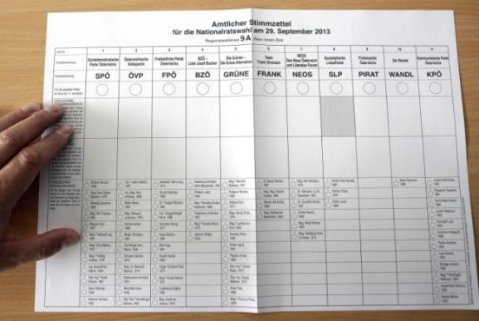

Image Description: Paper ballot with grid system. Each column denotes one party. There are lines for the name of the party, for the empty circle and for the candidates on the list. All these elements are aligned and separated by thin lines. Additionally, there are two lines with empty fields for each column, where preferential candidates can be added.-

Source: Vienna Online 2013

Bosnia: Federal Parliamentary Elections Ballot (2018)
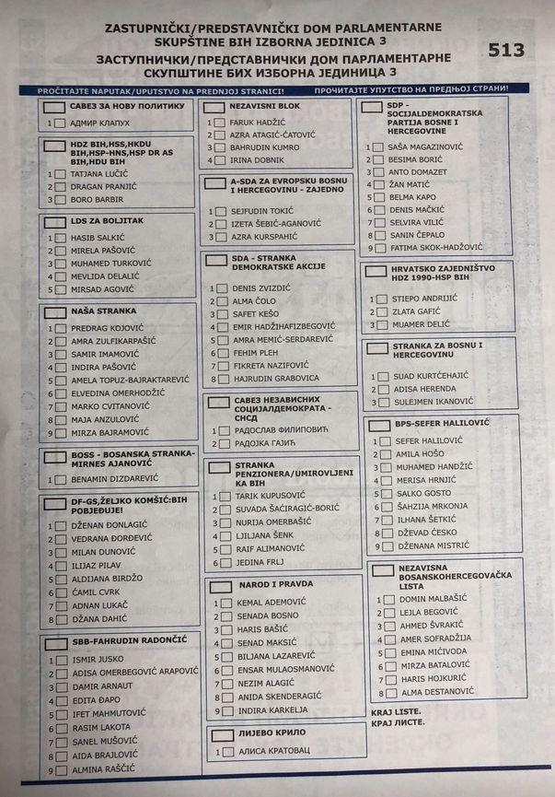

Image Description: Paper ballot with three columns. Each column consists of multiple boxes in different sizes. Each box contains the name of a party at the top and diverse numbers of individual candidates below. The size of the box depends on the number of candidates. There is a rectangular small box in front of each party and a squared small box in front of each candidate to mark the preference.

Source: Krajina 2018

Finland: Municipal Election Ballot (2017)
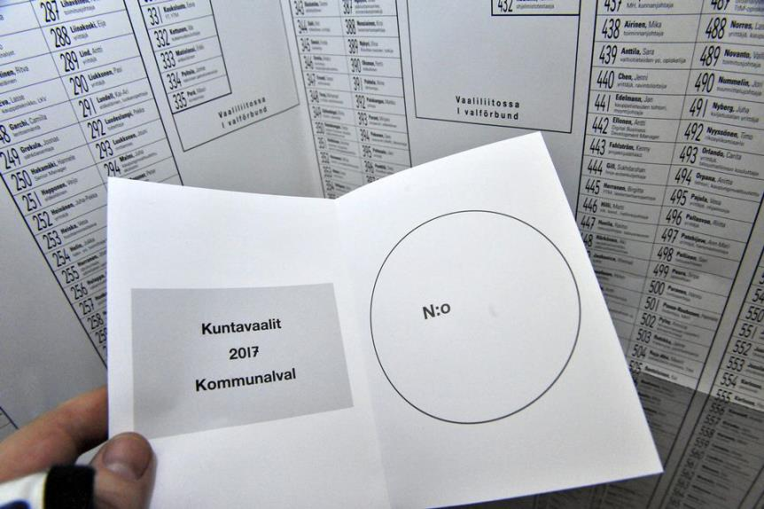

Image Description: Small paper ballot folded in half. On the left half, the name of the election is stated. On the right half, there is a large empty circle. In the background, the candidate sheet is visible with over 550 candidates listed, each one with a running number, name and additional information in fine print.

Source: Jaakonaho in YLE 2017

France: Presidential Election Ballot (2017)
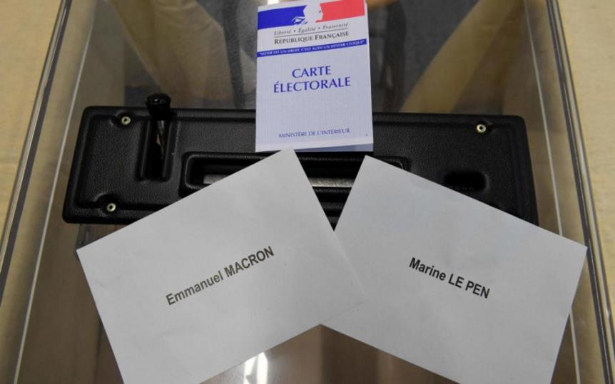

Image Description: Ballot box with two white paper ballots on top. Each paper carries the name of one candidate in large print.

Source: Mayer in La Parisien 2017

Germany: Regional Election Ballot (2017)
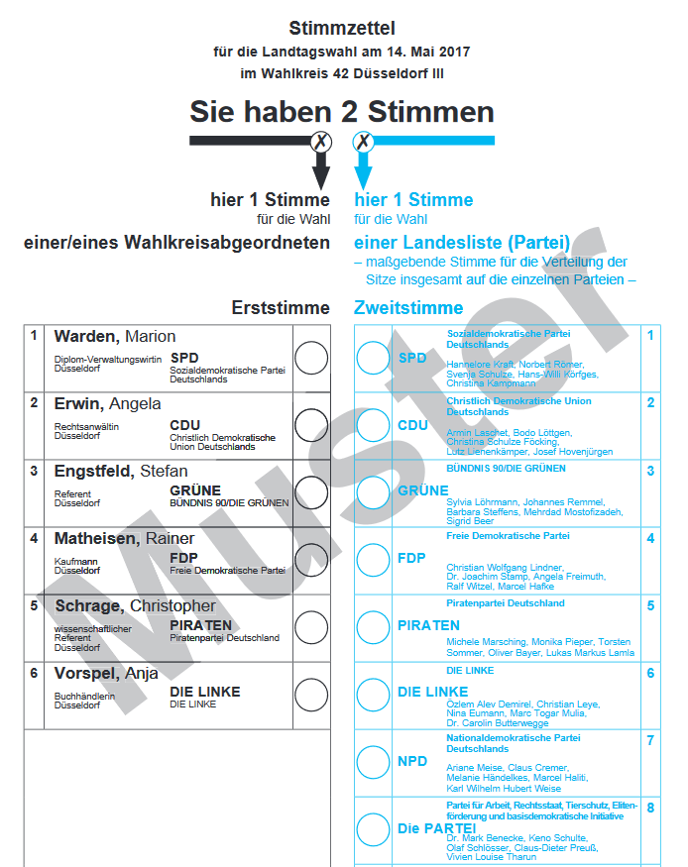

Image Description: Paper ballot with two columns. The left column gives multiple rows with names of candidates, the party and an empty circle. Additional details are given in fine print. The right column gives an empty circle, party name and the first names on the party list in fine print. All rows are aligned and have the same size. The columns have different colours and carry their respective title on top.

Source: Stadt Düsseldorf 2017

Hungary: Parliamentary Election Ballot (2018)
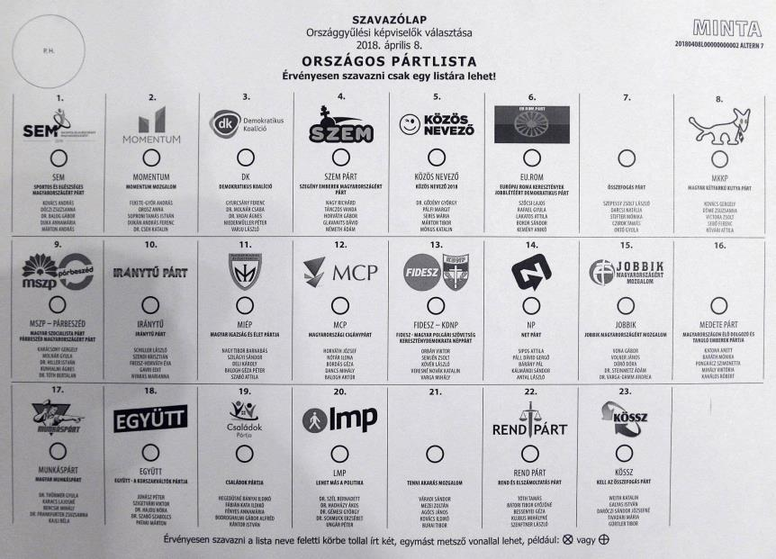

Image Description: Paper ballot with grid of three times eight parties. For each party, there is a logo, a small empty circle, the name and the first names of the list below each other. The parties are separated by single horizontal and vertical lines. All elements are aligned and all grid elements have the same size.

Source: unknown

Ireland: Referendum Ballot (2018)
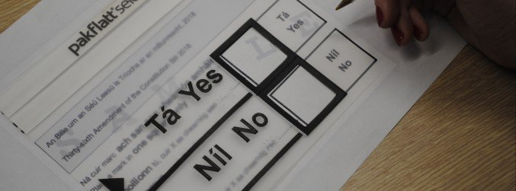

Image Description: Ballot and stencil on top of it. The ballot is rectangular in shape. Below a small introduction there are two big boxes labelled “Yes” and “No” in Gaelic and English. The stencil is made of see-through plastic with big square holes to mark the ballot and the same words in large-print.

Source: FLAC via Newstalk 2018

Netherlands: Parliamentary Election Ballot (2006)
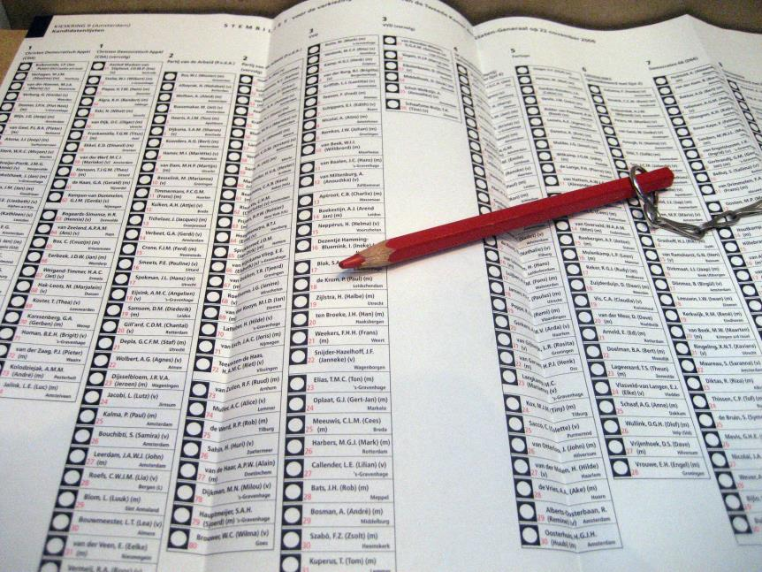

Image Description: Large paper ballot with countless small boxes in eleven columns. Each box contains an empty circle, the name and the constituency. The columns are set apart by lines. Multiple columns belong to one party. The elements are not aligned.

Source: Luijt via Wikipedia 2006

Romania: European Elections Ballot (2014)

Image Description: Booklet with multiple pages that are printed on both sides. On each page there are four boxes of equal size and separated by white space. In each box, there is the name of the party in all-capital letters and the logo with the names on the list in small print below.

Source: Oelbermann 2014

Russia: Presidential Election Ballot (2018)
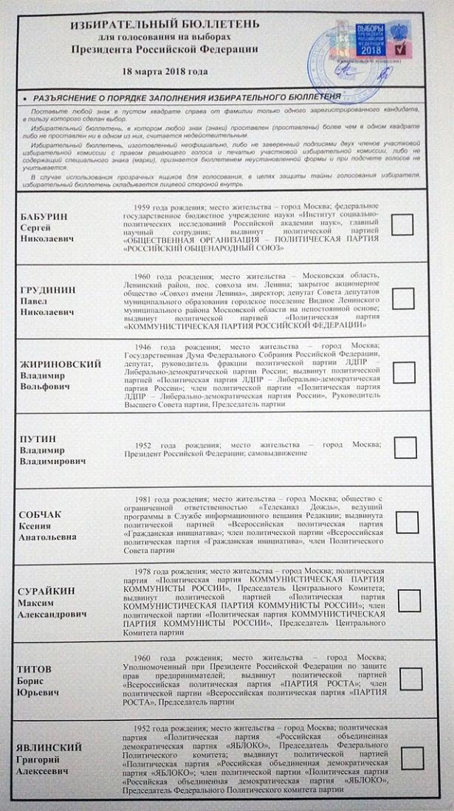

Image Description: Paper ballot with eight lines, one for each candidate. In each line, there is the name of the candidate in large print, additional information in small print and an empty square to the right. The elements are all aligned.

Source: Kless 2018

Turkey: Presidential Election Ballot (2018)
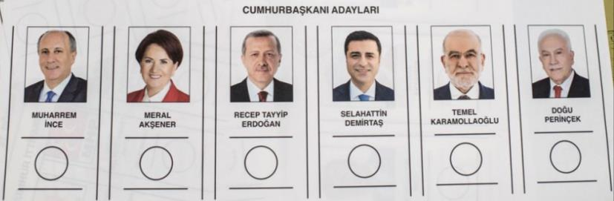

Image Description: Paper ballot with six candidates in one row. For each candidate, there is a photo, the name in all-capitals bold print and an empty circle below the name. The candidates are separated by double lines. All elements are aligned and of the same size.

Source: Akgul 2018

ABOUT THIS REPORT

This report was prepared on behalf of the European Blind Union by Benedikt van den Boom (DBSV – German Federation of the Blind and Partially Sighted), Gesa Körte (DBSV – German Federation of the Blind and Partially Sighted) and Daan de Kort (Oogvereniging – Eye Association Netherlands). All mistakes in this report are the sole responsibility of the authors.

For inquiries about this report and accessible voting please contact:

Antoine FOBE
EBU Head of Campaigning
European Blind Union
E-Mail: ebucampaigning@euroblind.org

This report was co-funded by the “Rights, Equality and Citizenship Programme” Programme of the European Union.

END OF DOCUMENT

