INDEPENDENT AND SAFE MOBILITY:

BEST PRACTICES IN THE REPUBLIC OF BELARUS.
In 2016 the Republic of Belarus ratified the UN Convention on the rights of people with disabilities. This international document has provided the basis for running constructive activities on creating favorable conditions for independent and safe mobility of the visually impaired people.
Our practice on creation of independent and safe mobility of the visually impaired people has its own distinctive features:
- integrated/complex approach with the involvement of all responsible and interested parties;
- support of innovative ideas;
- creation of direct mechanisms of interaction between the legislative institutions, design and construction organisations with the non-governmental public associations of people with disabilities;
- informal approach towards the solution of issues of providing the independent and safe mobility for the visually impaired people;
- ensuring the dissemination of practices of creation of the accessible environment for the visually impaired people on the entire territory of Belarus;
- short terms (3 years) for creating the fundamentals for providing the independent and safe mobility for the visually impaired people.
The works on creation of the accessible environment for the visually impaired people and on ensuring their independent and safe mobility is carried out in the following directions:
- Legislative basis.
During 2016-2019 on the initiative of the public association “Belarusian Association of the Visually Handicapped” the creation of the accessible environment for the visually impaired people in Belarus has been fixed in the following technical normative regulatory documents:
Technical Code of Established Practice called “Road pavement out of paving slabs” introduces the term of “discrete warning and guiding element”, specifies the requirements for such elements and established the rules of laying tactile paving slabs, entitles the “Belarusian Association of the Visually Handicapped” to approve the design drawings of pavement slabs laying. Today many design and construction organisations do not start laying the pavement slabs without approval by the “Belarusian Association of the Visually Handicapped”.
Technical Code of Established Practice called “Living environment for physically impaired people. Building design standards”. It came into force on October 1, 2018. It specifies the requirements for design of living and public buildings (facilities) as well as industrial buildings in relate to the features of living environment ensuring the possibility of independent activities for physically impaired people of different categories necessary for their social integration. The above Code introduces such terms as “universal design”, “information equipment”, voice and tactile information tools”; for the visually impaired people it specifies the requirement of implementation of voice-and-sound electronic information appliances with remote control, information plates with Braille and tactile graphics, tactile schemes, floor warning and guiding discrete elements, including those made of polymeric materials and stainless steel as well as the rules of their installation. The Code prescribes to create accessible environment following the principles of logic interrelation of all its elements.
“Album of standard solutions” which regulates the issue of creating the accessible environment on the facilities of passenger infrastructure of the Belarusian railways (came into force in 2018). Its main objective shall be to create accessible environment for the visually impaired people on the railway facilities (platform, railway station building and the adjacent territory) to provide independent and safe mobility for the visually impaired passengers.
National Standard “Typhlo Technical Aids For the Blind and Visually Impaired. Tactile indicators in pedestrian zones”. In came into force since January 24, 2019.
A Draft Law of the Republic of Belarus “On Rights of People with Disabilities and their Social Integration” has been submitted to the Parliament of Belarus for consideration and approval. This draft law has been prepared with the direct participation of all public associations of people with disabilities. In addition, Article 7 of the Draft Law “On providing Accessible Living Environment for People with Disabilities” stipulates unconditionally providing barrier free access for people with disabilities to the objects of social and production infrastructure and conditions for independent mobility around the territory on which such objects are located as well as use of transport and street-road network. Some Articles (40-42) specify the creation of accessible environment for people with disabilities, including those with visual impairment, on the objects of transport infrastructure, in dwellings, in the field of information support.
Being a member of the State Ministerial Council on the problems of people with disabilities established within the Council of Ministers of the Republic of Belarus, the “Belarusian Association of the Visually Handicapped” ensures the solution of the issue of independent and safe mobility of the visually impaired people through giving orders to the Ministries and Departments. For example, as instructed by the State Ministerial Council the National airport “Minsk” has been carrying out the works on creation of accessible environment for the visually impaired people in full during the first half of 2019. It is also stipulated to allocate funds for implementation of duplication of publicly available information by means of Braille in the state institutions; new decisions have been passed on respective amendments and changes to be made to the current technical normative documents.
The State Ministerial Council on the problems of people with disabilities has its sessions twice a year, and its decisions are binding for all state executive bodies and organisations.
During 2016 – 2019 a very constructive and fruitful work has been completed on creation of legislative basis on providing the accessible environment for the visually impaired people and as a consequence ensuring their independent and safe mobility on the basis of the experience of European countries. We believe that we have succeeded in establishing uniform rules and regulations for all participants of the process of creation of the accessible environment for the visually impaired people as well as to improve technical requirements on creation of accessible environment for the visually impaired people, by inclusion into them of 3 interrelated and inseparable elements: tactile discrete elements, Braille and voice information appliance with remote control.
- Innovative solutions.
In 2018 – 2019 an idea of creation of the universal voice and sound information system has been successfully developing which, first of all, is aimed at providing the independent and safe mobility for the visually impaired people.
On April 18, 2019 the first presentation of the voice-and-sound navigation system was held in Gomel, Belarus, which is called “Steps towards audio signals” and literary means if translated from the Belarusian language “Steps towards sounds”.
The author of this idea and the developer of the system is Mikhail Antonenko – director of the public institution of the visually impaired people rehabilitation “Centre of successful person” (Minsk, Belarus). The above presentation took place within the implementation of the project called “More freedom: navigation systems for people with disability”.
What is the difference of the “Steps towards sounds” system from other existing navigation systems?
- To use this system a blind person needs only a smartphone. No other additional appliances, such as bracelets or other gadgets, are required. Practically any person has a smartphone! In Belarus visually impaired people are provided with smartphones by the State Committees of Labour and Social Order on favourable terms.
- A simple operation principle allowing to accurately find a required location. The navigation system “Steps towards sounds” consists of 2 components: voice-and-sound information appliance and free mobile apps “BuzzPoint”.

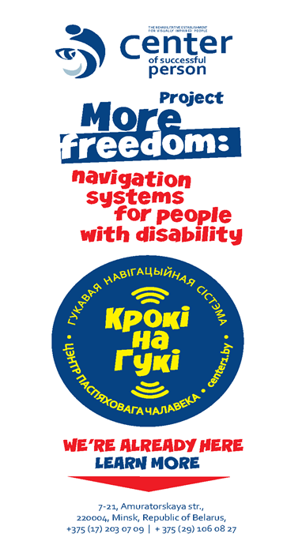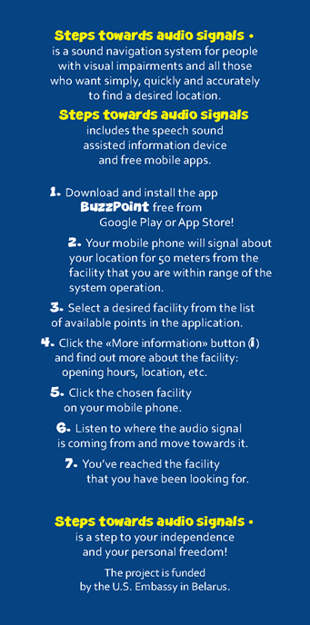
- Low price of the voice-and-sound information appliance, low level of energy consumption, possibility of autonomous operation. Warranty – 5 years.
- Universality. This voice-and-sound navigation system can be used on stationary locations (both indoors and outdoors) and in transport. At the moment there have been installed more than 150 information appliances in Belarus, including the building of the Ministry of Labour and Social Order of the Republic of Belarus. In 2019 the voice-and-sound navigation system “Steps towards sounds” will be also installed in the building of the National airport “Minsk” and in the main railway station in Minsk, in the bus terminal in the city of Brest as well as in other social objects in each region of the Republic of Belarus.
- Wide range of consumers. Irrespective of the fact that the system is designed, first of all, for people with deep visual impairments, nevertheless it can be used by anyone due to the availability of additional voice information about the object/location: e.g. deaf people can read necessary information in the smartphone without using a sign language translator; wheelchair users can call an assistant with the help of information appliance by activating the information appliance installed in the room of the respective technician; or can get information about the building accessibility; and, finally, any person can learn in Russian or in English, and soon also in Belarusian, where this or that object is located, information about its working hours and operation, peculiarities of its location. What is convenient for disabled people is convenient for everyone!
- Usage of audio description technology. Additional information is now being prepared by audio description staff. This ensures brevity and accuracy of the provided information, with an accent being put on providing independent and safe mobility of a blind person. Watch the video.

- Integrated/complex approach.
Creating the conditions of independent and safe mobility of the visually impaired people we strive to approach this task by taking into consideration the constructive features of the particular object and by creating optimal logically justified elements of accessible environment for the visually impaired people. Our work is carried out in several stages. A group of experts, which among others obligatory includes blind and partially sighted people, goes to the object and examines the availability of accessible environment ensuring independent and safe mobility of the visually impaired people. Following the results of monitoring of the situation recommendations and plans-schemes (drawings) of the location of all necessary elements of accessible environment with indication of their qualitative and quantitative characteristics are prepared: tactile, warning and guiding indicators (pointers); tactile schemes; information plates in Braille and with magnified flat type font and QR-code; voice-and-sound navigation system “Steps towards sounds”. The “Centre of successful person” is currently developing the internal point navigation system “Sun-T” specially designed for rest rooms (toilets).
The owner of the object receives practical recommendations for the placement of all elements of the accessible environment, and while carrying out construction and mounting works can contact at any moment respective experts for consultation.
In such a way the preparatory work on creation of accessible environment was carried out at such large facilities as the National airport “Minsk”, Ministry of Labour and Social Order of the Republic of Belarus, Minsk City Central Railway Station, Centre of inclusive culture in Gomel, Gomel Regional Olympic Training Centre for Paralympic and Deaflympic Sports.
To provide possible independent and safe mobility the accessible environment the following elements are used, including those produced by Belarusian manufacturers:
Tactile pavement slabs.
For the last 5 years more than 10 manufacturers in Belarus have started to produce tactile pavement slabs the specimen of which have been agreed by the “Belarusian Association of the Visually Handicapped” regarding their tactile and colour characteristics. There are various modifications as for dimensions and for the type of used discrete warning elements: truncated cones and pyramids, semi-spheres.
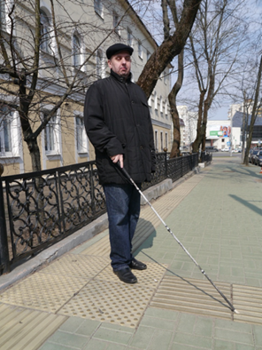
On the left figure Amuratorskaya Street in Minsk is shown where the main office of the “Belarusian Association of the Visually Handicapped” is situated.

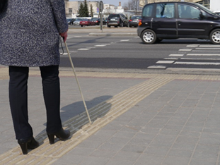 | 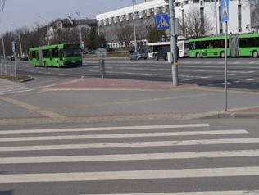
Fig. 1  Shows Independent Avenue in Minsk | Fig. 2  Shows Filimonov Street in Minsk | Fig. 3  Shows an example of indication of staircase on Kirov Street in Minsk.

Adaptive information plates. Tactile schemes.
In 2018 own production of tactile schemes and information plates with Braille and tactile graphics was launched observing the contrasting characteristics and ability to use QR-code. The manufacturer is the public institution of the visually impaired people rehabilitation “Centre of successful person”. The production was organized at the expense of budgetary funds allocated for creation of jobs for people with disability. Today 87% of the total strength of the staff of this Centre are people with disability. The quality of text and Braille point printing meets the requirements of European standards. Who, if not visually impaired people, can ensure the quality control of tactile graphics and Braille printing!

Fig.4. Belarusian Post: post office “Bearoza-4”; 225209; open hours: 08:00 – 19:00; Saturday: 08:00 – 17:00; Sunday: 09:00 – 14:00. Tel.: 8(01643) 39954. | Fig.5. Tactile scheme of the bus terminal in Brest: $ - You are here; 1- entrance; 2- waiting hall; 3- tickets offices; 4- bus terminal attendant; 5- medical aid; 6- rest rooms (toilets); 7- baggage storage; 8- exit to the platforms.

- Ad hoc aid.
Alongside with the works on developing the legislative basis and improving the accessible environment in facilities and on streets of Belarusian cities and towns there have been created possibilities of obtaining ad hoc aid by the blind and partially sighted people.
Coordinated activities of 3 interested organisations helped to come out such a service as “Navigator” allowing blind and partially sighted people to use ad hoc aid (assistance)of the sighted navigator on-line at any distance.
Service of ad hoc aid for the blind and partially sighted people “Navigator” has appeared due to the collaborative work of OOO “BelHard Development”, Mobile telephone operator “MTC” and “Belarusian Association of the Visually Handicapped”. The essence of this service shall be that a blind person who needs some assistance, e.g. orientation on unknown territory, receiving the required information, etc., if necessary, can enlist the help of a sighted assistant. The “Navigator” can remotely direct him to the desired location and render him any other required assistance by using a special application installed in the smartphone or the tablet and by observing through camera installed in the appliance of the blind person.
“MTC” Company provides free Internet traffic for the service consumers, and OOO “BelHard Development” has worked out software enabling the most easy and convenient to use the given service for the owners of appliances operating on Android platform.
Today all mobile operators working in Belarus provide free Internet traffic for the users of “Navigator” service. Video can be watched on the following link: https://www.youtube.com/watch?v=XUpETgQIwPs.
Blind people can get the accompanying service of the trained personnel at all Belarusian transport hubs and terminals, airports. The “Belarusian Association of the Visually Handicapped” organizes annually special training workshops for the employees of organosations of social and transport service on the Rules and regulations of accompanying people with visual impairments. “Belarusian Association of the Visually Handicapped” has prepared a special educational video and a poster.
The inscription on the poster on Fig.6:
Do you want to help a blind person, but do not know how? Typical situations in which you may find yourself being next to a blind person: red colour – your actions are wrong; green colour – you are doing the right thing. Simple rules – civilized relations.

- Conclusion.
Republic of Belarus is a young country. Up to 2016 there were practically no any conditions for the independent and safe mobility for the visually impaired people. For almost 3 years there appeared all necessary conditions for creating accessible environment in the broadest sense of this word. The peculiarity of our practice in this field is not only successful persistence of the visually impaired people to defend their rights of creating conditions for independent life, but also the appearance of such innovative ideas as the development of the voice-and-sound navigation system “Steps towards sounds” that has already aroused wide interest of our European colleagues. On the road of ensuring the independent and safe mobility for the visually impaired people there are still many problems and they obviously will always remain. But we are happy that for such a short period of time our ideas have been implemented in life and have acquired a stable impulse of further development. This fact inspires us to new ideas and we have them!

