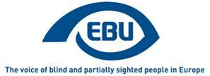

EBU Members' Newsletter

Number ten, November, 2019.

OUR CAMPAIGNS
Marrakesh Treaty
Slovenia has now communicated to the European Commission its national measures to implement the Marrakesh Treaty Directive. Over a year after deadline, 2 EU countries still need to adopt national legislation: Greece and Luxembourg.
No recent progress in the status of ratification of the Treaty in wider Europe.
More generally, on accessible books, Fondazione LIA (for Italian Accessible Books) released a paper: E-Books for all: towards an accessible publishing ecosystem and consulted us about it.
Audiovisual Media Services Directive
EBU was represented by DBSV’s Dr Jan Meuel at the annual Access Services Experts Meeting of the European broadcasting Union in Dublin, on 17 and 18 October. Apparently we were the only organisation representing the interests of disabled persons. Hopefully EBU participation is such annual events will become systematic.
EDF published a toolkit on the transposition of the AVMSD.
Air transport
We sent to the European Civil Aviation Conference (ECAC) facilitation sub-group on transport for persons with reduced mobility, our recent report, 'Most frequent problems experienced by blind and partially sighted persons when travelling by air'
Connected and automated vehicles
EBU was represented by our Hungarian member MVGYOSZ (Attila Ollé Coordinator of International Affairs, and Orsolya Németh Accessibility Expert) on an ITU Panel Session and Workshop on "The Turing Test for Autonomous Driving - A Global Performance Standard for AI on our Roads" (Budapest, 10 September 2019).
MISCELLANEOUS
Developments in EU Institutions after European elections
The new European Commission is expected to be in place at the beginning of December 2019, after that the last commissioners-designate will have been approved by the European Parliament.
Without further delay, the EBU President has sent a letter in November to Commissioner-designate for Equality, Helena Dalli, to congratulate her, send her our Statement on European Elections 2019 and make contact for future collaboration with her services.
We are organising a cocktail event at the European Parliament, kindly sponsored by French MEP Chrysoula Zacharopoulou (Renew Europe Group), to meet with MEPs and exchange around our Statement.

The 16th EBU ACCESSCAST!
Welcome to the 16th episode of the EBU Access Cast . The European Blind Union held its 11th General Assembly in Rome on October 27-30. Bart was invited to record a special edition of the podcast. He spoke with the outgoing and incoming Presidents of EBU, Wolfgang Angermann, and Rodolfo Cattani, as well as with its Executive Director Mokrane Boussaïd who is about to retire. He also interviewed the exhibitors in the tech fair. The assembly was held with the generous support of Google.
Good news, the EBU Access Cast has been selected as one of the top ten Assistive Technology Podcasts You Must Follow in 2019

The Fourth EBU Vision for Equality Award.
As part of its General Assembly proceedings EBU presented the fourth edition of the “Vision for Equality” Award.
The Award is granted every four years to European organisations, institutions, policy makers, enterprises or individuals in recognition of their commitment and ongoing endeavour in the defence and promotion of the rights and improvement of the living conditions of blind and partially sighted people.
The 2019 award, which consists of a certificate and a piece of art by a visually impaired artist, was given to the Bavarian Union of the Blind and Partially Sighted (Bayerischer Blinden- und Sehbehindertenbund e. V, BBSB) for their project “We go to school”, which started in 1993.
The project offers information material on visual impairment and sight loss for schools across Bavaria.
In practical terms this means that since 1993, more than 520.000 children and adolescents participated in the “We go to school” project and received tailored information material about blind and partially sighted persons. Well over 2.000 classes were visited by BBSB volunteers. School teachers return annually to BBSB for visits and participants reach out to BBSB during their adulthood to praise the project. Several regional associations of the blind and partially sighted persons have initiated similar projects. Blind and partially sighted volunteers are further empowered by their own activities for the project.
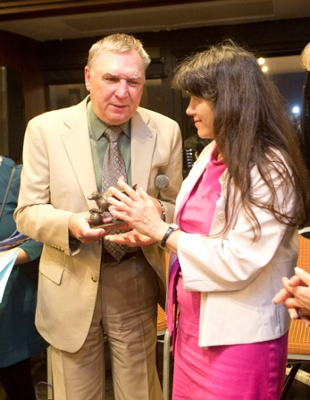
The first photograph shows Judith Faltl, chairwoman of the BBSB, receiving the award from outgoing EBU President Wolfgang Angermann, during the gala dinner on Tuesday 29th October in Rome.
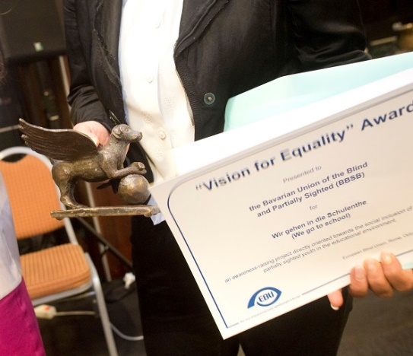
The second photograph is a close-up of the artwork and certificate. The work of art is a small bronze sculpture of a dog with wings.

Accessible pick-up stations for the Austrian Mail Service.
After close cooperation for over a year, the Austrian Federation of the Blind and Partially Sighted was happy to see the Austrian Mail Service set up its first accessible pick-up stations. Now it is possible for visually impaired recipients to get accessible notifications and to collect their parcels independently at the new stations.
The notifications recipients will find in their mail have a beveled edge on the left upper side under which the barcode for the pick-up station is printed. In the accessible stations, machines with tactile signage and audio response will scan the barcode, which then opens the lock to the box in which the parcel is stored. A ticking sound allows visually impaired users to find their way to that box. The stations are open 24/7.
The Austrian Mail Service is planning to adapt all existing pick-up stations according to the described model in the coming years, including a tactile guiding system and a bell to call for assistance. BSVÖ serves as their main partner and started to collect user experiences from the first prototype set up in 2018. We are therefore very happy to see the first stations in place and to see the model spread in the coming years.

Celebrating progress in Estonia
The Estonian Blind Union has chosen the most important deeds of the year 2019 that have improved the lives of blind and partially sighted people in Estonia.
The Vabamu Museum (https://www.vabamu.ee/en) has made their whole building accessible for visually impaired people.
Piret Aus is the person who arranged the descriptive translation and tactile guides of Estonian national dance festival. Every blind and partially sighted person in Estonia had the opportunity to be part of the celebration via TV.
A Small Estonian company Studio ALU (https://studioalu.com) has made a special board game named ALU that is acessible for blind people and inclusively designed.
Also, the Estonian company E Vision that sells contact lenses has supported the making of the first musical manual for visually impaired people in Braille.

NCBI launches Bookshare Ireland – creating equity of access
On thursday 14th November 2019, National Council for the Blind of Ireland (NCBI) launched Bookshare Ireland which is the country’s largest digital accessible library.

Bookshare Ireland is specifically designed to support students with a visual impairment and print disabilities attending higher or further education by providing instantaneous access to over 500,000 academic books and other materials, in the student’s preferred format (DAISY Audio, DAISY with images, digital braille, PDF and Word). For the first time ever, this guarantees equity of access to the curriculum with their sighted peers.

Chris White, NCBI CEO said “we are acutely aware that studying in third level with sight loss is a huge challenge, obtaining books and information in accessible formats should not be an additional barrier to achievement for students with a visual impairment in higher and further education. Through using Bookshare.ie, these students will no longer be at a disadvantage but instead be able to embrace and thrive in 3rd level education like their peers as the books and resources they need will be available to them. It will also hopefully lead to an increase in the number of students with a visual impairment attending 3rd level as it is chronically low at 1.8% of the student population.

Ivan O’Brien, Managing Director of O’Brien Press said “O’Brien Press is thrilled to be a part of NCBI Bookshare.ie as it is cutting edge and inclusive. Ensuring that people with print disabilities can have rapid access to the broadest possible range of reading material, whether for work, study or pleasure, is really important. Now students can read and learn from over 300 O’Brien Press publications on their computers, tablet, smartphones, assistive technology devices, and more.”

Rosie Bissett, CEO, Dyslexia Association of Ireland added "given one in ten people have some form of dyslexia, we are delighted to be part of the Bookshare.ie initiative. It means students with dyslexia will be on par with all other students, thereby empowering them to reach their potential."
Aoife Watson, recent NUIM graduate with sight loss added “I absolutely loved my time in university but it was extra challenging for me as the books I needed were simply not in an accessible format. It was so frustrating seeing how easy it was for other students to access the books that I couldn’t. I know if I had access to the books I needed when I needed them, I would have achieved a higher overall mark in my degree. Having Bookshare.ie will now revolutionise a student with visual impairment’s experience of 3rd level, as being able to access a book at the same time as your classmates is essential to creating an inclusive experience. I am envious of them, yet feel I will return to do a Masters sooner than planned now because of Bookshare.ie.”
Already Bookshare Ireland is pleased to welcome O’Brien Press, Gill and Oak Tree Press to the new platform and will continue to work with other Irish publishers to increase homegrown content available to readers. To register students for this new service, please Sign Up at Bookshare.ie

Bookshare Ireland is funded by Department of Education.
ENDS.
European Blind Union
6 rue Gager Gabillot, 75015 Paris, France
+33 1 88 61 06 60 | ebu@euroblind.org | www.euroblind.org

