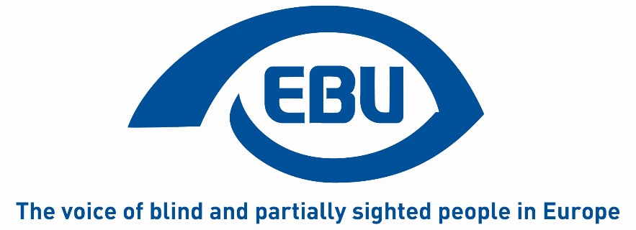

European Blind Union

Action Plan 2020

Status: Discussed and approved by the EBU Board at its meeting held on 08 February 2020 in Prague (Czech republic).

Notes:
- This document sets out actions to be conducted in 2020 to implement the Strategic Orientation Plan agreed by the 11th EBU General Assembly (Rome, 28-30 October 2019). Because it is action-based, we suggest to call it action plan instead of work programme. This will avoid it to be confused with the REC work programme. The actions it contains are numbered in the same way as in the Strategic Orientation Plan 2020-2023.
- The very last item in the document, on the Marrakesh Treaty, was not foreseen in the Strategic Orientation Plan but the EBU Board, meeting on 08 February 2020, recognised the need to take action in this area.
- The EBU Project Officer will liaise with the action leaders to inform on the expected outputs and other modalities.

Objective 1 – Improving Braille teaching and literacy
Action 1 – Braille report implementation.
Description: As a follow-up to the EBU report on Braille teaching and literacy produced in 2017, a working group (WG) will be formed, meet and start working on the 11 recommendations contained in the implementation document already available - e.g. the creation of national Braille committees.
Leader: John HEILBRUNN (Denmark).
Partners: Members of the WG (to be identified).
Funding secured: REC.
Outputs: WG’s Terms of Reference, meeting agenda, WG yearly report.

Objective 2 – Employment
Action 4 – ADVISE.
Description: ADVISE aims to enhance young blind and partially sighted job-seekers employment opportunities. It is based on an approach, developed in 2018 and tested in 2019 in 4 pilot countries. In 2020, it will be fine-tuned by experts and a new group of young job-seekers will be trained and coached in each country.
Leader: Bárbara MARTIN (Spain).
Partners: Austria, Montenegro, Poland and Spain.
Funding secured: REC and Solidarity Fund.
Outputs: 4 training courses held in 4 countries, 24 young BPS trained and accompanied, ADVISE trainer manual available in English, German, Montenegrin, Polish and Spanish.

Objective 3 – Access to ICTs
Action 6 – Web-accessibility.
Description: EBU will collect and publish best practices on the implementation of the EU Directive on the Accessibility of Public Sector’s websites. The publication will be available in at least 4 languages.
Leader: to be identified.
Partners: to be identified.
Funding secured: REC.
Outputs: 1 publication on good practices available in English, French, German and Spanish.

Objective 4 – Participation in public life
Action 9 – Accessible voting.
Description: EBU will promote the use of the AVA report and its information module. At least 4 EBU countries where elections will be held in 2020 will raise the awareness of policy makers and election officials on accessible voting.
Leader: to be identified.
Partners: Bulgaria, Greece, Poland and Slovakia.
Funding secured: REC.
Outputs: 4 national AVA awareness-raising reports in EN.

Objective 5 – Non-discrimination
Action 11 – Equal Treatment Directive.
Description: To lobby the EU institutions to re-activate the EU Equal Treatment Directive and have it adopted.
Leader: Antoine FOBE (EBU office).
Partners: EBU members in EU countries.
Funding secured: REC.
Output: preparatory document.

Objective 6 – Inclusive design
Action 15 – Audio-description.
Description: To prepare the ground for a campaign for audio-description to be made mandatory for EU Creative Media funding to the film industry.
Leader: Antoine FOBE (EBU office).
Partners: EBU members in EU countries.
Funding secured: REC.
Output: preparatory document.

Objective 7 – Mobility
Action 17 – Acoustic systems.
Description: The EBU 2020 conference on "Acoustic systems for Information and Navigation purposes" will aim to share new trends and best practices to help harmonise or even standardise such systems.
Leader: Stefanie STEINBAUER (Austria - tbc).
Partners: Organising committee members (to be identified).
Funding secured: REC.
Outputs: 60 participants, 1 conference programme, 1 conference report, good practices identified.

Action 19 – Connected and Autonomous Vehicles (CAVs).
Description: EBU will continue to contribute to the PAsCAL project on CAVs, in particular to collect data on how they are assessed by persons with visual impairment.
Leader: Romain FERRETTI (EBU office).
Partners: EBU members to be identified.
Funding secured: Horizon 2020.
Output: survey 1 report.

Objective 8 – Governance and working processes
Action 20 – Gender equality.
Description: Following the EBU 2019 conference on Gender Equality, EBU will support 3 national members to set up or strengthen national women committees to identify and implement activities to enhance blind and partially sighted women’s participation in civil society.
Leader: Karin HJALMARSON (Sweden - tbc).
Partners: 3 EBU members to be identified.
Funding secured: REC.
Outputs: 30 blind and partially-sighted women empowered, 3 national GEAR reports.

Action 20 – Low vision.
Description: Following the work carried out in 2019 as a result of the EBU 2018 conference on Low Vision, EBU will support 3 national members to set up or strengthen national low vision committees to address the specific needs of persons with low vision.
Leader: Birgitta BLOKLAND (the Netherlands).
Partners: 3 EBU members to be identified.
Funding secured: REC.
Outputs: 3 national LV meetings, 45 partially sighted participants, 3 national reports, 3 national plans of action 2020-2022.

Action 20 – Youth.
Description: Following the trainings held in 2019, EBU will continue to build the capacity of blind and partially-sighted youth in the framework of EByouth. This will empower them to hold leading positions in visual impairment organisations at national and European level.
Leader: Francesca SBIANCHI (Italy – tbc).
Partners: 3 EBU members to be identified.
Funding secured: REC.
Outputs: 3 e-workshops held, 1 TC held, 15 young BPS leaders empowered

Objective 9 – Communication and campaigning
Action 26 – Information and campaigning.
Description: EBU will commission an audit of its information setup (incl. social media) to optimise the way it manages its information processes.
Leader: Gary MAY (EBU office).
Partners: 3 EBU members to be identified.
Funding secured: REC.
Outputs: 1 audit report (incl. recommendations).

Action 27 – Sustainable Development Goals (SDGs).
Description: SDGs were at the core of the EBU 11th General Assembly. EBU will work to raise its members’ awareness on specific SDGs to be determined.
Leader: Antoine FOBE (EBU office).
Target: EBU members.
Funding secured: No.
Output: 1 e-workshop.

Action not foreseen in the strategic Orientation Plan 2020-2023 – The Marrakesh Treaty.
Description: EBU will work to build the capacity of its national members, those outside the EU in particular, to lobby their governments and ensure the ratification and effective implementation of the Marrakesh Treaty.
Leader: Bárbara MARTIN (Spain).
Target: EBU members outside the EU.
Funding secured: No.
Output: 1 e-workshop aimed at EBU members in the Balkan region.

END OF DOCUMENT

