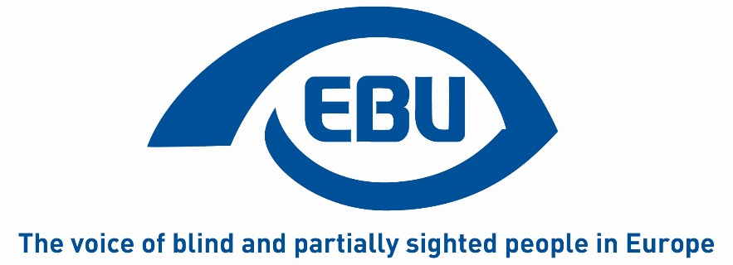

European Blind Union - Action Plan 2021
Status: Approved by the Board on 6th February 2021
Notes:
This document sets out actions to be conducted in 2021 to implement the Strategic Orientation Plan agreed by the 11th EBU General Assembly (Rome, 28-30 October 2019). In cases where the actions are directly taken from the Orientation Plan, they are numbered in the same way as in the original document. In addition, it contains other key actions to be conducted in 2021, all in line with the Orientation Plan. This is in a view to show the links between different areas of EBU’s work which are part of a coherent agenda. The document also tries to identify the bodies responsible for implementing the action, as well as the source of their funding. The bodies identified to implement various actions will obviously consult with other EBU stakeholders such as our sectorial and thematic networks.
It should be noted from the outset, that one cross-cutting key priority in 2021 for EBU will be the development of a new multi-year application to be submitted to the European Commission. Due to its strategic and cross-cutting nature, it is not listed as a separate action, because it will require EBU as a whole to engage.

Objective 1: Promoting Braille and Braille literacy
Description: Braille means for generations of blind people accessibility in so many areas of life and a key to independent living. In times of new technologies, learning, promoting and using Braille undergoes significant changes. Against that backdrop, EBU will:
- Agree a statement clarifying EBU’s position on Braille to support standardisation work (action 2)
- Conduct the Onkyo Braille Essay Contest and communicate its results.
- Follow-up to the 2020 Braille survey.
- Start work towards a EP Resolution to promote Braille.
Resources: REC (activity 2.5. and 1.1.) and own resources
Led by: Braille project team, LC and the Board for the Onkyo Contest.

Objective 2: Employment
Description: While we are still lacking reliable, comparable and disaggregated data on the employment situation of blind and partially sighted people, we know that they are disproportionately represented amongst the unemployed population and, when employed, often in precarious jobs. The consequences of the COVID-19 crises will undoubtedly worsen that situation. Though employment is not only a right, but also a formidable means of inclusion of blind and partially sighted people in society. Against that backdrop, EBU will:
- Organise its annual conference (second half of the year) on access to jobs and rehabilitation.
- Promote the dimensions of the EP Report on the employment of persons with disabilities (Langensiepen Report) in which EBU strongly believes.

Pursue the ADVISE approach to support VI young people’s job access (Action 4).
Resources: REC (2.3 and 4.5.)
Led by: ADVISE Project team, host committee of the EBU Annual Conference and the Taskforce mandated by the Board for the EP Report.

Objective 3: Access to Technology
Description: Access to technology is more than ever a key to inclusion in literally all areas of life. For blind and partially sighted people, technology has already opened-up so many possibilities unthinkable a few years ago. At the same time, when designed in an inaccessible way, technology can also lead to further exclusion. Against this backdrop EBU will:
- Provide information on ICTs through EBU Access Cast (Action 8).
Resources: REC (3.3)

Objective 4: Participation in public life
Description: Equal participation by blind and partially sighted people in public life is one of the most powerful means of inclusion, and at the same time a prerequisite for it. Today, there are still many barriers to participation, e.g. when it comes to voting. Against that backdrop, EBU will:
- Promote the AVA report on the Accessibility of Elections for Blind and Partially Sighted Voters in Europe (action 9).
- Lobby for an EP resolution calling for fully accessible EP Elections in 2024 (Action 10).
Resources: REC (3.2.)
Led by: AVA Project team and LC on the EP Elections

Objective 5: Non-Discrimination
Description: While there is a growing body of legislation in the field of anti-discrimination, including on grounds of disability, many blind and partially sighted people are still facing discrimination in their daily lives. This can be exacerbated by discrimination on other grounds such as gender. Against this backdrop, EBU will:
- Promote the need for an EU Equal Treatment Directive (Action 11).
- Lobby for the extension of the EU Disability card scheme (Action 12).
Resources: REC (1.1.) and PARVIS
Led by: LC

Objective 6: Accessible goods and services
Description: In the vast area of accessible goods and services, often linked with new technologies, the very daily needs of blind and partially sighted people are concerned. Working towards fully accessible goods and services therefore can have such a direct and positive impact on concrete life situations. Unfortunately, the opposite is also true. Against that backdrop, EBU will:
- Push the EU and Member States to use their financial leverage to promote the production of accessible audio-visual productions, including productions for children (Action 15).
- To collect and publish good practice at national level on audio-description.
- To pursue our advocacy for accessible lifts.
- Continue to advocate for an effective implementation of the Marrakesh Treaty with a focus on non-EU countries.
- Consider other goods and services such as payment terminals and house hold appliances.
Resources: REC (1.1.) and PARVIS
Led by: LC

Objective 7: Mobility
Description: It is obvious that mobility is an area in which many spectacular changes can be observed, and this trend will continue. The challenges, obstacles, but also the aids and means to overcome them, are constantly changing. This requires a constant effort to adapt and develop by e.g. urban planners, public authorities, the industry, and, of course, blind and partially sighted people themselves. Against that backdrop EBU will:
- In follow-up to the 2020 EBU Conference, start collaborative work to harmonise acoustic information and navigation systems (Action 17).
- Pursue our engagement with developments regarding connected and automated vehicles (CAVs) so that the user perspective of blind and partially sighted people is taken into consideration from the outset (Action 19).
Resources: REC and PASCAL
Led by: RSAT network and PASCAL project team

Objective 8: EBU has improved governance and working processes.
Description: EBU strives to become even more diverse and representative of its constituency at all levels of the organisation and recognises that this requires further action. In parallel, EBU endeavours to constantly improve its working processes and methods in a view to increase member’s participation. Against that backdrop, EBU will:
- Continue its work towards balanced representation in terms of gender, age, and type of visual impairment (Action 20) through the respective REC activities.
- Start the work of the newly established Gender Equality WG.
- Enhance cohesion amongst the membership (Action 21).
- Promote the EBU Solidarity Fund amongst members.
- Establish a new Development Commission
- Stimulate an increased use of virtual communication between meetings.
- A focussed meeting on the outcome of Carine Marzins report
Resources: REC (2.2. 4.1. 4.2. and 4.3.)
Led by: Board, the respective project teams under REC.

Objective 9: EBU and its organisations have improved communication and campaigning capacity.
Description: It is widely acknowledged that effective campaigning and advocacy go hand in hand with effective communication, and that communication has both an internal and external dimension. For EBU, the link between campaigning and communication is made further complex by our nature as a European umbrella organisation having to deal with the language barrier and multi-level communication. Taking stock of where we have reached and how to improve requires ongoing attention. Against that backdrop, EBU will:
- Conduct a communications audit and develop a social media strategy to support campaigning (Action 26)
- - Provide information and training on campaigning through the “how to memos” and ongoing collaboration.
Resources: own resources for coms audit/social media strategy and REC (2.1.).
Led by: Board and Head of Campaigning on “how to memos”.

Objective 10: EBU and its organisations have improved fundraising capacity.
Description: Growing and diversifying our funding resources, in order to implement and sustain our ambitious agenda is an obvious goal for EBU and its members. In this competitive, fast-changing and complex market, facilitating exchange of good and bad practice is really important. Against that backdrop, EBU will:
Provide an overview of the new EU funding programmes during an online presentation (Action 28).
Resources: REC
Led by: Project Officer
End of document– EBU Action Plan 2021 - Agenda item 6.2 – 25 January 2021

