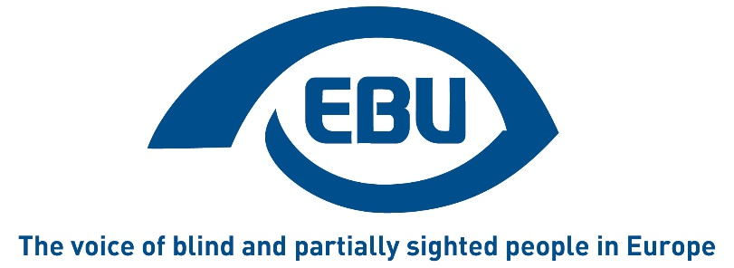

EBU Malmo declaration 2019

Call for action by the participants in the EBU GEAR conference held in Malmo, Sweden June 14-16, 2019
and acknowledging
the United Nations Convention on the Rights of Persons with Disabilities, especially its Article 6 on women with disabilities and all other articles; article 13 of the Treaty of the European Union; the Beijing UN World Conference on Women Declaration and Platform for Action and that girls and women with disabilities face multiple discrimination

- Gender Equality and Balanced Representation
  - EBU national members to set up women’s networks, providing necessary resources and facilities
  - EBU national members to provide
a. leadership training and facilitate for women to take up decision making and leadership positions; using the material developed in this area by EBU and WBU
b. organise national conferences and trainings on women’s empowerment and gender equality
  - National members to comply with the EBU constitution and send balanced delegations to the upcoming and future General Assemblies
  - EBU Board to make national members aware of their obligation to comply with the EBU constitution and likewise make national members aware of the need for balanced representation in the EBU when putting forward nominations for the Board and other leading positions
  - The General Assembly to adopt a quota system for the purpose of balanced representation of blind and partially sighted women and men of all ages
  - The EBU Board to set up a permanent gender equality committee/ working group while maintaining the current set up of the EBU women’s network as an email list. The role of this gender equality committee/working group is to:
- mainstream gender in all EBU work, policies and documents, including the constitution and by-laws;
- advance the work on balanced representation at all levels of EBU;
- raise awareness on the situation of visually impaired women and girls and work towards the inclusion of blind and partially sighted women in society and ensure that EBU’s work with the EU, EDF, EWL, ICEVI and other organisations takes into account the perspective and specific needs of visually impaired women of all ages. The committee/working group membership consists of both women and men with a visual impairment.
  - The General Assembly to make a constitutional amendment to establish a limit of two consecutive terms of office in the same position on EBU Board for all Board members including table officers.
  - EBU to continue applying for and directing funds for gender equality work.

- Discrimination and violence against blind and partially sighted women and girls:
Visually impaired women are at greater risk compared to other women of being sexually harassed, as a Norwegian study shows. Preventative measures must be put in place as well as psychological care for victims, to reduce violence against women.
  - EBU national members to actively engage in wider political debates about violence against women – e.g. collecting data, lobbying government, developing campaigns, collaborating with other organisations addressing violence against women.
  - National organisations to use EBU material for campaigning regarding violence against women and engage with social work services, women’s shelters, national policy makers etc.
  - EBU to continue its engagement with and representation in the wider network of organisations such as EDF(European Disability Forum) and EWL (European Women’s Lobby), using the skills and tools at its disposal to raise awareness about the situation of blind and partially sighted women and insure that their specific needs are included
  - EBU and national members to establish mechanisms internally for prevention of and dealing with discrimination and violence such as
- Code of conduct
- Confidential person to go to
- Ensured protection of whistle-blowers
- Making sure that everyone in the organisation is aware of these measures
- Recognising that the “#Me Too” is equally relevant for organisations of blind and partially sighted people as for other organisations

- Gender Equality and the CRPD/SDGs:

  - EBU and national members to link their strategies and actions to the UNCRPD and the SDGs
  - EBU and national members to collect disaggregated data for the implementation and the monitoring of the CRPD and the SDGs
  - EBU and national members to include Gender Equality policies in their policies

- Follow up
  - EBU to facilitate face-to-face networking meetings on gender equality on a more regular basis, at least every four years in conjunction with each General Assembly and preferably also mid-term.
  - EBU Board and national members to report to the next General Assembly and onward on work undertaken regarding this EBU Malmö declaration/call for action.
  - EBU board to make an inventory of earlier Declarations, Calls for action, policy papers, position papers decision etc. regarding gender equality and the progress made in implementing these.

- Acknowledgements:
Many thanks to the organisers, SRF, speakers and moderators and to the EBU office, for facilitating this GEAR conference in June 2019, celebrating the 20th anniversary of the EBU Women’s Network.
Ends
About EBU
EBU is a non-governmental, non-profit making European organisation founded in 1984. It is one of the six regional bodies of the World Blind Union. It protects and promotes the interests of blind and partially sighted people in Europe. It currently operates within a network of national organisations of the visually impaired in 41 European countries.
6 rue Gager Gabillot 75015 PARIS (France)
Contact: ebu@euroblind.org
www.euroblind.org
Twitter @euroblind

