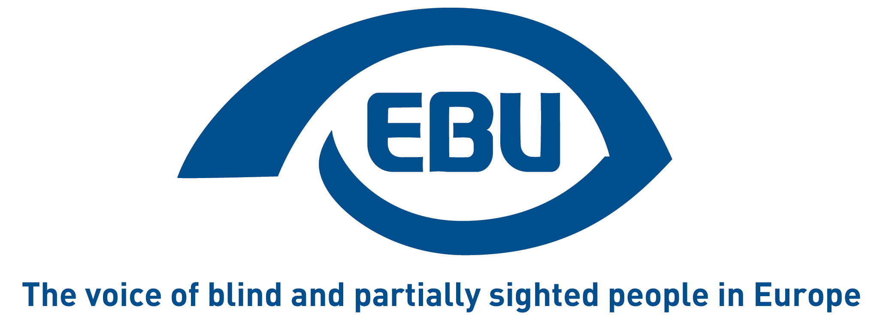

European Commission survey:

Combating gender-based violence – protecting victims and punishing offenders

EBU response | April 2021

Preliminary remarks
- The survey, on most questions, forces us to reply from a single EU Member State perspective, whereas we are a Europe-wide umbrella organisation, representing the interests of blind and partially sighted (“visually impaired”) persons in Europe.
- Our replies are based on feedback collected through an internal survey within our membership. The 27 responses received cover 11 EU countries (Austria, Belgium, Bulgaria, Cyprus, Czech Republic, Denmark, Finland, Germany, Ireland, The Netherlands, Romania, Slovenia and Sweden) plus 4 non-EU countries (Bosnia-Herzegovina, Iceland, Moldova, Montenegro, Norway).
- Our replies particularly focus on the four questions of the survey that relate to persons with disabilities (questions 29, 30, 56 and 57) or otherwise allow comments about that. Below is an analysis of the replies we received to our internal survey on the four key questions for us, the text of which needed to be further reduced to fit in the free text explanation of answers of the survey.
- In the absence of space in the survey for additional comments, we bring such comments further below, essentially to signpost to additional sources of information/sensitisation on our concerns.

Full replies to disability-related questions

Q29. To your knowledge, are support services accessible to persons with disabilities (i.e. availability of barrier free environment, easy to read and understand language, sign language interpretation, etc.)?

Most respondents to our internal survey answered “No” and justified their replies by a combination of inaccessibility of the information (most often on the internet, increasingly so, or in TV advertisements) and of the built environment (of the services premises but also, importantly, of the transport to get to the support services).
Some replied that there are no support services or that, if there are, they are not sufficiently made known to reach visually impaired persons.
Some underlined that only support services of dedicated NGOs are accessible for visually impaired victims. In general, it is felt that the attention to persons with disabilities in this area is not particularly mindful of blind and partially sighted persons.

Q30. To your knowledge, are support services available to all women victims of violence without discrimination on grounds such as racial or ethnic origin, religion or belief, disability, age or sexual orientation?

50% of respondents answered “Yes” and 35% “No”. The divergent replies and nuances relate to the fact that discrimination results in practice from the accessibility shortcomings described under the previous question, and also from the lack of training of the personnel of support services to address the specific needs of visually impaired victims.

Q56. If data is being collected, to your knowledge, is it disaggregated at least on following characteristic: sex, age, type of violence, the relationship of the perpetrator to the victim, geographical location, disability, migrant background or something else?

52% of respondents logically answered “I don’t know”, with slightly more respondents answering “Yes” (28%) rather than “No” (20%). The attached comments however indicate scepticism – which is why we have opted for “No” in the survey. If surveys and research on abuse against women and children in general are scarce, surveys on violence against visually impaired people are almost non-existent; there is some idea about violence against disabled people, but that is mostly about mentally disabled persons. We would add that, in general, in all areas of life (education, employment, etc), disaggregated data on disability are sadly missing at EU level, precisely because they are widely missing at national level. It seems unlikely that gender-based violence is an exception. If disaggregated data exists in this area, we have not seen it. One of our respondents wrote: “There are significant limitations to the way data is collected and it has been extremely difficult for me in my capacity as a researcher to find disaggregated information by characteristics that could usefully be used to influence or even contribute to policy. This has been most frustrating.” In any case, the reply would be a clear “No” if considering statistics by type of disability, i.e. to consider specifically blind and partially sighted victims.

Q57. Are there aspects of gender-based violence or domestic violence targeting women with disabilities that, in your opinion, are not addressed by the general measures against domestic violence of your Member State? Which ones?

Only 24% of respondents answered “No”, with the vast majority of the other respondents answering “Yes” (40%) or “I don’t know” (36%). Domestic violence (from parent or partner) is most often mentioned in the comments and, to a lesser extent, violence in institutional settings. Also repeatedly mentioned is the lack of recognition, even within the disability community, of certain types of violence, namely psychological or resulting from discrimination (not being allowed to testify as a witness in court e.g.). One respondent felt that violence against persons with disabilities in general was neglected. One interesting comment, which also relates to the question 29 about accessibility above was: “The disability specific aspects that make avoiding, fleeing, finding help and safety extremely complicated and often impossible when you’re blind or partially sighted. You literally don’t see it coming which makes the violence often much more violent; you don’t know how to get away or hide for safety.”

Further information and sensitisation

- EBU information package “The right to live without violence” (2015), brochure 1 “Information for professionals”. See in particular the description of different forms of disability-based violence in the section “Women with visual disability and disability-based violence”, and the recommendations in sections “Access to the built environment” and “Access to information”.
- “In Plain Sight”, a film by Magnus Berggren (2019), presented at an EBU conference on raising awareness about gender equality, which illustrates the extra vulnerability of blind and partially sighted women and girls against sexual violence. (The second of the 4 videos offers best accessibility in English.)
- Norwegian study on sexual assault (2017), showing that the risk of experiencing sexual assault is higher in women with visual impairment than in the general population. The study also addresses preventative measures as well as psychological care needed by the victims.
- Study by the Swedish National Board of Health and Welfare (NBHW): “Looking the other way - A study guide to female victims of violence with disabilities” (2011) – see in particular the section “Leaving a violent relationship” in Chapter 2, which describes why many women have difficulties leaving a violent relationship; and section “Accessibility – a prerequisite for providing help” in Chapter 3.

About EBU
The European Blind Union (EBU) – Interest Representative Register number 42378755934-87 – is a non-governmental, non-profit making European organisation founded in 1984. It is one of the six regional bodies of the World Blind Union, and it promotes the interests of blind and partially sighted people in Europe. It currently operates within a network of 41 national members including organisations from 25 European Union member states, candidate countries and other countries in geographical Europe.

European Blind Union
6 rue Gager-Gabillot - 75015 Paris
+33 1 47 05 38 20 | ebu@euroblind.org | www.euroblind.org

Contact: Antoine FOBE, Head of Advocacy and Campaigning
ebucampaigning@euroblind.org | +33 1 88 61 06 64

