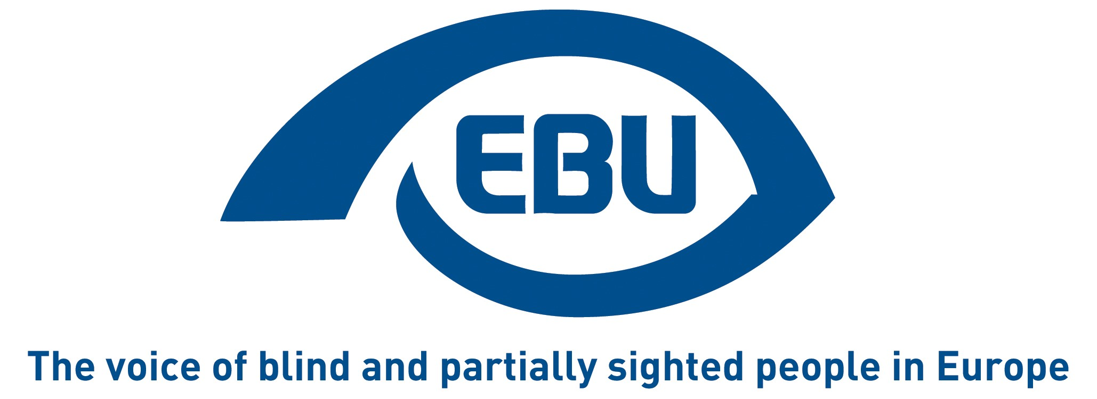

EBU Statement on
the European Elections 2019
February 2019

Introduction
The European Blind Union (EBU) – Interest Representative Register number 42378755934-87 – is a non-governmental, non-profit making European organisation founded in 1984. It is one of the six regional bodies of the World Blind Union, and it promotes the interests of blind and partially sighted people in Europe. It currently operates within a network of 41 national members including organisations from 27 European Union member states, candidate countries and other countries in geographical Europe.
With this Statement, we call on political leaders to pay attention to the demands of blind and partially sighted persons in Europe in the campaign for the European elections of 2019, and during the following five years.

Political participation
European elections should set a standard on accessible voting, i.e. accessibility of the vote itself (voting procedures), of electoral information (election campaign facilities and materials, political debates, political party programmes and websites) and of post-election procedures (e.g. complaint mechanisms), as well as equality in the right to stand as a candidate.
We ask political parties to make that effort for 2019, and the European Parliament to pass a resolution to ensure full accessibility of the European elections in 2024.

Equality
Over 10 years ago, the Equal Treatment Directive was proposed by the European Commission to protect EU citizens against discrimination in all areas of life, be it disability, age, sexual orientation, or religious belief. The directive, which has always been supported by the Parliament, is still being blocked by the Council.
We call on the EU political leaders to resume progress on this horizontal directive which is very much needed to close the legislative gaps, and urge the European Parliament to issue a resolution to press the Council to that effect.

Accessibility
While there has been significant progress in this area recently with the European Accessibility Act (EAA), the EU missed the opportunity to deliver a truly horizontal directive. With its limited scope, the EAA remains mostly a digital act and it does not address the needs of blind and partially sighted persons in the physical world.
We urge the European Parliament to ask the Commission to prepare legislative initiatives to promote accessibility in particular as far as the built environment, public urban transport and household appliances are concerned.

Digital Europe
The 2016 Web Accessibility Directive does not apply to the websites and mobile applications of EU institutions. While the importance in volume and languages of the information that they publish justifies extra-time to adapt, EU institutions should nevertheless make every effort to put in practice what they require from Member States.
We expect the European Parliament in particular to set the example and apply the respective provisions to its websites and apps.

Mobility
In its Third Mobility Package, the European Commission committed to an increase in automated driving, for private and public transportation. Connected and autonomous (or ‘self-driving) vehicles can greatly enhance the independent mobility of blind and partially sighted persons; at the same time, from a pedestrian perspective, they pose particular threats to the safe transit of the same persons.
We call on the European Parliament to sensitise the Commission to address the needs and concerns of blind and partially sighted persons at the outset in any related future legislative proposal.

Culture
The EU funding for the film industry can usefully play a role in promoting films that are accessible to blind and partially-sighted persons, following the good practice and positive results observed of similar initiatives in some EU countries.
We ask the European Parliament to make audio-description a mandatory requirement for support under Creative Europe Media, the EU’s funding instrument for cross-border film productions.

Disability across borders
The EU Disability Card, which provides facilitated access for people with disabilities to a variety of services, notably in the areas of recreation and leisure (museums and cultural sites) and transport, is currently still just a Commission project in a pilot phase. As such it is implemented on a voluntary basis, is available only in a few (8) EU countries, and does not cover the same areas in all the participating countries.
We call on the European Parliament to press for a scaling-up of the initiative, to make it what citizens with disabilities already expect it to be: an EU-wide scheme of recognition of disability for equal access to related services.

Informed policy-making
There are currently no reliable and comparable statistics at EU level on the inclusion of persons with disabilities, with disaggregated data per types of disability, a clear and consistent cut-off point to accurately class a person as disabled and consistent questions over time. This is particularly prejudicial, for instance, in addressing access to employment of blind and partially sighted persons: the dimension of the problem is largely hidden, as revealed by evidence gathered by EBU in some EU countries.
We ask the EU institutions, and in particular the European Parliament through its research service, to push for the collection and collation by Eurostat and national statistical offices of the necessary data to inform policy-making.

External action
The EU Instrument for Pre-Accession Assistance and Eastern Partnership should address inclusion and disability-related concerns, as a way for the EU to promote best practices in the wider Europe.
We ask the Parliament to recommend this.

Disability Intergroup of the European Parliament
The Disability Intergroup is an informal cross-country and cross-party grouping of Members of the European Parliament (MEPs) who are interested in promoting disability policy in their work at the Parliament as well as at the national level. It has been a key ally in advocating for and advancing the rights of persons with disabilities in Europe, and in enabling their participation in decisions that concern them.
We encourage future MEPs from all countries and groups to participate in the Disability Intergroup, in order to be better informed about the impact and possibilities of EU policies in the area of disabilities.

Contact: Antoine Fobe, Head of Campaigning
Email: ebucampaigning@euroblind.org - Tel: +33 1 47 05 04 84
www.euroblind.org
Twitter: @euroblind - Facebook: @EuropeanBlindUnionEBU

