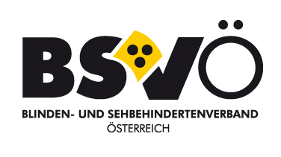

**GEAR - GENDER EQUALITY AWARENESS-RAISING**

**Report on the status of gender equality in EBU member organizations**

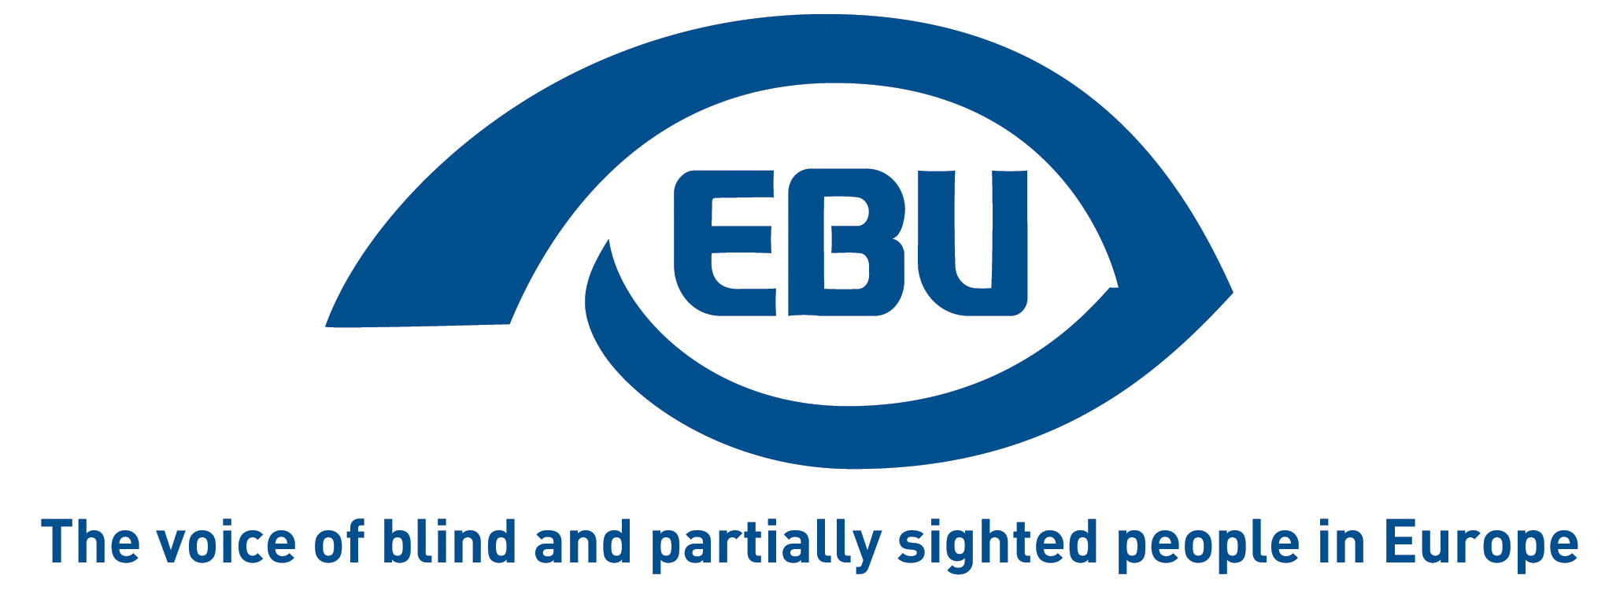

The survey was carried out from March to May 2018 by the Swedish Association of the Visually Impaired (SRF) as the first step of the GEAR (Gender Equality Awareness-Raising) activity.INTRODUCTION

The purpose of the survey was to learn how gender equality work is progressing and also to get an idea to what extent gender equality thinking is part of the work in the member organisations. The results from the survey will be used as a basis for further discussions and for designing measures hopefully leading to increased participation by blind and partially sighted women in decision-making bodies throughout the member organisations.

# RESULTS

All 42 EBU member organisations were invited to participate in the survey, 24 took part. The respondents range from small (less than 800 members) to big (more than 200,000 members) organisations. Answers to the survey questions were collected through interviews, and those respondents who preferred to give their answers in writing did so. The interviewees were appointed by the member organisations themselves.

The first half of the questionnaire consisted of quantitative questions:

## How many women and men respectively are on the board?

Women’s representation on the national boards differs a lot between members. Two respondents have 0% women on the board, six have between 1% and 20%, six between 21% and 30%, one between 31% and 40%, six between 41% and 50%, and three member organisations have between 51% and 60% female representatives.

## Is there a woman or a man in one of the following posts?

**(President, vice president, other. )**

Looking at the presidency and vice presidency on the national boards, 5 out of 24 presidents are women and 8 out of 40 vice presidents are female. Other posts, like treasurer, secretary etc., are held by both women and men. Since types of additional posts differ between different organisations the comparability is lost.

## What about the regional boards (if existing) when it comes to the president post: man or woman?

When it comes to presidency on regional boards the picture changes a bit. Seven respondents have no regional boards, but among the remaining 17 as many as 10 have a female presidency share between 42% and 65%. The last seven respondents have 31%, 29%, 15%, 14%, 5%, 0% and 0% respectively. According to a couple of respondents one possible reason for this higher share of female presidents on regional boards can be that often it is difficult to find people volunteering for board posts and anyone accepting gets it.

## What is the gender split like on member level in your national organisation?

When asking about the gender split on the national membership level in the organisations 16 survey participants declare a female share ≥50%, one has 45%, one has 30% - the remaining six respondents do not have this data. The average among the respondents is a women membership of 55%.

The second half of the questionnaire consists of more qualitative questions:

## Have you examined the life conditions of visually impaired women and men respectively?

Just over a third of the respondents answer yes. Two clear tendencies can be distinguished, both when a survey has been conducted and when talking general impressions: when it comes to accessibility to aids both women and men have the same possibilities. Work accessibility, on the other hand, is a field where men seem to be favoured. Blind or partially sighted women are unemployed or work part-time to a larger extent than BPS men. This double discrimination (being a woman, having a disability) is something to be aware of. One of the life conditions studies shows that BPS women feel more insecure in daily life than men do. This also mirrors the situation of women in general in many countries. Another observation made by one of the responding organisations is that psychosocial assistance is more used by women (62%) than men (38%) in the organisation in question.

## Are there any member activities intended specifically for women (or men)?

14 out of 24 survey participants have or have had activities during the past years intended specifically for women. It can be courses of personal empowerment where you learn to argue, learn how the work of local societies is run, learn IT, etc. Other courses assemble women around activities like styling/make-up, aerobics, Pilates, self-defence, first-aid at home, cooking and more. One respondent arranges courses for women with migrant backgrounds to help them overcome difficulties to integrate in their new community.   
  
One of the responding organisations uses its website to reach its female members, both with information and audio-video materials on different topics. Another organisation has a special supplement of their member magazine dedicated to women.  
  
Organised activities appear to normally target both men and women. When there are, for example, courses intended specifically for women the organisation has seen a special need or demand for setting up such an activity.

Some activities are funded by the organisation or by the State, but often money must be applied for. Reasons for discontinuing activities can be shortage of money or lack of committed persons.

## Are gender equality matters a part of your political/influencing work? If yes, in what way?

The most common reply is: “No, focus lies on visually impaired people, not on gender.” But as many as 11 organisations have a more or less explicit agenda for gender equality matters, and three of them give clearly affirmative answers. Of these three, two have gender equality committees in their organisations which, when needed, take issues further and ask for lobbying actions.

## On a scale from 1 to 10, where 1 = No priority and 10 = High-priority, where would you place the gender equality work of your organisation?

The answers are well spread and range from 1 to 9 (two respondents chose not to give an estimation). Among the 22 answers position 5 was given by 32%. As many as 68% landed at positions 4-7.

Note that answers to this question are an estimate made by someone in the organisation who considers to what extent the gender equality work is prioritised today. The answer does not say anything about how far gender equality work has come within the organisation.

## According to you, how should the EBU work with gender equality issues?

This very open question has evoked many different suggestions.   
They can be categorized into four main fields:

1. **Strengthen women** in all EBU member organisations through different activities such as training courses and share good examples on well going activities.
2. **Arrange** **equal representation** on the boards and in other decision-making bodies. Change the ‘masculine cultures’. Look at possibilities to facilitate participation for women. Change the meeting procedures to make them more transparent and logical.
3. **Involve the men** in the work with gender equality.
4. **Integrate gender equality thinking** into all fields of work and a gender perspective in all EBU documents, position papers, policies, etc.

A complete list of all comments is included in the end of the report.

# Conclusions

Gender equality work is in progress in the EBU member organisations even though the picture is not homogeneous and considerable work is required to further increase representation and participation by women. When comparing the share of female members on the national level to the share of female representation on the national boards we see that in most cases the two do not match very well. Also, gender equality work is very differently prioritised in the different organisations.

Women risk double discrimination to a larger extent than men.   
Many member organisations arrange activities of various sorts intended for women - some with a more social purpose, some with more educating/personal-development contents.

The work of most responding organisations is focused on discrimination of the blind and visually impaired, not on gender specific issues. Still, the awareness of gender equality is present in many organisations and some of them have formed a structure to concretely handle the issue.

The EBU has been offered many well-thought-out suggestions of possible ways to continue the gender equality work from the survey participants. The report is a basis for continuing discussions on further activities in the project.

# Supplement

## According to you, how should the EBU work with gender equality issues?

**This very open question has evoked many different suggestions:**

R1: “Important to make the member organizations work with these questions. This project is a good thing. Gender equality should be made part of the thinking within each organization.”

R2: “The EBU needs to achieve gender equality gradually in accordance with the interests and needs of women. And also, I think the EBU must make efforts to engage woman as activists.”

R3: “We are highly supporting activities related to awareness-raising (e.g. the EBU video portraying stories of women with VI). Furthermore we support the exchange of good practice - for instance in the area of professionalized social services to women with VI. We’d support the activities and recommendations mentioned within the WBU statement on International women’s day as well as ongoing support and enhancing of leadership capacity and self-confidence of women in general (and more specifically in developing countries).”

R4: “Important, in general, not to focus on gender equality, but to integrate gender equality thinking into all fields of work. Also important to train women and increase their self-esteem. Put more focus on the men! They have to understand the problem with inequality. Good to collect data (like in this project) to use for background when working for changes. I think conferences and workshops attract people, and when they attend such events they feel obliged to take home what they've learned.”

R5: “The EBU should make a research to see what prevents women from participating. There are differences between countries (like child day care, possibility to get higher education…). Tools to use could be women meetings.”

“We believe that it is important that EBU works on gender equality issues in countries where the differences are still very large. EBU can help the member organizations in these countries, to train people in campaigns for this issue and to organize courses to strengthen and empower visually impaired women.”

R6: “Gathering of data, highlighting of trends and observations on maltreatment, exclusion, violence, abuse or the like. Maintain a women's wing or network. Ensuring that gender issues, in a balanced way, are highlighted at General assemblies.”

R7: “Sharing good examples! Tell about well-working activities and agendas from countries/organizations that are more gender equality advanced. Carry out surveys like this one. Develop tool kits. Raising awareness. Target the men!”

R8: “The gender equality issue is important and must be given a higher profile. Try to change the ‘masculine cultures’. Look at possibilities to facilitate participation for mothers (financial support for nanny fees, for example). Change the meeting procedures to make them more transparent and logical and formed to suit visually impaired persons. Limit the term of office in boards and the possibility to hold a post for several terms.”

R9: “The EBU should lobby for directives against multiple discrimination. The EBU should also work with gender equality projects within the union.”

R10: “The women's network exists and that's good, but it is not clear who is part of it and when. Something more concrete is needed. A get-together where women meet and really see each other to exchange experiences and discuss ideas and what should be done. Not a regular meeting but arranged when needed. But this is not a thing that the bureau in Paris should initiate - it should come from the members.

Both the EBU and the WBU are mostly run by men and are very tradition bound. More women must be part of the decision-making bodies.”

R11: “In my experience, in the past EBU concentrated too much on theoretical principles but often what emerged in terms of resolutions and/or documents was not applicable or importable everywhere. I consider it necessary, on the one hand, to set up effective information campaigns on equal representation, gender violence, motherhood, right to adoption, employment, etc., and, on the other hand, to create tools such as manuals, distance training courses, documentaries, short awareness-raising videos. It could be a good idea to have a publication or some articles to be disseminated among member associations to let women in other countries know about the activities that the EBU carries out to promote women or high profile initiatives that can be duplicated in other countries. It could be useful if the EBU could also organize regular audioconferences with national committees from different countries.  
Another idea is that EBU could have radio broadcasts dealing with various subjects European women are interested in or proposed by EBU itself.”

R12: “Gender equality should be integrated into all kind of issues. Men and women should work together, complete each other.”

R13: “We consider that EBU should be a pace setter in the field of gender equality for all the member organizations. Here are some recommendations:

* Regulations for 50% of the delegates in the general assembly to be women should be adopted and take effect.
* The number of male and female members of initially the management board, and all the other organs and working commissions should be equal.
* Regular training sessions should be arranged within the field of gender equality with the active participation of all the member organisations.
* EBU should be supportive and work in solidarity with all the member organisations to help the blind women in the countries of these organisations to enjoy all the fundamental rights and freedoms equally.
* EBU should be actively involved in the Works of the member organisations regarding gender equality. The best practices regarding gender equality, if available, should be shared publicly within the countries of member organisations in order to create measureable social pressure.
* EBU should establish an assembly of women composed of woman members from all the member organisations. The representatives in this assembly should be renewed at each general meeting. This assembly should hold meetings in all the countries where member organisations exist. The practices of the country where the meeting is arranged regarding gender inequality in both public and private life should be shared publicly.”

R14: “Important to keep the topic active. Important that both sexes are represented in activities. Empower women, make them more self-confident. Facilitate for mothers to participate.”

R15: “EBU should educate, raise the awareness of EBU member states, that gender equality provides a better understanding of women's and men's problems. EBU can also point out the advantages and disadvantages of both sexes. EBU can promote creative women and men. I would suggest that the EBU organize joint workshops for women and men in the field of managing the organization.”

R16: “It's good to motivate women and girls through different activities. The EBU project VISAL was a good project.”

R17: “First step is to arrange equal representation on the boards and in other decision-making bodies. And this goes for structure and activities throughout the union as a whole.”

R18: “EBU should adopt a twin-track approach, involving the inclusion of the gender perspective in all EBU documents, position papers, policies, etc., and, at the same time, developing specific actions within the organization aimed at addressing the issues affecting women and girls with low vision in Europe. These actions should be led by blind and partially sighted women and girls themselves.”

R19: “Relying on the EU Directives and all positive International Acts defining this issue and bearing in mind that one of the 17 goals of the Agenda 2030 is the issue of gender equality, we believe that the EBU should include and promote the issue of gender equality in its programming activities. By organizing educational meetings and regional conferences and implementing project activities, it is necessary to affirm the active participation of women in all segments of social life. It would be very useful to point out in particular the positive practice from some countries that should be an example to others. It is also necessary to disclose all positive acts of an international character on the website, such as the Articles of the Convention, the Charter, the Declarations, the Directive and other acts that suggest and recommend a fair attitude towards gender equality.”

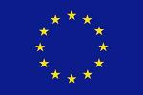

This report was co-funded by the “Rights, Equality and Citizenship Programme” Programme of the European Union.

END OF DOCUMENT