Grant agreement no.: 815098

D3.2 – Connected and Autonomous Vehicle 360° Acceptance Map

Date of publication: [30-11-2021]

Disclaimer
This report is part of a project that has received funding by the European Union’s Horizon 2020 research and innovation programme under grant agreement number 815098.
The content of this report reflects only the authors’ view. The Innovation and Networks Executive Agency (INEA) is not responsible for any use that may be made of the information it contains.
D3.2 – Connected and Autonomous Vehicle 360° Acceptance Map
Work Package No. | 3 | Work Package Title | Outreach
Tasks involved in the reported results |  | - 3.1  - 3.2  - 3.3
Deliverable owner |  | UMA
Dissemination level |  | [PU/PP/RE/CO]
Due date |  | 30.11.2021
Delivery date |  | 30.11.2021

List of contributors
Section | Author(s) | Reviewer
1 | Celina Kacperski
2 | Celina Kacperski, Aaron Heinz, Tobias Vogel, Florian Kutzner
3 | Haibo Chen (3.1), Guillaume Gronier (3.2), Joanne Wirtz (3.3)
4 | Guillaume Gronier (4.1), Haibo Chen (4.2)
5 | Friederike Kühl
6 | Celina Kacperski, Tobias Vogel, Florian Kutzner

Version History
Version | Date | Main author | Summary of changes
0.1 | 21.09.2021 | Celina Kacperski, Tobias Vogel, Florian Kutzner | Structure, conceptual work
02. | 25.10.2021 | Celina Kacperski, Haibo Chen, Guillaume Gronier, Joanne Wirtz, Friederike Kühl | Submission of literature review sections
0.3 | 10.11.2021 | Celina Kacperski, Haibo Chen, Guillaume Gronier, Joanne Wirtz, Friederike Kühl | Submission of survey data analysis sections
0.4 | 14.11.2021 | Celina Kacperski | Merge of all versions
0.5 | 14.11.2021 | Celina Kacperski | Additional literature related to acceptance in sections 3, 4 and 5 added
0.6 | 16.11.2021 | Celina Kacperski, Tobias Vogel, Florian Kutzner | Discussion and executive summary
0.7 |  | Friederike Kühl, José F. Papí | Revisions

List of acronyms
Acronym | Meaning
AV | Autonomous Vehicle
EBU | European Blind Union
CAV | Connected and Autonomous Vehicle
CAVA | Connected and Autonomous Vehicle Acceptance Assessment Tool
KPI | Key Performance Indicator
PEU | Perceived Ease of Use
PU | Perceived Usefulness
TAM | Technology Acceptance Model
TPB | Theory of Planned Behaviour
UTAUT | Unified Theory of Acceptance and Use of Technology
VOT | Perceived value of travel time
VKT/VMT | Vehicle Kilometers/Miles travelled
ABM | Activity-based modelling
WTP | Willingness to Pay

Notice
This document complies with the European Bliclnd Union’s guidelines (http://www.euroblind.org/publications-and-resources/making-information-accessible-all) in order to be accessible to anyone, including blind and partially sighted people, and at the same time and at no additional cost.

Table of Contents
1 Introduction [UMA] 12
1.1 Purpose and organization of the document 12
1.2 Intended audience of this document 13
2 CAV Acceptance – Why – Attitudes, Motivators and Barriers [UMA] 14
2.1 Literature Overview 14
2.1.1 Attitudes 14
2.1.2 Motivators: Perceived ease of use and perceived usefulness 15
2.1.3 Motivators: Social Influence and Trust 16
2.1.4 Barriers: Perceived risk, safety and privacy concerns 16
2.1.5 Motivators and barriers: Large-scale consequences 17
2.1.6 Interrelations between drivers and pathways to CAV acceptance 18
2.2 Survey results 18
3 CAV Acceptance and individual differences – Influence of socio-demographics, visual impairment and mobility behaviour 26
3.1 Socio-demographics [UnivLeeds] 26
3.1.1 Literature Overview 26
3.1.2 Survey results 29
3.2 Individuals with visual impairments [LIST] 40
3.2.1 Literature Overview 40
3.2.2 Survey results 42
3.3 Individual mobility behaviour [LuxM] 49
3.3.1 Literature Overview 49
3.3.2 Survey results 52
4 CAV Acceptance and geographical differences [ULEE & LIST] 59
4.1 Literature overview 59
4.1.1 CAV adoption capacities 59
4.1.2 Interest in and expectations of CAVs 60
4.2 Survey results 61
5 CAV Acceptance and mobility solutions [ETELÄTAR] 65
5.1 Literature overview 65
5.1.1 Privately Owned CAVs 66
5.1.2 Shared CAVs 67
5.1.3 Public CAVs 68
5.1.4 Conclusions 69
5.2 Survey results 71
5.2.1 Privately Owned CAVs 71
5.2.2 Shared CAVs 72
5.2.3 Public CAVs 74
6 Conclusions - Recommendations [UMA] 76
7 References 79
7.1 Chapter 2 79
7.2 Chapter 3.1 81
7.3 Chapter 3.2 83
7.4 Chapter 3.3 85
7.5 Chapter 4 85
7.6 Chapter 5 87
Table of Figures
Figure 1 Illustration of mean values across the 6 consequence factors (affordability, efficiency, independence, privacy, safety and sustainability) as well as ease of use. 22
Figure 2 Polarization (worsening and improvement expectations) among participants displayed for the expected consequence factors. 23
Figure 3 Regression model estimates predicting affective and cognitive evaluations of CAV introduction. 24
Figure 4 Age variation on perception of CAV safety. 30
Figure 5 Gender variation on perception of CAV safety. 30
Figure 6 Age variation on privacy concern over CAVs. 31
Figure 7 Education variation on privacy concern over CAVs. 32
Figure 8 Age variation in sustainability effect from CAVs. 33
Figure 9 Gender variation in sustainability effect from CAVs. 33
Figure 10 Education variation on independence from CAVs. 34
Figure 11 Employment variation on independence from CAVs. 35
Figure 12 Education variation on efficiency from CAVs. 36
Figure 13 Employment variation on efficiency from CAVs. 37
Figure 14 Gender variation for affordability and ease of use of CAVs. 37
Figure 15 Gender variation on intention to use CAVs. 38
Figure 16 Age variation on intention to use CAVs. 39
Figure 17 Education variation on intention to use CAVs. 39
Figure 18 Relationship between age and intention to use CAVs in sighted people. 43
Figure 19 Relationship between age and intention to use CAVs in visually impaired people. 44
Figure 20 Relationship between age and intention to use CAVs in sighted people and visually impaired. 45
Figure 21 Intention to use CAVs in sighted people and visually impaired. 46
Figure 22 Intention to use CAVs in sighted people and visually impaired, according to the use of public transport. 47
Figure 23 Perceived independence and age group in sighted people and visually impaired people. 48
Figure 24 Intention to use CAVs vs Public transport usage by car ownership 53
Figure 25 Intention to use CAVs vs car sharing usage by car ownership 54
Figure 26 Intention to use CAVs vs ride hailing usage by car ownership 55
Figure 27 Perceived affordability for participants owning/not owning a car by age 56
Figure 28 Perceived efficiency for participants owning/not owning a car by age 57
Figure 29 Variation in mean ratings for safety and privacy across different countries 62
Figure 30 Variation in mean ratings for sustainability and independence across different countries 63
Figure 31 Variation in mean ratings for ease of use and intention to use CAVs 64
Figure 32 - Ownership categories for CAVs 65
Figure 33 - Simulation results (change in VKT and energy) by penetration and VOT change (Source: Auld et al.) 67
Figure 34 Intention to use private vs. shared CAVs depending on current public transport usage 75

List of tables
Table 1 Example items for expected consequences from the survey. 19
Table 2. Overview of descriptive statistics from survey as a baseline. 20
Table 3 Absolute number of participants owning a car vs absolute number of participants not owning a car, classified by age. 52
Table 4 Intention to use CAVs by car ownership and age. 53
Table 5 CAV Ownership category advantages and disadvantages. 70
Table 6 Intention to use private CAVs by age. 71
Table 7 Intention to use private CAVs by age and country 72
Table 8 Intention to use shared CAVs by age. 73
Table 9 Intention to use shared CAVs by age and country 73
Table 10 Perceived affordability of private vs. shared CAVs by age. 74

Executive summary
The PAsCAL project, funded under the "Horizon 2020" Research and Innovation program, has the goal to provide insights and develop a better understanding about citizens’ and stakeholders’ expectations for connected and automated vehicles (CAVs), and the acceptance of CAVs.
The following document, D3.2, aims to introduce the user-centered research conducted in the context of WP3, which is the Work Package in charge of studying attitudes of citizens towards Connected and Autonomous Vehicles (CAVs) and assess which consequences are expected from CAV introduction into different traffic scenarios. The results of this research are presented in this 360° Acceptance Map. It delivers a multidimensional analysis indicating who accepts what types of CAVs, detailing also where and why.
The data introduced in the survey results sections below are based on data collection conducted using the Connected and Autonomous Vehicle Acceptance Assessment Tool (CAVA) developed in WP3 over the course of the PAsCAL project, which is also presented in-depth in D3.3, the companion deliverable to D3.2. The aim of the CAVA is to measure CAV acceptance via evaluation of expected CAV consequences.
First results from descriptive insights of the data collected indicate that there are variations on almost all levels of analysis, though the overall acceptance tends towards ambivalent neutrality. In terms of motivators, safety and ease of use seem the most important factors, though gains in independence and expectations with regards to sustainability should not be overlooked.
Across socio-demographic strata, age, gender and education levels play roles, with older individuals, and women more sceptical of CAV adoption, and university level educated individuals more willing to adopt CAVs. Across countries, participants from Eastern and Southern countries such as Hungary, Spain, Portugal and Italy seem to be more optimistic and willing to adopt CAVs than participants from Central European countries such as France, Austria and Germany. Furthermore, experience with public transport, car sharing and ride hailing seems to go together with higher acceptance, though currently, for a variety of reasons, a slight preference for personal, owned vehicles can be observed among participants. Introduction as part of shared mobility is seen as beneficial in terms of affordability and sustainability. Finally, more optimistic expectations are reported by participants with visual impairments, and a higher willingness to use CAVs.
Recommendations that can be gained from this research will allow insights into potential impacts of interventions as well as help data collection related to CAVs.

Introduction

Purpose and organisation of the document
The purpose of this document is to present findings based on the research conducted in the context of WP3, which is the Work Package in charge of studying attitudes of citizens towards connected and autonomous vehicles (CAVs). A large part of the research undertaken via surveys in WP3 is to assess which consequences are expected from CAV introduction, individuals’ attitudes and intentions to use CAVs, and how these differ between individuals with different socio-demographics, from different geographical locations, with different mobility behaviours, when judging consequences of owned as compared to shared autonomous vehicles. The results of this research are to be presented in a 360° Acceptance Map.
In line with Tasks 3.1 (Creation of inclusive pool of item measures), 3.2 (Initial assessment of acceptance dimensions and citizen clusters) and 3.3 (Behavioural and experimental validation of assessment instrument), this document, D3.2, outlines literature on a variety of factors that impact CAV acceptance, which supports the development of the Acceptance Map; it also presents descriptive results based on survey data collected with the CAVA (see D3.3 – CAVA (Connected and Autonomous Vehicles Acceptance Assessment Tool), related to important issues in the context of existing literature on CAV acceptance.
Including the Introduction (Chapter 1), the document is divided into six chapters.
In Chapter 2, we convey the ‘Why’ dimension of the acceptance map and describe the literature for motivators and barriers that drive CAV acceptance, garnering first recommendations for CAV integration into mixed traffic of existing road ecosystems.
In Chapter 3, we target the ‘Who’ dimension of the Acceptance Map, looking into the impact of socio-demographics, sightedness/visual impairment, and mobility behaviour as possible factors in CAV acceptance.
In Chapter 4, we cover the ‘Where’ dimension of the Acceptance Map, introducing differences found between citizens of different countries.
In Chapter 5, we target the ‘What’ dimension of the Acceptance Map, discussing different user schemes for CAVs, such as shared vs owned vehicles and compare results in acceptance.
Chapter 6 discusses the results across the previous chapters and presents some recommendations.

Intended audience of this document
The audience for this document can be categorised in three different groups:
- The consortium members of the PAsCAL project, specifically partners responsible for the different CAV trials, simulations, pilots, CAV training skills development and development of business cases;
- Policymakers, specifically those with an interest in creating a more participatory CAV introduction that suits the needs of a variety of subpopulations;
- Researchers of academic and industry with an interest in CAV acceptance measures as well as motivators and barriers to CAV integration.
The wider CAV community is invited to use the here presented document to gain an overview over which motivators and barriers are relevant for CAV adoption, as well as acceptance in relation to individual differences, mobility behaviour and geographical location of citizens.
A main objective of the PAsCAL project is to move the focus towards a more user-centric design of CAV research, so the analysis of data on citizens’ attitudes across a wide range of demographics, locations and expected consequences should facilitate this objective.

CAV Acceptance – Attitudes, Motivators and Barriers

Literature overview
To gain deeper insights into CAV acceptance, researchers have recently started to identify potential influencing factors and assessed their impact, as well as the relationships among each other (Zhang et al., 2021; Kacperski et al., 2021). So far, as recently published literature reviews demonstrate (Golbabei et al., 2020; Jing et al., 2020; Zhang et al., 2021), research has mainly focused on factors reflecting citizens’ expectations about their own personal risks or benefits when directly interacting with CAVs, such as perceived ease of use, perceived usefulness, attitude, social norm, trust, and perceived risk. Most of these factors are rooted in domain free behaviour theories like the Theory of Planned Behaviour (TPB, Ajzen, 1991), which postulates that behavioural intentions are influenced by the attitude towards certain expected outcomes, made up by subjective evaluation of that outcome, involving constructs such as social norms, perceived behavioral control and perceived power. They can also be based on more specialized adaptations and extensions like the Technology Acceptance Model (TAM, Davis, 1989) or the Unified Theory of Acceptance and Use of Technology (UTAUT, Venkatesh et al., 2012) -models that include some form of performance and effort expectancy and facilitating conditions to predict usage behaviour - and are thus theoretically based predictors of the behavioural intention to use CAVs.
However, citizens’ expectations about how wide-spread CAV adoption might affect society as a whole as well as the environment also need to be considered. Research that tries to identify the citizen’s hopes and fears about such large-scale consequences is still sparse but has recently identified factors that play a role in shaping CAV acceptance, like general road safety sustainability (Wu et al., 2019; Kacperski et al., 2021).
Hence, the following sections introduce both expected personal consequences and general consequences of CAV introduction that have been shown to drive CAV acceptance. Moreover, their potential interrelations and the pathways in which they exert an influence on CAV acceptance will be discussed.

Attitudes
Attitude describes an individual’s positive or negative feelings (evaluative affect) about performing a certain target behaviour (Fishbein & Ajzen, 1975, p.216) and is assumed to mediate the corresponding behaviour intention according to the TPB (Ajzen, 1991) and the TAM (Davis, 1989). Thus, a positive attitude towards CAVs can be regarded as a prerequisite for forming an intention to use CAVs. Not surprisingly, the assessment of attitudes towards CAVs has been part of many studies of CAV acceptance. In multiple surveys all around the globe respondents overall reported initial positive attitudes towards CAVs (e.g., Shoettle & Sivak, 2014; Payre et al., 2014; Liljamo et al., 2018; for a recent overview see, Sharman & Mishra, 2020), although not being free from worries about safety and privacy. Giving people the opportunity to experience autonomous system intuitively, e.g., in a driving simulator (Hartwich et al., 2017), might lead to a more favourable attitudes, especially among the elderly, who might have a poor understanding of driver assistance systems, at least in countries like China (Jing et al., 2020).

Motivators: Perceived ease of use and perceived usefulness
Perceived Ease of Use (PEU) can be defined as “to what degree people believe that using a particular system or technology could be free from physical and mental effort” (Davis, 1989). Perceived usefulness (PU) can be defined as “the degree to which a person believes that using a particular system would enhance his or her […] performance” (Davis, 1989, p. 320). Both variables are part of the TAM and can be expected to influence CAV acceptance. According to this model, a higher PEU of CAVs should exceed a positive influence on an attitude towards CAV usage via two paths:
- Directly by increasing the attitude towards CAV usage;
- Indirectly, by increasing the PU of CAVs, which is also beneficial to the attitude towards CAV usage. Additionally, a higher PU of CAVs should directly increase the behavioural intention to use CAVs.
The literature on CAV acceptance clearly supports these assumptions. Regarding PEU, studies found an indirect (Solbraa, 2016) as well as a direct effect of PEU on acceptance intention (e.g., Buckley et al., 2018; Zhang et al., 2019; Zhang et al., 2021). This effect of PEU on CAV acceptance becomes stronger, after people had the chance to experience a ride in a CAV (Xu et al., 2018). The literature suggests that PU might be even more important for shaping CAV acceptance. Some studies found PU is the strongest predictor of the behavioural intention to use CAVs (compared to other psychological variables like trust or social influence, Panagiotopoulos & Dimitrakopoulos, 2018).

Motivators: Social influence and trust
Social influence, as part of the UTAUT refers to “the degree to which an individual perceives important that others believe he or she should use the new system” (Venkatesh et al., 2012, p. 451). This concept is based on that of the subjective norm, which is also one of the three key determinants for forming a behaviour intention in the TPB (Ajzen, 1991). People who believe that other people close to them (e.g., their family members, friends, or peers) think they should use CAVS have a higher likelihood of using CAVs.
In line with this theoretical assumption, the intention to use CAVs is directly predicted by social norms in multiple studies (Panagiotopoulos & Dimitrakopoulos, 2018; Zhang et al., 2020). Moreover, by affecting peoples’ perception on how easy and beneficial it is to use CAVs and by influencing the extent to which the system can be trusted, social norms also exert an indirect influence on CAV adoption (Acheampong & Cugurullo, 2019; Zhang et al., 2019).
Trust in CAVs has been defined as “the attitude that AVs will help achieve an individual’s goals in a situation characterized by uncertainty and vulnerability” (Lee and See, 2004, p.54). Although not explicitly mentioned in the most prominent behaviour theories, trust is expected to be an important driver for CAV acceptance and has been assessed in numerous CAV acceptance studies. Many of them show that trust is a strong or the strongest predictor of behaviour intention (e.g., Buckley et al., 2018; Zhang et al., 2021). Trust influences CAV adoption both directly (Buckley et al., 2018; Panagiotopoulos & Dimitrakopoulos 2018; Xu et al., 2018; Zhang et al., 2019; Zhang et al., 2021) and indirectly by increasing PEU, PU and the perceived safety of the vehicles (Xu et al., 2018; Zhang et al., 2021).

Barriers: Perceived risks, safety and privacy concerns
Numerous risks that might lead to physical injuries, privacy leakage or financial loss have been associated with CAVs (Zhang et al., 2021). Some of the most prominent ones are the risk of accidents, e.g., because of system malfunctioning or poor decision making (especially in the case of unexpected situations) or because of attacks by hackers (König & Neumayr, 2017; Shoettle & Sivak, 2014), as well as legal concerns (e.g., potential personal liability in case of accidents) and privacy concerns (e.g., excessive data collection and misuse) (Rezaei & Caulfield, 2020). Such risks can be expected to mitigate CAV acceptance.
Indeed, studies that incorporated measures of these perceived risks into models to predict CAV acceptance have found a negative influence of perceived risks on general acceptance of CAVs (Liu & Xu, 2019) and the intention to use CAVs (Zhang et al., 2021), as well as a negative correlation with trust for the technologies. It can be argued that the relation between perceived risk and trust might be bidirectional: On the one hand, people that perceive higher risks with CAVs show reduced levels of trust towards CAVS, but on the other hand, low trust in CAVs also leads to an increased risk perception (Jing et al., 2020).

Motivators and barriers: Large-scale consequences
As soon as CAVs are widely introduced into mixed traffic on public streets, they will not just affect the life of individuals, but of society as a whole. Hence, people might consider also the bigger picture and include their expectations regarding CAVs general safety, privacy, efficiency, and environmental friendliness in their formation of attitudes towards CAVs and intentions to use CAVs (Kacperski, 2021).
According to recent literature reviews, “safety is the most frequently occurring word in all of the collected literature” (Jing et al., 2020, p. 13). While the relevance of the expected personal risk of being involved in an accident has already been highlighted before, expectations about the overall number of accidents and the severity of accidents involving CAVs should also be important. Overall, many surveys indicate that citizens expect a decrease in the number and severity of crashes through CAVs (e.g., Shoettle & Sivak, 2014; Bansal et al., 2016; König & Neumayr (2017); Kacperski et al., 2021), although at the same time, in other studies safety issues are still mentioned as the biggest concern (e.g., Liljamo et al., 2018). It has recently been shown that the expected impact of widespread CAV usage on overall road safety plays an important role in the evaluation of and the intention to use CAVs (Kacperski et al., 2021).
In terms of sustainability, simulations have shown that shared CAVs could save up to ten times the number of cars that would be needed for self-owned personal vehicle travel and therefore lead to overall emission savings (Fagnant, 2014), despite higher mileage due to empty driving (Fagnant, 2014; Harb, 2018). Surveys indicate that citizens share the expectation of environmental benefits: They believe CAVs to be more environmentally friendly than traditional cars (Shoettle, 2014; Kacperski et al., 2021), with many people even projecting the benefits of zero-emission electric cars to CAVs (Berliner et al., 2019). These expected environmental benefits seem to be a driver for CAV acceptance and usage: In one study about 60 % of respondents stated, that they would consider purchasing an AV, if it would emit fewer pollutants than a traditional vehicle (Haboucha et al., 2017). Moreover, environmental concerns pose a powerful indirect effect on the intention to use CAVs, mediated by the perceived green usefulness and ease of use of CAVs (Wu et al., 2019). Hence, especially for environmentally aware citizens factors like greenhouse gas savings should be an important driver.

Interrelations between drivers and pathways to CAV acceptance
As already pointed out the mentioned drivers do not only exert isolated direct influences on CAV acceptance but can be expected to interact in a complex manner. Recent conceptual frameworks of CAV acceptance based on literature reviews highlight this interrelatedness (Jing et al., 2020). Especially the role of trust is noteworthy, as it has been shown to have a direct impact on intentions to use CAVs, but also influences perceived ease of use, perceived usefulness and is bidirectionally related to perceived risk of CAV usage and therefore is included in various indirect pathways to CAV acceptance (Jing et al., 2020).
Another important finding is that although acceptance is often studied as a largely cognitive construct, the affective component of CAV evaluation plays a crucial role as well (Kacperski, 2021). Four facets of expected CAV consequences (both on personal and societal level) have been derived analytically: sustainability, privacy, safety, and efficiency (referring to aspects like the speed of CAVs and duration of trips). All of them, as well as perceived ease of use, were significantly related to the affective evaluation of CAVs, which strongly predicted the intention to use CAVs.

Survey results
All in this deliverable presented results are based on the analysis of the data collected in the survey conducted in summer 2021 with participants drawn representatively for a variety of countries by a panel provider (Austria, Belgium, France, Germany, Hungary, Italy, Portugal, Spain, UK) and supported by the European Blind Union in Czech Republic, Germany, Hungary, Italy, Lithuania, Macedonia, Portugal, Switzerland. Further details about the survey, its contents, items, factor analyses, and information about benchmark values, can be found in D3.3.
To give a brief overview, the survey consists of 19 items that target expected consequences of the introduction of connected and autonomous vehicles into mixed traffic, as well as an additional number of items related to intention to use CAVs, ease of use of CAVs, general evaluation, cognitive evaluation and affective evaluation.
The survey also collected information on gender, age, educational background, employment status, average monthly income and whether the participant has a visual impairment as well as participants’ habits and intentions concerning present and future modes of transport (including shared or private CAVs and the current usage of public transport, car sharing and ride hailing services). This allowed for an interesting comparison of the respondents’ intention to adopt CAVs for their daily mobility needs.
In total 5,661 persons participated in this survey, of which 4,858 were participants recruited by a panel provider that has access to representatively drawn samples across many countries, and 801 participants were recruited by the European Blind Union’s member organisations from their respective constituents. The full survey, including all questions and responses is documented in D3.3 in form of tables, including also gender and age distributions for the survey across all countries.
Items for expected consequences were rating scales (specifically, polarity scales), either ranging from 1 to 7 or offering a binary positive or negative statement, in the following form:

Table 1 Example items for expected consequences from the survey.
KPI | Question | User choices
Willingness to let others use | Please imagine a time in which large sections of the population use autonomous vehicles. What effect do you think this would have? | 1-7 (wherein 1 is very negative, 7 is very positive)
Data privacy concerns | If I used autonomous vehicles, my personal data would be... | 1-7 (less secure / more secure)
Data privacy concerns | If I used autonomous vehicles, the risk that my personal data were misused would be… | 1-7 (higher / lower)
Road safety concerns | If large sections of the population used autonomous vehicles, travel for all citizens would be... | 1-7 (more dangerous / less dangerous)
Road safety concerns | If large sections of the population used autonomous vehicles, the number of traffic accidents would be... | 1-7 (higher / lower)

Again, please see Deliverable 3.3 for a table of all items as well as gender and age distributions for the survey across all countries.
An example for each consequence expectation factor follows:
- Safety: the number of traffic accidents would increase or decrease;
- Privacy: personal data would be more or less secure;
- Sustainability: greenhouse gas emissions would be higher or lower;
- Independence: meetings with peers would be more or less frequent;
- Efficiency: travel time would be longer or shorter;
- Affordability: cost per journey would be higher or lower.
The following table displays descriptive statistics for the subsample of sighted individuals (panel participants) across all factors of the survey, with the participants being asked about personal, privately owned autonomous vehicles (i.e. a subsample of 2,419 participants). This table should serve as a baseline table to keep in mind when interpreting results in the following sections, which will delve deeper into other subsamples, such as results from participants with visual impairments, and results for the target shared vehicle (compared to owned, personal vehicles).

Table 2. Overview of descriptive statistics from survey as a baseline.
Target variable | n | mean | SD | median | skew | kurtosis | SE
intention to use | 2419 | 4.12 | 1.98 | 4 | -0.15 | -1.14 | 0.04
general evaluation | 2419 | 4.08 | 1.97 | 4 | -0.06 | -1.22 | 0.04
affective evaluation | 2419 | 4.11 | 1.85 | 4 | -0.13 | -0.98 | 0.04
cognitive evaluation | 2419 | 4.17 | 1.67 | 4 | -0.19 | -0.63 | 0.03
safety | 2419 | 4.47 | 1.77 | 4.5 | -0.34 | -0.79 | 0.04
privacy | 2419 | 3.21 | 1.57 | 3.5 | 0.33 | -0.36 | 0.03
sustainability | 2419 | 4.66 | 1.58 | 4.5 | -0.38 | -0.2 | 0.03
independence | 2419 | 4.38 | 1.28 | 4 | -0.13 | 0.66 | 0.03
efficiency | 2419 | 4.15 | 1.51 | 4 | -0.07 | -0.18 | 0.03
affordability | 2419 | 4.12 | 1.58 | 4 | -0.08 | -0.32 | 0.03
ease of use | 2419 | 4.26 | 1.86 | 4 | -0.19 | -0.92 | 0.04
Note: n is participant number. SD is the standard deviation. SE is the standard error. Analyses conducted for panel sample (owned CAV variant). All variables measured from 1 to 7 (midpoint: 4). For the consequence factors (e.g., safety), 1 implies worsening, 7 implies improvement of status quo.

The table shows that, looking at participants’ attitutes, they stayed relatively neutral, around the midpoint (4) of all target variables such as their intention to use CAVs, their general evaluation of CAVs, as well as their affective and cognitive evaluation.
The following graph illustrates the reported values in the above table visually for the six KPIs (affordability, efficiency, independence, privacy, safety and sustainability) as well as CAV ease of use. One can see that most respondents’ expectations remain neutrally around the midpoint value (4) for most factors. For privacy, however, respondents seem to expect a worsening, i.e. they expect large-scale CAV introduction to detoriate privacy. For safety and sustainability as well independence, a slightly positive outlook can be seen, i.e. participants seem to expect that large-scale proliferation of CAVs will improve these areas, such as lead to a higher attendence to family and friends (independence), a reduction in road accidents (safety) and a reduction in emissions (sustainability).

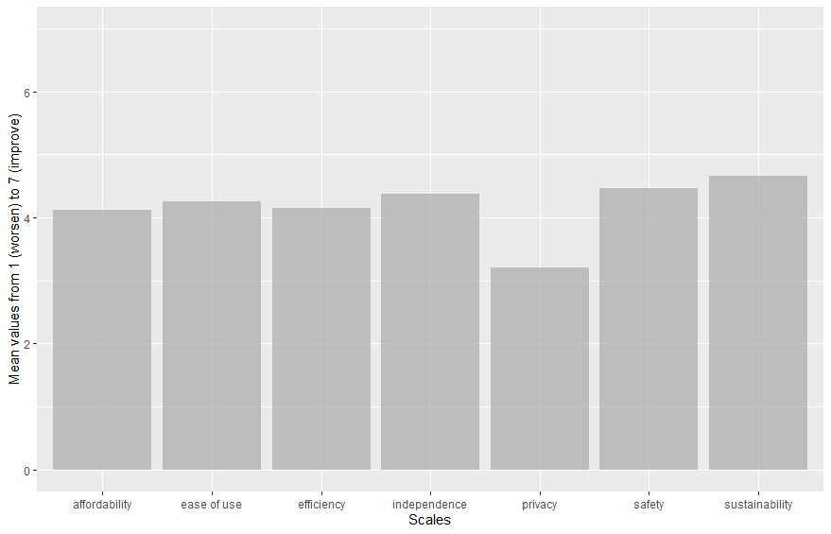
Figure 1 Illustration of mean values across the 6 consequence factors.
Note: From left to right: affordability, ease of use, efficiency, independence, privacy, safety and sustainability. Values are close to the midpoint (4) for all except privacy (closer to 3) and sustainability (closer to 4.5).

The average across respondents is not the only way to look at the data. In the figure below, the polarization across the respondents is illustrated for the six consequence factors. Values above 4.5 were coded as expectations for improvement, while values below 3.5 were coded as expectations for worsening (values between 3.5 and 4.5 were considered neutral responses and discarded). It can be observed that the majority of participants have positive expectations regarding sustainability and safety, while they have negative expectations regarding privacy. About 40% of participants do expect improvements in independence and affordability of vehicle usage, though as can be seen from the percentages, about half of respondents remained neutral. Efficiency is polarizing: over 30% of the population feel that it will either improve or worsen.
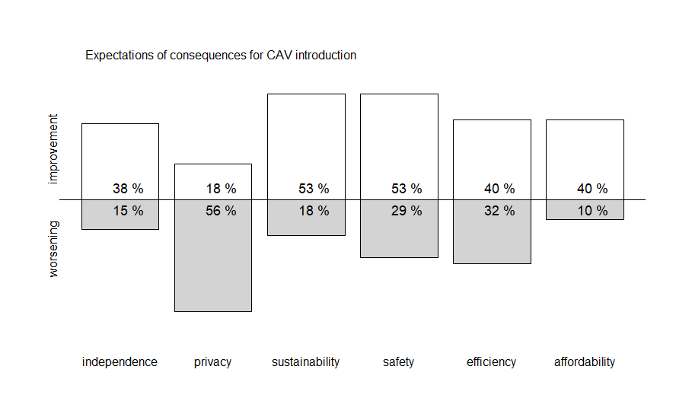
Figure 2 Polarization (worsening and improvement expectations) among participants displayed for the expected consequence factors.
Note: From left to right: independence (38%/15%), privacy (18%/56%), sustainability (53%/18%), safety (53%/29%), efficiency (40%/32%), affordability (40%/10%).
There remains the question whether evaluations of CAVs, both cognitive as well as affective, are somehow affected by expected consequences. We calculated regressions predicting both affective and cognitive evaluations from the six consequence factors as well as ease of use. In the figure, the further right the marker, the more impact the factor has predicting evaluations. We find that safety is the major predictor of both affective and cognitive evaluations, much in line with previous literature. Additionally, ease of use of CAVs plays a major role in formation of attitudes; this also, has previously been found in the literature and is replicated in our data.
For the other consequences, while most are significant predictors, effects tend to be small. For cognitive evaluations, sustainability, efficiency and independence play a role; for affective evaluations, privacy, sustainability, efficiency and independence play a role.
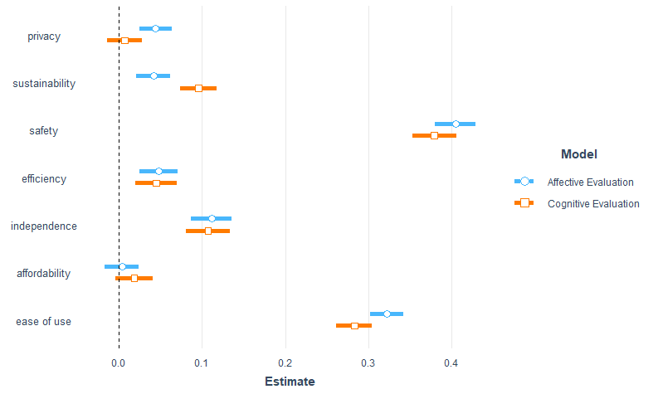
Figure 3 Regression model estimates predicting affective and cognitive evaluations of CAV introduction.
Note that data in this table do not represent precise values, as they are only an estimate derived from the visual representation of the chart above.
Data for Figure 3 Regression model estimates predicting affective and cognitive evaluations of CAV introduction.
 | affective | cognitive
privacy | 0.045 | 0.005
sustainability | 0.040 | 0.095
safety | 0.405 | 0.380
efficiency | 0.050 | 0.045
independence | 0.110 | 0.105
affordability | 0.005 | 0.020
ease of use | 0.320 | 0.280

The here presented results are averaged however across populations from a variety of countries (including Germany, France, Italy, UK, Hungary, Portugal and Spain), across a variety of socio-demographic factors (of all ages, genders, education and income levels), and for participants with a variety of mobility behaviours such as car owners, pedestrians and public transportation users. Additionally, responses might change if other forms of transportation and mobility solutions aside from personal vehicles are considered, such as for example shared vehicles. In the following chapters, literature over such differences will be presented, and results from the large-scale survey across these dimensions will be discussed.

CAV Acceptance and Individual Differences – Influence of Socio-Demographics, Visual Impairment and Mobility Behaviour

Socio-demographics
This section provides a literature review, as well as findings from the survey, which examine the influence of socio-demographic factors on CAV acceptance. It is expected that with the introduction of a new technology, different sections of the society could have different preferences and experience various impacts from such technology. Section 3.1.1 provides a literature review of the socio-demographic factors on CAV acceptance and Section 3.1.2 provides the results from the beforementioned survey.

Literature overview
CAV acceptance has been related with socio-demographic factors such as age, gender and income. Various studies have been conducted that incorporate the effect of socio-demographic variables on CAV and AV acceptance. This section provides an overview of the literature that examines the influence of socio-demographic factors. The literature review reveals that while socio-demographic variables can have some influence on CAV acceptance, the extent of this varies across different studies and can be context- as well as region specific. However, these factors do have some effect on CAV acceptance, which needs to be examined in detail.
Concerns over safety and security of driverless shuttle are more pronounced in case of women than in men. Women were found to be concerned about traffic safety such as accidents, security related to violence, robbery, harassment as well as security related to hacking, terrorism and data privacy. Moreover, a significant difference was also found between the gender for trust in autonomous vehicles. While 83% women considered a driver on-board to be important for the autonomous shuttle, only 73% of men considered this factor to be important. In comparison to 8.9% of women who accepted the autonomous shuttles without human steering, 17% of men accepted the technology without human steering. However, no significant differences were found between age and gender groups in their likeliness to use the autonomous public transport (Roche-Cerasi, 2019). Gender effects were also found to be significant in perceptions towards fully automated vehicles, with males found to have a higher affinity towards AVs (Wali et al., 2021).
While opinion on automated vehicles does not differ by gender, males prefer higher levels of automation (L5) than females (Ackaah et al., 2021). In a study to examine the acceptance of automated vehicles in Australia, males were found to be more positive towards AVs than females (Pettigrew et al., 2019) while it was found that men are more positive concerning KPIs like the intention to use, concern and willingness to pay, or private ownership of AVs (Becker & Axhausen, 2017). Also, males seem to have a more positive outlook towards AVs than females (Hilgarter & Granig, 2020).
Trust over automated vehicles and CAVs play a crucial role in acceptance of these technologies. In opinions over automated shuttles, it was found that women tend not to trust CAVs (Soldouz et al., 2020) while higher income, tech-savvy males in urban areas are more likely to adopt CAVs (Bansal et al., 2016). Households with safety concerns towards fully automated vehicles were less likely to consider purchase of these vehicles (Wali et al., 2021). Women also considered the presence of a driver in the driverless shuttle to be more important for the perception of security (Salonen, 2018).
While some studies report no significant effect of gender on the acceptance and behavioural intention to use autonomous vehicles and public transport (Nordoff et al., 2018; Pakusch & Bossauer, 2017), it is also emphasised in various literature that a marked difference exists between the gender in their perceptions of trust and security towards driverless technologies (Bansal et al., 2016; Liljamo et al., 2018; Pakusch & Bossauer, 2017; Schoettle & Sivak, 2014). A significant relationship thus exists between gender and perception of trust and security towards AVs.
Age has been found to be another important socio-demographic factor affecting the perception and use of CAVs. However, the effect of age on perception towards CAVs has been found to be strongly related to the geographical location. For example, while positive ratings for automated transport systems was obtained in case of older persons in France and Switzerland (Madigan et al., 2016), negative ratings were obtained for automated public transport users in Greece (Madigan et al., 2017).
In a review study of AV acceptance, younger respondents were less concerned about AV use and were less anxious (Becker & Axhausen, 2017). In another study, age effects were significant in the intention to use automated shuttles. Older people in this case expressed a higher intention to use the shuttle but rated the shuttle effectiveness as negative (Pakusch & Bossauer, 2017). In another case, no significant difference could be found between the different age groups in their likeliness to use the autonomous public transport (Roche-Cerasi, 2019). Pakusch and Bossauer also did not find a significant relationship between age and the acceptance of future autonomous public transport [10]. While Haghzare et al. found that older adults reported a generally high acceptance towards fully automated vehicles (Haghzare et al., 2021), Ackaah et al. found that people older than 60 years had a negative opinion of AVs compared to 18-29 years old.
Literature on acceptance of AVs and CAVs have also pointed towards a relationship between education and acceptance of this technology. People with higher education ranked the importance of driverless shuttles to contribute to less car traffic and pollution more highly. While the author found that majority of respondents did not evaluate the driverless shuttles to be useful, higher educated people were more positive towards the driverless shuttles (Roche-Cerasi, 2019). More educated people have a higher willingness to use partially connected and automated vehicles, with households having members with postgraduate degrees more likely to use and purchase automated vehicles (Wali et al., 2021). Becker and Axhausen on the contrary reported that education does not have a significant effect on the intention to use AVs.
While education level has been found to have some effect on CAV acceptance in a few studies, an important factor determining CAV use is the experience of the technology. In a study to examine the intention to use autonomous buses, the intention to use CAVs before they were introduced was associated with the perception of infrequent conventional buses and lower age of respondents. While the intention to use after the autonomous bus was introduced was largely positive. The acceptability of the technology in this case was found to be based on the frequency of the service (Mouratidis & Serrano, 2021).
Household income also determines the intention to use or purchase CAVs and automated vehicles. Households with greater income are more likely to purchase fully automated vehicles and also show a higher affinity to use partially connected and automated vehicles (Wali et al., 2021). It can be argued that income has a positive effect on the willingness to pay for ownerships of AVs and adoption timing. While income effects are more significant in case of private autonomous vehicles, lesser effect of income in public CAVs can be anticipated, especially when the travel fare of CAVs is regulated (Becker & Axhausen, 2017).
Other factors determining the use and acceptance of CAVs and AVs are previous experience with autonomous driving (Pakusch & Bossauer, 2017), presence of children in the household (Becker & Axhausen, 2017), technology savviness of individuals (Soldouz et al., 2020; Tsouros & Polydoropoulou, 2020), current mode choice decisions such as willingness to participate in carshare or rideshare (Wali et al., 2021) and CAV service characteristics such as travel time, waiting time and travel cost (Mouratidis & Serrano, 2021; Paddeu et al., 2021). It also seems that people who have experienced being near an accident with an electric vehicle were less likely to choose CAVs along with individuals who expressed concern about the low noise of electric vehicles. Moreover, visually impaired people who rely on conventional navigation tools such as white cane or guide dog are also less likely to use CAVs (Soldouz et al., 2020).

Survey results
The socio-demographic variables such as age, gender, education, employment and income were examined over several factors affecting CAV use such as safety, privacy, ease of use and intention to use CAVs. The following results were obtained for the different indicators for CAV acceptance.
It was found that younger people had a higher mean perception of safety with CAVs compared to older people.

Figure 4 Age variation on perception of CAV safety on a scale of 1-7.
Data for Figure 4 Age variation on perception of CAV safety on a scale of 1-7.
Age | 18-29 | 30-39 | 40-49 | 50-59 | 60-69 | 70-100 | Totals
Totals | 4.67 | 4.63 | 4.47 | 4.36 | 4.21 | 4.31 | 4.47

Men showed a significantly higher mean perception rating of safety than women.

Figure 5 Gender variation on perception of CAV safety on a scale of 1-7.

Data for Figure 5 Gender variation on perception of CAV safety on a scale of 1-7.
Gender | diverse | men | women | Totals
Totals | 4.63 | 4.61 | 4.33 | 4.47

In case of privacy, 18-29- and 30–39-year-olds showed higher mean values for trust with privacy issues in CAVs compared to respondents above 70 years of age.

Figure 6 Age variation on privacy concern over CAVs on a scale of 1-7.
Data for Figure 6 Age variation on privacy concern over CAVs on a scale of 1-7.
Age | 18-29 | 30-39 | 40-49 | 50-59 | 60-69 | 70-100 | Totals
Totals | 3.33 | 3.47 | 3.22 | 3.01 | 3.02 | 2.25 | 3.21

University educated respondents showed a higher trust in CAVs than respondents who had middle or high school education.

Figure 7 Education variation on privacy concern over CAVs on a scale of 1-7.
Data for Figure 7 Education variation on privacy concern over CAVs on a scale of 1-7.
Education | elementary school | high school | middle school or apprenticeship | none | university | Totals
Totals | 3.24 | 3.19 | 3.16 | 3.1 | 3.29 | 3.21

Interestingly, when comparing the effects of CAVs on sustainability, the data showed that respondents over the age of 70 showed a higher mean rating that sustainability could be improved by CAVs.

Figure 8 Age variation in sustainability effect from CAVs on a scale of 1-7.
Data for Figure 8 Age variation in sustainability effect from CAVs on a scale of 1-7.
Age | 18-29 | 30-39 | 40-49 | 50-59 | 60-69 | 70-100 | Totals
Totals | 4.52 | 4.69 | 4.69 | 4.73 | 4.69 | 5 | 4.66

Also, men showed a higher mean rating for improvement in sustainability as shown in Figure 6.

Figure 9 Gender variation in sustainability effect from CAVs on a scale of 1-7.
Data for Figure 9 Gender variation in sustainability effect from CAVs on a scale of 1-7.
Gender | diverse | men | women | Totals
Totals | 4 | 4.79 | 4.53 | 4.66

Examining the effect of CAVs on travel independence (meeting with friends, family would be more frequent), it was found that respondents with university education considered that CAVs could provide a higher travel independence.

Figure 10 Education variation on independence from CAVs on a scale of 1-7.
Data for Figure 10 Education variation on independence from CAVs on a scale of 1-7.
Education | elementary school | high school | middle school or apprenticeship | none | university | Totals
Totals | 4.15 | 4.41 | 4.32 | 4.01 | 4.53 | 4.38

Respondents older than 70 years provided a lower rating for improvement in travel independence while lmen and self-employed respondents provided a high mean rating from improvement in travel independence from CAVs.

Figure 11 Employment variation on independence from CAVs on a scale of 1-7.
Data for Figure 11 Employment variation on independence from CAVs on a scale of 1-7.
Employment | employed/civil servant | none | other | self-employed | student | Totals
Totals | 4.4 | 4.4 | 4.12 | 4.62 | 4.62 | 4.38

In case of efficiency from CAVs, it was found that university educated respondents provided a higher mean rating for efficiency.

Figure 12 Education variation on efficiency from CAVs on a scale of 1-7.
Data for Figure 12 Education variation on efficiency from CAVs on a scale of 1-7.
Education | elementary school | high school | middle school or apprenticeship | none | university | Totals
Totals | 3.97 | 4.14 | 4.06 | 4.15 | 4.32 | 4.15

Self-employed respondents provided a higher mean rating for efficiency from CAVs.

Figure 13 Employment variation on efficiency from CAVs on a scale of 1-7.
Data for Figure 13 Employment variation on efficiency from CAVs on a scale of 1-7.
Employment | employed/civil servant | none | other | self-employed | student | Totals
Totals | 4.2 | 4.15 | 3.89 | 4.39 | 4.2 | 4.15
Men showed a higher mean rating for affordability and ease of use.

Figure 14 Gender variation for affordability and ease of use of CAVs on a scale of 1-7.
Data for Figure 14 Gender variation for affordability and ease of use of CAVs on a scale of 1-7.
 | diverse | men | women
affordability | 4.5 | 4.19 | 4.06
ease of use | 4.75 | 4.44 | 4.07

In case of intention to use CAVs, a marked difference was found between the mean ratings obtained from men and women.

Figure 15 Gender variation on intention to use CAVs on a scale of 1-7.
Data for Figure 15 Gender variation on intention to use CAVs on a scale of 1-7.
Gender | diverse | men | women
Totals | 4,06 | 4,19 | 4,06

Men and university educated respondents provided a higher mean rating for intention to use CAVs.

Figure 16 Age variation on intention to use CAVs on a scale of 1-7.
Data for Figure 16 Age variation on intention to use CAVs on a scale of 1-7.
Age | 18-29 | 30-39 | 40-49 | 50-59 | 60-69 | 70-100
Totals | 4.51 | 4.35 | 4.17 | 3.8 | 3.77 | 2.5

Respondents older than 70 years provided a lower mean rating for intention to use CAVs.

Figure 17 Education variation on intention to use CAVs on a scale of 1-7.
Data for Figure 17 Education variation on intention to use CAVs on a scale of 1-7.
Education | elementary school | high school | middle school or apprenticeship | none | university
Totals | 3.67 | 4.19 | 3.93 | 3.68 | 4.47

In conclusion, it was found that age was related to safety, privacy, sustainability and intention to use. Respondents older than 70 years of age provided a lower rating for safety, privacy and intention to use. However, they provided a higher rating for sustainability effects from CAVs. Gender variation was found in case of safety, privacy, sustainability, affordability, ease of use and intention to use, with men providing higher mean ratings than women.
Education level was related to intention to use CAVs, independence from CAVs and efficiency arising from CAVs. University educated respondents provided a higher mean rating for these variables. Employment status was also found to affect independence and efficiency arising from CAVs with self-employed respondents providing higher mean ratings for these criteria.

Individuals with visual impairments
This section provides a literature review, as well as findings from the survey when examining the influence of visual impairment on CAV acceptance. It is expected that with the introduction of a new technology that could vastly change their lives, persons with visual impairments might differ greatly in their expectations and intentions towards CAVs. Section 3.1.1 provides a literature review on CAV acceptance and Section 3.1.2 provides the results from the aforementioned survey.

Literature overview

Introduction
Taking into account people with disabilities in the design of tomorrow's new transport arrangements is of paramount importance and can be made possible today by developments in autonomous driverless vehicles. Indeed, today, people with special needs have unique transport needs and face significant barriers to access essential services and subsequently leading an independent life (Kassens-Noor et al., 2021). It is estimated that more than 40% of disabled people are dependent on others to get around, and more than 70% limit their travel completely (Dicianno et al., 2021).
The young, the elderly and the disabled suffer the most from mobility restrictions, by for example not having access to drivers’ licenses, or facing entry barriers due to technological skill or physical requirements. A study by The Society of Motor Manufacturers and Traders Limited (Hawes, 2017) indicates that these three groups have identified CAVs as a potential solution to improve their mobility and quality of life. The study shows that more than 50% of the respondents felt that their mobility was limited, while 48% stated that reducing driving stress would be the main benefit of CAVs. Thus, CAVs would promote social inclusion by providing greater freedom of mobility for those excluded from current transport models (Pettigrew, 2017). According to Crayton & Meier (2017), however, these benefits could not be effective without a new comprehensive policy by the authorities.
Bennett et al., (2020) note the frustrations of blind people in having to depend on others and the fear of having to move around in unfamiliar environments without assistance.

Acceptance of CAVs by visually impaired people.
The findings of a survey show that people with visual impairments, and particularly those who already use public transport, are the most likely to embrace CAVs, ahead of other people with special needs, such as the hearing impaired or people with motor disabilities. Benefits assumed by literature include improved abilities to gain paid employment, to attend entertainment and leisure activities, to travel door-to-door without assistance, and to avoid the loneliness that often results from social isolation experienced by people who are blind (Kassens-Noor et al., (2021)). Another survey of people with visual impairments showed that participants with a strong desire for independence welcomed the prospect of travelling in CAVs, which were seen as offering interesting opportunities to go to places that were not previously accessible to them. In general, however, some reservations were expressed: 37% of respondents directly expressed positive opinions about CAVs, 45% were sceptical or had reservations about safety (Bennett et al., 2020).
Brinkley et al., (2017) had also noted, in focus group interviews with visually impaired people, that 37% of participants expressed the belief that CAV technology could solve most of the accessibility problems of autonomous vehicles, but that manufacturers needed to be made aware of the importance of the issue. On the other hand, 57% of participants expressed the view that the needs of visually impaired people were not sufficiently taken into account in the development of autonomous vehicle technologies. Finally, a minority of participants (18%) expressed the view that using a self-driving vehicle could save them time compared to their current means of transport, which in most cases is public transport, friends or family. Many told personal stories about their daily difficulties or those of their visually impaired friends and how these difficulties could be overcome by using a self-driving vehicle.

External Human-Machine Interfaces and people with visual impairments
One of the challenges of human-centered designs is the interaction between pedestrians and CAVs. Indeed, there are situations where vehicles need to transmit information to pedestrians, especially when pedestrians are planning to cross. The problem of the potential absence of drivers in CAVs, which would no longer allow pedestrian-driver interactions when crossing the road, has been taken into account since the mid-2010s. Palliative solutions are proposed in the form of human-machine interfaces (HMIs) often integrated on the external elements of the vehicle, earning these solutions the acronym eHMI (external Human-Machine Interface) (Bazilinskyy et al., 2019).
However, most of these eHMIs are visual (Dey et al., 2020), thus rejecting the possibilities of interaction with visually impaired people. Some palliative solutions are nevertheless proposed, in order not to exclude a population already in difficulty in urban areas.
Soldouz (2019) recommends that audible alerts are a practical solution to overcome communication problems with autonomous vehicles. It is also recommended that the wireless connection system, integrated with cellular mobile communications and WiFi connection systems, should be considered as the main communication system between visually impaired people and CAVs. However, Soldouz (2019) points out that communication between smartphones and autonomous vehicles should be a complementary approach, and not take over communication with CAVs for pedestrians.

Survey results
In the following results, a comparison is made between sighted and visually impaired people, according to different acceptance factors towards CAVs.

Age and intention to use CAVs
When the responses of visually impaired and sighted people are described separately regarding the intention to use CAVs, a progressive decrease in the intention to use CAVs can be descriptively observed for sighted people, depending on their age. Thus, the younger the person, the higher the intention to use, and the older people are, the less they declare to intend to use CAVs.

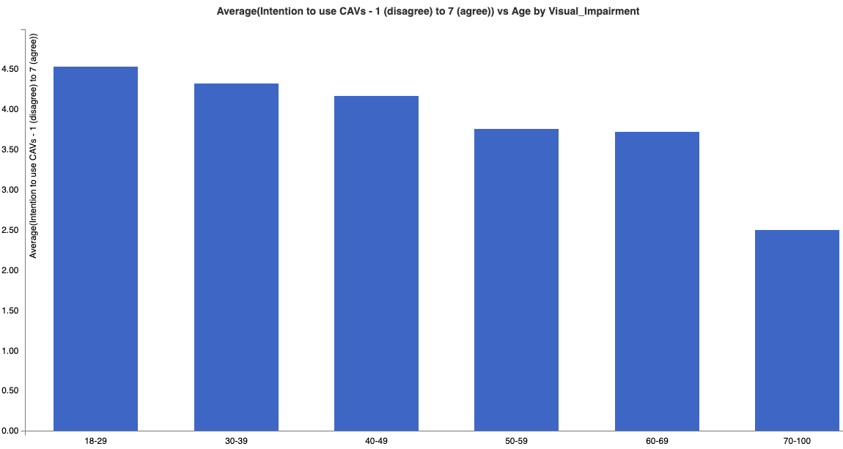
Figure 18 Relationship between age and intention to use CAVs in sighted people on a scale of 1-7.
Data for Figure 18 Relationship between age and intention to use CAVs in sighted people on a scale of 1-7.
Age | 18-29 | 30-39 | 40-49 | 50-59 | 60-69 | 70-100
Totals | 4.51 | 4.35 | 4.17 | 3.8 | 3.77 | 2.5

Note: Left to right, ages read: 18-29; 30-39; 40-49; 50-59; 60-69;70-100.
Among visually impaired people, there seems to be no clear trends between age and intention to use CAVs. Thus, the 18-29 and 40-49 age groups are the ones who declared the lowest intention to use CAVs, while the 30-39 and 60-69 age groups are the ones who obtained the highest intention to use scores.

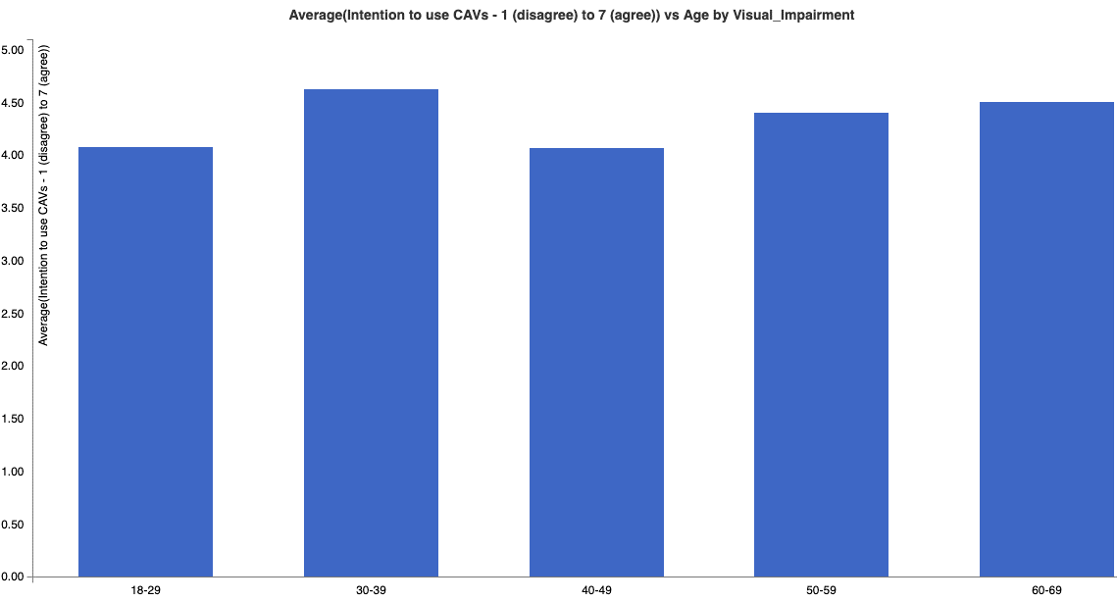
Figure 19 Relationship between age and intention to use CAVs in visually impaired people on a scale of 1-7.
Note: Left to right, ages read: 18-29; 30-39; 40-49; 50-59; 60-69;70-100.

Data for Figure 19 Relationship between age and intention to use CAVs in visually impaired people on a scale of 1-7.
Age | 18-29 | 30-39 | 40-49 | 50-59 | 60-69 | Totals
Totals | 4.08 | 4.63 | 4.07 | 4.41 | 4.51 | 4.35

Comparing the responses of visually impaired and sighted people by age group, we can observe overall that visually impaired people have a higher intention to use CAVs than sighted people (age groups 30-39, 50-59 and 60-69). Only younger, sighted respondents (18-29) have a higher intention to use than the visually impaired. The results for 40-49 are quite similar, with a slightly increased willingness to use by sighted participants.
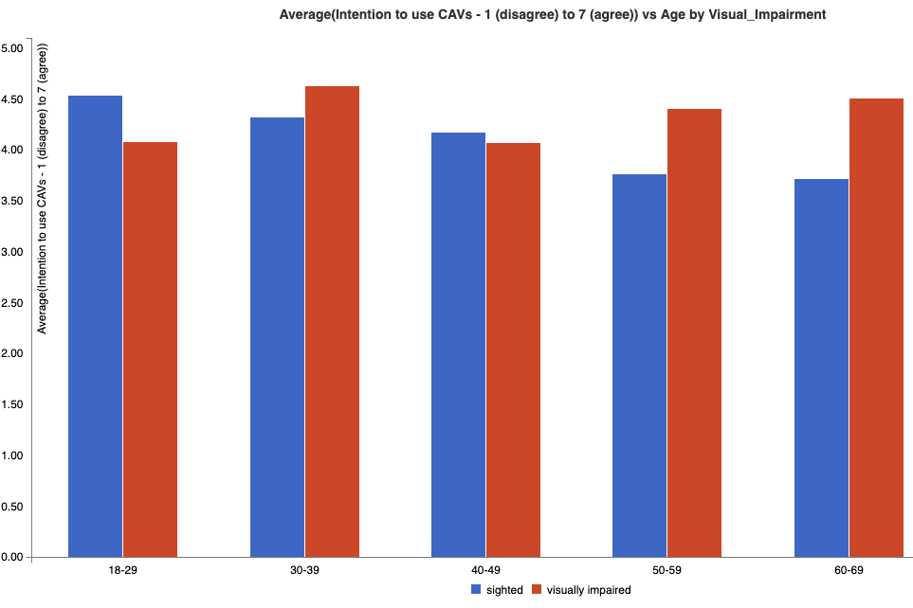
Figure 20 Relationship between age and intention to use CAVs in sighted people and visually impaired on a scale of 1-7.
Note: Left to right, ages read: 18-29; 30-39; 40-49; 50-59; 60-69.
Data for Figure 20 Relationship between age and intention to use CAVs in sighted people and visually impaired on a scale of 1-7.
Visual  Impairment | 18-29 | 30-39 | 40-49 | 50-59 | 60-69 | 70-100 | Totals
sighted | 4.54 | 4.33 | 4.17 | 3.76 | 3.72 | 2.5 | 4.11
visually impaired | 4.08 | 4.63 | 4.07 | 4.41 | 4.51 |  | 4.35
Totals | 4.51 | 4.35 | 4.17 | 3.8 | 3.77 | 2.5 | 4.12

Across all ages, visually impaired people have a slightly descriptively higher intention to use than sighted people, see Figure 21 below.

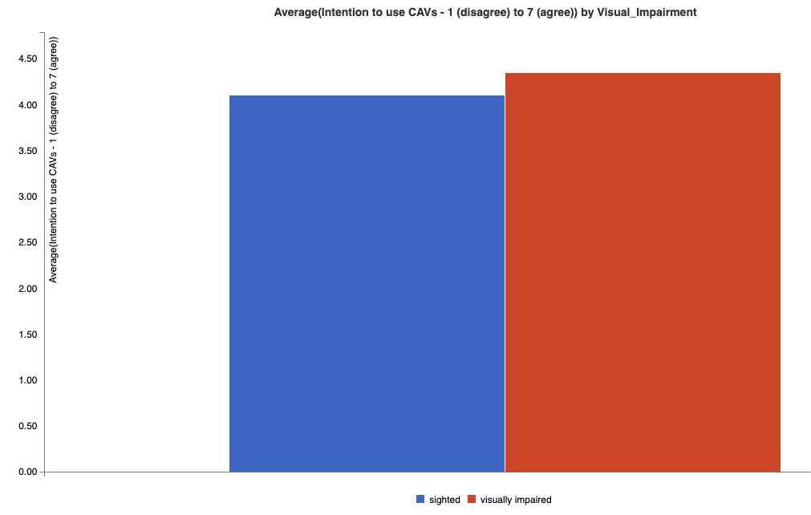
Figure 21 Intention to use CAVs in sighted people and visually impaired on a scale of 1-7.
Note: Left to right: sighted; visually impaired.
Data for Figure 21 Intention to use CAVs in sighted people and visually impaired on a scale of 1-7.
Visual_Impairment | Totals
sighted | 4.11
visually impaired | 4.35
Totals | 4.12

Public transport usage and intention to use CAVs
If we look at the intention to use CAVs in relation to the current use of public transport, we can observe that intentions are stronger among sighted people who use public transport, compared to those who do not. On the other hand, among visually impaired people, the intentions of use are almost identical. Thus, for this citizen category, the use or non-use of public transport seems not to relate much with the intention to use CAVs.

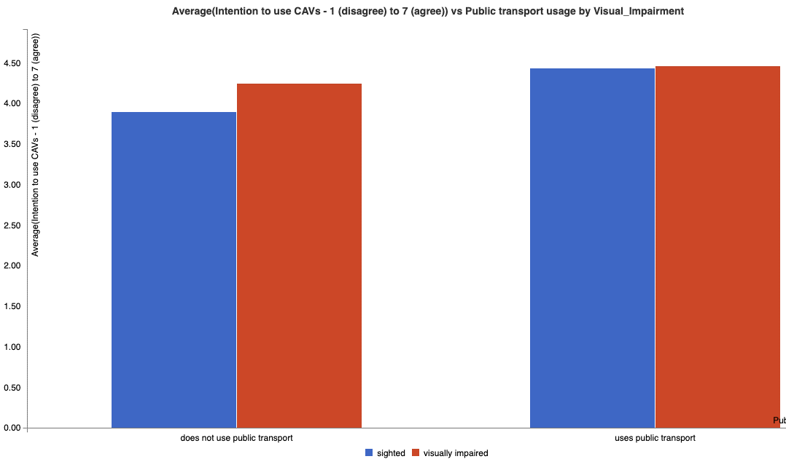
Figure 22 Intention to use CAVs in sighted people and visually impaired, according to the use of public transport on a scale of 1-7.
Note: Left to right, does not use public transport; uses public transport (blue: sighted, red: visually impaired).
Data for Figure 22 Intention to use CAVs in sighted people and visually impaired, according to the use of public transport on a scale of 1-7.
Visual_Impairment/Public transport usage | does not use public transport | uses public transport | Totals
sighted | 3.9 | 4.44 | 4.11
visually impaired | 4.25 | 4.47 | 4.35
Totals | 3.92 | 4.44 | 4.12

Age and perceived independence
If we look at the perceived independence as a consequence of using CAVs, split by age, we notice first that among sighted people, the feeling of independence that can be gained by the introduction of CAVs is similar to the downwards trend one can observe in the intention to use CAVs. On the other hand, among visually impaired people, there is a high expectation of independence in the 30-39 age group. The other age groups have similar scores to those of sighted persons.

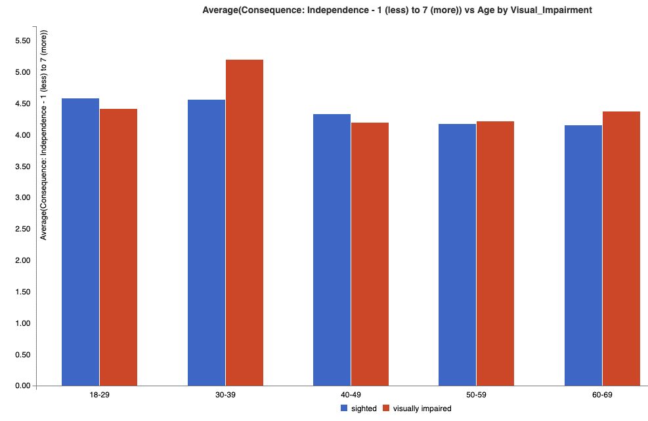
Figure 23 Perceived independence and age group in sighted people and visually impaired people on a scale of 1-7.
Note: Left to right, 18-29; 30-39; 40-49; 50-59; 60-69. (blue: sighted, red: visually impaired).
Data for Figure 23 Perceived independence and age group in sighted people and visually impaired people on a scale of 1-7.
Visual_Impairment/Age | 18-29 | 30-39 | 40-49 | 50-59 | 60-69 | 70-100 | Totals
sighted | 4.59 | 4.57 | 4.34 | 4.18 | 4.16 | 3.42 | 4.37
visually impaired | 4.42 | 5.21 | 4.2 | 4.22 | 4.38 |  | 4.51
Totals | 4.58 | 4.61 | 4.33 | 4.18 | 4.18 | 3.42 | 4.38

Individual mobility behaviour
This section provides a literature review, as well as findings from the survey with the aim to examine the influence of individual mobility behaviours and patterns (e.g. car ownership, car sharing patterns, pedestrians) on CAV acceptance. It is expected that with the introduction of a new technology, people with different mobility behaviour pre-introduction might accept and expect different consequences. Section 3.1.1 provides a literature review of the individual mobility behaviours on CAV acceptance and Section 3.1.2 provides the results from the survey.

Literature overview
An individual mobility behaviour describes in which patterns and through which means of transport individuals move within a network on a frequent basis. It is necessary to analyse mobility behaviour on an individual basis and in an explanatory approach, in order to initiate transition processes at the user level and to introduce innovative mobility solutions, such as the integration of CAVs in the transport network. Socio-psychological explanatory models (Seebauer, 2011) are used to analyse the influence of attitudes, perceptions, norms and values ​​on the mobility behaviour of individuals (Mobility Transition, 2020).
The individual mobility behaviour depends on a variety of influencing factors, such as:
- Characteristics related to the trip (e.g., the time of the day, purpose of the trip and its length);
- Attributes of each mode of transportation and the number of options available for the user (e.g., monetary costs, consistency & predictability of travel times, parking availability, walking distance, waiting time, frequency, number of changes, the level of satisfaction, comfort and security).
Beyond trip and travel factors, other aspects such as socio-economic and demographic characteristics of the travellers influence mobility behaviour, including:
- Income, car or bike ownership, gender, age, social status and environmental and health consciousness;
- Past experiences with a mode of transport, transport and land-use policies, urban sprawl, subsidies, car use restrictions, public transport infrastructure, and level of service or public transport systems;
- Weather and seasonal conditions (e.g., rain and snow play a role on whether a person chooses to drive instead of using the bus, the bike or walk).
All these factors determine the cost incurred by travellers when selecting a mode of transportation. Car or public transport ridership is driven by the users’ perceived cost. One study analysed of the car-based mobility of a city from the perspective of emergent behaviours of individuals who choose to commute using either a car or anything else, including public transport, cycling and walking (Prieto et al., 2021). The interaction between drivers and public transport users, and among themselves, is quantified as direct or induced costs and measured as commuting time. Travellers choose the mode of transportation, which is minimising their travel cost. However, they also induce a cost to the rest of the travellers (marginal social costs), especially through travel time. This can be explained by the fact that an additional car on the road implies a reduction of the speed and thus higher congestion and travel times for the rest of the users on both car and public transport. The same case implies when an extra user in a saturated public transport induces a cost to the rest of the travellers, for example, by longer alighting times and the need for more vehicles and infrastructure that reduce the speed on the roads.
When travellers’ choices are considered altogether during a period of time, a collective behaviour emerges. When all individuals in a city decide to drive a private car, the probability of traffic jams and overall congestion increases, and there is a lack of parking spaces, both effects create enormous costs for everyone. Some people will explore their opportunities and decide to walk, cycle or try public transport instead and reducing their own cost. More users might choose to walk or cycle as they notice that other users experience fewer costs that way, and so more cyclists or public transport users are expected as some replicator dynamics. Yet, they impose now a cost on other walkers, cyclists or public transport users for example with more public transport users, queues and delays might become more frequent, and rush hours become less comfortable (Prieto et al., 2021).
To avoid road congestion, CAVs can be introduced. Trommer et al. (2016) evaluate how self-driving cars might impact people’s travel behaviour and their choice of transportation mode. When analysing potential changes in mobility behaviour by autonomous driving, they identified these influencing areas:

Use cases and business models
Use cases at lower automation levels (especially level 1-2), where the driver still has to pay attention to the traffic and intervene, are not expected to change mobility behaviour significantly. However, higher levels of automation (level 3-4), which enable fully autonomous driving in certain situations, have the potential to change users’ mode preferences for certain trips. The highest level of automation (level 5), which enables zero-occupant and fully autonomous trips, might lead to new business models offering services similar to a taxi (known as ‘autonomous vehicle on- demand’) at costs lower than those of today’s car-sharing services, and might therefore have the greatest impact on mobility behaviour.

Generalised costs of travel and value of time
Autonomous driving might change the generalised costs of driving, especially the value of travel time, and thus also change users’ mobility patterns. CAVs can reduce the value of time spent on trips by car, since they enable people to undertake other activities while travelling. People might prefer driving autonomously to using other modes of transport, and also choose to take more trips or travel longer distances, which is especially relevant for commuting trips or longer travel. Further expected changes could be reduced access times, a reduction in the overall travel time, and the lowering of variable costs for privately owned vehicles. In addition, autonomous vehicle on-demand services might significantly reduce car-use costs by reducing operating costs for the provider of such services.
Changing travel modality and mobility behaviour implies modifying practices depending on social conditions or circumstances upon which users’ mobility is affected. Transition from car dependency is likely to involve new expectations about the conduct of everyday life (Shove and Walker, 2010) and the possibilities to carry out daily life through alternative forms of transport. There is still a raising need for understanding the everyday circumstances and conditions in which new technological services or products like CAVs are deployed and used (Sopjani et al. 2020).

Survey results
Out of the 4,858 panel participants, 4,200 participants (86.45%) owned a motorised vehicle. The highest number of vehicles were owned by 911 participants (18.75%) aged between 50-59. Only 658 out of 4,858 panel participants did not own a vehicle. Most of them were aged between 18-29.

Table 3 Absolute number of participants owning a car vs absolute number of participants not owning a car, classified by age on a scale of 1-7.
Car ownership | 18-29 | 30-39 | 40-49 | 50-59 | 60-69 | 70-100 | Totals
motorized | 811 | 833 | 870 | 911 | 765 | 10 | 4.200
pedestrian | 156 | 118 | 125 | 141 | 118 |  | 658
Totals | 967 | 951 | 995 | 1.052 | 883 | 10 | 4.858

Having a look at the figure/table below, it can be stated that especially younger participants aged between 18-29 were more willing to use CAVs. There was only a very slight difference between the participants owning a car or not. The higher their ages, the less people intended to use CAVs in the future. Especially elderly people aged from 50 to 69 and over 70 seemed to have a low intention to use CAVs.
Table 4 Intention to use CAVs by car ownership and age on a scale of 1-7.
Car ownership | 18-29 | 30-39 | 40-49 | 50-59 | 60-69 | 70-100 | Totals
motorized | 4.50 | 4.33 | 4.18 | 3.84 | 3.76 | 2.50 | 4.12
pedestrian | 4.55 | 4.46 | 4.07 | 3.60 | 3.83 |  | 4.13
Totals | 4.51 | 4.35 | 4.17 | 3.80 | 3.77 | 2.50 | 4.12

The following graphs show the intention to use CAVs depending on the current transport mode usage. The different transport mode patterns include public transport, car sharing and ride hailing.
For the three different modes, the intention to use a CAV was the highest for citizens who owned (motorized, blue) a vehicle while at the same time being a user of either public transport, car sharing or ride hailing services. The intention to use a CAV was the lowest for participants who did not own a vehicle and did not use public transport.
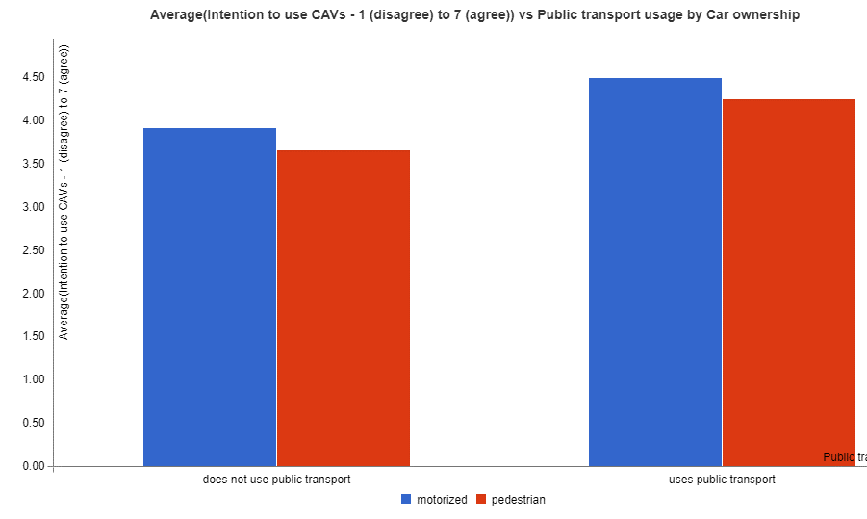
Figure 24 Intention to use CAVs vs public transport usage by car ownership on a scale of 1-7.
Note: Left to right, does not use public transport; uses public transport (blue: motorized, red: pedestrian).
Data for Figure 24 Intention to use CAVs vs public transport usage by car ownership on a scale of 1-7.
Car ownership | does not use public transport | uses public transport | Totals
motorized | 3.93 | 4.51 | 4.12
pedestrian | 3.67 | 4.27 | 4.13
Totals | 3.92 | 4.44 | 4.12

Similarly, the intention to use a CAV was the highest for participants owning a vehicle and using car sharing services, while it was similarly low for participants that did not use car sharing at all.
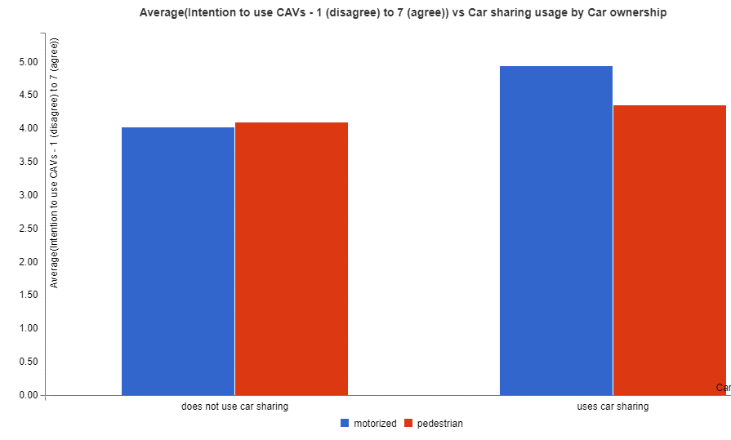
Figure 25 Intention to use CAVs vs car sharing usage by car ownership on a scale of 1-7.
Note: Left to right, does not use car sharing; uses car sharing (blue: motorized, red: pedestrian).
Data for Figure 25 Intention to use CAVs vs car sharing usage by car ownership on a scale of 1-7.
Car ownership | does not use car sharing | uses car sharing | Totals
motorized | 4.04 | 4.95 | 4.12
pedestrian | 4.1 | 4.36 | 4.13
Totals | 4.05 | 4.86 | 4.12

In case of ride hailing, the lowest intention to use CAVs has been reported from participants who never used ride hailing services, while higher intention to use could be observed for participants who were motorised but did use ride hailing services.

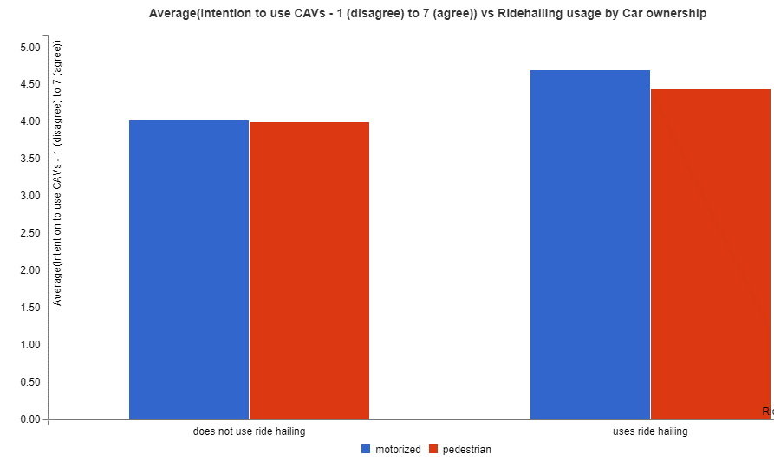
Figure 26 Intention to use CAVs vs ride hailing usage by car ownership on a scale of 1-7.
Note: Left to right, does not use ride hailing; uses ride hailing (blue: motorized, red: pedestrian).
Data for Figure 26 Intention to use CAVs vs ride hailing usage by car ownership on a scale of 1-7.
Car ownership | does not use ride hailing | uses ride hailing | Totals
motorized | 4.03 | 4.7 | 4.12
pedestrian | 4.01 | 4.45 | 4.13
Totals | 4.03 | 4.64 | 4.12

If we look at the perceived affordability of CAVs, according to age and car ownership, it can be noticed that people not owning a vehicle, see the usage of CAVs as slightly less affordable. Considering the age, the perceived affordability can be descriptively observed as decreasing by age, especially for participants owning a vehicle. Participants aged between 40-49 and not owing a vehicle had the least perceived affordability.
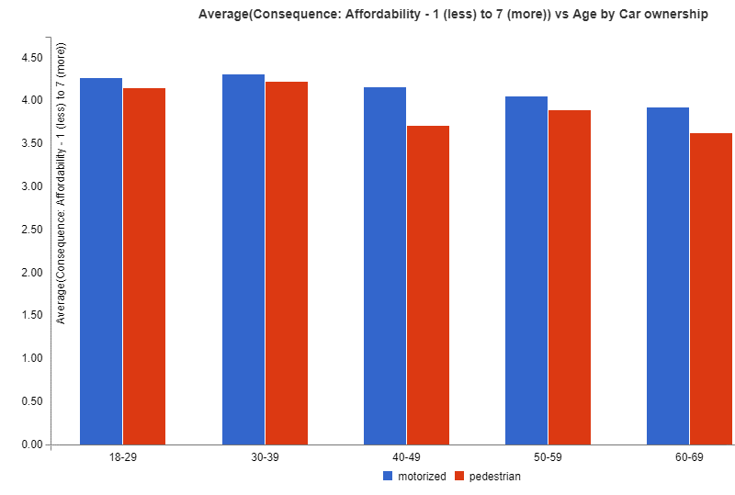
Figure 27 Perceived affordability for participants owning/not owning a car by age on a scale of 1-7.
Note: Left to right, 18-29; 30-39; 40-49; 50-59; 60-69. (blue: motorized, red: pedestrian).

Data for Figure 27 Perceived affordability for participants owning/not owning a car by age on a scale of 1-7.
CAV mode | Car ownership | 18-29 | 30-39 | 40-49 | 50-59 | 60-69 | Totals
motorized | owned cars | 4.28 | 4.32 | 4.16 | 4.06 | 3.94 | 4.15
pedestrian | owned cars | 4.16 | 4.23 | 3.72 | 3.9 | 3.63 | 3.95
Totals |  | 4.26 | 4.31 | 4.11 | 4.04 | 3.9 | 4.12

Looking at the expected efficiency of CAVs, motorized participants reported expecting CAVs to be less efficient in terms of time spent on the road and speed of travel overall. Participants that described themselves as pedestrians had higher efficiency expectations, but mostly when they were younger, or over 60 years of age.
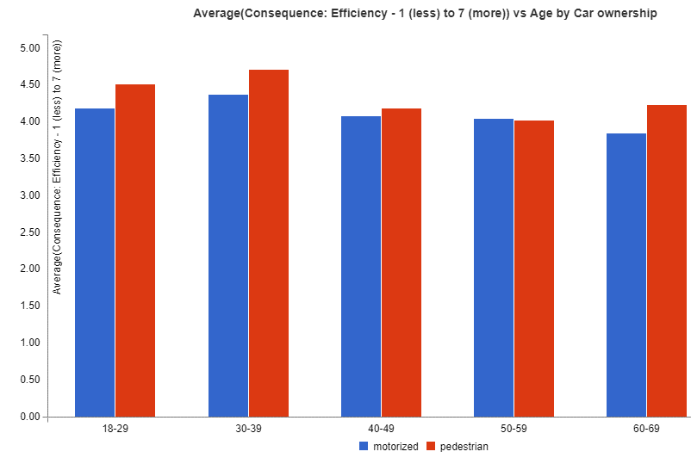
Figure 28 Perceived efficiency for participants owning/not owning a car by age on a scale of 1-7.
Note: Left to right, 18-29; 30-39; 40-49; 50-59; 60-69. (blue: motorized, red: pedestrian).

Data for Figure 28 Perceived efficiency for participants owning/not owning a car by age on a scale of 1-7
Car ownership | CAV mode | 18-29 | 30-39 | 40-49 | 50-59 | 60-69 | Totals
motorized | owned cars | 4.19 | 4.38 | 4.09 | 4.05 | 3.86 | 4.12
pedestrian | owned cars | 4.52 | 4.72 | 4.19 | 4.03 | 4.24 | 4.34
Totals |  | 4.25 | 4.42 | 4.1 | 4.05 | 3.9 | 4.15

To conclude, only small differences can be observed between participants that own a car and those who don’t. With increasing age, more participants owned a vehicle and their intention to use CAVs in the future decreased. The participants using public transport and mobility solutions like car sharing and ride hailing seemed to be more open to use CAVs in the future, even if they owned a vehicle.
The mobility behaviour of each person is very dependent on the affordability and efficiency of the transport mode. Affordability seems to play a role especially for younger people. Participants who did not own a car, saw CAVs as less affordable than participants that did own a car. In terms of efficiency, pedestrian participants aged between 30-39, did see CAVs as most efficient, expecting that the usage of CAVs could shorten travel time.
Users’ mobility behaviour might change, especially when the generalized costs of driving, i.e. affordability and travel time are changed by the usage of CAVs. If people own a CAV in the future, it could reduce the value of time spent on trips. People might prefer driving autonomously to using other modes of transport, and also choose to take more trips or travel longer distances, which is especially relevant for commuting trips or long travel. In addition, autonomous vehicle on-demand services, like ride-hailing, might significantly reduce car-usage costs.

CAV Acceptance and geographical differences

Literature overview
Among the factors influencing the acceptance of CAVs, the country of origin plays an important role and has been studied in several surveys. In this section we differentiate between two levels of analysis. The first level focuses on the capacity of the country to adopt CAVs, in terms of its infrastructure, technological advances, policy and legislation, and publications that relate geographic location with CAV acceptance of citizens. The second level focuses on the citizens' opinion of CAVs as assessed with our survey, and in particular their perceived interest in them, and the expectations they have of them.

CAV adoption capacities
In a paper published in IEEE Potentials, a synthesis on the social acceptance of CAVs (Kurniawan et al., 2021) refer to KPMG's ranking of the 10 most advanced countries in the implementation of CAVs (Threlfall, 2019). This commercial report considers a variety of factors to be important for readiness for CAV introduction, which are:
- Policy and legislation;
- Technology and innovation;
- Infrastructure;
- Consumer acceptance.
In this report, the authors rank Singapore first, ahead of The Netherlands, in terms of overall AV readiness. Singapore is also reported to rank first in terms of its policy, legislation and consumer acceptance.
Some country-specific factors can be identified that enable autonomous mobility. A case study was conducted to assess the readiness of nine countries for the advent of autonomous vehicles: Australia, Brazil, China, Germany, Japan, Singapore, South Africa, United Arab Emirates and the United States. Several rankings were established, according to the following criteria: Consumer acceptance, Legislation, Infrastructure investment, Ecosystem, Integrity of Technology (Theoto & Kaminski, 2019).
The top four countries, namely Singapore, Germany, Japan and the United States, are reported in this mapping to be the first countries to be ready to host autonomous mobility. However, due to its small size, and the government's centralized efforts towards a "Smart Nation", Singapore's pace towards autonomous mobility is reported to be faster than all other countries. Germany, Japan and the United States are discussed to be taking greater advantage of their technical capabilities, advanced infrastructure and industrial development-oriented governments to lead a migration to CAVs, not only in their countries, but also globally.

Interest in and expectations of CAVs
So far, many studies on CAV acceptance have been conducted with participants of one country of residence only, or they included a random sample from multiple English-speaking countries. As an example, English-speaking countries were reported in 38 out of 43 surveys listed by the literature review by Gkartzonikas and Gkritza (2019), 14 out of 16 of the surveys reviewed by Becker and Axhausen (2017), and all studies focusing on behavioural intentions reviewed by Keszey (2020).
Often, in prominent literature reviews or meta-analyses, country of residence is not reported (Faisal et al., 2019, Golbabaei et al., 2020, Milakis et al., 2017, Nordhoff et al., 2019).
Some studies, who take place outside of the EU and the US, have shown differences in citizens' perceptions and acceptance between countries. In a survey of six major countries that could be strongly impacted by CAVs (China, Japan, India, the United States of America, the United Kingdom and Australia), Schoettle and Sivak (2014) showed, for example, that opinions on the ability of CAVs to better manage traffic and decongest roads are very divergent from one country to another. Thus, residents from India were reportedly optimistic (72.3% of respondents in this survey believe that CAVs will have a positive impact on traffic congestion), while the British were much more sceptical (47.3% of respondents have positive expectations), as were the Japanese (55.9%), Americans (49.7%) and Australians (47.5%) (Schoettle & Sivak, 2014).
In general, the authors reported that positive opinions were more frequent in China and India than in Japan and the United Kingdom. It is interesting to note that the countries whose respondents had already heard about CAVs were also those whose opinions were the most positive, and vice versa. Thus, it is likely that citizens' fears stem from a lack of information and communication about CAV technologies.
Another study, (Yun et al., 2021) investigated the relationship between cross-cultural differences and public opinion on automated vehicles. Six countries were selected for this survey: China, India, Japan, the United States, the United Kingdom and Australia. Using this data, the influence of cross-cultural differences in public opinion was identified, and statistical models for predicting public opinion on autonomous vehicles were developed. The results of this study indicate that most Chinese and Indian citizens reported having concerns particularly about safety and legal liability differently from Japanese citizens. Also, participants from Autralia, UK and US reported far less concerns about data privacy and security than their counterparts in China and India. On the other hand, Chinese participants indicated the highest willingness to pay extra for CAVs, while the UK and Japan had the lowest.
Previous other studies had studied country-level differences in acceptance in order to predict the effects of GDP and developmental indexes (Kyriakidis et al., 2015, Nordhoff et al., 2018). This study (across 43 countries with 25 or more respondents), for example, found that there was a positive relationship between the GDP per capita of the respondents’ country and the countries’ mean general acceptance score. The authors argued that this might be due to the correlation between lower-income countries’ citizens being less supporting of car-free environments and less comfortable with technology.

Survey results
Examining the averages of the ratings obtained from the survey data for the various indicators of CAV acceptance such as safety, privacy, sustainability, independence, efficiency, affordability, ease of use and intention to use, it was found that a significant variation in mean ratings was obtained for safety, privacy, sustainability and independence.
Figure 29 provides the variation in mean ratings for safety and privacy across the different countries. It was found that respondents in Hungary and Italy thought that CAVs could improve safety more highly than respondents in Austria, Spain and the UK. In case of privacy, respondents in Austria, France, Germany and Spain gave a lower rating where their expectations for privacy were concerned, compared to respondents in Hungary, Portugal and the UK.

Figure 29 Variation in mean ratings for safety and privacy across different countries on a scale of 1-7.
Data for Figure 29 Variation in mean ratings for safety and privacy across different countries on a scale of 1-7.
 | Austria | Belgium | France | Germany | Hungary | Italy | Portugal | Spain | UK
Safety | 4.27 | 4.41 | 4.39 | 4.36 | 5.08 | 5.02 | 4.66 | 4.43 | 4.11
Privacy | 2.76 | 3.09 | 2.87 | 3 | 3.69 | 3.59 | 3.74 | 3.12 | 3.48

In case of variation in perception towards improvement in sustainability and independence from CAVs, it was found that respondents in France, Hungary, Italy and Portugal considered the CAVs to improve sustainability.
Respondents in Austria, Belgium, France and Germany gave a lower mean rating for independence arising from CAVs while respondents from Portugal gave a considerably higher mean rating for independence from CAVs. A marked difference is thus found in the mean ratings obtained for independence from CAVs in the various countries. Figure 30 provides the ratings obtained for sustainability and independence from CAVs.

Figure 30 Variation in mean ratings for sustainability and independence across different countries on a scale of 1-7.
Data for Figure 30 Variation in mean ratings for sustainability and independence across different countries on a scale of 1-7.
 | Austria | Belgium | France | Germany | Hungary | Italy | Portugal | Spain | UK
Sustainability | 4.21 | 4.52 | 4.74 | 4.51 | 4.82 | 4.84 | 4.8 | 4.68 | 4.71
Independence | 4.22 | 4.24 | 4.26 | 4.28 | 4.42 | 4.55 | 4.91 | 4.46 | 4.35

In case of efficiency and affordability of CAVs, it was found that the mean ratings across the different countries was not markedly different for these indicators. However, Hungary and Portugal showed a slightly higher mean ratings for efficiency from CAVs while Italy and Portugal showed higher ratings for affordability of CAVs.
Ease of use and intention to use CAVs was found to vary across the different countries. Belgium provided a relatively lower mean ratings for ease of use and intention to use CAVs while Portugal provided higher mean ratings for both these indicators, followed by Italy and Spain. Figure 31 provides the mean ratings for ease of use and intention to use CAVs across the different countries.

Figure 31 Variation in mean ratings for ease of use and intention to use CAVs on a scale of 1-7.
Data for Figure 31 Variation in mean ratings for ease of use and intention to use CAVs on a scale of 1-7.
 | Austria | Belgium | France | Germany | Hungary | Italy | Portugal | Spain | UK
Ease of use | 4.37 | 3.45 | 4.12 | 4.09 | 4.54 | 4.57 | 4.83 | 4.6 | 4.1
Intention to use CAVs | 3.9 | 3.61 | 3.98 | 3.86 | 4.44 | 4.56 | 4.81 | 4.34 | 4.01

In summary, Hungary, Italy and Portugal provided a relatively higher mean ratings for safety, sustainability and efficiency as well as affordability, ease of use and intention to use CAVs. Portugal showed a markedly high mean ratings for independence and affordability from CAVs. Austria, France and Germany showed a lower average rating in case of privacy and independence and also, Austria and Germany showed a lower mean rating for sustainability arising from CAVs. Belgium showed a lower mean rating than other countries in case of ease of use of CAVs.

CAV Acceptance and mobility solutions
This section provides a literature review as well as findings from the survey, examining and comparing three different types of CAVs: privately owned, shared and publicly available vehicles. It can be expected that the ownership mode of CAVs has a large impact on public acceptance, exposure and concerns of these technologies. Further, it is interesting to explore possible modal shifts between ownership modes to anticipate the eventual percentage of persons who would be willing to switch from private ownership of traditional cars to shared and more efficient, safe and sustainable modes of transport. Section 5.1 provides a literature review of private, shared and public CAV acceptance depending on the ownership respectively and section 5.2 provides the results from the survey, containing some conclusions respectively.

Literature overview
The general public’s perception and acceptance of CAV technologies will heavily impact such attributes as travel demand, travel behaviour, transport network performance, sustainability of mobility and the overall transport and mobility market (Hyland & Mahmassani, 2017). At this point in time, there is an overall consensus in research that optimised transport systems consisting mainly of CAVs would lead to higher levels of efficiency, improved safety conditions and decreased emission of greenhouse gases. Large differences however, can be expected depending on the ownerships and rights of usage of these vehicles. In general, it is possible to differentiate between three types of ownerships:

Figure 32 - Ownership categories for CAVs
Private CAVs | Shared CAVs | Public CAVs
- Owned by households or individual persons  - Purchased or leased  - For private use only as drivers | - Owned by company or private person  - Rented out on the base of time or distance  - For private or company use (in fleets) as drivers | - Owned by public body  - Pay-per-use or forfeits  - Usable by anyone as passengers

While each of these ownership categories holds their own external benefits and conditions, among many more factors for example perceived value of travel time (VOT), income, average vehicle kilometres travelled (VKT), availability of alternatives or comfort, the deployment of CAVs can be expected to serve especially current non-drivers and underserved population groups. This is due to reduced operational cost, shorter travel times, adjusted and optimised parking behaviour and overall increase of comfort, leading to a direct increase in VKT (Wadud et al., 2016).
In order to be able to determine the potential impact of different kinds of CAV ownership categories, it can be useful to make use of a combination of activity-based modelling (ABM) and traffic simulation software to examine the VKT within a complex and mixed transport environment given a predetermined share of CAVs within the system in comparison to a baseline scenario without CAVs (Bansal & Kockelman, 2018). Important KPIs which give an idea of the effectiveness of private, shared and public CAVs are the average speed of vehicles, their density, flow rate and vehicle trajectories (all per individual trip) since these factors change drastically, depending on the share and availability of CAVs within the system (J. Auld et al., 2016).

Privately Owned CAVs
In the case of privately owner CAVs, special attention needs to be paid to the willingness to pay (WTP) of citizens, which could be interpreted as a measure of CAV acceptance, as well as their socio-economic background. It has been found that households whose willingness to pay for a privately owned vehicle is higher will also adopt private CAVs faster (Sharma & Mishra, 2020).
Another study has found that the more connected or autonomous features a vehicle contains, the higher its price is, which is directly correlated with the willingness to pay (Bansal & Kockelman, 2018).
Additionally, a simulation for the Chicago metropolitan area compared the hypothetical reduction of value of travel time (VOT) and the share of level 4 CAVs:

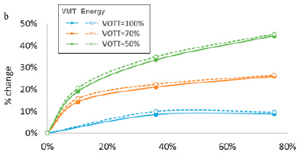
Figure 33 - Simulation results (change in VKT and energy) by penetration and VOT change (Source: Auld et al.)
In worst-case scenarios, the consumption of fuel is increased by 21-43%, while VOT are reduced by approximately 50% under the assumption that marginal cost of the technology transfer will be low (J. Auld et al., 2018).
Still, some surveys have led to the interpretation that most private households will prefer to own a CAV due to increased convenience and comfort of the availability of the vehicle (Litman, 2021).

Shared CAVs
Shared CAVs consist usually of fleets, which can be used either by the general public as a commercial service, such as services like car2go or TIER or by a pre-determined pool of users such as company employees. Today, experts have still not agreed on whether shared fleet offerings reduce the share of vehicle ownership or simply acts as an addition to owned vehicles.
The environmental impacts of shared CAVs depend largely on their ability to entice drivers of traditional vehicles to switch to more sustainable shared CAV fleet usage. Since most CAVs today and in the future will be electric vehicles, increased travel demand would not lead to increased emissions due to fuel or to contamination, at least due to exhaust gases. Enhanced driver comfort, simplified parking options and accessibility to non-drivers might support the aim of nudging drivers of private non-CAVs to turn to CAV fleets (Axsen & Sovacool, 2019).
It can be expected however, that the operational cost of shared CAVs will be higher than in conventional vehicles but still below the cost of human-operated services. Their cost will be approximately the same as public CAVs (Litman, 2021).
The efficiency of shared CAV fleets is expected to be far more efficient for the overall transport system than privately owned CAVs. This is because they are expected to reduce the overall occupancy, congestion and parking needs within the transport system (between 8% and 74% of traffic in cities is search traffic for a parking spot) (Rask et al., 2020; Shoup, 2006).
Finally, a high percentage of shared vehicles in mixed traffic tends to be more efficient overall with lower overall congestion, empty travel miles and energy use compared to scenarios with private vehicle ownership, which directly impacts the acceptance of shared CAV fleets.
The prevailing trend toward greater automation and connectivity requires modelling and analysis tools to explore connectivity, automation, decision science and other future mobility issues at multiple scales. One example paper describes various modelling efforts in order to model the mobility and energy impact of autonomous and connected technologies (J. A. Auld et al., 2019).
A major paper on shared autonomous vehicles has been published (Narayanan et al., 2020) that has made a first review of all published literature on shared mobility, and created a mapping of foreseen impacts, which are categorised in this paper into seven groups: (i) Traffic & Safety, (ii) Travel behaviour, (iii) Economy, (iv) Transport supply, (v) Land–use, (vi) Environment & (vii) Governance. They also review some numbers for shared autonomous vehicle usage, namely that some authors estimate that 40% of individuals at any time might be willing to use shared autonomous vehicles for most of their trips, while almost 80% would be willing to use them for about half of their trips. Private vehicles are expected to be the only viable transport option for about 16% of drivers. The author’s prediction is a penetration rate of less than 50% in the next 10–15 years. The authors also review some evidence that suggests that younger, students and educated citizens will be the early adopters, while wealthy, non-tech savvy and people from rural areas will be non–adopters.

Public CAVs
Public CAVs are all CAVs which are operated and offered by public bodies, such as city councils, transport authorities or public transport operators. Their offering is traditionally addressed towards non-drivers and their inherent comfort is low due to limited availability and approximated trajectory. Public vehicles are inherently more sustainable, since they carry a higher number of passengers, replacing private vehicles in traffic and therefore reduce zero occupancy miles, mitigating some of the increased VMT and energy consumption impacts (Rask et al., 2020). They also don’t require parking space within the urban sphere.
CAVs could allow to raise the convenience and comfort of public transport by offering custom schedules and trajectories – “mobility on demand”, which might be especially convincing for rural or suburban areas with low public transport operations (Rask et al., 2020).
In terms of acceptance, some evidence has been reported with regards to the introduction of autonomous busses. Kassens-Noor et al. (2020) reported that autonomous buses might increase willingness to use public transit. They found that out of those people who rarely use PT, 15% of would accept using autonomous bus services. Regular fixed-route riders were very likely to accept autonomous busses. For those used to public transport, the main concerns listed were reported to be concerns over safety, the fact that there would be no humans on board, and distrust in technology. In a study actually employing an autonomous shuttle bus to test its effect on individuals riding it, respondents were not very happy with the efficiency, in particular related to speed and space for luggage. However, overall, the autonomy of the shuttle was valued by passengers (Nordhoff et al., 2018). A review of the literature on this topic showcased similar ideas: concerns about service characteristics (times, schedules, fares) and safety issues (road-safety, on-board security) were reported to be most common, whereas comfort was not as important (Pigeon et al., 2021).

Conclusions
Each different kind of CAV ownership category offers its own set of advantages and disadvantages, whose impact also largely depends on the geography, demographics and existing availability of transport operations in any given area:

Table 5 CAV Ownership category advantages and disadvantages.
 | Private CAVs | Shared CAVs | Public CAVs
Advantages | - High comfort & convenience;  - Reduced emissions;  - Increased vehicle efficiency;  - Reduced value of travel time. | - Reduced cost;  - Increased system efficiency;  - Enhanced driver comfort;  - Improved parking options;  - Decrease of congestion;  - Accessible to non-drivers. | - Accessible to non-drivers;  - Incrased sustainability;  - Increased comfort through “mobility on demand”.
Disadvantages | - High purchasing & maintenance cost;  - Increased power consumption;  - No impact on congestion or limited parking offering. | - Increase in travel demand;  - Attractiveness to private CAV owners uncertain;  - Large investments by companies needed. | - Large investments by public bodies needed;  - Adaptation of PT operations required.

Overall, a mixture of shared and public CAV operations is probably more favourable for urban and city operations, while private CAVs are more suited to rural or suburban operations due to the different cost versus value ratio in both locations.
Furthermore, public subsidies of the purchase and operation of CAVs for all owners will have a large impact on the eventual composition of ownership categories. At the current moment, only companies or public operators are able to purchase and operate highly advanced CAVs, while only selected features are available at an affordable price to private owners.

Survey results

Privately Owned CAVs
When comparing the intention to use private CAVs across age groups, it should be noted that the younger the participants, the higher their overall acceptance of CAVs. One might assume from this that younger persons are more receptive to the new technologies and perceive them as an improvement of the current transport system rather than an obstacle.
Table 6 Intention to use private CAVs by age on a scale from 1-7.
CAV mode | 18-29 | 30-39 | 40-49 | 50-59 | 60-69 | 70-100 | Totals
owned cars | 4.51 | 4.35 | 4.17 | 3.8 | 3.77 | 2.5 | 4.12
Totals | 4.51 | 4.35 | 4.17 | 3.8 | 3.77 | 2.5 | 4.12

Once the dataset is split up by country (including Austria, Belgium, France, Germany, Hungary, Italy, Portugal, Spain and UK), geographic differences become visible, with Belgium, Germany, Austria and France being the least receptive to CAV technology today. On the other hand, many southern and eastern European countries like Portugal, Italy, Spain and Hungary seem to be more open to adopting private CAVs.
Table 7 Intention to use private CAVs by age and country on a scale from 1-7.
Country | 18-29 | 30-39 | 40-49 | 50-59 | 60-69 | 70-100 | Totals
Austria | 3.89 | 4.02 | 3.79 | 4.1 | 3.59 |  | 3.9
Belgium | 4.45 | 4.11 | 3.2 | 3.48 | 2.97 |  | 3.61
France | 4.53 | 4.03 | 4.00 | 3.69 | 3.62 |  | 3.98
Germany | 4.23 | 4.19 | 3.89 | 3.49 | 3.48 |  | 3.86
Hungary | 4.13 | 3.77 | 4.93 | 4.8 | 4.39 |  | 4.44
Italy | 4.65 | 4.68 | 4.8 | 4.34 | 4.44 | 2.67 | 4.56
Portugal | 5.01 | 5.08 | 4.67 | 4.38 | 4.85 |  | 4.81
Spain | 4.46 | 4.45 | 4.64 | 3.77 | 4.26 |  | 4.34
UK | 4.9 | 4.55 | 3.7 | 3.58 | 3.02 | 2.00 | 4.01
Totals | 4.51 | 4.35 | 4.17 | 3.8 | 3.77 | 2.5 | 4.12

Overall, the intention to adopt privately owned CAVs remains medium high with an average of 4.12 points only. This is probably linked also to the unclear legislative framework at the current moment and the opaque value and price of a private CAV today and in the future.

Shared CAVs
The same participants were also asked to report on their intention to use shared CAVs. It is interesting to note that the acceptance of shared CAVs is slightly lower (to be exact 0.5 points) than those of private CAVs due to reduced personal comfort and anxiety surrounding shared liability for costly vehicles and infrastructure.
Table 8 Intention to use shared CAVs by age on a scale from 1-7.
CAV mode | 18-29 | 30-39 | 40-49 | 50-59 | 60-69 | 70-100 | Totals
shared cars | 4.2 | 4.05 | 3.69 | 3.46 | 3.09 | 3.42 | 3.7

The comparison across countries reveals that shared CAVs do not have a large impact on the geographical gap between countries overall – with the exception of Austrian users, who reported being much more receptive to shared CAVs than private CAVs almost all other other countries show the same divide between southern-eastern European countries vs. northern-western European countries.
Table 9 Intention to use shared CAVs by age and country on a scale from 1-7.
Country | 18-29 | 30-39 | 40-49 | 50-59 | 60-69 | 70-100 | Totals
Austria | 4.07 | 4.39 | 3.84 | 3.42 | 3.30 |  | 3.86
Belgium | 3.66 | 4.25 | 3.39 | 3.04 | 3.14 | 1.75 | 3.52
France | 4.00 | 3.89 | 3.46 | 3.26 | 3.36 |  | 3.60
Germany | 4.31 | 3.81 | 3.69 | 3.35 | 2.80 | 1.75 | 3.55
Hungary | 4.04 | 4.71 | 3.72 | 4.35 | 4.61 |  | 4.28
Italy | 4.71 | 4.34 | 3.88 | 3.91 | 3.55 | 4.25 | 4.06
Portugal | 4.47 | 3.92 | 4.06 | 3.55 | 3.74 |  | 3.96
Spain | 3.85 | 3.86 | 3.95 | 3.48 | 2.82 |  | 3.63
UK | 4.25 | 4.06 | 3.37 | 3.16 | 2.49 |  | 3.50
Totals | 4.20 | 4.05 | 3.69 | 3.46 | 3.09 | 3.42 | 3.70

Another key aspect is the willingness of users to pay and perceived affordability according to the usage mode of CAV, which shows that the participants are more keen to pay for shared CAVs than private CAVs. Also, the willingness to pay decreases with age – which could mean that older persons expect to receive less useful services for their needs from investments into CAV technology and will probably not profit directly from future CAV technologies by investing in them today.
Table 10 Perceived affordability of private vs. shared CAVs by age on a scale from 1-7.
CAV mode | 18-29 | 30-39 | 40-49 | 50-59 | 60-69 | 70-100 | Totals
owned cars | 4.26 | 4.31 | 4.11 | 4.04 | 3.9 | 3.63 | 4.12
shared cars | 4.62 | 4.47 | 4.49 | 4.59 | 4.23 | 4.25 | 4.49
Totals | 4.44 | 4.39 | 4.3 | 4.33 | 4.06 | 4 | 4.31

Overall, the differences between the acceptance of private and shared CAVs does not vary a lot, the average for both types of CAVs lies at 4.3 points, indicating a medium high willingness to adopt these technologies in the near future.

Public CAVs
Since the survey, whose data we are analysing did not ask users of their perception of public CAVs concretely, and since they can be both private (for example as a leased vehicle) and shared (for example in the form of a high-capacity bus), we focus on the users’ intention to use private and shared CAVs depending on whether they currently already use public transport on a regular basis.
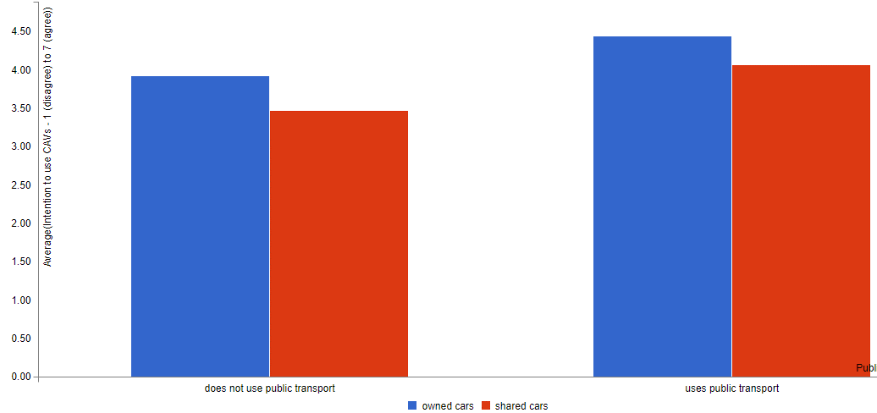
Figure 34 Intention to use private vs. shared CAVs depending on current public transport usage on a scale from 1-7.
Note: Left to right, does not use public transport; uses public transport (blue: owned cars, red: shared cars).
Data for Figure 34 Intention to use private vs. shared CAVs depending on current public transport usage on a scale from 1-7.
CAV mode | does not use public transport | uses public transport | Totals
owned cars | 3.92 | 4.44 | 4.12
shared cars | 3.48 | 4.06 | 3.7
Totals | 3.7 | 4.25 | 3.91

By comparing these factors, it becomes clear that those who already use public transport today on a regular basis are approximately 0.5 points more likely to adopt both private and share CAVs than those who don’t. Further, the willingness to adopt private CAVs is around 0.5-0.6 points higher than the willingness to adopt shared CAVs in both groups.

Conclusions - Recommendations
Researchers have started to identify which factors can make a difference in the acceptance of connected and autonomous vehicles. The purpose of this deliverable was to gather some first insights into who, where accepts what CAV solutions, and why. For this purpose, a survey (described in detail in PAsCALs’ D3.3) was conducted and data was collected from over 5000 participants. Socio-demographics, visual impairment, mobility behaviours and motivations were descriptively analysed, with an additional focus on the geographical location of residence of participants, aiming to understand CAV acceptance.
Overall, the descriptive results conducted so far suggest that the here selected baseline of sighted participants that are asked about using personal, owned autonomous vehicles, tend around the midpoint, i.e. they are fairly neutral towards CAVs, with the exception of sustainability expectations, where participants expect an improvement, and privacy concerns, where participants tend to believe CAVs will worsen the situation. Sustainability and privacy expectations have previously been identified in the literature as major predictors of CAV acceptance, so this is in line with these findings. The neutral outlook, as mentioned in previous chapters, might be due to the unclear legislative framework at the current moment and the opaque value and price of a private CAV today and in the future.
We analysed acceptance from the perspective of demographics: the main finding here is that a clear relationship exists between age and the intention to use CAVs, with older participants having lower intentions. This relationship is especially prominent for factors safety and privacy, and further analysis of the data will provide insights in whether they might be mediators of this relationship.
A gender variation was found for intention to use as well, with men providing higher mean ratings than women on average. In terms of expected consequences, this was the case for almost all factors, i.e., safety, privacy, sustainability, affordability, and ease of use.
Education played a role in the sense that university-educated participants were more willing to use CAVs.
We analysed acceptance taking into consideration whether participants had visual impairments: When comparing attitudes of participants with visual impairments to sighted participants, the survey data points towards the idea that visually impaired citizens seem to be more optimistic towards CAVs, with a higher intention to use across almost all age groups, and even when they don’t use public transport normally.
We analysed acceptance based on whether participants reported owning a private vehicle, using public transportation or being pedestrians. We found that intention to use a CAV was the lowest for participants who did not own a vehicle and did not use public transport. On the other hand, motorized participants reported expecting CAVs to be less efficient in terms of time spent on the road and speed of travel overall. Usage of mobility services such as car sharing or ride hailing also went together with a higher intention to use.
We also looked into whether personal, owned CAVs or shared CAVs would be more readily accepted. Maybe also influenced by the current COVID-19 situation, intention to use the former was somewhat higher than the latter, though the overall average still stayed around the midpoint, indicating a fairly neutral outlook. Two other factors that were lower for shared CAVs were reduced personal comfort, so this might be another reason, and efficiency. However, looking at the literature, participants seem keener to pay for shared CAVs than private CAVs, and affordability is expected to be better for shared CAVs. Thus, following a first descriptive analysis of the survey results, it seems that private CAVs hold the currently largest potential of a wide-spread adoption, followed closely by shared and finally public offerings. Based on survey insights and literature, an increased personal comfort as well as increased certainty of liability, cost and ownership.
It is interesting to see that differences in acceptance are not large, so CAVs do have the opportunity to enable a modal shift from privately owned vehicles to shared modes of transport. This needs to align with an increase of efficiency of not only public and shared transport services but the entire transport system as a whole with the gradual introduction of higher-level automation vehicles.
Finally, in terms of geography, there was a relatively large variability in almost all expected consequence factors, and intention to use. Belgium, Germany, Austria and France seemed to be the least receptive to CAV technology today. On the other hand, many southern and eastern European countries like Portugal, Italy, Spain and Hungary seemed to be more open to adopting private CAVs. Specifically, regarding safety, more optimistic expectations were reported by participants from Hungary and Italy, especially compared to participants from Austria, Spain and the UK. For factors privacy, respondents in Austria, France, Germany and Spain were more pessimistic, compared to respondents in Hungary, Portugal and the UK.
Overall, it becomes clear that the case of acceptance of autonomous vehicles is not a simple, but rather a multi-faceted issue that requires juggling many demands from a large variety of stakeholders and individuals from different socio-demographic strata.
Some aspects of the CAV ecosystems can be tackled based on the currently existing literature and findings from our survey that can be expected to improve acceptance: designing CAVs to be environmentally friendly and to lower traffic infrastructure demands. This might require regulations to how CAVs operate without occupants and how they make use of parking spaces. Car sharing models and integration into public transport are other features, though health and safety concerns should be at the forefront when designing these solutions. Frustrations with ease of use and safety might be especially pronounced for visually impaired citizens, who despite this evaluate CAVs more optimistically.
While efficiency seems a less divisive issue, safety remains a main focus of many respondents, which can positively or negatively affect acceptance depending on whether CAVs will manage to build a history of accident reduction and avoid scandals, in particular related to cyber safety. Speed and efficiency might be reduced for the benefit of safety, but currently it looks like most individuals might be willing to accept this trade-off.
Finally, the literature and findings in our survey agree that CAVs will need a better privacy solution in place, especially regarding control by governments and less oversight by companies. Remote control might be impossible to avoid in autonomous vehicles, though a decentralized approach to data storage could provide a first answer.
In conclusion, the here presented deliverable aimed to give an overview over the literature as to who and where accepts CAVs in what way, and why – and provide first insights into expected consequences of wide-spread CAV adoption, particularly of various subpopulations that we managed to recruit in a large cross-national survey.
Future studies should focus on more carefully examining the interactions between the different factors that affect CAV acceptance, and maybe more carefully design target CAV solutions to be able to more specifically pinpoint motivations for their potential adopters.

References

Chapter 2

Acheampong, R. A., & Cugurullo, F. (2019). Capturing the behavioural determinants behind the adoption of autonomous vehicles: Conceptual frameworks and measurement models to predict public transport, sharing and ownership trends of self-driving cars. Transportation Research Part F: Traffic Psychology and Behaviour, 62, 349–375.
Ajzen, I. (1991). The theory of planned behaviour. Organizational Behaviour and Human Decision Processes, 50(2), 179–211. https://doi.org/10.1016/0749-5978(91)
Attitudes and concerns on automated vehicles. (2021). Transportation Research Part F: Psychology and Behaviour, 59(2018), 24–44. https://doi.org/10.1016/j.trf.2018.08.010
B., S. & A.J.T. (2016). Innovation Adoption in Robotics: Consumer Intentions to Use Autonomous Vehicles [Master’s Thesis,]. Norwegian School of Economics.
Buckley, L., Kaye, S. A., & Pradhan, A. K. (2018). Psychosocial factors associated with intended use of automated vehicles: A simulated driving study. Accident; Analysis and Prevention, 115, 202–208. https://doi.org/10.1016/j.aap.2018.03.021
Davis, F. D. (1989). Perceived usefulness, perceived ease of use, and user acceptance of information technology. MIS Quarterly, 13(3), 319.
Golbabaei, F., Yigitcanlar, T., Paz, A., & Bunker, J. (2020). Individual predictors of autonomous vehicle public acceptance and intention to use: A systematic review of the literature. Journal of Open Innovation: Technology, Market, and Complexity, 6(4), 106. https://doi.org/10.3390/joitmc6040106.
Hartwich, F., Witzlack, C., Beggiato, M., & Krems, J. F. (2019). The first impression counts – A combined driving simulator and test track study on the development of trust and acceptance of highly automated driving. Transportation Research Part F: Traffic Psychology and Behaviour, 65, 522–535. https://doi.org/10.1016/j.trf.2018.05.012
Jing, P., Xu, G., Chen, Y., Shi, Y., & Zhan, F. (2020). The determinants behind the acceptance of autonomous vehicles: A systematic review. Sustainability, 12(5), 1.
Kacperski, C., Kutzner, F., & Vogel, T. (2021). Consequences of autonomous vehicles: Ambivalent expectations and their impact on acceptance. Transportation research part F: traffic psychology and behaviour, 81, 282–294.
König, M., & Neumayr, L. (2017). Users’ resistance towards radical innovations: The case of the self-driving car. Transportation Research Part F: Traffic Psychology and Behaviour, 44, 42–52. https://doi.org/10.1016/j.trf.2016.10.013
Lee, J. D., & See, K. A. (2004). Trust in automation: Designing for appropriate reliance. Human Factors, 46(1), 50–80.
Liu, P., Yang, R., & Xu, Z. (2019). Public Acceptance of Fully Automated Driving: Effects of Social Trust and Risk/Benefit Perceptions. Risk Analysis, 39(2), 326–341. https://doi.org/10.1111/risa.13143
Panagiotopoulos, I., & Dimitrakopoulos, G. (2018). An empirical investigation on consumers’ intentions towards autonomous driving. Transportation Research Part C: Emerging Technologies, 95, 773–784.
Payre, W., Cestac, J., & Delhomme, P. (2014). Intention to use a fully automated car: Attitudes and a priori acceptability. Transportation Research Part F: Traffic Psychology and Behaviour, 27(PB), 252–263. https://doi.org/10.1016/j.trf.2014.04.009
Rezaei, A., & Caulfield, B. (2020). Examining public acceptance of autonomous mobility. Travel Behaviour and Society, 21, 235–246. https://doi.org/10.1016/j.tbs.2020.07.002
Schoettle, B., & Sivak, M. (2014). Public opinion about self-driving vehicles in China, India, Japan, the US, the UK, and Australia. University of Michigan, Ann Arbor, Transportation Research Institute.
Sharma, I., & Mishra, S. (2020). Modeling consumers’ likelihood to adopt autonomous vehicles based on their peer network. Transportation Research Part D: Transport and Environment, 87(August), 102509. https://doi.org/10.1016/j.trd.2020.102509
Venkatesh, V., Thong, J. Y. L., & Xu, X. (2012). Consumer acceptance and use of information technology: Extending the unified theory of acceptance and use of technology. MIS Quarterly, 36(1), 157–178. https://doi.org/10.2307/41410412.
Xu, Z., Zhang, K., Min, H., Wang, Z., Zhao, X., & Liu, P. (2018). What drives people to accept automated vehicles? Findings from a field experiment. Transportation Research Part C: Emerging Technologies, 95(February), 320–334. https://doi.org/10.1016/j.trc.2018.07.024
Zhang, T., Tao, D., Qu, X., Zhang, X., Lin, R., & Zhang, W. (2019). The roles of initial trust and perceived risk in public’s acceptance of automated vehicles. Transportation Research Part C: Emerging Technologies, 98(November 2018), 207–220. https://doi.org/10.1016/j.trc.2018.11.018
Zhang, T., Zeng, W., Zhang, Y., Tao, D., Li, G., & Qu, X. (2021). What drives people to use automated vehicles? A meta-analytic review. Accident; Analysis and Prevention, 159(June), 106270. https://doi.org/10.1016/j.aap.2021.106270

Chapter 3.1
Ackaah, W., Leslie, V. L. D., & Osei, K. K. (2021). Perception of autonomous vehicles – A Ghanaian perspective. Transportation Research Interdisciplinary Perspectives [Online, 11, 100437. https://doi.org/10.1016/j.trip.2021.100437
Bansal, P., Kockelman, K. M., & Singh, A. (2016). Assessing Public Opinions of and Interest in New Vehicle Technologies: An Austin Perspective. Transportation Research Part C: Emerging Technologies [Online, 67, 1–14. https://doi.org/10.1016/j.trc.2016.01.019
Becker, F., & Axhausen, K. W. (2017). Literature review on surveys investigating the acceptance of automated vehicles. Transportation [Online, 44, 1293–1306. https://doi.org/10.1007/s11116-017-9808-9
Haghzare, S., Campos, J. L., Bak, K., & Milhalidis, A. (2021). Older adults’ acceptance of fully automated vehicles: Effects of exposure, driving style, age and driving conditions. Accident Analysis and Prevention [Online, 150, 105919. https://doi.org/10.1016/j.aap.2020.105919
Hilgarter, K., & Granig, P. (2020). Public perception of autonomous vehicles: A qualitative study based on interviews after riding an autonomous shuttle. Transportation Research Part F: Traffic Psychology and Behaviour [Online, 72, 226–243. https://doi.org/10.1016/j.trf.2020.05.012
Liljamo, T., Liimatainen, H., & Pöllänen, M. (2018). Attitudes and concerns on automated vehicles. Transportation Research Part F: Traffic Psychology and Behaviour [Online, 59, 24–44. https://doi.org/10.1016/j.trf.2018.08.010
Madigan, R., Louw, T., Dziennus, M., Schieben, A., & Merat, N. (2017). What influences the decision to use automated public transport? Using UTAUT to understand public acceptance of Automated Road Transport Systems. Transportation Research Part F: Traffic Psychology and Behaviour [Online, 50, 55–64.
Madigan, R., T., L., Dziennus, M., Graindorge, T., Ortega, E., Graindorge, M., & Merat, N. (2016). Acceptance of automated road transport systems (ARTS): An adaptation of the UTAUT model. Transportation Research Procedia [Online, 14, 2217–2226.
Mouratidis, K., & Serrano, V. C. (2021). Autonomous buses: Intentions to use, passenger experiences, and suggestions for improvement. Transportation Research Part F: Traffic Psychology and Behaviour [online, 76, 321–335. https://doi.org/10.1016/j.trf.2020.12.007
Nordoff, S., Winter, J. D., Madigan, R., Merat, N. van A., B., H., & R. (2018). User acceptance of automated shuttles in Berlin-Schoneberg: A questionnaire study. Transportation Research Part F: Traffic Psychology and Behaviour [Online, 58, 843–854.
Paddeu, D., Tsouros, I., Parkhurst, G., Polydoropoulou, A., & Shergold, I. (2021). A study of users’ preferences after a brief exposure in a Shared Autonomous Vehicle (SAV. Transportation Research Procedia [Online, 52, 533–540.
Pakusch, C., & Bossauer, P. (2017). User acceptance of Fully Autonomous Public Transport. Proceddings of the 14th International Joint Conference on E-Business and Telecommunications (ICETE 2017) [Online, 2, 52–60. https://doi.org/10.5220/0006472900520060
Pettigrew, S., Worrall, C., Talati, Z., Fritschi, L., & Norman, R. (2019). Dimensions of attitudes to autonomous vehicles. Urban, Planning and Transport Research [Online, 7(1), 19–33. https://doi.org/10.1080/21650020.2019.1604155
Roche-Cerasi, I. (2019). Public acceptance of driverless shuttles in Norway. Transportation Research Part F: Traffic Psychology and Behaviour [Online, 66, 162–183. https://doi.org/10.1016/j.trf.2019.09.002
Salonen, A. (2018). Passenger’s subjective traffic safety, in-vehicle security and emergency management in the driverless shuttle bus in Finland. Transport Policy [Online, 61, 106–110. https://doi.org/10.1016/j.tranpol.2017.10.011
Schoettle, B., & Sivak, M. (2014). Public opinion about self-driving vehicles in China, India, Japan, the U.S., the U.K., and Australia [Technical Report]. University of Michigan, Ann Arbor, Transportation Research Institute. http://deepblue.lib.umich.edu/handle/2027.42/109433
Soldouz, S. A., Hasnine, M. S., Sukhai, M., & Habib, K. N. (2020). Looking through the Perceptions of Blinds: Potential Impacts of Connected Autonomous Vehicles on Pedestrians with Visual Impairment. Transportation Research Record [Online, 2674, 183–195. https://doi.org/10.1177/0361198120914299
Tsouros, I., & Polydoropoulou, A. (2020). Who will buy alternative fueled or automated vehicles: A modular, behavioral modeling approach. Transportation Research Part A: Policy and Practice [Online, 132, 214–225. https://doi.org/10.1016/j.tra.2019.11.013
Wali, B., Santi, P., & Ratti, C. (2021). Modeling consumer affinity towards adopting partially and fully automated vehicles – The role of preference heterogeneity at different geographical levels. Transportation Research Part C: Emerging Technologies [Online, 129, 103276.

Chapter 3.2
Bazilinskyy, P., Dodou, D., & Winter, J. (2019). Survey on eHMI concepts: The effect of text, color, and perspective. Transportation Research Part F: Traffic Psychology and Behaviour, 67, 175–194. https://doi.org/10.1016/j.trf.2019.10.013
Bennett, R., Vijaygopal, R., & Kottasz, R. (2020). Willingness of people who are blind to accept autonomous vehicles: An empirical investigation. Transportation Research Part F: Traffic Psychology and Behaviour, 69, 13–27. https://doi.org/10.1016/j.trf.2019.12.012
Brinkley, J., Posadas, B., Woodward, J., & Gilbert, J. E. (2017). Opinions and preferences of blind and low vision consumers regarding self-driving vehicles: Results of focus group discussions. ASSETS 2017 - Proceedings of the 19th International ACM SIGACCESS Conference on Computers and Accessibility, 290–299. https://doi.org/10.1145/3132525.3132532
Crayton, T. J., & Meier, B. M. (2017). Autonomous vehicles: Developing a public health research agenda to frame the future of transportation policy. Journal of Transport and Health, 6(February), 245–252. https://doi.org/10.1016/j.jth.2017.04.004
Dey, D., Habibovic, A., Löcken, A., Wintersberger, P., Pfleging, B., Riener, A., & Terken, J. (2020). Taming the eHMI jungle: A classification taxonomy to guide, compare, and assess the design principles of automated vehicles’ external human-machine interfaces. Transportation Research Interdisciplinary Perspectives, 7. https://doi.org/10.1016/j.trip.2020.100174
Dicianno, B. E., Sivakanthan, S., Sundaram, S. A., Satpute, S., Kulich, H., Powers, E., & Cooper, R. A. (2021). Systematic review: Automated vehicles and services for people with disabilities. Neuroscience Letters, 761(March), 136103. https://doi.org/10.1016/j.neulet.2021.136103
Hawes, M. (2017). Connected and Autonomous Vehicles: Revolutionising Mobility in Society. International Automotive Summit. https://www.smmt.co.uk/wp-content/uploads/sites/2/Connected-and-Autonomous-Vehicles-Revolutionising-Mobility-in-Society.pdf
Kassens-Noor, E., Cai, M., Kotval-Karamchandani, Z., & Decaminada, T. (2021). Autonomous vehicles and mobility for people with special needs. Transportation Research Part A: Policy and Practice, 150(May), 385–397. https://doi.org/10.1016/j.tra.2021.06.014
Pettigrew, S. (2017). Why public health should embrace the autonomous car. Australian and New Zealand Journal of Public Health, 41(1), 5–7. https://doi.org/10.1111/1753-6405.12588
Soldouz, S. A. (2019). The potential impacts of connected autonomous vehicles on pedestrians with visual impairment. Transportation Research Record Journal of the Transportation Research Board.

Chapter 3.3
MobilityTransition. (2020). CHANGE! Mobilwende in den Köpfen. http://www.mobilitytransition.at/en/users/
Prieto Curiel, R., González Ramírez, H., Quiñones Domínguez, M., & Orjuela Mendoza, J. P. (n.d.). A paradox of traffic and extra cars in a city as a collective behaviour. Royal Society Open Science, 8(6), 201808. https://doi.org/10.1098/rsos.201808
Seebauer, S. (2011). Individuelles Mobilitätsverhalten in Großstädten. Erklärungsmodell und Veränderungsmöglichkeiten für die Nutzung öffentlicher Verkehrsmittel [Karl-Franzens-Universität Graz]. https://docplayer.org/15135969-Individuelles-mobilitaetsverhalten-in-grossstaedten-erklaerungsmodell-und-veraenderungsmoeglichkeiten-fuer-die-nutzung-oeffentlicher-verkehrsmittel.html
Shove, E., & Walker, G. (2010). Governing Transitions in the Sustainability of Everyday Life. Research Policy, 39, 471–476. https://doi.org/10.1016/j.respol.2010.01.019
Sopjani, L., Stier, J. J., Hesselgren, M., & Ritzen, S. (2020). Shared mobility services versus private car: Implications of changes in everyday life. Journal of Cleaner Production, 259.
Trommer, S., Kolarova, V., Fraedrich, E. M., Kröger, L., Kickhöfer, B., Kuhnimhof, T., Lenz, B., & Phleps, P. (2016). Autonomous Driving—The Impact of Vehicle Automation on Mobility Behaviour. Undefined. https://www.semanticscholar.org/paper/Autonomous-Driving-The-Impact-of-Vehicle-Automation-Trommer-Kolarova/44ba6d62245a120d923ff13a5ae0328f47f82f95

Chapter 4
Becker, F., & Axhausen, K. W. (2017). Literature review on surveys investigating the acceptance of automated vehicles. Transportation, 44(6), 1293–1306. https://doi.org/10.1007/s11116-017-9808-9
Faisal, A., Yigitcanlar, T., Kamruzzaman, M., & Currie, G. (2019). Understanding autonomous vehicles: A systematic literature review on capability, impact, planning and policy. https://doi.org/10.5198/jtlu.2019.1405
Faisal, A., Yigitcanlar, T., Kamruzzaman, M., & Paz, A. (2020). Mapping Two Decades of Autonomous Vehicle Research: A Systematic Scientometric Analysis. Journal of Urban Technology, 0(0), 1–30. https://doi.org/10.1080/10630732.2020.1780868
Gkartzonikas, C., & Gkritza, K. (2019). What have we learned? A review of stated preference and choice studies on autonomous vehicles. Transportation Research Part C: Emerging Technologies, 98, 323–337. https://doi.org/10.1016/j.trc.2018.12.003
Golbabaei, F., Yigitcanlar, T., Paz, A., & Bunker, J. (2020). Individual predictors of autonomous vehicle public acceptance and intention to use: A systematic review of the literature. Journal of Open Innovation: Technology, Market, and Complexity, 6(4), 106. https://doi.org/10.3390/joitmc6040106.
Keszey, T. (2020). Behavioural intention to use autonomous vehicles: Systematic review and empirical extension. Transportation Research Part C: Emerging Technologies, 119, 102732. https://doi.org/10.1016/j.trc.2020.102732
Kurniawan, J. H., Chng, S., & Cheah, L. (2021). The Social Acceptance of Autonomous Vehicles. IEEE Potentials, 40(4), 39–44. https://doi.org/10.1109/MPOT.2020.2991059
Menon, N., Barbour, N., Zhang, Y., Pinjari, A. R., & Mannering, F. (2019). Shared autonomous vehicles and their potential impacts on household vehicle ownership: An exploratory empirical assessment. International Journal of Sustainable Transportation, 13(2), 111–122. https://doi.org/10.1080/15568318.2018.1443178
Merfeld, K., Wilhelms, M.-P., Henkel, S., & Kreutzer, K. (2019). Carsharing with shared autonomous vehicles: Uncovering drivers, barriers and future developments – A four-stage Delphi study. Technological Forecasting and Social Change, 144, 66–81. https://doi.org/10.1016/j.techfore.2019.03.012
Milakis, D., Van Arem, B., & Van Wee, B. (2017). Policy and society related implications of automated driving: A review of literature and directions for future research. Journal of Intelligent Transportation Systems: Technology, Planning, and Operations, 21(4), 324–348. https://doi.org/10.1080/15472450.2017.1291351
Nordhoff, S., de Winter, J., Kyriakidis, M., van Arem, B., & Happee, R. (2018). Acceptance of Driverless Vehicles: Results from a Large Cross-National Questionnaire Study. Journal of Advanced Transportation, 2018, e5382192. https://doi.org/10.1155/2018/5382192
Nordhoff, S., Kyriakidis, M., van Arem, B., & Happee, R. (2019). A multi-level model on automated vehicle acceptance (MAVA): A review-based study. Theoretical Issues in Ergonomics Science, 20(6), 682–710. https://doi.org/10.1080/1463922X.2019.1621406
Schoettle, B., & Sivak, M. (2014). Public opinion about self-driving vehicles in China, India, Japan, the U.S., the U.K., and Australia [Technical Report]. University of Michigan, Ann Arbor, Transportation Research Institute. http://deepblue.lib.umich.edu/handle/2027.42/109433
Theoto, T. N., & Kaminski, P. C. (2019). A country-specific evaluation on the feasibility of autonomous vehicles. Product Management & Development, 17(2), 123–133. https://doi.org/10.4322/pmd.2019.013
Thomopoulos, N., Cohen, S., Hopkins, D., Siegel, L., & Kimber, S. (2021). All work and no play? Autonomous vehicles and non-commuting journeys. Transport Reviews, 41(4), 456–477. https://doi.org/10.1080/01441647.2020.1857460
Threlfall, R. (2019). 2019 Autonomous Vehicles Readiness Index (No. 136024-G; p. 56). KPMG’s Global Mobility.
Yun, Y., Oh, H., & Myung, R. (2021). Statistical Modeling of Cultural Differences in Adopting Autonomous Vehicles. Applied Sciences, 11(19), 9030. https://doi.org/10.3390/app11199030

Chapter 5
Auld, J. A., de Souza, F., Enam, A., Javanmardi, M., Stinson, M., Verbas, O., & Rousseau, A. (2019). Exploring the mobility and energy implications of shared versus private autonomous vehicles*. 2019 IEEE Intelligent Transportation Systems Conference (ITSC), 1691–1696. https://doi.org/10.1109/ITSC.2019.8917125
Auld, J., Hope, M., Ley, H., Sokolov, V., Xu, B., & Zhang, K. (2016). POLARIS: Agend-based modelling framework development and implementation for integrated travel demand and network and operations simulations”. Transportation Research C: Emerging Technologies, 64, 101–116.
Auld, J., Verbas, O., Javanmardi, M., & Rousseau, A. (2018). Impact of Privately-Owned Level 4 CAV Technologies on Travel Demand and Energy”. In The 7th International Workshop on Agent-based Mobility, Traffic and Transportation Models, Methodologies and Applications (ABMTRANS), Procedia Computer Science (Vol. 130, pp. 914–919).
Axsen, J., & Sovacool, B. K. (2019). The roles of users in electric, shared and automated mobility transitions”. Transportation Research Part D: Transport and Environment, 71, 1–21.
Bansal, P., & Kockelman, K. M. (2018). Are we ready to embrace connected and self-driving vehicles? A case study of Texans”. Transportation, Edition, 45, 641–675.
Hyland, M. F., & Mahmassani, H. S. (2017). Taxonomy of Shared Autonomous Vehicle Fleet Management Problems to Inform Future Transport Mobility”. Transport Research Record: Journal of the Transportation Research Board, Edition, 2653, 26–34.
Kassens-Noor, E., Kotval-Karamchandani, Z., & Cai, M. (2020). Willingness to ride and perceptions of autonomous public transit. Transportation Research Part A: Policy and Practice, 138, 92–104. https://doi.org/10.1016/j.tra.2020.05.010
Krueger, R., Rashidi, T. H., & Rose, J. M. (2016). Preferences for shared autonomous vehicles. Transportation Research Part C: Emerging Technologies, 69, 343–355. https://doi.org/10.1016/j.trc.2016.06.015
Litman, T. (2021). Autonomous Vehicle Implementation Predictions: Implications for Transport Planning”. Victoria Transport Policy Institute.
Merfeld, K., Wilhelms, M.-P., Henkel, S., & Kreutzer, K. (2019). Carsharing with shared autonomous vehicles: Uncovering drivers, barriers and future developments – A four-stage Delphi study. Technological Forecasting and Social Change, 144, 66–81. https://doi.org/10.1016/j.techfore.2019.03.012
Pigeon, C., Alauzet, A., & Paire-Ficout, L. (2021). Factors of acceptability, acceptance and usage for non-rail autonomous public transport vehicles: A systematic literature review. Transportation Research Part F: Traffic Psychology and Behaviour, 81, 251–270. https://doi.org/10.1016/j.trf.2021.06.008
Rask, E., Auld, J., & Bush, B. (2020). SMART Mobility Connected and Automated Vehicles Capstone Report”. US Department of Energy.
Shoup, D. C. (2006). Cruising for parking”. Transport Policy, 13(ue 6), 479–486.
Wadud, Z., MacKenzie, D., & Leiby, P. (2016). Help or hindrance? The travel, energy and carbon impacts of highly automated vehicles”. Transportation Research Part A: Policy and Practice, Volumne 86, 1–18.
--- End of the document ---

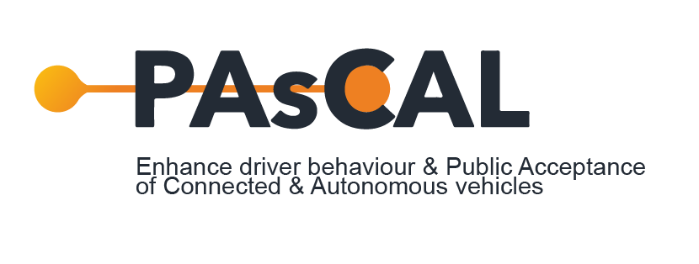

https://www.share-now.com/
https://www.tier.app/

