Connected and Autonomous Vehicles
and Visual Impairment:
Opportunities and Challenges
Erwin DENNINGHAUS
European Blind Union (EBU). 6 rue Gager-Gabillot, 75015 Paris (France).
erwin@denninghaus.eu
Paper submitted for the 56th SELF congress (Society of French-speaking Ergonomists) - 6-8 July 2022 - Geneva.

Abstract
This paper proposes a general reflection on the principles of design for all, applied more specifically to the needs and characteristics of visually impaired or blind people, in the context of autonomous and connected vehicles (ACVs). As a voice and advocate for the rights of visually impaired citizens in Europe, the European Blind Union (EBU) is regularly involved in research projects that require consideration of this population. Based on the results of the PAsCAL project and a project in Germany testing a fully autonomous shuttle bus without a driver, we suggest some good practices and recommendations that would lead to a better design for all, and in particular to a design that is more inclusive of blind and visually impaired passengers.

Introduction
The future is digital. So will traffic, mobility and infrastructure. Simple changes in society go hand in hand with digital transformation, which bring both risks and opportunities for citizens, and in particular for visually impaired citizens.
Forty years ago, for example, the visually impaired and blind benefited from a real technological breakthrough with computers equipped with Braille displays, which finally gave them the possibility to read newspapers or other written content that they had not been able to access without human assistance.
However, there is evidence that nowadays visually impaired and blind people are increasingly disabled by the visual elements that are omnipresent in their environment (the use of screens - smartphones, computers, tablets, etc. - is now associated with most daily activities). - (the use of screens - smartphones, computers, tablets, etc. - is now associated with most daily activities). This is because this information cannot be transcribed into Braille or rendered by the artificial voice of a screen reader. In order to avoid the technological divide and to avoid sidelining these populations, it is necessary to always consider visually impaired and blind people for a better design for all (Abascal & Nicolle, 2005).
This is what the European Blind Union (EBU) strives to do by giving a voice to millions of blind and partially sighted Europeans. EBU works for an inclusive and accessible society, giving people with vision impairments the same opportunities as any other citizen to participate fully in all aspects of social, economic, cultural and political life. EBU is a network of 41 national organisations of people with vision impairments throughout geographical Europe.
Just as with the transition to paid employment, autonomous mobility for visually impaired and blind people requires an ongoing commitment to ensure that the benefits outweigh the risks. This is why EBU has joined the European research project PAsCAL (Enhance driver behaviour and Public Acceptance of Connected and Autonomous Vehicles) on autonomous and connected vehicles.
This article presents a general reflection, accompanied by recommendations written in the form of 7 main principles, which aims to guide the design for all for a better consideration of visually impaired and blind people in the field of transport, and in particular autonomous and connected transport which will probably constitute the mobility landscape of tomorrow.
Firstly, we will take up some theoretical elements in order to position our reflections in relation to previous research carried out on design for all, and those concerning the design of autonomous and connected vehicles (ACV). We will then position the framework of our reflection, from a methodological point of view and from the European projects that have supported these reflections. Finally, we will present the 7 principles that we believe are fundamental to support a design for all, applied in particular to visually impaired people.

Designing for the visually impaired

Design for all principles
Design for all aims to take users and their differential characteristics into account from the early stages of product design, while integrating them into a participatory approach (Conte, 2004). The aim is to foresee possible uses during the development of a product, in order to respond to the various incapacities due to age or disability. The ISO IEC/71 guide, "Guidelines for standardisation to meet the needs of older people and people with disabilities", specifies that accessible design should be able to respond to users' limitations so that products, services or environments can be easily used without any modification.
Therefore, in line with Abascal and Nicolls (2005), we consider that Design for All is, in essence, the reverse of previous approaches to designing specifically for disabled and older people as a subset of the population.
Finally, it should be noted that Design for All is based on an inclusive design (the two terms are often used to designate the same approach), i.e. it considers that designing a product by including the specificities of disabled populations will also serve able-bodied populations. In this sense, Spérandio (2007) underlines that "the difficulties that disabled subjects encounter in using certain technical products are often indicative (magnifying glass effect) of the difficulties that young and completely able-bodied users also encounter, at a minor level and in certain circumstances". Thus, taking the disabled user into account is not only an ethical issue, but also a way of optimising technologies for the benefit of the greatest number.
On 23 December 2010, the United Nations Convention on the Rights of Persons with Disabilities (CRPD) was ratified by the European Union. This was the first time that a regional organisation became party to an international human rights treaty. Since then, the Convention has been ratified by all EU member states. It is therefore legally binding throughout the European Union, and national legislation has progressively followed in areas covered by the Convention.

Design for all in transport
Transport is an area where accessibility is a priority, as it should enable any person to travel for work, social life, personal needs, etc. It is estimated that more than 40% of disabled people depend on others to get around, and more than 70% limit their travel completely due to accessibility problems (Dicianno, 2021).
Spérandio (2007) takes the example of train accessibility and the contribution of design for all: steps to access trains or stations are real obstacles for wheelchair users, to the point of requiring special human assistance. But they are also annoying, tiring and even dangerous for all users. So improving their accessibility is a benefit for everyone.
Article 9 of the CRPD (Convention on the Rights of Persons with Disabilities) refers directly to accessibility, and deals in particular with transport. This article specifies in particular: "In order to enable persons with disabilities to live independently and participate fully in all aspects of life, States Parties shall take appropriate measures to ensure access on an equal basis with others to the physical environment, to transportation, to information and communication, including information and communication systems and technologies, and to other facilities and services open or provided to the public, in both urban and rural areas [...]".
Based on the CRPD, the European Union institutions have passed several texts to ensure accessible travel, such as the one on passengers' rights in bus and coach transport (Regulation No. 181/2011), or the one on accessibility of rail transport (Regulation No. 1300/2014). At the national level, other texts have been adopted to reinforce the accessibility of transport, such as the Accessibility Act of 22 July 2021 in Germany. At the same time, the European Committee for Standardisation (CEN) published the final draft of the future European standard "EN 17478" (Transport services - Communications for customers of public transport services - A universal design approach).

Autonomous vehicles: a welcome technology for the visually impaired
The young, the elderly and the disabled suffer the most from mobility restrictions. A study by The Society of Morot Manufacturers and Traders Limited (Hawes, 2017) indicates that all three groups have identified CAVs as a potential solution to improve their mobility and quality of life. The study shows that more than 50% of respondents felt that their mobility was limited, while 48% said that reducing driving stress would be the main benefit of Autonomous and Connected Vehicles. Thus, CAVs would promote social inclusion by offering greater freedom of mobility to those excluded from current transport models (Pettigrew, 2017). According to Crayton & Meier (2017), however, these benefits could not be effective without a new comprehensive policy implemented by the authorities. Bennett, Vijaygopal and Kottasz (2020) note the frustrations of blind people in having to depend on others and the fear of having to move around unfamiliar environments without assistance.
In focus groups with visually impaired people, Brinkley, Posadas, Woodward et Gilbert (2017) also noted that 37% of participants were convinced that CAV technology could solve most of the accessibility problems, but that manufacturers needed to be made aware of the importance of this issue.
The results of a study conducted by Kassens-Noor et al. (2021) show that visually impaired people, particularly those who already use public transport, would most likely use CAVs, ahead of other people with special needs such as people with hearing impairment or people with motor disabilities. People with vision impairments would then be better able to find paid employment, participate in leisure and entertainment activities, go door-to-door without assistance, and overcome the loneliness that often results from their social isolation. Another study (Bennett et al., 2020) of visually impaired people showed that those with a strong desire for autonomy were considering the possibility of travelling in CAVs, which were seen as offering interesting opportunities to get to places that are currently inaccessible to them. However, there were reservations: while 37% of respondents directly expressed a positive view of CAVs, 45% were skeptical or had reservations, particularly about safety.
A study from the European PAsCAL project shows that there are differences in the acceptance of CAVs between sighted and visually impaired people (PAsCAL consortium, 2021). In a survey involving 5659 respondents of which 1030 were visually impaired, two observations were made. Firstly, visually impaired people have a greater intention to use a CAV than sighted people (age groups 30-39, 50-59 and 60-69). Only young sighted respondents (18-29 years) have a higher intention to use than young visually impaired respondents. The results for the 40-49 age group are rather similar, but slightly in favour of the sighted. Furthermore, unlike sighted people, who have a decreasing intention to use a CAV with increasing age, there was no relationship between age and intention to use a CAV among visually impaired people (Figure 1).

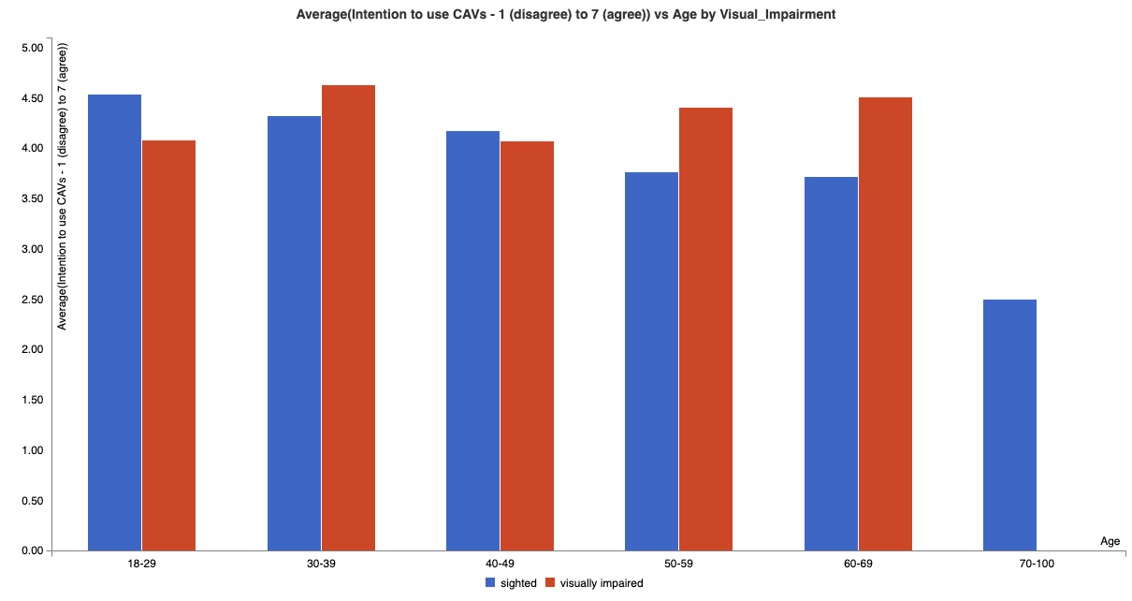
Figure 1: Relationship between age and intention to use a CAV for sighted (blue) and visually impaired (red) people (PAsCAL consortium, 2021)
Description for blind or partially sighted readers:
Figure 1 shows bar charts. The blue bars are for sighted people (S) and the red bars are for visually impaired people (VD). The horizontal axis shows the following 6 age groups: 18-29, 30-39, 40-49, 50-59, 60-69 and 70-100. The vertical axis shows the average intention to use a CAV on a scale from 1 (disagree) to 7 (agree). The results by age group are as follows:
- 18-29: V: 4.54. DV: 4.08.
- 30-39: V: 4.33. DV: 4.63.
- 40-49: V: 4.17. DV: 4.07.
- 50-59: V: 3.76. DV: 4.41.
- 60-69: V: 3.72. DV: 4.51.
- 70-100: V: 2.5. DV: no response.

Problem and purpose of this study
As outlined in the previous theoretical section, visually impaired people seem to have a rather positive attitude towards CAVs. But many questions arise in terms of design for all: what are the conditions that need to be fulfilled in order to fulfil their hopes and design inclusive mobility in the future? How will visually impaired people communicate with their cars? How will digitalisation replace the human assistance of bus and tram drivers? Who will alert the blind passenger to the number of the bus line? Who will deploy the ramp to allow access to a person in a wheelchair, and who will look after a vulnerable passenger who cannot find their seat?
We believe it is important that these services are taken into account, and that technical solutions are developed to make future mobility inclusive. There are already national and European legislation and guidelines that oblige manufacturers and service providers to provide inclusive solutions.

Methodological framework
In this article, we attempt to answer some of the questions posed in the problematic, by taking up the 7 main principles of design for all from the Center for Universal Design, North Carolina State University (1997). These principles are applied to a particular case study (stop request buttons for an autonomous shuttle bus) observed in the context of the "Ride4All" project (www.Ride4All.nrw) carried out in the city of Soest, near Dortmund, Germany, in which the Vocational Training Centre for the Blind and Visually Impaired in Soest was one of the partners (Figure 2).

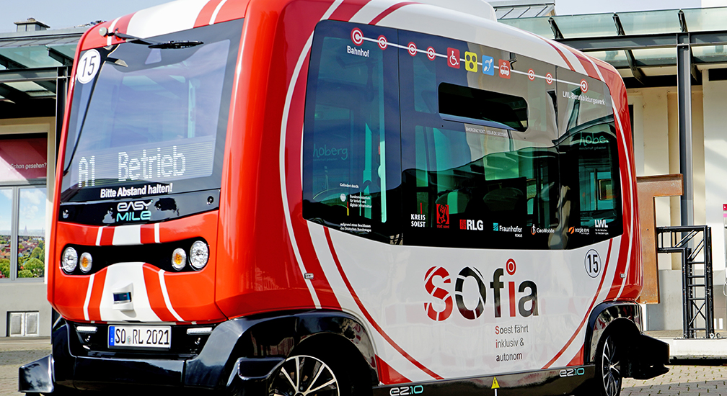
Figure 2. The EasyMile autonomous shuttle (source: Ride4All, 2021).

Description for blind or partially sighted readers:
Figure 2 shows an autonomous shuttle bus with the inscription “Sofia” parked in front of a shelter. It is a small bus, red and white in colour and cubic in shape. As an autonomous shuttle, there is no driver on board.
The Avenue project, co-funded by the European Union (https://h2020-avenue.eu), is also one of the few projects looking at inclusive design in the context of CAVs.
Finally, as the European Blind Union is a partner in the European project PAsCAL (Enhance driver behaviour and Public Acceptance of Connected and Autonomous vehicLes), we have been able to formalise and promote the needs of visually impaired and blind people in the design of CAVs.

Principles and reflections on Design for All

Principle 1: Design is useful and marketable to people with different abilities
The Ride4All project tested the use of push buttons in an EasyMile shuttle, a world leader in intelligent mobility solutions and driverless technology (Figure3). These buttons are positioned vertically next to the door. They are easy to find and can be reached by adults and children as well as wheelchair users. They are easy to identify as they are different colours and pictograms, and even have Braille markings. But despite these real qualities and the effort on accessibility that has been made, these buttons still present some problems of use for certain populations.
This simple technical device can still be improved. In the following principles, we propose to use this case study to illustrate our thoughts and feedback.
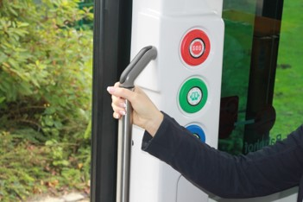
Figure 3. Photo of push buttons in the EasyMile shuttle (Ride4All, 2021)
Description for blind or partially sighted readers:
Figure 3 shows three push buttons arranged vertically near the exit door of a shuttle. The first one from the top has a red outline and the inscription SOS in its centre on a white background. The second button has a green outline and a green pictogram of two doors opening on a white background. The last button has a blue outline. It is not possible to see the pictogram in the centre because it is hidden by the arm of a user holding a handrail.

Principle 2: Flexible use
"Design for all caters for a wide range of individual abilities and preferences.
The guidelines of this second principle stress that different forms of use should always be offered.
With the Ride4All project, communication between the autonomous shuttle and a smartphone application is currently being tested. Instead of using the buttons described in the first principle, it is also possible to use this application and ask for the next stop, for example. The application also gives the line number and the stations served verbally. Very importantly, elderly, visually impaired or blind people often need more time to react, as they may need more time to read the screen.
The user test carried out during the project showed that programming the communication between the vehicle and the application is a very complex challenge, which should be planned and carried out at an early stage of the development of any autonomous system. This means taking into account the needs and characteristics of all users as early as possible in the design phase, in line with the human-centred design approach (ISO 9241-210:2010).

Principle 3: Simple and intuitive design
"Using the product is easy to understand, regardless of the user's experience, knowledge, language skills or current concentration level."
Building a device that is intuitive to use is a real challenge for designers. Indeed, with the knowledge and familiarity of the system, which is currently under development, it is not easy to imagine how people without experience with the system will use it. Language barriers and technological illiteracy add to the challenge. In addition, there are users with very specific needs, which cannot be anticipated without their own experience. Comfortable use of autonomous vehicles by blind people is - as far as we know today - only possible through the use of an accessible smartphone application. But a technically accessible application does not guarantee ease of use.
Figure 4 shows the GeoMobile "Mobil Info" application used in the Ride4All project. To activate the visual and audible announcement of bus stops, one has to touch a small triangle which we have circled in red on the figure. It turned out that the position of the button is crucial because blind users do not find it by themselves. They have to be taught how to use it. It would be much more intuitive to have a big button under the chosen connection, comparable to the "Rückweg planen" button. In order to find a satisfactory solution, it is necessary to know how a blind person uses a smartphone, or to test the application with different user groups. In addition, different smartphones, different operating systems and different screen readers, such as VoiceOver on iOS or Talkback on Android, must be taken into account.

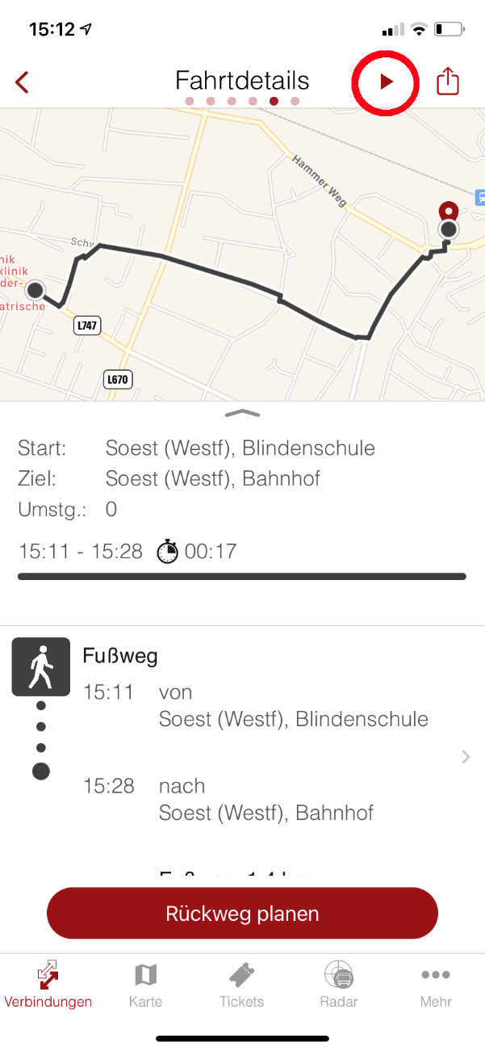

Figure 4. Screenshot of the GeoMobile application.
Description for blind or partially sighted readers:
Figure 4 shows a screenshot of the GeoMobile application on iOS. It shows a street map with a starting and an ending point. Underneath, the calculated route is displayed with the names and times of the starting and ending points. At the bottom a large, rounded, red button displays the text "Rückweg planen" (plan way back). At the top right of the screen a small triangle appears, circled in red.

Principle 4: Perceptible information
"The product design effectively conveys the necessary information to the user, regardless of the environmental conditions or the user's sensory capabilities."
This fourth principle can also be called the "two-way principle". Any information should be offered in at least two ways to ensure that it reaches as many users as possible. In practice, this means that it is necessary to provide mainly aural and visual information or - if an aural announcement does not make sense or is technically limited - visual and tactile information. In addition, for visually impaired people, high contrast is important, for example for the edges of steps. And, as far as colours are concerned, it is important to remember that 8% of people have limited colour vision.
During the Ride4All project's tests with the autonomous shuttle, the implementation of an Acoustic Vehicle Alerting System (AVAS) proved to be very important. A slow-moving electric vehicle - in this case the EasyMile shuttle - cannot be recognised by a blind person at a bus stop or pedestrian crossing because of the usual city noise in the background. AVAS is therefore an essential part of the two-way principle for autonomous electric vehicles.

Principle 5: A tolerance for error
"Design for all minimises the hazards and negative consequences of accidental or unintended actions.
This is a very important principle, especially with regard to autonomous vehicles that can injure passengers or pedestrians if they act unintentionally. Let's look again at the buttons on the EasyMile vehicle. These buttons are not push buttons but touch screens (Figure 5).

Figure 5. Close-up of one of the three touch buttons (source: Ride4All, 2021).
Description for blind or partially sighted readers:
Figure 5 shows a blind or partially sighted person placing his or her fingers on the Braille writing around a round button. The button has a green outline and a green pictogram representing two doors opening on a white background.
Of course, these touch screens are "state of the art". Perhaps touch screens make it easier for one or other physically disabled person to activate a function. However, touch screens in public transport have a high risk of unintentional activation. The touch of a sleeve is sometimes enough to activate them. For blind and visually impaired people, the use of mere touch buttons is unthinkable. Before they can even read the Braille letters on the edge of the button, they will have activated it. Therefore, touch screens should never be recommended or used in autonomous vehicles that are intended for use by the general public! This principle does not interfere with principle 6.

Principle 6: Low physical effort
"The product can be used efficiently and comfortably with minimal fatigue.
As we have seen, visually impaired and blind people need push buttons, because they require a certain amount of muscle power to prevent them from being activated by mistake. In addition, many physically disabled people prefer push buttons to touch screens. This applies to people with Parkinson's disease, for example. Another important parameter of the buttons is the feedback, which should also be not only visual, but also audible or tactile.
For autonomous vehicles, Principle 6 refers to another relevant element: Design for All must address not only the vehicle itself, but also its physical and virtual environment. To improve the prospects for autonomous mobility for people with disabilities, the vehicle needs to be integrated into an appropriate virtual and physical environment that allows visually impaired, blind and wheelchair users to move from door to door. And the needs of each of these populations are different: while a visually impaired or blind person may have difficulty finding the vehicle and will need electronic assistance to be guided to their door, a wheelchair user needs information about steps and lifts, as well as a ramp to the vehicle or a platform at the vehicle (Figure 6).

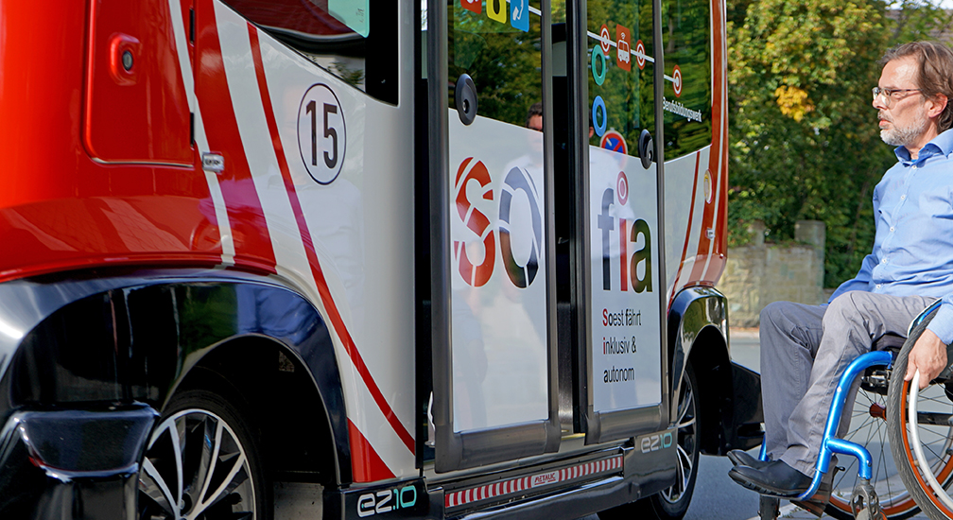
Figure 6. A person with reduced mobility facing the autonomous shuttle (source: Ride4All, 2021).
Description for blind or partially sighted readers:
Figure 6 shows a man with a motor disability sitting in a wheelchair. He is facing the two open doors of an autonomous shuttle. While the man is positioned on the road, there is a large gap of about 30 cm between the road and the platform of the autonomous shuttle.
These different needs must be taken into consideration when designing for all and programming an application, and it is necessary to offer different functionalities according to the specific needs of the users.

Principle 7: One size and use of space for a good approach and use.
"Appropriate size and space is provided for approaching, reaching, handling and using the product, regardless of the user's size, posture or mobility."
Nowadays, it is common to have sufficient space for luggage or pushchairs on public transport. But getting on and off a bus (Sperandio, 2007, using trains as an example) with a wheelchair could be a problem.
Indeed, there is currently no solution for securing a wheelchair in a vehicle without human assistance. Also, user tests carried out as part of the Ride4All project revealed that the position of the button on the outside of the vehicle to activate the ramp must be carefully considered: the wheelchair user must not be in front of the ramp, otherwise the ramp and the wheelchair may collide when the ramp is activated.
In the specific case of a visual impairment, blind passengers will also need sufficient space for their guide dog, if any.

Conclusion
This paper aimed to share a set of reflections on Design for All applied to autonomous and connected vehicles, with a focus on the specific needs of visually impaired or blind users. Based on a case study from the German research project Ride4All, we have highlighted several principles, in the form of reflections or recommendations, which should further promote efforts towards Design for All.
From these principles, three main points seem important to us to retain:
- Design for all provides the necessary preconditions for accessibility and usability for all people with special needs. For sufficient and adequate solutions, specific expertise is still needed, especially for visually impaired and blind users. This expertise can be provided by their organisations and should be complemented by practical testing of products under development.
- To foster an inclusive society, European guidelines and standards as well as national legislation impose increasingly detailed requirements on the accessibility and usability of products and services.
- Although the mobility of the future offers more opportunities for autonomy to visually impaired and blind people, their needs must be taken into account at the earliest stages of the design process. The later implementation of features usually makes solutions more expensive, less usable, possibly more dangerous and even less reliable.
Based on the results of research projects such as PAsCAL and Ride4All, the European Blind Union will develop a more comprehensive document in 2022. We will be happy to share it with anyone interested in this area.

Bibliography
Abascal, J., & Nicolle, C. (2005). Moving towards inclusive design guidelines for socially and ethically aware HCI. Interacting with Computers, 17(5), 484-505. https://doi.org/10.1016/j.intcom.2005.03.002.
Bennett, R., Vijaygopal, R., & Kottasz, R. (2020). Willingness of people who are blind to accept autonomous vehicles: An empirical investigation. Transportation Research Part F: Traffic Psychology and Behaviour, 69, 13-27. https://doi.org/10.1016/j.trf.2019.12.012.
Bundesministerium für Arbeit und Soziales: Barrierefreiheitsstärkungsgesetz. Online verfügbar unter: https://www.bmas.de/DE/Service/Gesetze-und-Gesetzesvorhaben/barrierefreiheitsstaerkungsgesetz.html, zuletzt geprüft am 13.10.2021.
Center for Excellence in Universal Design (CEUD) (2020): The 7 Principles. Hg. v. Center for Excellence in Universal Design (CEUD). Dublin. Online verfügbar unter https://universaldesign.ie/what-is-universal-design/the-7-principles/, zuletzt geprüft am 07.10.2021.
Conte, M. (2004). Towards a sustainable design ethic for products for all. Report of the National Technical Centre for Study and Research on Handicaps and Disabilities.
Crayton, T. J., & Meier, B. M. (2017). Autonomous vehicles: Developing a public health research agenda to frame the future of transportation policy. Journal of Transport and Health, 6(February), 245-252. https://doi.org/10.1016/j.jth.2017.04.004.
Design für Alle - Deutschland e.V.: Barrierefreiheit mit attraktiver Gestaltung verbinden. Hg. v. Design für Alle - Deutschland e.V., Münster. Online verfügbar unter https://www.design-fuer-alle.de/design-fuer-alle/, zuletzt geprüft am 07.10.2021.
Dicianno, B. E., Sivakanthan, S., Sundaram, S. A., Satpute, S., Kulich, H., Powers, E., ... Cooper, R. A. (2021). Systematic review: Automated vehicles and services for people with disabilities. Neuroscience Letters, 761(March), 136103. https://doi.org/10.1016/j.neulet.2021.136103.
European Committee for Standardization: Transport Services - Customer communications for passenger transport services - A Universal Design Approach. Final Draft FprEN 17478. Ref. No. FprEN 17478:2021 E. Brussels 2021.
Freyler, Heinrich (1985): Augenheilkunde für Studium, Praktikum und Praxis. Zweite Auflage, Springer-Verlag Wien New York, S. 40.
Hawes, M. (2017). Connected and Autonomous Vehicles: Revolutionising Mobility in Society. International Automotive Summit. Retrieved from https://www.smmt.co.uk/wp-content/uploads/sites/2/Connected-and-Autonomous-Vehicles-Revolutionising-Mobility-in-Society.pdf.
ISO 9241-210:2010. (2010). Ergonomics of human-system interaction - Part 210: Human-centred design for interactive systems.
PAsCAL consortium (2021): D 3.2 - CAV Acceptance Map. - Part of the report of PAsCAL Project, https://www.pascal-project.eu/deliverable/D3.2.
Pettigrew, S. (2017). Why public health should embrace the autonomous car. Australian and New Zealand Journal of Public Health, 41(1), 5-7. https://doi.org/10.1111/1753-6405.12588.
Ride4All: Ride4All - Development of an integrated and integrated traffic system for independent travellers. Hg. v. Kreis Soest. Soest. Online verfügbar unter https://www.ride4all.nrw, zuletzt geprüft am 07.10.2021.
Sperandio, J.-C. (2007). Designing technical objects for a normal population, i.e. also including disabled or very old people. PISTES, 9(2).
Tölke, Eberhard; Heinke, Stephan; Groenewold, Hilke; Woltersdorf, Peter: Anforderungskatalog von blinden und sehbehinderten Nutzern an das Autonome Fahren. Herausgeber: Gemeinsamer Fachausschuss für Umwelt und Verkehr (GFUV) des Deutscher Blinden- und Sehbehindertenverband e. V.. 2. Fassung. Berlin 2019.
United Nations Organization (2006): Convention on the Rights of Persons with Disabilities (CRPD). Online available: https://www.un.org/development/desa/disabilities/convention-on-the-rights-of-persons-with-disabilities.html (2021-11-28)
United Nations Organization: CRPD, Article 9, Accessibility. Online available: https://www.un.org/development/desa/disabilities/convention-on-the-rights-of-persons-with-disabilities/article-9-accessibility.html (2021-11-28)
END OF DOCUMENT

