STRATEGIC ACCESSIBILITY PLANNING
DOSTOP (Accessibility Institute) is a NGO that has developed and implemented the concept of strategic accessibility planning in Slovenia. Strategic Accessibility Plan (SAP) is a document representing an agreement between the local community and organisations of people with disabilities on city connections that should be addressed as priorities in terms of accessibility. This encompasses measures to ensure the best possible accessibility as well as tighter control and intensified maintenance of those connections. Good accessibility of routes that are vital for accessing important public services and public spaces is ensured in this way. The measures to ensure accessibility are dealt with at the level of centres of national and regional importance, i.e. cities with important social infrastructure activities, supply, service, administrative and other activities as well as important economic areas and transport hubs. Each document is unique, as it is prepared on the basis of spatial planning and other features of each city.

1. The purpose and aim of Strategic Accessibility Plan
The purpose of SAP is to enable everyone, regardless of their functional limitations, to access buildings and open space, with a special emphasis on ensuring accessibility for the blind and partially sighted. SAP deals with problems that usually arise in ensuring open space accessibility (especially for the blind and partially sighted people):

1.1 Difficulties in the standardisation of measures for open space accessibility
Experience has shown that standardised measures for open space accessibility cannot be generalised to be applicable in every situation and every city. Accessibility has to be planned in view of the characteristics of each place and by finding alternatives and compromises. This is especially true in cases when cities within a country differ substantially in their design (as an expression of social circumstances of certain time period and spatial characteristics of the location). In SAP the measures to ensure accessibility are proposed on the basis of:
- the city master plan or city quarters master plan;
- elements, materials, colours and other features that contribute to the city's image;
- the principles of guiding the blind and partially sighted (considering the standards for tactile warning surface indicators);
- the consensus on adapted solutions in case of reconstruction, especially in areas of protected cultural or natural heritage.
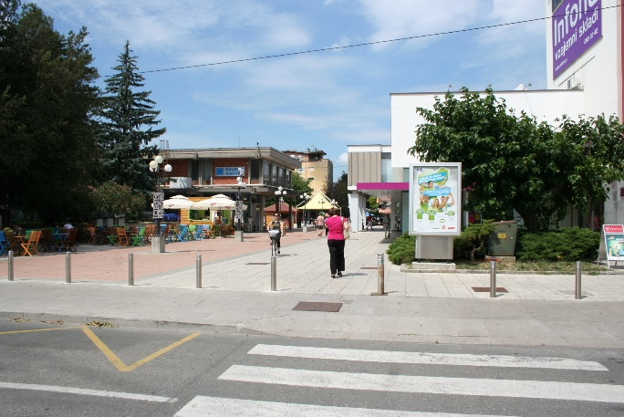
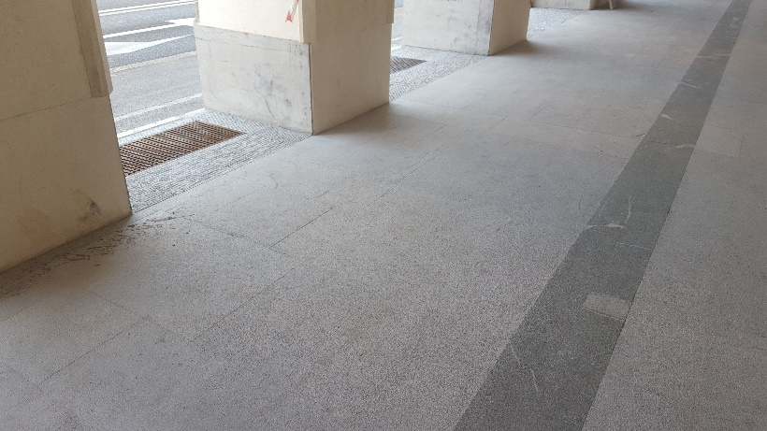
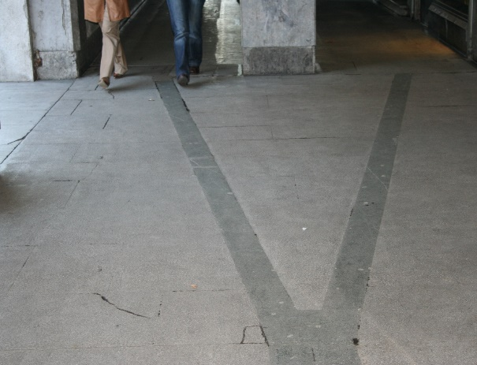
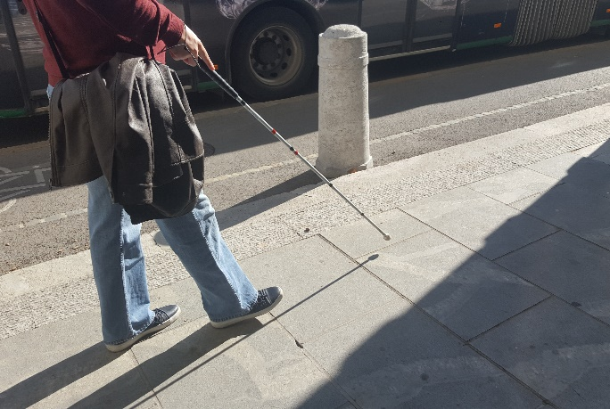
Pictures: photographs of two city parts built in different time periods. Accessibility features are planned considering the basic design concepts and features of each city. Photographs 1a and 1b: The Bevkov trg Square in Nova Gorica. The city of Nova Gorica was built after World War 2 as a “garden city”. The square was renovated several years ago (Picture 2) with the tactile warning surface indicators incorporated in the structure of the new pavement as a part of its visual design. Photographs 2a and 2b: The first photograph shows the paving in front of the Ursuline Church in Ljubljana (under cultural heritage protection). During the reconstruction the tactile paving was made from the stone with a rough surface structure to help white cane users. Line made from dark stone was preserved as a guiding line for partially sighted people.

1.2 Lack of important interactions
The second important difficulty in ensuring accessibility in cities is lack of communication and exchange of information between different stakeholders (municipal administration, project designers, maintenance services, public passenger transport services, designers). Cooperation between those services is vital for their success in ensuring accessibility. Since accessibility of built environment is closely related with accessibility of information and services, all the above services should follow the same goal. Main goals are laid down in SAP.

1.3 Difficulties in determining “disproportionate costs”
In some environments it is not viable or reasonable to implement certain measures, bearing in mind the relevance of the space for the users. For example, in a village with no blind users it would be neither reasonable nor cost effective to build a complex tactile guiding system, while in a city it is very important to ensure, for example, access to a health centre for the blind. The problem is setting the priorities. Who determines whether a cost is disproportionate and unnecessary? In line with the Convention on the Rights of Persons with Disabilities the preparation of SAP is carried out in cooperation with organisations of people with disabilities (local representatives), which determine when the measure is necessary and reasonable in certain environment and when the local community may simplify certain legal requirements. SAP also lays down the group that is responsible for monitoring the implementation of the plan on behalf of organisations and taking measures in cases when it is necessary to make compromises.

2. Structure of the Strategic Accessibility Plan
The task of SAP draftsman is to determine the safe routes (or higher accessibility level routes) leading to selected buildings and open spaces, in order to enable access from the starting point to the destination to all users including the blind.

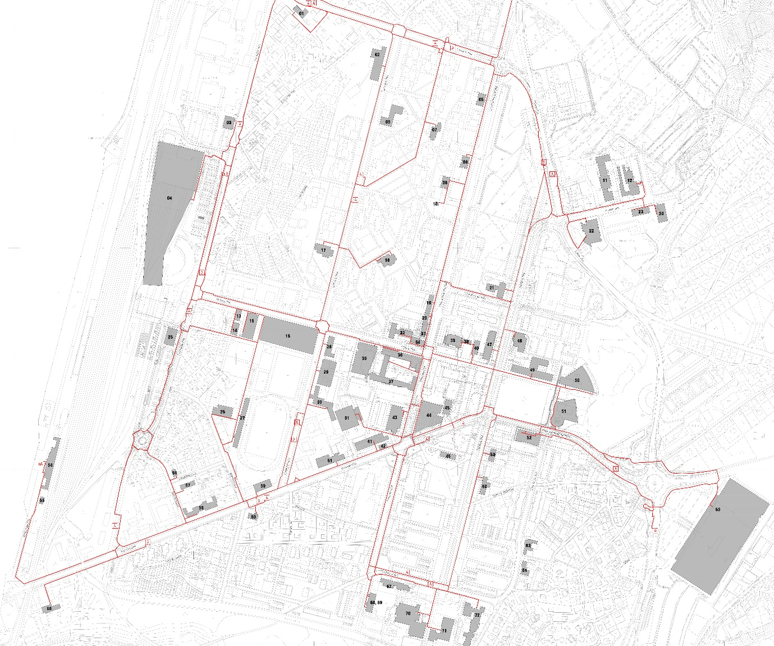
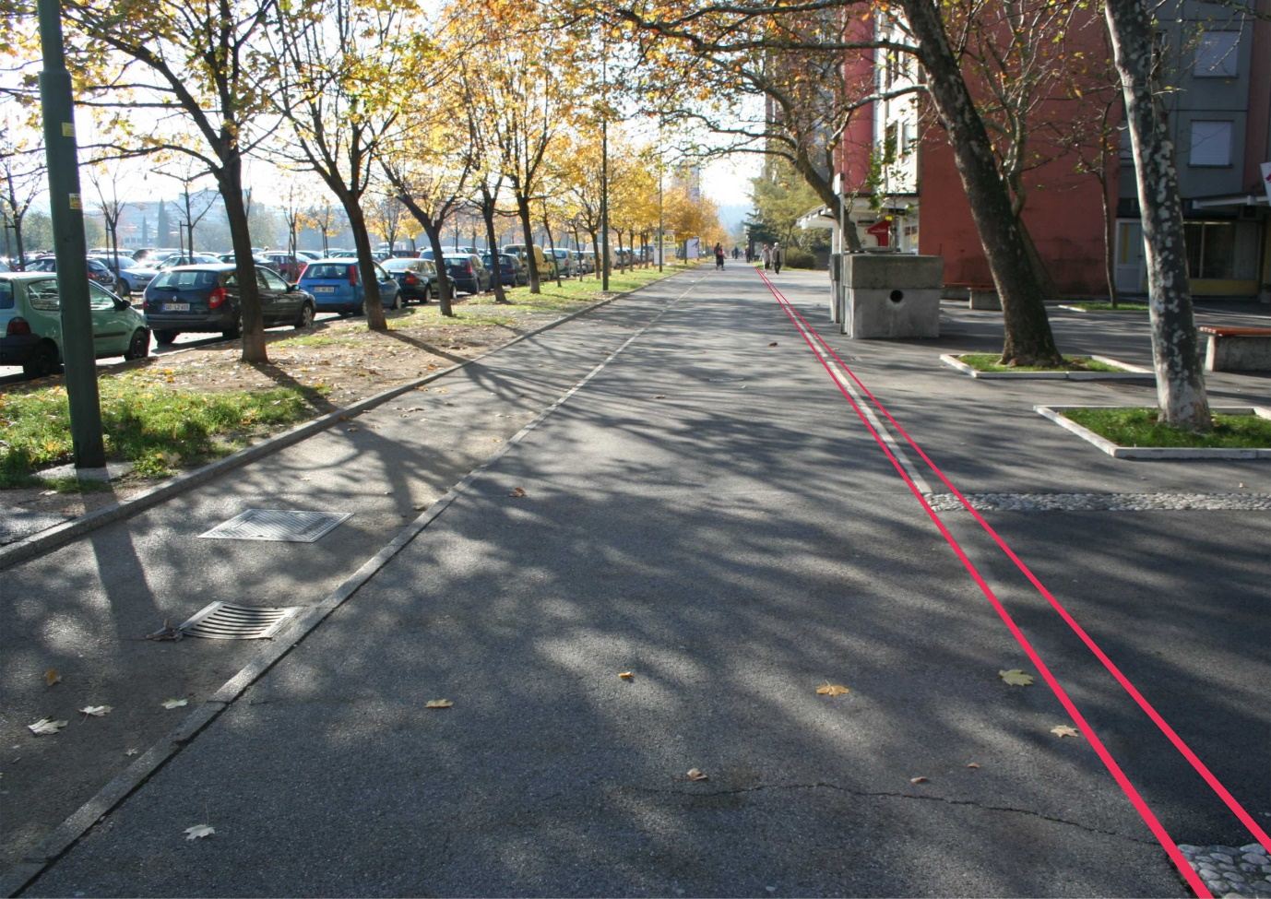
Picture: An overview of the situation in the Strategic Accessibility Plan. It shows the buildings and open spaces selected by the expert group and highlights safe routes (or higher accessibility level routes), railway and bus stations and bus stops. Guiding is designed so as to enable access from the starting point (public transport stations and stops) to the destination (building or external surface) to all people.
Picture: the above photograph shows a solution that can improve accessibility for the blind and partially sighted. A strip is marked on the pedestrian zone, which is to be paved with gravel-stone. Such strips paved with gravel-stone are already incorporated in the existing design (on the right side of the picture). The guiding line paved with gravel-stone is to be joined on both sides with the existing built edges.

2.1 Starting points: public transport stations
The starting points in SAP are public transport stations. Public transport is defined as the most efficient and the most appropriate mode of connecting the regional centre with its outskirts. SAP therefore dedicates a special chapter to the public transport system and lists the proposals for its improvement (e.g. dial-a-ride services, a funicular in case of large differences in height between buildings etc.). SAP also includes proposals for new bus stops or other public transport stops in cases when this would further improve accessibility (e.g. introducing a bus stop at the railway station). Public transport stops can be regarded as starting points if they are appropriately adapted (both in terms of spatial accessibility and accessibility of information and services) and if the use of public transport vehicles is enabled (low-floor buses, stopping at defined entrance points and other requirements in line with European legislation). Accessibility of public transport is dealt with in a separate chapter of SAP that covers:
- measures for enabling access to railway and bus stations and stops;
- provision of access to the main information desk or information board;
- provision of access to toilet facilities and railway platforms;
- platform markings (using letters of appropriate size and contrast, as well as Braille when appropriate).
Recommendations are also given for the design and siting of bus stops (contrasting design against the background, appropriate marking of the bus stop name, appropriate sitting elements, appropriate paving of the bus stop etc.), with an emphasis on the standardisation of projecting roofs and appropriate ways to show information on bus arrivals.

2.2 Connections: Safe routes
Safe routes enable access from public transport stations and stops to the destination (a building or open space such as parks, squares etc.). There are several possible routes from the public transport station to the destination, and the task of the SAP draftsman is to define those routes that can be upgraded with the most acceptable measures (from the social, environmental and spatial points of view). It is not possible to fully adapt all the routes in the city due to various reasons (ownership, cultural heritage protection, costs etc.). The aim of SAP is to determine the most suitable routes from the starting point to the destination, which are also the most appropriate in terms of realisation and maintenance. The other areas are defined in SAP as basic accessibility level routes and can be transformed into higher accessibility level routes at the users' initiative, which is especially important when reconstruction of those areas is planned.
On safe routes some solutions ensuring the highest accessibility level are proposed. In practice that means continued routes enabling the guiding of the blind and partially sighted. At sections where route edges are discontinued or provide insufficient tactile information, measures are envisaged to enable tactile recognition of the edge.<0} Edges can be equipped with standard or non-standard tactile indicators, depending on the spatial context. Tactile warning surface indicators in Slovenia follow the SIST 1186: 2016 national standard. Apart from TWSI, SAP provides the use of acoustic traffic lights and other additional features to improve accessibility.
<0}
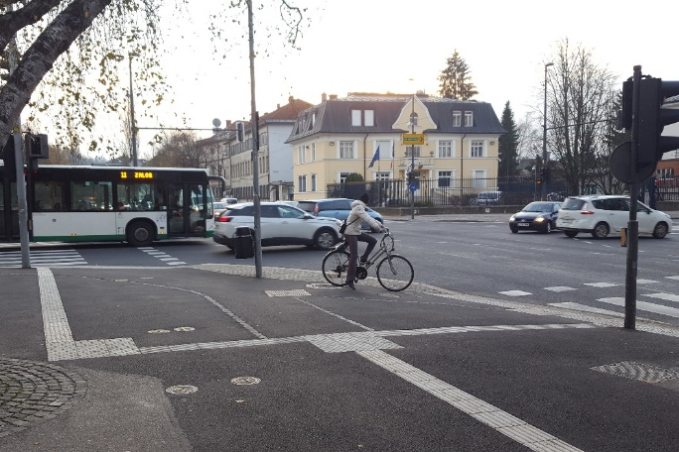
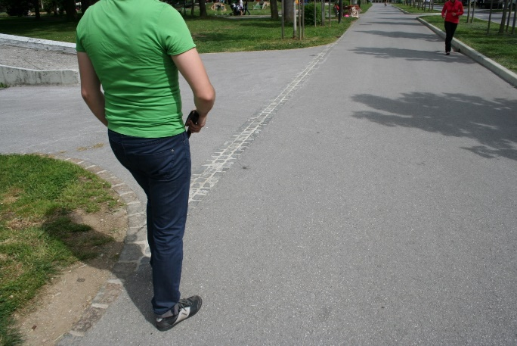
Photograph 1: An example of standard tactile indicators for guiding the blind. A line of warning indicators is placed at the edge of the road surface, while the tactile guiding lines connect pavement edges with pedestrian crossings and acoustic traffic lights. Photograph 2: An example of non-standard tactile paving in the protected natural area (Tivoli Park). Standard indicators were not used due to the protection of cultural and natural heritage in the park. Instead, alternative solutions were found in cooperation with the Union of the Blind and Partially Sighted of Slovenia (ZDSSS). The white cane user follows the edge between the green area and the road surface. At the section where the edge is interrupted due to the access road, the line is continued with non-standard warning indicators made of granite cubes.

2.3 Destinations – buildings and open spaces
SAP can also contain a detailed analysis of buildings and open spaces selected by the expert group. It may propose measures to ensure access to the entrance (the guiding line, appropriate equipment of staircases and ramps, requirements for entrance door etc.) and to the information desk or information board that enables orientation in the building. It may also contain proposals for the design of information boards that are accessible for the blind and partially sighted.

2.4 Safe routes and other routes in the city
Safe routes are routes with the highest accessibility level. In addition to measures enabling guiding of the blind and partially sighted it is important that no barriers are placed on those routes (such as pub gardens, dustbins, benches etc.). Other routes in the city are regarded as routes with the basic accessibility level. That means that they have to be barrier-free with appropriately designed bus stops, pedestrian zones and pedestrian crossings while ensuring basic safety and movement to all people. In those areas it is not necessary to ensure full continuity of access routes for the blind. However, it may be subsequently established that a higher accessibility level is required at a certain section within that area (for example if there is a new building of vital importance for which access has to be provided, or if there is a blind student that needs special measures to ensure him/her a safe route to school etc.). Such an initiative is dealt with by the Accessibility Council (explained in the next chapter), which may decide to include such areas into the highest accessibility level.
SAPs are important for maintenance also. The municipality has to ensure that the inhabitants are informed of the opening of a construction site. This is especially important when the construction site is located in the highest accessibility level area. In such cases alternative routes have to be provided with appropriate connection with the highest accessibility level route.

3. Strategic Accessibility Plan preparation procedure
The SAP draftsman invites the representatives of people with disabilities and municipal administration representatives responsible for the realisation of SAP to participate in its preparation as members of the expert group for the preparation of SAP. The expert group draws up a list of all important buildings and open spaces that require universal access.
After the expert group carries out site visits and meetings, the draftsman prepares the draft plan and submits it to the expert group for approval or amendment.
An important part of SAP is the presentation organised in the form of a workshop after the plan is drawn up, to which the managers of buildings and open spaces laid down in SAP are invited. The draftsman informs them of the contents of SAP and the measures envisaged in the area where those buildings or open spaces are located. Such workshops enable a better insight into the accessibility measures, and they motivate the managers and provide guidelines for the implementation of those measures.

4. Implementation of SAP
A proposal for the establishment of the Accessibility Council (representatives of organizations of people with disabilities) is prepared in agreement with the expert group and included in SAP. The task of the Accessibility Council is to monitor the implementation of SAP. It points to architectural and communicational barriers, proposes initiatives to remove them and organises activities related to accessibility. Under the SAP the municipality undertakes to prepare the action plan for the implementation of measures contained in SAP and to ensure annual funds for the realisation of those measures in the next four years. The Accessibility Council monitors the SAP-related activities carried out by the municipality with the aim to constantly improve the quality of spatial arrangements and accessibility of information and services. The Accessibility Council is also responsible for reaching compromises in cases of large-scale reconstructions that significantly change the traffic arrangement and may affect the routes for the blind.
The municipality includes safe routes into its spatial portal, which provides information on safe routes that may not be discontinued to persons planning a new construction or reconstruction in the safe route area. When planning new accessibility arrangements the municipality may provide assistance or refer planners to accessibility experts who are able to plan the accessibility measures so as to appropriately integrate them and give an impression that they are a part of the general visual image. This ensures that the fundamental concepts of universal planning and design are followed to the best possible extent.
The concept of strategic accessibility planning is summarized with the following diagram:

STRATEGIC ACCESSIBILITY PLAN
SETTING UP THE EXPERT GROUP (representatives of people with disabilities, municipal administration representatives and the SAP draftsman)

SELECTION OF IMPORTANT BUILDINGS AND OPEN SPACES (determined by the expert group), SITE VISITS

DRAWING UP SAFE ROUTES (from the public transport station to the destination) + presentation of concrete measures for ensuring accessibility

REVIEW OF THE PLAN (the expert group presents its comments), AMENDMENT OF THE PLAN

ADOPTION OF THE PLAN AND SETTING UP THE COUNCIL FOR PERSONS WITH DISABILITIES

ORGANISATION OF WORKSHOPS FOR EMPLOYEES WORKING IN THE BUILDINGS SELECTED IN SAP, TRAINING OF MUNICIPAL ADMINISTRATION WORKERS (the general public is also invited)

REALISATION OF THE PLAN: ACTION PLAN IS DRAWN FOR THE NEXT 4 YEARS, IMPLEMENTATION IS MONITORED BY THE MUNICIPALITY (REALISATION) AND THE COUNCIL FOR PERSONS WITH DISABILITIES (INITIATIVES)

AUDIT IS PERFORMED AFTER 4 YEARS

5. Importance of SAP concept in Slovenia and follow-up activities
Over the years, the preparation of Strategic Accessibility Plans has proven to be an example of good practice. The idea of SAP, the way all stakeholders are involved in its preparation and its applicability were very positively assessed, so its concept is now included in national legislation also. Along with the preparation of the concept other activities were also carried out. The DOSTOP Accessibility Institute has prepared the handbook for the Ministry of the Environment and Spatial Planning entitled Strategic Accessibility Planning. It contains detailed information for municipalities about the SAP preparation procedure. DOSTOP also provides information to project designers about the measures ensuring better accessibility for the blind and partially sighted as well as other users and the ways to implement them. Future activities are also envisaged for the improvement of public transport accessibility.
DOSTOP carries out its activities in cooperation with the blind and partially sighted, mostly through the Union of the Blind and Partially Sighted of Slovenia. In addition to its contribution to development of national legislation DOSTOP is very active in practice where it promotes cooperation between project designers, users, local communities and the legislator. This is of key importance for improving accessibility which goes beyond the interests of individual groups. The concept of SAP involves and integrates various groups, each of which can contribute in its own way to better accessibility. In the last decade, thanks to intensive activities carried out by members of DOSTOP, sensitivity for the needs of the blind and partially sighted has improved significantly in Slovenia.

