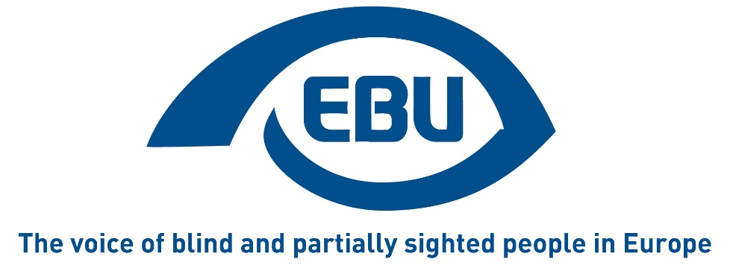

Adequate standard of living and social protection.
Monitoring the Rights of Blind and Partially- Sighted People in Europe: An Analysis of the European Blind Union CRPD Database

By Sarah Woodin
on behalf of the European Blind Union
September 2016

Table of Contents

Abbreviations 3

Country Abbreviations 4

1. Purpose of the Report 5

2. Article 28 of the CRPD 6
- 2.1. Links to other CRPD measures 7

3. UN Policy on Social Protection and Sustainable Development Goals 8

4. EU Policy on Social Protection 10
- 4.1. European Union 10
- 4.2. Council of Europe 11

5. EU Social Protection Information Systems 12
- 5.1. ESSPROS 12
- 5.2. MISSOC 13
- 5.3. MISSCEO 13

6. Analysis of Data on Social Protection (Article 28 of CRPD) on the EBU Database 13
- 6.1. Introduction 13
- 6.2. Distinction between the Measures 15
- 6.3. Resources and Income of Disabled People 17

6.3.1. Types of Allowance 18

6.3.2. Resources for people who become
disabled during their working lives 26

6.3.3. Disability Compensation 32

7. Conclusion 39

Abbreviations

CRPD Convention on the Rights of Persons with Disabilities
EBU European Blind Union
ESSPROS Integrated system of social protection statistics
EU European Union
IDA International Disability Alliance
MISSOC Mutual Information System on Social Protection
OECD Organisation for Economic Cooperation and Development
OMC Open Method of Co-ordination
SDG Sustainable Development Goal
UK United Kingdom of Great Britain and Northern Ireland
UN United Nations

Country Abbreviations

AL Albania
AT Austria
BG Bulgaria
CH Switzerland
CZ Czech Republic
DE Germany
DK Denmark
EE Estonia
FR France
HR Croatia
HU Hungary
IS Iceland
IT Italy
ME Montenegro
MT Malta
PL Poland
RU Russian Federation
SI Slovenia
SK Slovakia
UK United Kingdom

Purpose of the Report
This report will present findings on social protection measures provided by European Blind Union (EBU) country experts with regard to blind and partially sighted people. Twenty one countries took part in compiling the information and the data on which this report is based is available on the EBU online database.
The information in this report can inform a wide range of interested parties, including campaigners, policy makers and others who are working to further social protection for blind and partially sighted people. The importance of the issues raised cannot be overlooked. An adequate standard of living and social protection is fundamental to the wellbeing of all people and underpins the social policies and raison d'être of welfare states. It is therefore to be expected that the subject is complex and cannot be comprehensively dealt with in a report of this size and scope. Nevertheless, this report is able to highlight some important issues that may be overlooked elsewhere, especially the perspectives of people in receipt of allowances.
The work is timely in that the global financial crisis and ensuing austerity measures have raised questions about nation states’ strategies for cutting costs. The United Nations, and OECD as well as other international bodies have raised pertinent questions about the impact of austerity measures on disabled people’s standard of living, including the countries included in this report. Reporting from the Academic Network of European Disability Experts (ANED) shows, for example, continuing poverty among disabled people across Europe in 2015 /2016.
In this report, after outlining the provisions of Article 28 of the United Nations Convention on the Rights of Persons with Disabilities (CRPD), the measures taken by the United Nations (UN) and European Union (EU) on social protection are described. The various types of databases that provide information on allowances and social protection, reports and other monitoring are also discussed.
The main part of the report presents a synthesis of the findings of EBU experts, after which some conclusions are offered, together with some suggestions for further research.

Article 28 of the CRPD
Article 28 states that:
1. States Parties recognize the right of persons with disabilities to an adequate standard of living for themselves and their families, including adequate food, clothing and housing, and to the continuous improvement of living conditions, and shall take appropriate steps to safeguard and promote the realization of this right without discrimination on the basis of disability.
2. States Parties recognize the right of persons with disabilities to social protection and to the enjoyment of that right without discrimination on the basis of disability, and shall take appropriate steps to safeguard and promote the realization of this right, including measures:
- To ensure equal access by persons with disabilities to clean water services, and to ensure access to appropriate and affordable services, devices and other assistance for disability-related needs;
- To ensure access by persons with disabilities, in particular women and girls with disabilities and older persons with disabilities, to social protection programmes and poverty reduction programmes;
- To ensure access by persons with disabilities and their families living in situations of poverty to assistance from the State with disability-related expenses, including adequate training, counselling, financial assistance and respite care;
- To ensure access by persons with disabilities to public housing programmes;
- To ensure equal access by persons with disabilities to retirement benefits and programmes.
Article 28 therefore covers a wide range of measures that are essential to survival and basic wellbeing, with a primary focus on protection from poverty for all disabled people, especially women and girls and older people. Access to water, food, clothing, and housing and decent living conditions is emphasised and action to promote inclusion through accessibility as well as the availability of assistance is required.
What is meant by ‘services and devices’ is not clearly explained in the CRPD, although there is some further information in the Concluding observations on countries’ progress. Examples mentioned include loss of access to health care services when taking up employment in Thailand and the need for support services and shelter homes in situations where people fall into destitution in Portugal. Conceivably a much wider range of services might be covered by this measure.

Links to other CRPD measures
There is an overlap with other CRPD Articles, with Articles 19(b), and 26 are particularly relevant. According to Article 19(b) states should ensure that:
“Persons with disabilities have access to a range of in-home, residential and other community support services, including personal assistance necessary to support living and inclusion in the community, and to prevent isolation or segregation from the community”.
Further, Article 26 requires States Parties to:
“organize, strengthen and extend comprehensive habilitation and rehabilitation services and programmes, particularly in the areas of health, employment, education and social services.”
Concluding Observations of the CRPD committee emphasise overall the problem of poverty experienced by disabled people, although services, devices and assistance which States are expected to provide are mentioned in Article 28(2)(a). Indeed, they contain very few references to ‘services’ and ‘devices’ for disability-related needs - in connection with Article 28.

UN Policy on Social Protection and Sustainable Development Goals
From the point of view of the UN, social protection refers to a set of public policy actions aimed at dealing with income poverty and also at addressing social disadvantage, with implications for social inclusion and human rights. Although initiatives may take the form of financial assistance they are not limited to this and policies need to address not only the current context and problems but also potential future uncertainties. As noted above, social protection has taken on particular importance in recent years due to the effects of the 2008 financial crisis and the subsequent austerity policies that characterise many governments’ priorities.
In the 1 January 2016 the UN stated implementation of the 2030 Agenda for Sustainable Development, which builds on the Millennium Development Goals. Eradication of extreme poverty is a key issue and of the 17 goals, the following have particular relevance to social protection and Article 28 of the CRPD:
Goal 1: End poverty in all its forms everywhere. This goal explicitly includes the provision of social assistance and social protection.
Goal 2: End hunger, achieve food security and improved nutrition and promote sustainable agriculture
Goal 5: Achieve gender equality and empower all women and girls
Goal 6: Ensure availability and sustainable management of water and sanitation for all
Goal 10: Reduce inequality within and among countries
Goal 16: Promote peaceful and inclusive societies for sustainable development, provide access to justice for all and build effective, accountable and inclusive institutions at all levels.
However in the Concluding observations of the CRPD committee, where reference has been made to the need of countries to more closely link measures to the Agenda, it is Goal 10 that is cited, which:
“calls for reducing inequalities in income, as well as those based on sex, age, disability, race, class, ethnicity, religion and opportunity—both within and among countries”.
The International Disability Alliance points out that seven of the 169 targets across the 17 goals make explicit reference to persons with disabilities and that furthermore, all goals and targets apply to disabled people because of the overarching principle of universality: “leave no one behind.” Therefore there are clear links with other measures that have wider aspirations for the reduction of inequality between social groups within a non-medical framework although the formation of these links is quite recent and there would seem to be scope for further consolidation, something that is reflected in UN development policy

EU Policy on Social Protection

European Union
Social Protection is presented by the European Union as central to the Europe 2020 strategy, where it is stated that the central aim is the development of a ‘smart, sustainable and inclusive economy.’ There are targets for the EU as a whole to lift at least 20 million people out of poverty and social exclusion, and to increase employment of the working age population aged 20-64 to 75%.
Flagship Initiatives linked to the Europe 2020 strategy include the Platform against Poverty and Social Exclusion and the Agenda for New Skills and Jobs, which aim to support reaching these targets. EU funding is aimed towards the promotion of social investment by member states, with a primary focus on support for independent living and workplace accessibility for disabled people. At the same time as an emphasis on social inclusion, there is also support for efficiency, activation and modernisation of the economies of member states, which have been both supported and criticised by disabled people. Austerity measures have attracted particular criticism, for example in 2015 the UN CRPD Committee noted a:
disproportionately adverse and retrogressive effect the austerity measures in the EU have on the adequate standard of living of persons with disabilities.
Political co-operation on social inclusion and social protection is achieved through the Open Method of Co-ordination (OMC), a voluntary process employing agreed objectives, indicators and collaboration with social partners and civil society. This means that the policies of member states have a continuing relevance for social protection.

Council of Europe
The Council of Europe has a wider membership of 41 countries and has adopted two treaties in support of UN Universal Declaration of Human Rights: the European Convention on Human Rights and the European Social Charter (renamed the Charter in its revised form). The latter guarantees social and economic rights, including social security, and social protection in the revised version. There is explicit recognition of disabled people.
The Council of Europe ‘Acton Plan to promote the rights and full participation of people with disabilities in society: Improving the quality of life of people with disabilities in Europe 2006-2015’ includes the following objective:
To guarantee an adequate level of social protection for persons with disabilities, while promoting policies which advance the shift from benefit dependency towards employment and independence.
This Plan has recently been evaluated. The evaluation report notes improvements in the access of disabled people to social protection. However, there is a continuation of a medical model of disability, which in conjunction with poor information and inadequate information, can lead to the removal of disabled children and adults from natural living environments (family, school and community). The need to ensure adequate social protection while ensuring access to community life is highlighted.
Consultation on the next Action Plan was opened in May 2016 and further developments had not been announced at the time of writing this report.

EU Social Protection Information Systems
Data is available on social protection measures and systems in EU member states including the European Economic Area and Switzerland (MISSOC) and Council of Europe countries (MISSCEO). A brief summary of these databases is provided below.

ESSPROS
EU statistics are provided by Eurostat. Because social protection data between member states is highly variable, the European system of integrated system of social protection statistics (ESSPROS), provides a framework for analysing and comparing social protection data across borders. Both social benefits to households and how they are financed are included. The functions included are disability, sickness/health care, old age, survivors, family/children, unemployment, housing and social exclusion.

MISSOC
This project provides information on 32 national social security systems: of the EU member states, EEA countries and Switzerland. Reporting is carried out by representatives of national ministries or organisations that have responsibility for social protection and data is updated twice a year. From 2011 country guides have also been produced.
The database provides a comprehensive official version of social protection systems and how they should work.

MISSCEO
The information contained in the MISSCEO database is intended to be complimentary to the MISSOC system. Countries included are those that are part of the COE but that are not already covered by MISSOC. Information is updated on an annual basis.

Analysis of Data on Social Protection (Article 28 of CRPD) on the EBU Database

Introduction
The EBU’s online database on the CRPD was initiated in 2008 and continues to be developed. Its focus is to collect and present data from the total of 40 participating countries on specific aspects of national law and policy. There is a particular emphasis on the collection of data especially relevant to blind and partially sighted people.
The database is organised into sections that correspond with the various UNCRPD articles. This report is based on the data presented by national authors in the section on Article 28. The 21 countries that participated and are included in this analysis are as follows, with abbreviations following the name of the country:
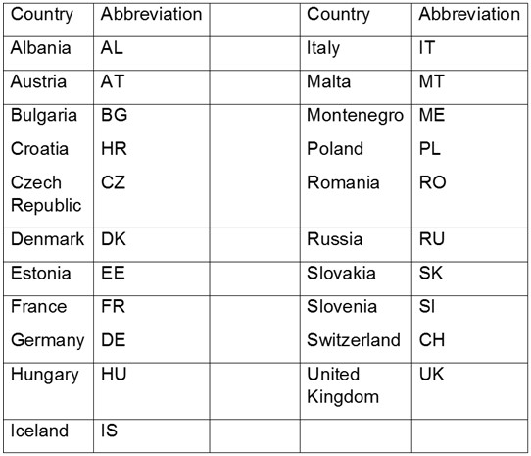
Albania - AL; Austria – AT; Bulgaria – BG; Croatia – HR; Czech Republic – CZ, Denmark – DK; Estonia – EE; France – FR, Germany – DE; Hungary – HU; Iceland – IS; Italy – IT; Malta – MT; Montenegro – ME; Poland – PL; Romania – RO; Russia – RU; Slovakia – SK; Slovenia – SI; Switzerland – CH; United Kingdom – UK.

Country authors were asked questions under two main headings:
- The Resources and Income of Disabled People
- Are there specific legislative procedures for disabled people to enable them to have a minimum of resources?
- Do laws exist in your country to enable a minimum of resources for people who become disabled during their working lives?
- Disability Compensation
A number of subsections asked authors to provide further details under these main headings and these are presented in the next section.

Distinction between the Measures
Measures in Part A aimed to find out about basic income, and income in lieu of earnings where people were unemployed. Part B considers payments in recognition of the additional costs of living with impairment. However it is evident from the expert responses that the difference between these two measures is not always clear in different countries and therefore the answers cannot be taken as definitive for the purposes of comparison. This is because there are differences in the way that countries initially conceive of social security payments and in the degree to which the distinction between income replacement and additional costs is clearly made. Secondly there may be differences in the way that payments are effected in policy over time. For example an allowance might be in theory intended to meet the additional costs of living with impairment or disability, while in practice it could be treated as if it were an income replacement benefit. This is not to suggest that this is necessarily the case in all countries but it is a possibility to be considered in interpreting the data. This would be a question to be potentially followed up in the future.
Questions asked of the experts also allowed for a certain amount of discretion with regard to how welfare payments are characterised. It may be assumed that some authors interpreted questions as asking whether specific measures for blind and partially sighted people were in place, while others interpreted them as asking about whether there are measures for disabled people more generally. It is for this reason that the answers cannot be taken as directly comparable.
There are also limitations to the data in that some questions were not answered or the answer ‘not applicable’ was given, even though in some cases there must have been a relevant answer (e.g. regarding age). In part this may be an issue of language that could be clarified with guidance notes for authors.
This being said, the data provides an opportunity to consider social protection measures from the point of view of service users, as actually implemented in practice, rather than the way that they ‘ought’ to be implemented according to official sources. This is the value of the EBU database and its contribution to work on the CRPD.
By way of introduction to the overall pattern of replies, a comparison is given of whether there are legal provisions made for disabled people to have minimum resources, compensation for lost earnings and compensation for additional costs. Explanation of the content is given directly below each table in this report.
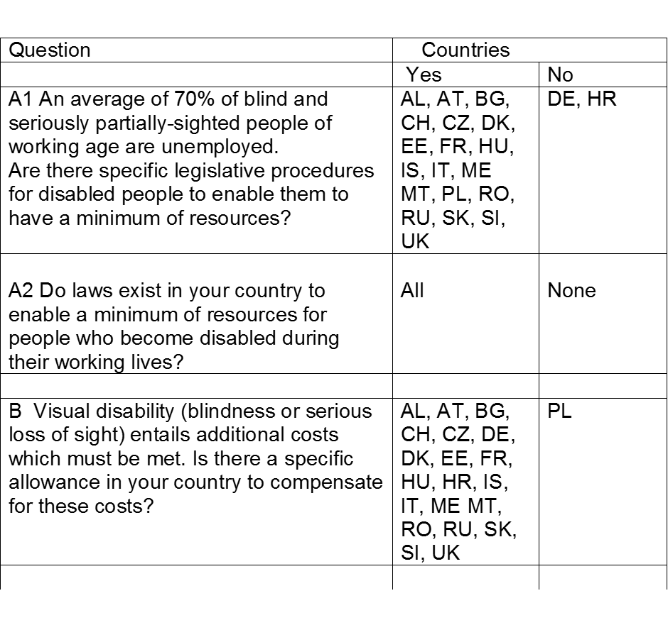
Explanatory note:
The Introductory question reads: A1) An average of 70% of blind and seriously partially-sighted people of working age are unemployed. Are there specific legislative procedures for disabled people in your country to enable them to have a minimum of resources?
In answer, the following countries said ‘Yes’: AL, AT, BG, CH, CZ, DE, DK, EE, FR, HU, HR, IS, IT, ME, MT, RO, RU, SI, SK, UK
The following countries answered ‘No’: DE, HR
The second overall introductory question reads: A2 Do laws exist in your country to enable a minimum of resources for people who become disabled during their working lives?
In answer, all countries replied ‘Yes’
The third overall introductory question reads: B Visual disability (blindness or serious loss of sight) entails additional costs which must be met. Is there a specific allowance in your country to compensate for these costs?
In answer, the following countries said ‘Yes’: AL, AT, BG, CH, CZ, DK, EE, FR, HU, IS, IT, ME, MT, PL, RO, RU, SI, SK, UK
The following country answered ‘No’: PL
It is evident therefore that virtually all countries make some provision for the basic income and additional costs of living with impairment experienced by disabled people. Of the exceptions, in Germany (question A1) it is reported that there are no legislative procedures specifically on account of disability for those without work but disabled people do receive unemployment benefits and special efforts are made to get them into work. Those who never worked or are long term unemployed are entitled to a benefit which is paid at a level below welfare payments (ALG II). Further details for Croatia and Poland were not available.

Resources and Income of Disabled People
The aim of this section is to assess whether disabled people and particularly blind and partially sighted people have access to adequate resources and income from whatever source. The CRPD highlights as important access to water, food, clothing and housing, as well as continual improvement in living conditions and financial resources.

Types of Allowance
A range of different kinds of allowances are described. Some countries provide single examples or describe the main allowance provided, while others indicate the wide range of measures that may be available (e.g. BG, HU, UK)

Authors are asked for details of national legislation: “If yes: what are these allowances?”
The replies about the existence of legislation have been detailed above. Answers given about the name of the allowance were very wide ranging, making it difficult to categorise the measures succinctly. However, they roughly fell into categories of allowances that depended on employment status and those that were awarded on the basis of impairment or disability (including levels of disability in some instances) without reference to employment, income or savings:
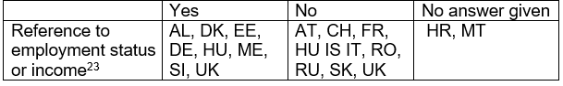
Explanatory note:
Question: Is the allowance given with reference to employment status or income?
Yes: AL, DK, EE, DE, HU, ME, SI, UK
No: AT, CH, FR, HU IS IT, RO, RU, SK, UK
Not answered: HR, MT
The database information does not specify the effectiveness of the laws or how they interact with other measures. As noted in the Albanian entry, existence of legal measures was no guarantee of implementation so these remain open questions for further investigation.
The following sections give an analysis of data given on other questions.

Question 1 reads: What are the eligibility criteria?
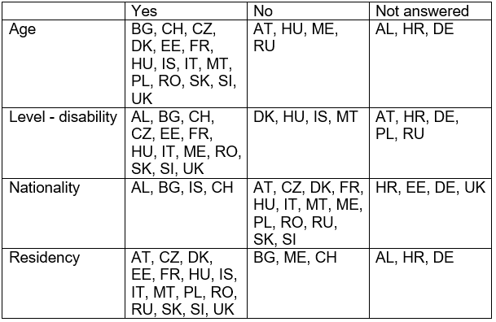
Explanatory note:
Several categories of data are provided in the above table, concerning age, whether different levels of impairment / disability are specified, whether nationality is necessary and whether residency is required. The answers given are as follows:
Is age specified as an eligibility requirement?
Yes: BG, CH, CZ, DK, EE, FR, HU, IS, IT, MT, PL, RO, SK, SI, UK
No: AT, HU, ME, RU
Not answered: AL, HR, DE
Are levels of impairment / disability specified?
Yes: AL, BG, CH, CZ, EE, FR, HU, IT, ME, RO, SK, SI, UK
No: DK, HU, IS, MT
Not answered: AT, HR, DE, PL, RU
In nationality required?
Yes: AL, BG, IS, CH
No: AT, CZ, DK, FR, HU, IT, MT, ME, PL, RO, RU, SK, SI
Not answered: HR, EE, DE, UK
Is residency required?
Yes: AT, CZ, DK, EE, FR, HU, IS, IT, MT, PL, RO, RU, SK, SI, UK
No: BG, ME, CH
Not answered: AL, HR, DE
The relationship between nationality and residency is a complex one and these issues are beyond the scope of this report. Nevertheless they are important for explaining how countries control eligibility to allowances. Residency rather than nationality is the main mechanism for determining eligibility by EU member states where there is free movement of labour. Age restrictions also serve to determine eligibility within the country and level of disability is used in a similar way. While certain countries use percentages of functioning others included in the ‘yes’ column are those who pay higher and lower rates for different perceived levels of need.

Question 2 reads: Is the allowance means tested?
The definition of means testing varies in different contexts and countries: here the data is presented as it is written.
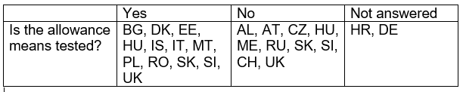

Explanatory note:
Counties that answered ‘Yes’: BG, DK, EE, HU, IS, IT, MT, PL, RO, SI, SK, UK
Countries that answered ‘No’: AL, AT, CH, CZ, HU, ME, RU, SK, SI, UK
Countries that did not answer the question: HR, DE
In the following countries the financial circumstances of family members are taken into account when calculating the allowance: DK, FR, IS, RO. This applies to some allowances only in: PL, UK and SI (for care allowance only).

Question 3 reads: What are the allowances and how are they paid?
This is an amalgamation of three questions in the database, which are about amounts, reductions of payment and the responsible authorities. Details are given below, with the question on responsible authorities answered later in section 5.
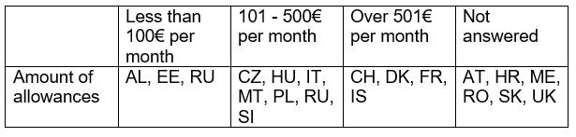
Explanatory note:
Amount of allowances:
Less than100€ per month: AL, EE, RU
101 - 500€ per month: CZ, HU, IT, MT, PL, RU, SI
Over 501€ per month: CH, DK, FR, IS
Not answered: AT, HR, ME, RO, SK, UK
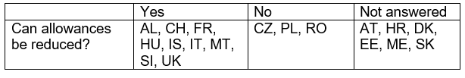
Explanatory note: Can allowances be reduced?
Yes: AL, CH, FR, HU, IS, IT, MT, SI, UK
No: CZ, PL, RO
Not answered: AT, HR, DK, EE, ME, SK
Note on reductions – some of the allowances have to do with employment, others relate to compensation for impairment, where less of a reduction might be expected, as long as there is no change in the condition. There are large variations, for example from 81 euros in Albania to 1,500 euros after tax in Denmark.

Question 4 Reads: What is the minimum wage and poverty line?
There are a range of methods for calculating the poverty line in relation to different household groups (e.g. individuals, couples and people with and without children). As there is no indication of sources and methods for each country the data is not used in this report. Further, there are no cumulative measures available in order to judge poverty in relation to minimum wages. These are complex questions and it is not possible in work of this scope to provide a definitive answer. However wage and poverty line data is provided by experts, as follows:

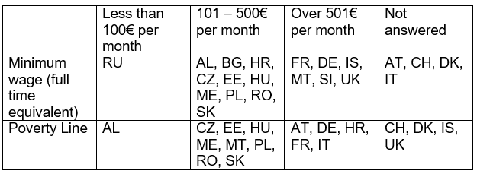
Explanatory note:
Amount of Minimum wage (full time equivalent)
Less than 100€ per month: RU
101 - 500€ per month: AL, BG, HR, CZ, EE, HU, ME, PL, RO, SK
Over 501€ per month: FR, DE, IS, MT, SI, UK
Not answered: AT CH, DK IT
Poverty line (note these are national levels and not equivalent)
Less than 100€ per month: AL
101 - 500€ per month: CZ, EE, HU, ME, MT, PL, RO, RU, SK
Over 501€ per month: AT, DE, HR, FR, IT
Not answered: CH, DK, IS, UK
There is a large variation in the levels at which the poverty line is set. (Author note: Insert explanation of different methods for calculating poverty line) Newer EU countries tend to have lower levels in comparison with longer standing members.

Question 5 reads: What are the organisations which calculate and attribute the allowance?
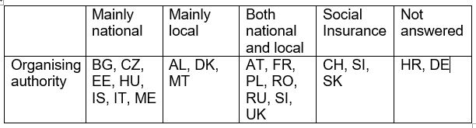
Explanatory note:
Organising authorities for distributing allowances
Mainly national: BG, CZ, EE, HU, IS, IT, ME
Mainly local: AL, DK, MT
Both national and local: AT, FR, PL, RO, RU, SI, UK
Social Insurance: CH, SI, SKs
Not answered: HR, DE
In practice, most authorities operate at both local and national levels. Often a national decision on allowances is put into practice in local areas. However the data above show where the main emphasis of decision making lies and at present this seems to be at the national level. Again, it should be assumed that there will be a range of other allowances other than the one example that most countries have chosen to identify and that different national and local responsibilities may be attributed to those allowances.

Question 6 reads: Is the benefit subject to tax? And: Does this allowance accord any fringe benefits?
Results given for each country are as follows:
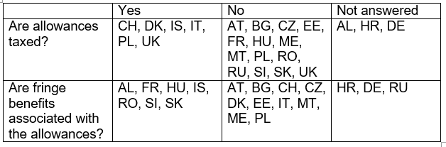
Explanatory note:
Are allowances taxed?
Yes: CH, DK, IS, IT, PL, UK
No: AT, BG, CZ, EE, FR, HU, MT, ME, PL, RO, RU, SK, SI, UK
Not answered: AL, HR, DE
Are fringe benefits associated with the allowance(s)?
Yes: AL, FR, HU, IS, RO, SK, SI
No: AT, BG, CH, CZ, DK, EE, IT, MT, ME, PL
Not answered: HR, DE, RU

Resources for people who become disabled during their working lives
All countries answered ‘Yes’ to the question of whether laws existed to protect people who became disabled during their working lives. Some authors indicated that the same laws protected disabled people as were previously identified, indicating the importance of employment as a determining factor for disability benefits, while others pointed to different measures. Many questions were not answered, indicating that many points had already been answered in previous section.

Question B1 reads: What are the eligibility criteria?
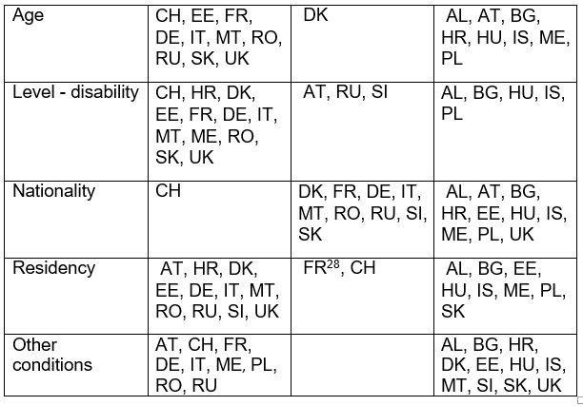

Explanatory text:
Are age levels specified?
Yes - CH, EE, FR, DE, IT, MT, RO, RU, SK, UK
No: DK
Not answered: AL, AT, BG, HR, HU, IS, ME, PL
Are disability levels specified?
Yes: CH, HR, DK, EE, FR, DE, IT, MT, ME, RO, SK, UK
No: AT, RU, SI
Not answered: AL, BG, HU, IS, PL
Is nationality required?
Yes: CH
No: DK, FR, DE, IT, MT, RO, RU, SI, SK
Not answered: AL, AT, BG, HR, EE, HU, IS, ME, PL, UK
Is residency required?
Yes: AT, HR, DK, EE, DE, IT, MT, RO, RU, SI, UK
No: FR, CH
Not answered: AL, BG, EE, HU, IS, ME, PL, SK
Do other conditions apply?
Yes: AT, CH, FR, DE, IT, ME, PL, RO, RU
No: No replies
Not answered: AL, BG, HR, DK, EE, HU, IS, MT, SI, SK, UK

Question 2 reads: What are the Financial Conditions?
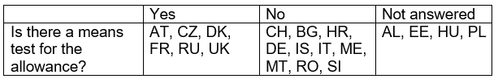
Explanatory note:
Is there a means test for the allowance?
Yes AT, CZ, DK, FR, RU, UK
No CH, BG, HR, DE, IS, IT, ME, MT, RO, SI
Not answered: AL, EE, HU, PL

Question 3 reads: What is the amount of the Allowance?
The amounts are not presented in chart form here because only 7 of the 21 countries gave a figure for the allowance. Other reasons are because:
- Amounts are highly variable, depending on the degree of impairment and / or previous earnings
- There are variations based on local administrative arrangements
- The details had already been given in the previous section
- No answer was provided
Because insufficient answers were given there is no overall conclusion that can be drawn.

Question 4 reads: Who attributes the allowance: State, local government, others?
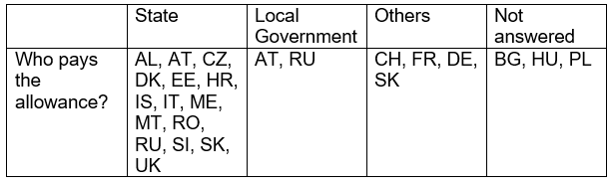
Explanatory note:
Who pays the allowance?
The State: AL, AT, CZ, DK, EE, HR, IS, IT, ME, MT, RO, RU, SI SK, UK
Local government: AT, RU
Others: CH, FR, DE, SK
The answers given did not rule out the involvement of both national and local government, simply reflecting the predominant influence in the administration of the allowance.

Question 5 reads: Is the benefit subject to tax, and does this allowance accord fringe benefits?
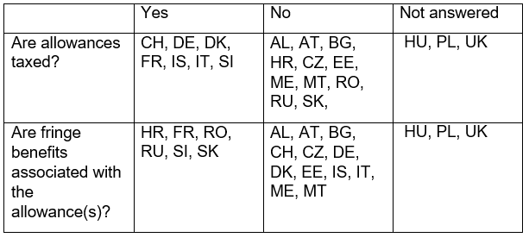
Explanatory note:
Are allowances taxed?
Yes: CH, DE, DK, FR, IS, IT, SI
No: AL, AT, BG, HR, CZ, EE, ME, MT, RO, RU, SK
Not answered: HU, PL, UK
Are fringe benefits associated with the allowance?
Yes: HR, FR, RO, RU, SI, SK
No: AL, AT, BG, CH, CZ, DE, DK, EE, IS, IT, ME, MT
Not answered: HU, PL, UK

Disability Compensation
The introductory question to this section asks:
“A visual disability (blindness or serious loss of sight) entails additional costs which must be met. Is there a specific allowance in your country to compensate for these costs?”
All countries answered ‘yes’ to this question except for Estonia and Poland. No further details were provided in this or other sections from these two countries. As the question may be interpreted to either refer specifically to blind and partially sighted people only, or to disabled people in general, it is possible that the question was interpreted narrowly by the EE and PL authors. Authors also gave an indication of the intended uses of the allowances, as follows:
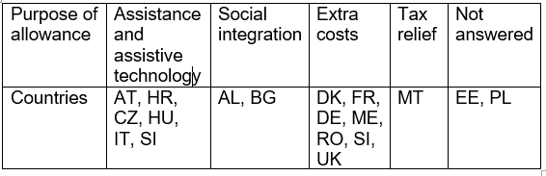
Explanatory note:
What is the purpose of the allowance?
Assistance and assistive technology: AT, HR, CZ, HU, IT, SI
Social integration: AL, BG
Extra Costs: DK, FR, DE, ME, RO, SI, UK
Tax relief: MT
Not answered: EE, PL

Question 1 Reads: What are the eligibility conditions?
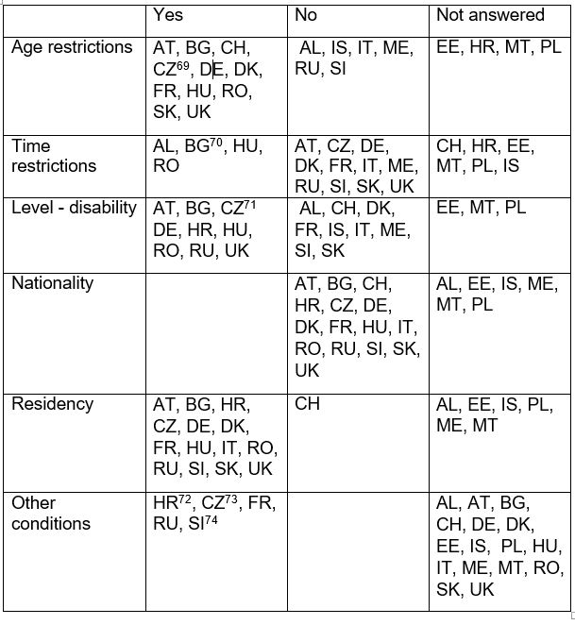
Explanatory note:
Are age restrictions specified?
Yes: AT, BG, CH, CZ, DE, DK, FR, HU, RO, SK, UK
No: AL, IS, IT, ME, RU, SI
Not answered: EE, HR, MT, PL
Are there time restrictions?
Yes: AL, BG, HU, RO
No: AT, CZ, DE, DK, FR, IT, ME, RU, SI, SK, UK
Not answered: CH, HR, EE, MT, PL, IS
Are disability levels specified?
Yes: AT, BG, CZ DE, HR, HU, RO, RU, UK
No: AL, CH, DK, FR, IS, IT, ME, SI, SK
Not answered: EE, MT, PL
Is nationality required?
Yes: None
No: AT, BG, CH, HR, CZ, DE, DK, FR, HU, IT, RO, RU, SI, SK, UK
Not answered: AL, EE, IS, ME, MT, PL
Is residency required?
Yes: AT, BG, HR, CZ, DE, DK, FR, HU, IT, RO, RU, SI, SK, UK
No: CH
Not answered: AL, EE, IS, PL, ME, MT
Do other conditions apply?
Yes: HR, CZ, FR, RU, SI
No: None
Not answered: AL, AT, BG, CH, DE, DK, EE, IS, PL, HU, IT, ME, MT, RO, SK, UK

Question 2 reads: What are the financial conditions?
Only 7 countries provided an answer to this question and those that did were brief. Therefore a table has not been provided for this data. The answers indicate that different types of allowance were being considered, meaning that answers cannot be compared with one another. Points made are that:
Applicants are provided with help if income has been below the poverty line: BG, FR, SK
The allowance is given regardless of other income: RO, SI, UK
Costs are met in line with an assessed level of impairment: RU

Question 3 reads: What is the amount of the allowance?
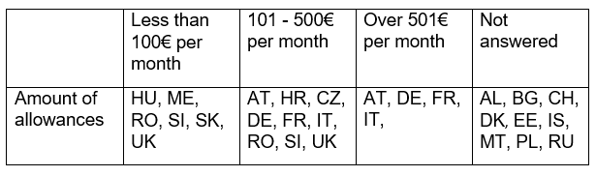
Explanatory note:
Amount of the allowance
Less than 100€ per month: HU, ME, RO, SI, SK, UK
101 - 500€ per month: AT, HR, CZ, DE, FR, IT, RO, SI, UK
Over 501€ per month: AT, DE, FR, IT
Not answered: AL, BG, CH, DK, EE, IS, MT, PL, RU
It is very important to note however that it is not possible to tell from the data provided whether we are comparing the same types of benefits with one another. Also, there is quite a lot of variation in the amounts between different benefits in the countries. Again some talk only of one benefit while others describe several. For example, one country (MT) discusses tax breaks on goods intended to be bought by blind and partially sighted people, while other countries describe extra costs payment etc., as described above, which might be a relatively significant amount.
The figures do indicate some idea about levels of benefit payment however.

Question 4 reads: Which organisations attribute and pay the allowance?
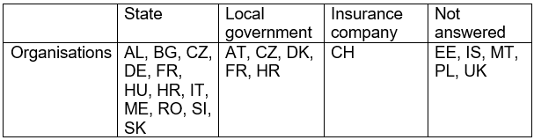
Explanatory note:
The organisations are:
The State: AL, BG, CZ, DE, FR, HU, HR, IT, ME, RO, SI, SK
Local Government: AT, CZ, DK, FR, HR
Insurance company: CH
Not answered: EE, IS, MT, PL, UK
As noted in the previous section, in practice both local and national government were involved in most payments. However the answers given reflect the predominant influence.
Question 5 reads: How is the allowance paid?
Regarding frequency of payments, only 8 countries answered the question (CZ, DE, FR, IT, HU, RO, RU, UK) and all indicated that allowances are paid monthly.

Question 6 reads: Under what conditions can the allowance be reduced?
Countries were evenly split between those where a reduction was possible and those where it was not.
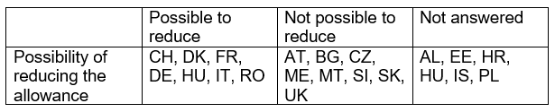
Explanatory note:
Whether the allowance can be reduced:
Possible to reduce: CH, DK, FR, DE, HU, IT, RO
Not possible to reduce: AT, BG, CZ, ME, MT, SI, SK, UK
Not answered: AL, EE, HR, HU, IS, PL
The reasons why the allowance can be reduced are very varied, as shown in the footnotes. It is therefore not possible to make any general comments on this issue.
Question 7 reads: Is the allowance subject to tax and are there fringe benefits?
 | Yes | No | Not answered
Are allowances taxed? | CH | AL, AT, BG, DE, DK, FR, HR, HU, IS, IT, ME, MT, RO, RU, SI, SK, UK | EE, PL
Are fringe benefits associated with the allowance(s)? | AL, HR, CZ, HU, RO, SI, UK | AT, BG, CH, CZ, DE, DK, FR, IS, IT, ME, MT, RU, SK | EE, PL

Explanatory note:
Are allowances taxed?
Yes: CH
No: AL, AT, BG, DE, DK, FR, HR, HU, IS, IT, ME, MT, RO, RU, SI, SK, UK
Not answered: EE, PL
Are fringe benefits associated with the allowance(s)?
Yes: AL, HR, CZ, HU, RO, SI, UK
No: AT, BG, CH, CZ, DE, DK, FR, IS, IT, ME, MT, RU, SK
Not answered: EE, PL
From these answers it is evident that the vast majority of allowances are awarded tax free, reflecting the fact that payments are intended to compensate for living with impairment, regardless of income.
For a few, the allowances provide a passport to other benefits and this is particularly the case in Eastern European countries where certification as a disabled person may allow automatic entitlement to other benefits.

Conclusion

In conclusion, it is clear that the EBU CRPD database has an important contribution to make in terms of highlighting the specific circumstances of blind and partially sighted people with regard to social protection and the experiences of disabled people more generally. Overall, social protection is far too broad an issue to be dealt with in its entirety in a piece of work of this size but the EBU database can add nuance and depth to other information sources, such as DOTCOM, MISSOC and MISSCEO. The EBU database is also a living instrument that gathers current information and so there is potential for further enhancement in the future.
While it is not possible to make definitive statements from the data provided by member countries, there is some cause for concern at the low levels of payment in Eastern European countries compared with many more established EU member states.
The lack of distinction between allowances that are intended for income replacement and those intended for additional costs of impairment are notable. This lack of clarity may well be indicative of understanding more generally in countries and is cause for concern.
Finally the usefulness of the EBU database, on Article 28 and also other Articles, would be considerably enhanced by the use of more targeted specific questions and briefing for the task. It could also be more closely aligned with CRPD requirements (e.g. the situation of women and girls, which is particularly pertinent to social protection). In relation to previous years it remains the case that it is often not possible to ascertain whether responses are referring to the existence of legal requirements or to the existence of measures that have been implemented. This problem could be avoided were questions to be designed so as to focus either on indicators of structure, indicators of process or indicators of outcome. This would also have the advantage of bringing the database into line with other measures on social protection. With this approach in place it should be possible to develop a better judgement in relation to poverty levels among blind and visually impaired people who rely on allowances.
Despite these suggestions for future development, it is evident that the EBU database is developing into a unique and very valuable information source that can illustrate realities for blind and visually impaired people in and associated with Europe that are not available from other sources.

This report is co-funded by the "Rights, Equality and Citizenship Programme" Programme of the European Union.

European Blind Union United Nations Convention on the Rights of Persons with Disabilities http://www.euroblind.org/convention
ANED European Semester 2015/2016 fiche on disability (495 kB)
Concluding observations on the initial report of Thailand CRPD/C/THA/CO/1 12 May 2016 http://tbinternet.ohchr.org/_layouts/treatybodyexternal/Download.aspx?symbolno=CRPD%2fC%2fTHA%2fCO%2f1&Lang=en
Concluding observations on the initial report of Portugal CRPD/C/PRT/CO/1 18 April 2016 http://tbinternet.ohchr.org/_layouts/treatybodyexternal/Download.aspx?symbolno=CRPD%2fC%2fPRT%2fCO%2f1&Lang=en
United Nations (2016) The Sustainable Development Goals Report http://unstats.un.org/sdgs/report/2016/
Millennium Development Goals http://www.un.org/millenniumgoals/
The Sustainable Development Goals Report: Overview http://unstats.un.org/sdgs/report/2016/overview/
International Disability Alliance http://www.internationaldisabilityalliance.org/resources/leave-no-one-behind-hlpf-2016-position-paper-persons-disabilities
United Nations Division for Social Policy and Development https://www.un.org/development/desa/disabilities/about-us/sustainable-development-goals-sdgs-and-disability.html
Europe 2020 http://ec.europa.eu/europe2020/index_en.htm and http://ec.europa.eu/social/main.jsp?catId=1137&langId=en
EU 2020 Targets http://ec.europa.eu/europe2020/europe-2020-in-a-nutshell/targets/index_en.htm
EU Flagship Initiatives http://ec.europa.eu/europe2020/europe-2020-in-a-nutshell/flagship-initiatives/index_en.htm
European Platform against Poverty and Social Exclusion http://ec.europa.eu/social/main.jsp?catId=961&langId=en
Agenda for New Skills and Jobs http://ec.europa.eu/social/main.jsp?langId=en&catId=958
European Union, Social Investment http://ec.europa.eu/social/main.jsp?catId=1044&langId=en
Committee on the Rights of Persons with Disabilities (2015) Concluding observations on the initial report of the European Union http://ec.europa.eu/social/BlobServlet?docId=14429&langId=en
Open Method of Co-ordination http://eur-lex.europa.eu/legal-content/EN/TXT/?uri=URISERV:em0011
Adopted in 2006
Council of Europe (2016)
ESSPROS http://ec.europa.eu/eurostat/web/social-protection/overview
Eurostat http://ec.europa.eu/eurostat/web/main
MISSOC http://www.missoc.org/
MISSCEO http://www.coe.int/en/web/turin-european-social-charter/missceo-database
A large number of examples were given by Hungary, also Bulgaria and the UK, meaning that both measures that were linked to employment and independent of it were mentioned. These countries therefore appear in both sections.
Includes countries where no allowance was previously identified. This also applies to other eligibility criteria.
Indicating that the allowance is available to people of all ages. For Level of disability ‘no’ indicates that gradations in impairment are not recorded: a person is eligible if they have disability status.
However, in Iceland different levels of impairment are taken into account when determining eligibility for the allowance as a whole.
Various arrangements in Switzerland are in place to allow others from outside the country to claim in certain circumstances.
Eligibility depends on insurance not nationality
EU and EEA citizens are eligible in Denmark
Different rules apply in the Czech Republic for those from EU member states and those from other countries.
Answered “same as the European Union”. As there are differences between EU countries this information is insufficient for categorisation.
Savings and income, including that of the family are taken into account.
In Estonia there is a financial taper: the allowance is gradually reduced with increased earnings from employment.
Hungary appears in both categories because several different allowances are discussed
In Poland several allowances are discussed and means testing is not a feature of all payments.
In Slovenia most are not means tested; this only refers to one benefit, care allowance
In the Czech Republic however, there is a financial ceiling.
In rural areas and small towns
At the lower end of the scale
In larger cities, e.g. Moscow.
Cumulative amount involving several benefits.
When the allowance is combined with other payments or the person has a stay in hospital.
Reduced if people are in hospital.
If there is a change in household or family circumstances.
Includes instances where there is no minimum wage, e.g. Italy and Switzerland.
There are variable rates in Austria.
In Denmark there is no official minimum wage; rates are negotiated between employers and trades unions.
In Estonia, the subsistence limit is 130 euros a month for a person living alone or firstborn member of a family and 104 euros for the second and each succeeding member of a family (130 euros for every underage family member)
For a single person in Hungary
For a single person in Slovakia
For a single person in Austria
For a family of 4 persons in Croatia
However, Jobseeker’s Allowance is subject to tax in Slovenia.
In Albania people receiving the benefit are exempted from some taxes. Electricity consumption reimbursed by €14 and landline telephone by €7.
The ‘Not answered’ category includes n/a replies unless these were clearly used to indicate ‘No’. This also applies to other criteria.
One level of incapacity to work.
Defined by the State Disability card.
Overall assessment as blind or partially sighted required.
Although not a formal requirement, the author indicates that in practice it appears that residency is actually required as effective controls are carried out in the country and eligibility relies on controls.
Must show a willingness to work.
Salary and years of contributions are taken into account.
Proof of registration with Social Security and of working hours and earnings are required.
Social insurance contributions are required.
The injury must have taken place at work.
Payments for invalidity pension are met by the Polish social insurance system.
Previous contributions to pension system required.
The injury must have taken place at work.
Means test refers to either a test of financial resources (savings and income or both) and / or work capacity. Please consult country questionnaires for more details.
Disabled people’s living conditions are monitored.
For this question, n/a answers have been interpreted as ‘no’. Social insurance payment based systems are also placed in this category.
Depends on insurance contributions.
Only social assistance benefit is means tested.
Shared responsibility between the federal state and Länder
State in conjunction with insurance contributions.
In Russia payments are made locally on behalf of national government.
The author states that only Jobseeker's allowance is subject to tax and depends on wage applicant received before becoming unemployed.
MISSOC indicates that general measures to support disabled people in respect of higher costs are available in EE and PL.
Indefinite after age 1 year.
The allowance is temporary if the medical assessment of the visually impaired person (VIP) is for a fixed period, otherwise it is lifelong.
The allowance does not directly depend on degree of disability, it depends on the number of daily activities for which the disabled person needs the help of another person.
Depends on the circumstances of the loss of vision.
In the related Act there are 36 designated activities in which the help of another person may be required. The number of those activities indicate the financial level of the support.
Applicants in Slovenia need insurance.
Austria: different amounts are paid or people who are blind and people who are partially sighted.
Amounts in Croatia are variable: some are over £501. It is assumed that this is per month but the time scale is not mentioned by the author.
In Denmark the allowance can vary if extra costs change.
In France, if relevant paperwork is not produced or the recipient is hospitalised, the allowance may be reduced.
In Germany, reduced rates are paid to people under 18 and there are regional variations in amounts paid.
In Italy a lower rate may be paid where there is receipt of assistance from another source.
In Romania payment may be reduced if health improves.

