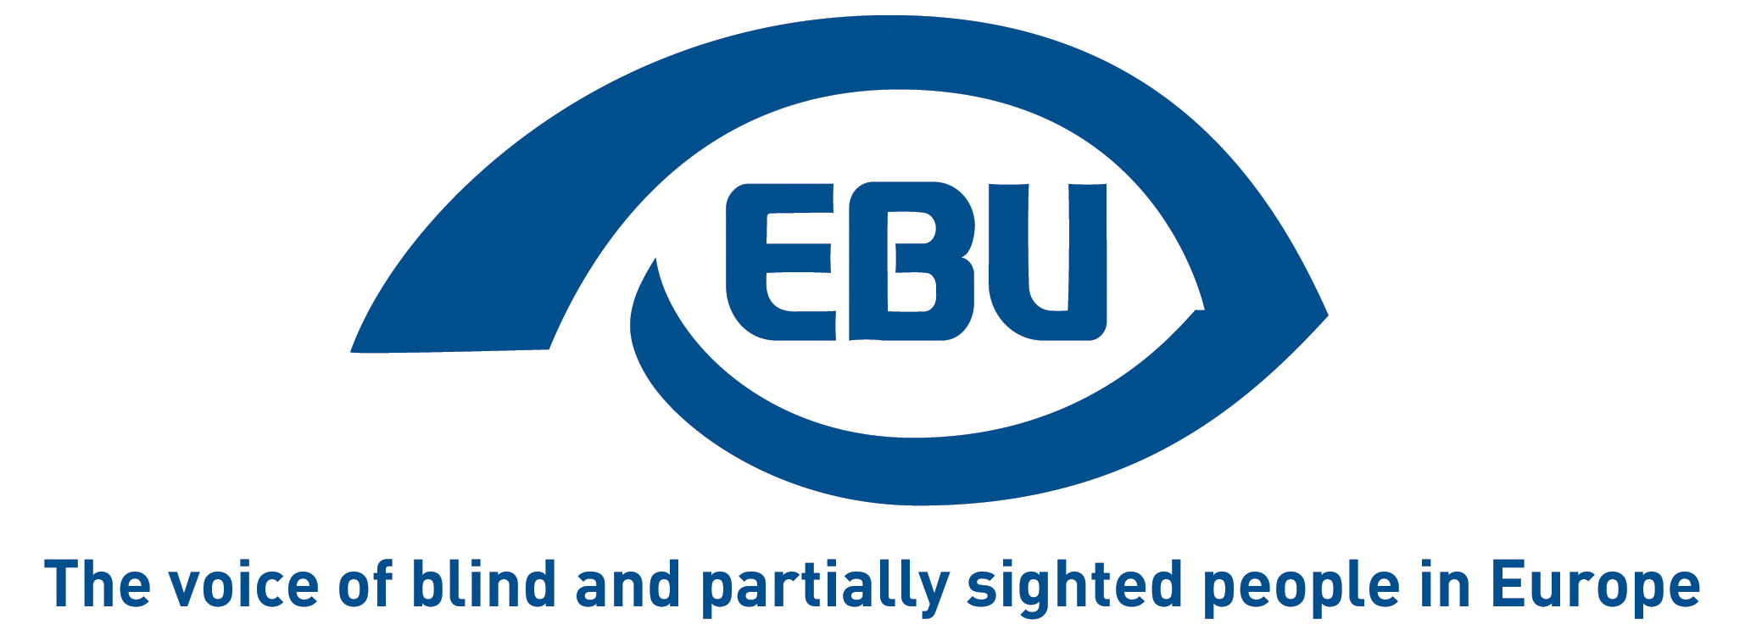
EBU training course on youth employability

29-31 July 2015
Tirrenia, Italy

Tuesday 28 July
Afternoon Arrival of participants
19:30 Dinner
21:00 – 22:00 Welcome and ice-breaking games (getting to know each other)

Wednesday 29 July
09:00 – 10:15 Programme explanation, practical information and energizers/team building games
10:15 – 10:30 Break
10:30 – 12:00 Being aware of our personal and professional competences: reflection to identify our competences, knowledges and attitudes
12:00 – 14:00 Lunch break
14:00 – 16:00 How to prepare a good CV and motivation letter: tips and practical exercise. Presentation of the Europass CV and, if there is time, of the other Europass tools
16:00 – 16.15 Break
16:15 – 18:00 Who am I? What are my skills and my values? (role playing)
19:30 Dinner

Thursday 30 July
09:00 – 10:30 How to prepare for a job interview
10:30 – 10:45 Break
10:45 – 12:45 Job interview in practice
12:45 – 14:45 Lunch break
14:45 – 16:00 Active job seeking, take a decision and make an action plan / how to overcome difficulties in a work placement
16:00 – 16:15 Break
16:00 – 18:00 Stay active while waiting for a job: useful experiences to increase young people’s competences (civil service, European voluntary service, trainings, internships, etc): debate to share experiences and good practices among the participating countries and presentation of opportunities founded by the EU Erasmus+ programme
19:30 Dinner followed by intercultural evening (e.g. typical dances / food from the different participating countries)

Friday 31 July
09:00 – 10:45 Tips for a peer to peer training course on youth employment
10:45 – 11:00 Break
11:00 – 12:00 Evaluation of the training and conclusions
12:00 – 14:00 Lunch break
Departures

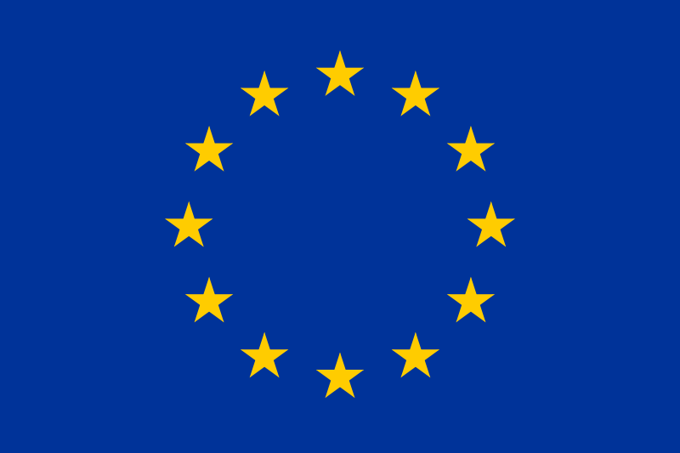
This training is co-funded by the "Rights, Equality and Citizenship Programme" Programme of the European Union.

