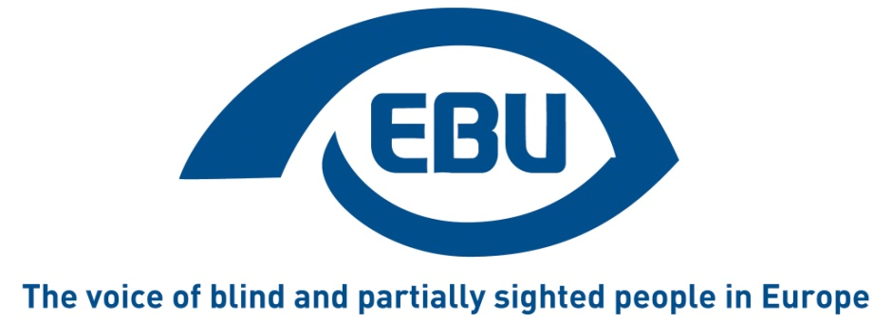

European Blind Union Response to the European Commission Public consultation on the European Pillar of Social Rights (COM/2016/127 final)
December 2016

The European Blind Union

The European Blind Union (EBU) is a non-governmental, non-profit making European organisation founded in 1984. It is one of the six regional bodies of the World Blind Union, and it promotes the interests of blind and partially sighted people in Europe. It currently operates within a network of 44 national members including organisations from 27 European Union member states, candidate countries and other countries in geographical Europe.

Our Interest Representative Register ID is 42378755934-87

We give our consent for our contribution to be made public.

For further information or clarification on this paper, please contact Rodolfo Cattani in the first instance. Email: inter@uiciechi.it.Tel: +39 0669988 375/388/385

Alternatively, please contact the EBU office:
EBU Office, 6 rue Gager-Gabillot 75015 Paris, France
Tel : +33 1 47 05 38 20 - E-mail: ebu@euroblind.org

Introduction
The European Blind Union (EBU) addresses the issues of poverty, employment and social protection of persons with disabilities from a human-rights perspective, in a social European dimension.

The rights of persons with disabilities are enshrined in the UN Convention that has been concluded by the European Union and its Member States. Following the ratification, all legislative measures, policies and programs must comply with the Convention and the rights of persons with disabilities have to be mainstreamed in all EU actions and strategies affecting them and their rights.

After the entry into force of the Convention a new approach to disability policy making is necessary. In the fields of poverty, employment and social protection the EU has limited influence s on legislative measures at national level. Nonetheless, the EU and the Member States should work jointly towards the full implementation of the UNCRPD and the active involvement of persons with disabilities and their representative organisations.

As a consequence of the economic crisis, poverty and social exclusion in the EU are growing. One in four Europeans are at risk of poverty or social exclusion and the divide between poor and rich people is widening within and between member states. To combat growing inequality and prevent social and political tensions in Europe there must be a radical paradigm shift towards a rights-based social and sustainable development strategy that stops austerity and backs public and social investment, putting people before markets.

The European Disability Strategy 2010-2020 aiming at the elimination of barriers to the full inclusion of persons with disabilities in society, which was adopted before the ratification of the UNCRPD, needs to be reviewed in order to comply with the principles of the Convention.

The stated aim of the Social Pillar is to provide a reference framework to screen the employment and social performance of the Eurozone member states.

EBU welcomes the European of Social Rights as an important social rights based initiative. However, we have identified a risk that the initiative is not sufficient to ensure a real new social agenda capable of making a decisive impact on poverty or reversing the threat of a popular revolt and disintegration of the EU. The three fields of action, equal opportunities and access to the labour market; fair working conditions; and adequate and sustainable social protection are important for persons with disabilities, but, regrettably, the Social Pillar pays attention to persons with disabilities only in chapter III on adequate and sustainable social protection in the section on disability benefits, which shows the wrong approach to disability in an outdated medical model, which sees persons with disabilities as people in need of care or as beneficiaries of benefits rather than as rights holders who are entitled to participate in all aspects of social life and are still discriminated against.

For these reasons, it is important that the EU and the Member States rethink their approach to the implementation strategy of the UNCRPD at all levels, resorting to the Concluding Observations that the UN Committee on the Rights of Persons with Disabilities addressed in 2015 and 2016 to the EU institutions and the 15 Member States that have already been examined by the Committee.

We call for a more ambitious and holistic approach to the Convention, especially in those areas where discrimination and exclusion still exist. We believe that there must be a new disability agenda to implement the CRPD in the coming years, revitalizing the 2010-2020 Disability Strategy and proposing a new strong reference framework for the period 2020-2030.

At this preparatory stage we think that the Social Pillar can be improved and we are submitting to the Commission the following suggestions.

General Comments
- The rights of persons with disabilities should be mainstreamed throughout the Social Pillar. Targeted, human-rights based measures are needed to secure equal rights, to guarantee the maximum degree of protection to persons with disabilities in order for them to be included in the community and enjoy independent living. This must be done to comply with EU and Member States’ obligations arising from the United Nations Convention on the Rights of Persons with Disabilities.
- The rights of women and young people should be mainstreamed throughout the Social Pillar, including specific actions on women and young people with disabilities.
- There is a need to clarify the legal status of the Social Pillar and ensure existing legal and policy measures are fully integrated in the final text.as well as to specify how implementation will be measured and include an accountability mechanism for the EU and the Member States;
- Furthermore, provision should be made to promote and monitor the Social Pillar at national level.
- Provisions must be added regarding the participation of and direct consultation with persons with disabilities and their representative organisations when implementing the Social Pillar at both European and national level, thus applying the civil dialogue principle.
- Specific measures are needed to make sure adequate protection is given against exploitation and forced labour involving persons with disabilities, and in particular those groups of persons with disabilities which are at greatest risk of exclusion, such as people who require high levels of support for autonomy, girls and boys, and older people.
- Provisions must be made regarding deinstitutionalisation and community-based services, in order to overcome segregation and enable people who are in institutions to switch to inclusive living models in the community with specific support.
- A social protection floor programme to ensure minimum income must be included in the Social Pillar to protect persons with disabilities from poverty and exclusion and ensure they enjoy a decent life.
- There is a need to guarantee freedom of movement of people, in particular of persons with disabilities, and transferability of services across all EU Member States.
- It is necessary to protect families, which are the principal, most extensive and most significant support network for persons with disabilities.
- The Social Pillar must be designed so as to avoid the adverse and regressive effects of austerity measures on a decent standard of living of persons with disabilities.
- The scope of the Social Pillar must be extended beyond Eurozone countries, EU citizens and legally resident third country nationals, in order also to encompass other excluded people such as migrants and refugees.
- In terms of EU decision-making the Social Pillar should insist on real checks and balances, in order to ensure accountability to the citizen on the ground. A more democratic European semester could provide a key instrument to support delivery on the Social Pillar, particularly if underpinned by the Europe 2020 strategy and linked to the SDGs 2030 Agenda.

Specific Comments On Chapters

Chapter I: equal opportunities and access to the labour market
I.1. Skills, education and lifelong learning

Equal opportunities and equal access to education and lifelong learning must be guaranteed, and in particular to persons with disabilities, through inclusive education systems which comply with accessibility standards in terms of the curricula and education facilities, the necessary tailored accommodations and support systems, and the required communication systems and support. These must be provided in line with article 24 of the Convention on the Rights of Persons with Disabilities, and especially in line with General Comment No 4 of the Committee on the Rights of Persons with Disabilities (CRPD/C/CG/4, dated 2nd September 2016), considering also that promoting inclusive education for persons with disabilities is an integral part of the Sustainable Development Goals (SDG 4).

I.4. Active support for employment
The European Social Fund must continue to act as an essential instrument to enhance social inclusion through employment for vulnerable groups, including persons with disabilities, and it must be a key tool in implementing the Social Pillar. The Social Pillar should be a means to influence the implementation of the ESF in Member States, in such a way that the distribution of funding should be in line with poverty and unemployment rates, and not be based solely on criteria concerning wealth or GDP.

I.6. Equal opportunities

European Commission actions in the field of Corporate Social Responsibility, within the framework of the 2011 Communication on a renewed European strategy for CSR (COM (2011) 681 final), which includes disability, should be used in the Social Pillar as an instrument to promote a positive impact by enterprises and other private and public entities alike in social inclusion and inclusion in the labour market for persons with disabilities. In addition, this must be in line with the acknowledgement that persons with disabilities are in a vulnerable position in employment and this is a challenge, as the recently published “Communication on European action for sustainability” points out, and in particular in relation to Sustainable Development Goal No 8, ‘Promote sustained, inclusive and sustainable economic growth, full and productive employment and decent work for all’ (COM (2016) 739 final).

In this respect, equal access to employment and to work opportunities for persons with disabilities must be boosted, while ensuring compliance with current regulations in the following areas:
- Incentives (subsidies and allowances) to boost the hiring of persons with disabilities;
- Quotas of reserved positions for persons with disabilities in public and private enterprises;
- Quotas of reserved positions for persons with disabilities in public employment.

Chapter II: fair working conditions
II.9. Health and safety at work

- In line with UNCRPD article 27 (Work and employment), it is necessary to promote reasonable accommodation in the workplace to enable persons with disabilities to perform jobs efficiently and safely.

Chapter III: adequate and sustainable social protection
III.12. Healthcare and sickness benefits

- In accordance with UNCRPD articles 19 (Living Independently and being included in the community), 20 (Personal Mobility), 25 (Health) and 26 (Habilitation and Rehabilitation), there is a need to enhance health and community-based services designed to promote personal autonomy, living in the community, and full social inclusion for persons with disabilities, from the earliest possible stage.

III.16. Disability benefits

- In line with UNCRPD article 28 (Adequate standard of living and social protection), and in addition to measures to ensure basic wellbeing (minimum income) in the face of precarious income and unemployment, there is a need to guarantee benefits to compensate for additional disability-related expenses, and especially in relation to purchasing support devices, rehabilitation, and accessibility in homes.

III.20. Access to essential services

- In line with UNCRPD article 9 (Accessibility), it is necessary to ensure current requirements are met, and to promote appropriate measures to guarantee equal access for persons with disabilities in general, and in particular those with a visual impairment, to the following services:
  - Urban public spaces and buildings;
  - Methods of transport;
  - Information and communications, including information and communication systems and technologies;
  - Public premises, citizen services devices and services, and devices and services required to participate in public affairs, including the administration of justice and participation in political life and electoral processes (accessible voting);
  - Other services and facilities open to the public or for public use, in both urban and rural areas and both public and private, with special regard to services and facilities in education, employment and recreational and cultural activities

