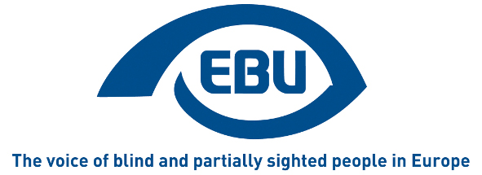

European Blind Union

Press release

Paris, 27/02/2014

‘92% of MEPs want accessible websites, now Council must act’ says EBU
On 26 February Members of the European Parliament (MEPs) gave their overwhelming support to the sweeping changes proposed by the IMCO Committee on the proposed Directive on Accessibility of Public Sector Bodies' Websites. The 30 million EU citizens who are blind or partially sighted are disproportionately affected by the inaccessibility of websites so the European Blind Union (EBU) welcomes the strong message sent by the European Parliament to EU governments.
‘When 92% of MEPs are calling for action, we believe that Council members should listen and engage with the democratic process’ says EBU President Wolfgang Angermann.
The Directive on Accessibility of Public Sector Bodies' websites is listed in the Greek Presidency's work programme but the Presidency has not scheduled a single meeting to discuss this dossier. EBU President Wolfgang Angermann says: ‘It is not enough for the Greek Presidency to have this directive on their ‘to do’ list; if the Presidency refuses to organise a meeting to discuss the Directive with Member States then they are effectively blocking the legislative process.’
EBU now wants swift action from the Greek Presidency to ensure that discussions in Council start within days. ‘Failure to act will delay new rules for many months and therefore be hugely detrimental for the 30 million blind and partially sighted EU citizens who struggle to access information and services online. People with sight loss have been shut out of the online world for far too long.’ says Angermann.
EBU wants the Council to take ownership of this issue and fulfil its obligations under the United Nations Convention on the Rights of Persons with disabilities. We are seeking an urgent meeting with representatives of the Greek Presidency to discuss next steps.
Ends
Notes to editors
1 – On 26 February the European Parliament adopted a legislative resolution on the Directive on Accessibility of Public Sector Bodies’ websites. 593 MEPs approved the text (40 voted against, 13 abstentions)

About EBU

EBU is a non-governmental, non-profit making European organisation founded in 1984. It is one of the six regional bodies of the World Blind Union. It protects and promotes the interests of blind and partially sighted people in Europe. It currently operates within a network of national organisations of the visually impaired in 45 European countries.

EBU
6 rue Gager-Gabillot
75015 PARIS (France)
Tel: +33 1 47 05 38 20
Fax: +33 1 47 05 38 21
Email: ebu@euroblind.org
www.euroblind.org

