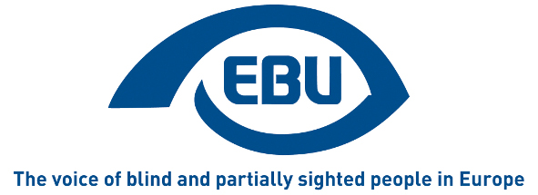

European Blind Union

Press release

Paris, 01/10/2014

Decoding hidden melodies, line by line

EBU announces the winners of the Onkyo World Braille Essay Contest 2014
The EBU jury for the 2014 Onkyo World Braille Essay Contest is delighted to present this year´s winners. Seven very different works were chosen from 62 essays contributed by participants from 21 EBU countries. Anna Fusz from Hungary with ´Mom’s telling tales´ wins the Otsuki first prize, A story told from the perspective of a sighted child with a blind mother and the natural role that Braille had in their lives and the happy memories it created.´….the picture of her chubby fingers decoding the hidden melodies, line by line…´. The chosen perspective and the sensitivity with which the story is told made Anna a worthy winner.

Another big favorite of the jury is the essay with the creative title ´Dots on belly´ by Josef Zbranek from Slovakia. An entertaining, clever, positive story filled with humor, showing the naturally integrated role of Braille. ´A natural storyteller´ the jury adds in its motivation. It gets Josef the Excellent Work prize in the senior category, while in the junior category young Brandon C. Halcoop from the UK, only 12 years old, receives the same Excellent Works prize for his very creatively structured essay called ´Braille is fascinating!´ in which the first letter of each paragraph form the word FASCINATING. Well written, to the point, personal, interesting, smartly done.

The four third prize winners (Fine Work prize), 2 in the junior and 2 in the senior category, are: 17 year old Aoife Watson from Ireland with her essay titled ´Life with braille´. The jury motivation reads: ´A graceful, sincere and luminous essay....´ alongside Jaroslav Bohovič, 23 from Slovakia with ´Living with Braille´ that the jury found inspiring, well composed and with an ambitious message.
Swiss Annemarie Vit-Meister delighted the jury with her ´Life is reading – reading is life´. The title is very well supported by the content. Ingeniously done with the contrasting pictures. Alongside
Blerina Shalari from Albania with her thoughtful essay called ´Life with Braille´, pointing out the benefits of Braille in a well-structured and clever way, with an enthusiasm for Braille that the jury found inspiring.

Jury members Ann Jönsson, Maria Kyriacou, Sergiu Ruba, Karin Hjälmarson and Birgitta Blokland (chair) also wish to highlight with a special mention the essays by Denise Lanfalusi from Austria, a brave, bold piece with sense of drama; another by Corinne Bianchi from Switzerland, a good, motivating essay; and from Albania Frrok Gjikola, sent a beautifully written essay with a personal touch, painted with words.
You can find the winning essays and the shortlist on the EBU website.
http://www.euroblind.org/projects-and-activities/activities/nr/210 Warmly recommended!

About EBU

EBU is a non-governmental, non-profit making European organisation founded in 1984. It is one of the six regional bodies of the World Blind Union. It protects and promotes the interests of blind and partially sighted people in Europe. It currently operates within a network of national organisations of the visually impaired in 45 European countries.

EBU
6 rue Gager-Gabillot
75015 PARIS (France)
Tel: +33 1 47 05 38 20
Fax: +33 1 47 05 38 21
Email: ebu@euroblind.org
www.euroblind.org

