Coordination and support action
Grant Agreement number: 645584
Topic: ICT-35-2014
Call: H2020-ICT-2014-1

Innovative PROcurement for Visual Impaired People
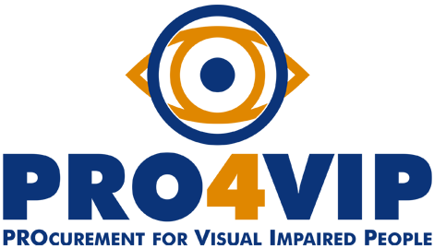

Definition of uncovered common needs

FG report

CYPRUS
Status: Final
Issue date: 12.05.2016
Organisation name: Pancyprian Organization of the Blind
Author: Maria Kyriacou

TABLE OF CONTENTS

1 Introduction 3
2 Summary of the focus group 4
3 Participant profiles 5
4 Methodology 7
5 List of topics 8
Topic 1 – Indoor and outdoor orientation and mobility 8
Topic 2 – Reading and writing 11
Topic 3 – Personal care 14
Topic 4 – Access to information, goods and services 18
6 Findings 21
7 Recommendations 28

Introduction
PRO4VIP held a series of focus groups across EU, involving low-vision people, who are the primary target of this analysis phase, for which their feedbacks are considered paramount. Through the focus groups, the consortium gathered information to help decision makers, procurers and (potential investors) to analyze and define hierarchy between partially-sighted (PS) persons’ unfulfilled needs in terms of assistive devices, to scan the market and assess the technology state-of-the-art and to design prospective procurement models and approaches to solve the innovation gap between actual needs and solutions currently available on the market.
This document describes the activities performed and the evidences emerged during the focus group held in Nicosia, Cyprus, the 23rd of April 2016 aimed at problem domain and uncovered needs analysis.

Summary of the focus group
Pancyprian Organization of the Blind held a focus group discussion with 14 PS persons on 23rd of April on the premises of St. Barnabas School for the Blind. The focus group was conducted as part of the involvement of the European Blind Union in PRO4VIP. Participants provided information in two ways: written responses (questionnaires) and group discussion.
The discussion was designed to gather information from the PS persons’ in regard to the following common outcomes, emerged as statistically relevant from the questionnaires:
- Indoor and outdoor orientation and mobility
- Reading and writing
- Personal care

Additionally, has been selected and/or has emerged also the following mega topic:

- Access to information, goods and services (banking system and money exchange)

Participant profiles
14 participants took part in the focus group:
- There was no participant under the age of 15. 1 person was between the ages of 15 – 24, 7 persons were between the ages of 25 – 50 and 6 persons were over 50.
- 8 participants identified themselves as having moderate low vision and 6 as severe low vision.
- 3 participants - MD, 1 participant - glaucoma, 1 participant- diabetic retinopathy, 2 participants- albinism, 1 participant - toxoplasma, 2 participants- tumor, 1 participant - aniridia, 1 person- Leber’s, 2 participants - retinitis pigmentosa
- 4 of the 14 participants are gainfully employed, 2 of the 14 participants are retired, 4 of the 14 participants are able to work but currently not working, 3 of the 14 participants are unable to work because of his disability, 1 of the 14 participants is a homemaker

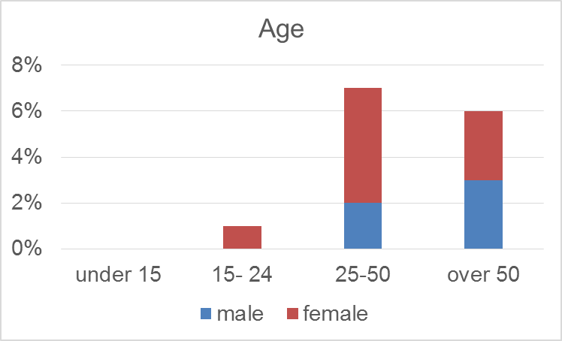
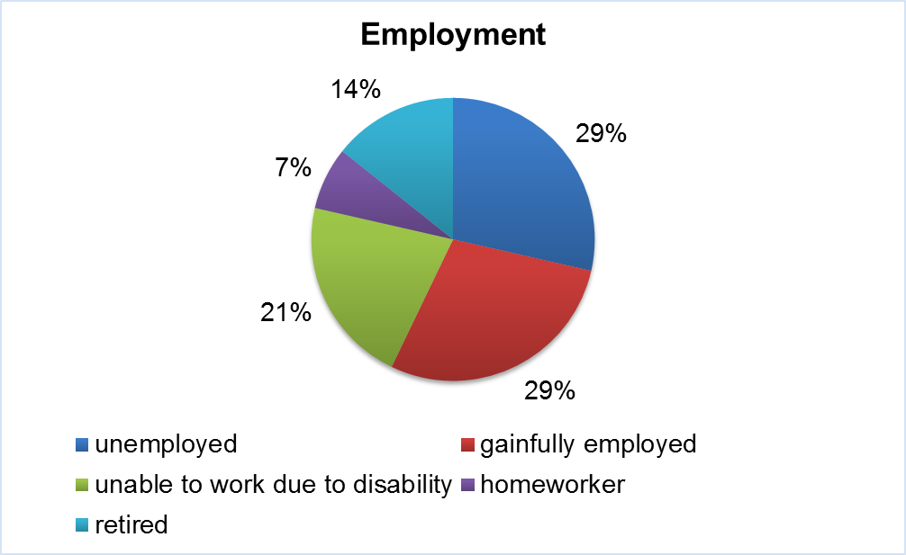

Methodology
The method used to identify innovation needs, validating them against their end-user relevance is the WIBGI developed by the English National Health Service (NHS UK). It uses collective brainstorm exercises with end-users to complete the sentence “Wouldn’t It Be Great If….”
In this setting, focus groups ought to be made by end-users: as they work and interact with a process on a daily basis, they are best-placed to see its problems or inefficiencies and identify possible areas of improvements.
WIBGI’s basic concept is to make time to take end-users out of their usual environment, group them and ask them to finish the sentence “Wouldn’t It Be great If....?” and, as a second step, to provide guide to collaboratively describe the problem to be solved, defining clear outcomes that are required (functionality / performance / efficiency improvements) rather than prescribing technologically how the solution for the problem should be built.

List of topics

Topic 1 – Indoor and outdoor orientation and mobility
In general, PS persons were extremely reactive when talking about indoor and outdoor orientation and mobility as this seems to be the greatest challenge faced by PS persons living in Cyprus.
- Wouldn’t it be great if….?
14 of the 14 participants outlined as very important the need to be able to travel independently without having to ask for constant directions, to be able to locate bus stops and buildings, to detect obstacles on the way not easily identified by a simple cane or their residual vision, to be warn about unexpected danger, to locate crossings and traffic lights, and to be sure when to cross safely at the traffic lights. 6 out of the 14 participants outlined as very important the need to be able to orient themselves indoors: to locate specific offices, to be informed what services are inside a building and where these can be found, to be warned about sliding and revolving doors, to locate steps going up or down.
The PS persons offered a number of reasons for their evaluations:
- Bus stops and building entrances are not always clearly marked and easily identified as signs are not always available or are in a hard to find location, printed in signs with bad color contrast and small font size,
- Bright sunlight prevents PS persons from detecting obstacles, dangerous obstacles outside their visual fields, broken tiles in damaged pavements,
- Bright light prevents from identifying when it is safe to cross a busy street, oftentimes the guide on the pavement does not lead to the traffic lights or crossings, the absence of audio warning prevents persons to easily locate traffic lights while a beacon that controls traffic lights is not available yet in Cyprus and for many crossings even a control button is not available or is out of order.
- Signs outside an office are printed in a bad color contrast with small fonts and hard to read font style. Also signs are placed sporadically in a building making it hard to locate,
- Some buildings are too complicated to navigate,
- Sometimes sliding or revolving doors are out of order causing in this way injuries,
- Steps are not properly marked

- What are the main shortcomings of available solutions on the market?
All the participants agreed that in the area of indoor and outdoor orientation and mobility there are significant weaknesses and shortcomings, including:
- Navigation systems - require internet connection, routes are not always accurate, expensive to purchase, work only on smart phones, do not include crossings and traffic lights, no warning about unexpected hazards in the way, bus stops are not always included in the navigation systems. There are some white canes that incorporate devices for detecting obstacles but even then, these are too heavy, too long, bulky and used by totally blind people and in any case such canes detect obstacles up to a certain high and are extremely expensive to purchase.
- Bus stops and traveling – no audio announcements in buses and bus stops, bus numbers and destinations are not clearly marked for easy identification, bus stops do not always have a sunshade which makes it hard to read the displayed information on screens and identify the appropriate bus.
- They had specific needs for a device to assist with independent orientation and mobility, a device to allow traveling independently by bus, a device to easily orient inside a complicated building. They used various words to describe their needs, “wouldn’t it be great if there was a device to allow me to travel from the front door of my house to the bus station without having to ask for directions, board the bus and go to my destination”, “wouldn’t it be great if there was a device to help me locate with ease the entrance of the building that I am looking for”, “wouldn’t it be great if there was a device to warn me for unexpected gaps holes and other hazards in the pavements so as not to be in danger of falling”, “wouldn’t it be great if there was a device that will assist me when it is safe to cross the street when the sunlight is too bright”, “wouldn’t it be great if there was a device to help me control the traffic lights and crossings especially in busy and dangerous streets”, “wouldn’t it be great if there was a device to warn me when a sliding door is out of order and prevent me from crashing into it” “wouldn’t it be great if there was a device with accurate bus routes so I wouldn’t have to depend on the driver’s good will to let me know when to get off the bus”.
Topic 1 – Indoor and outdoor orientation and mobility
Need 1.1 | The need for a navigation system that can assist with outdoor orientation and mobility to enhance independent traveling.
Need 1.2 | The need for a navigation device to assist with safe and independent traveling by bus (locate bus stops, identify bus number, destination)
Need 1.3 | The need for a device to access the information inside a complicated building (locating offices, steps, elevators, bathrooms, reception)

Topic 2 – Reading and writing
In general, PS persons were extremely reactive when talking about reading.
- Wouldn’t it be great if….?
10 of the 14 participants outlined as very important the need to have a device to help them read with ease and effectively any font size either this being from a near or far distance. 8 out of 14 participants outlined as important the need to have a device to ensure and facilitate the homogeneity of their signature.
The PS persons offered a number of reasons for their evaluations:
- Signs (i.e. above the isles in supermarkets, departments in a big store) are displayed at a very high level with not adequate font size and color contrast.
- Information in packages is printed on bad color contrast in a very small font size and not easy to read font style,
- Due to their low vision, oftentimes PS persons sign in a variety of ways due to limited available space for signing, the signature line is not well marked (bold line or dots), signing on a tablet or screens sometimes is hard due to brightness from reflection, bad room lighting in the banks or stores.
- What are the main shortcomings of available solutions on the market?
All the participants agreed that in the area of reading and writing there are significant weaknesses and shortcomings, including:
- Signature – the only available non-tech device is the signature frame that still requires guidance from a sighted person and has limitations for the case of some letters.
Some participants also quoted a number of shortcomings of actual technologies and assistive devices, including:
- The width of existing reading devices (portable CCTVs) is too narrow prohibiting a line of an A4 size paper from being entirely displayed when the magnification is too big. causing disorientation in locating the next line and losing valuable time,
- Many reading devices with speech output are not available in the Greek language,
- Many devices are complicated to use and are bulky.
- Devices are design for a certain task (only for close distance reading or reading from long distance)
- Many devices require the upgrading and updating of their software which many times is far too expensive.
- They had specific needs for a single device that will allow them to access written information from a near or far distance, a device to allow them to create the same signature when signing various documents. They used various words to describe their needs, “wouldn’t it be great if there was a device to read what it is displayed on the signs on top of each supermarket isle and at the same time read the product description and price tag”, “wouldn’t it be great if there was a device to allow me to read an entire line in a text without having to hold or move the camera left or right loosing productive time”,, “wouldn’t it be great if there was a device to allow me to create my signature in a homogeneous way so that the banks will not contact me to verify if indeed that was me signing”.
Topic 2 – Reading and writing
Need 2.1 | The need for a single device to allow reading from a near or far distance that is small in size and easy to operate
Need 2.2 | The need for a device that will allow the PS person to create his/her signature in the same homogeneous manner.

Topic 3 – Personal care
In general, PS persons were extremely reactive when talking about personal care
- Wouldn’t it be great if….?
8 of the 14 participants outlined as very important the need to be able to read labels on various products at home when cooking (ingredients, expiration dates, and price tags). The remaining 5 participants stressed the importance of having a device to help with locating spots and dust especially at high up surfaces. 3 out of 14 expressed the need for a device to accurately identify colors, 1 out of 14 expressed the need to have a device to shave safely and with ease, 1 out of 14 an accessible kitchen scale, 2 out of 14 the need for a nail clipper to be easily used by PS persons, 2 out of 14 a device to assist with the use of the sewing machine, 10 out of 14 participants asked for a device on the windows that will easily adjust the sunlight inside the house.

PS persons offered a number of reasons for their evaluations:
- Printed information on home products is printed in small font size and not in a clear font style, also there is not a good color contrast and a lot of labels are printed on a glossy paper.
- Spots or dust on the ceiling are too high above and not easily spotted by PS persons when cleaning the house.
- Severe sight problems prevent PS persons from differentiating between colors with similar shadings such as black/blue light blue/grey/white.
- PS persons whose sight decreased over the years used to depend on vision to shave and when this is no longer possible they find out that touch prohibits them from having a smooth and fine shaving.
- Accessible kitchen scales are necessary to measure food quantities in kg and ml when trying to maintain good health without depending on significant others.
- Nail clippers is a device used frequently by anyone and having to depend on others is oftentimes frustrating.
- Sewing machines are helpful and is nowadays a popular hobby for many but it is hard to use even with a magnification lens attached to it.

- What are the main shortcomings of available solutions on the market?
All the participants agreed that in the area of personal care there are significant weaknesses and shortcomings, including:
- Color identification – not always accurate especially when it comes to color shades and black and greys and blues, or white and grey. Easily affected by room lighting, when multiple colors on a surface then announces one of the main colors, when depending on a camera then hard to point the camera on the desired spot.
- Label readers – you have to pre-record with the assistance of a sighted person, labels are not always located at the same place, when depending on a camera for scanning then have to point the camera at the exact spot, scanners not available in the Greek language and they are expensive.
- Kitchen scale – talking scales only announce kg’s and not ml as well, existing scales in the market have not legible letters, have a bad contrast, the measuring cups have not good color contrast to help with pouring the ingredients, the displayed value is presented in small font size,
- Nail clipper – available with a small magnifying lenses that does not always meet the needs of all PS persons.
- Window shades – some sun shades exist but need to be adjusted manually and fitted in each window separately.
- Cleaning device – robotic systems that exist have limitation as they stop once they reach an obstacle and hard to reprogram, do not locate spots and dust that are above the floor level, some telescopic cleaning devices are not the solution for a PS person as spots are still not visible.
They had specific needs for a device to read labels on products and shelves, a kitchen scale with clear to read print, a device to shade the windows in a house as to prevent photophobia, an easy to operate shaving device for smooth shaving, an easy to use nail clipper, a device to assist with cleaning the house and reaching up to dirt in high surfaces. They used various words to describe their needs, “wouldn’t it be great if there was a device to connect to my telescopic cleaning set that will enable me to locate and clean all spots and dusty places that are high above and that I am unable to see myself”, “wouldn’t it be great if there was a device that will speak out the colors in an accurate way and not to have to worry if the existing device mixed black with blue or white with grey”, “wouldn’t it be great if there was a device that will enable me to access the information written in the various jars and tins in my kitchen closets”, “wouldn’t it be great if there was a kitchen scale that will allow me to measure independently my food as this is so important for me to maintain a healthy diet due to my diabetes”, “wouldn’t it be great if there was a device that will allow me to clip my nails on my own giving it a nice shape and without having problems such as too short nails or too long with not fine edges”, “wouldn’t it be great if there was a device that will automatically shade the windows in my house when the sunlight is too bright and causes me photophobia making it impossible to sit in certain areas in the house during morning hours”, “wouldn’t it be great if there was a device that can help me learn to operate a sewing machine just like I used to do in the past”.
Topic 3 – Personal care
Need 3.1 | The need to have an accessible kitchen scale that will display in a clear way quantities and liquids.
Need 3.2 | The need to have a device that will automatically shade windows in a room where bright sunlight causes photophobia to PS persons living there.
Need 3.3 | The need to have a device that can be inserted to telescopic cleaning tools to manage spots and dust in surfaces high above not seen by PS persons.

Topic 4 – Access to information, goods and services
In general, PS persons were extremely reactive when talking about access to information goods and services with special attention given to banking services, websites and shopping.
- Wouldn’t it be great if….?
10 of the 14 participants outlined as very important the need to have accessible ATM machines. Also, 8 participants out of the 14 expressed the need to be informed of what is available in the isles of a supermarket. 9 participants also found it extremely useful to be able to have a software that will automatically adjust color contrast in websites that are not designed in an accessible way. Also, PS persons found interesting the idea to have a program to inform them in case a person they know is in the same room as they are.
The PS persons offered a number of reasons for their evaluations:
- Unable to use ATM machines independently as the text is in small size and there is a lot of glare from direct sunlight.
- Websites that are not designed with the accessibility features are often impossible to navigate even with accessibility software’s because colors cannot be adjusted the colors according to the individual needs.
- The printed information displayed in supermarkets is high above the isles and it is impossible to access the information of what is in the isles or the shelves.
- It is hard to recognize persons in a room since many visual pathologies prevent PS persons from seeing details or recognize faces especially in a crowded room.

- What are the main shortcomings of available solutions on the market?
All the participants agreed that in the area of access to information, goods and services there are significant weaknesses and shortcomings, including:
- ATM machines – in Cyprus there is no audio output, the font is displayed on a badly contrasted screen with small size, the screen has a lot of glare, most ATM are placed in direct sunlight making it impossible to read the screen, hard to find identical ATM machines as to memorize the buttons to press for a certain transaction.
Some participants also quoted a number of shortcomings of actual technologies and assistive devices, including:
- Adjusting colors in a website – there are software that can change background but not the colors of a website, websites are designed often without having in mind the needs of PS persons, accessibility software are expensive,
- Person identification – there are some programs that describe pictures but do not recognize faces or contact details, need a smart phone to operate.
- Navigation in a supermarket – in some countries there is a recording of what is available in the isle and on the shelves (not in Cyprus), CCTVs are too complicated to use when trying to complete shopping task, time consuming, different devices for near and far, information is displayed in small font without a good color contrast and way high above, sometimes the information is rotating and refreshes quickly on a display making it impossible to read even if it is visible.
They had specific needs for an ATM that will be easy to use, a software that will allow them to adjust the colors in various websites that were designed without taking into consideration their needs, an application that will allow them to know if someone they know is in the same room as they are and a device that will allow them to know what goods are displayed in the shelves inside a supermarket. They used various words to describe their needs, “Wouldn’t it be great if there was a device that can inform me of what products are in each isle inside a supermarket so that I could complete my shopping with ease without forgetting something and wasting too much time trying to find items.”, “Wouldn’t it be great if there was a program that I can run on my computer every time I come across a website which has very bad color contrast and prevents me from easily navigating in the page.”, “Wouldn’t it be great if there was an ATM that will allow me to do all my transactions independently without having to always have a sighted person even for a simple task as withdrawing cash.”, “Wouldn’t it be great if there was a program that will allow me to know if someone I know is in the same room as I am especially when attending a conference”.
Topic 4 – access to information, goods and services
Need 4.1 | The need for an ATM that will allow PS persons to operate it independently.
Need 4.2 | The need to have a device to access information displayed on signs in a supermarket such as what products can be found in the isle.
Need 4.3 | The need to have a program to inform me if persons I know are in the same room as myself.

Findings
Need 1.1: The need “for a navigation system that can assist with outdoor orientation and mobility to enhance independent traveling” is due to the evidences that today traveling independently can be a quite stressful ordeal and cause anxiety for a PS person. Unexpected obstacles along with badly constructed pavements might oftentimes cause injuries and unpleasant situations for them. Also, the unclear marking of building entrances, bus stops or street names makes it difficult for a PS person to orient themselves putting them in a situation where they will have to ask constantly for directions receiving oftentimes the weird looks and strange, unpleasant reactions of other pedestrians who might be unaware of their sight loss. In addition, the bright sunlight causes photophobia preventing them in this way to judge effectively when it is safe to cross a street. The challenge is to design a navigation system to assist with outdoors orientation and mobility that will enable PS persons to travel independently. Such device will be portable and will warn the user of any possible obstacles on their way while providing directions, and information such as names of streets, building entrances and bus stops.
Need 1.1 - a navigation system that can assist with outdoor orientation and mobility to enhance independent traveling
Function 1 | Portable device
Function 2 | Allow freedom of movement (free hands)
Function 3 | Easy to use
Function 4 | Display that will adjust to bright sunlight with clear print, good contrast and large font.
Function 5 | Contrast colors and Font size adaptable to personal needs.
Function 6 | Possibility of giving verbal commands (Voice Input)
Function 7 | Affordable
Function 8 | Have sound as well as vibration for warning
Function 9 | Allow user to record a route and insert landmarks along the route
Function 10 | User friendly

Use case #1
Need 1.1 - a navigation system that can assist with outdoor orientation and mobility to enhance independent traveling
Use-case today | Today, when I am to leave my house to go to a destination I have never been to before, I have to ask other pedestrians for directions. Even with the use of telescopic lenses, I have a hard time to locate the bus stop and even the entrance of the building once I arrive there. Even with the use of my simple cane, due to bright sunlight, I run the risk to trip over an obstacle or bang my head on hanging signs or branches causing me stress, making me feel embarassed, insecure and unsafe as I run the risk to fell and hurt myself.
Use-case tomorrow | Tomorrow, with the new navigation device I will be able to travel independently without having to constantly ask for directions. I, will manage to locate the bus stops and the entrance of the building of my final destination while at the same time avoiding any unexpected obstacles that might come my way and might cause injury or set me in an uncomfortable situation causing me stress and anxiety. Additionally, the device will allow me to record a new route, by allowing me to put landmarks, enabling me to access it in the future.

Need 2.1: The need for ‘a single device to allow reading from a near or far distance that is small in size and easy to operate’ is due to the evidences that today, most reading devices are design to perform a single task. Many PS persons have to carry with them two different portable devices or glasses or magnifying lenses in order to be able to read small font text from a close distance. They have to switch to another device to be able to read a sign, bus number or anything displayed at a distance. This causes frustration and requires time allowing also time for accommodation between near and far vision. Also for someone who does not carry a hand bag with them storing all these necessary devices and aids might be problematic. The challenge is for a small portable light-weight single device that will allow users to switch from near to far distance in a quick and easy manner. Users can carry this device hanged on their neck with a strap ensuring in this way that no storage space is required. The clear print information will be displayed in a mat finish screen with good color contrast.
Need 2.1 - a single device to allow reading from a near or far distance that is small in size and easy to operate
Function 1 | Have both near and far viewing
Function 2 | Easily change between the two modes
Function 3 | Small in size and lightweight
Function 4 | Screen Display that has a mat effect when in bright sunlight
Function 5 | Affordable
Function 6 | Adjust color contrast to personal wishes (different color contrast options and font size and type of options)
Function 7 | Have a strap to hang on neck or have a handle to hold
Function 8 | Have the possibility to capture still image
Function 9 | Include OCR function
Function 10 | Have scanned function of bar codes or other codes

Use case #2
Need 2.1 - a single device to allow reading from a near or far distance that is small in size and easy to operate
Use-case today | Today, when in a supermarket, I have to constantly switch between my near vision reading magnifying glasses and my portable camera for distance viewing in order to read the price tags or the product name and to view what is written on the top shelves of the supermarket or the signs above the isle. This takes up valuable time and means that I have to have a purse to carry all these aids or always free my hands from what I am holding in order to complete such tasks.
Use-case tomorrow | Tomorrow, with the new all in one device, I can easily switch from reading a product description and price tag to viewing what is written on the sign hanged above the supermarket isle without having to take off glasses or switch to a CCTV device. Its small size and lightness along with the fact that it can be hanged on my neck allows me to move around the shop without having to worry about putting away the various aids in my purse and complete my shopping in an effective manner, saving valuable time. In addition, the OCR and recognizing functions, will allow me to retrieve information regarding a product’s content and price at a glance.

Need 3.1: The need to have ‘an accessible kitchen scale that will display in a clear way quantities and liquids’ is due to the evidences that today, kitchen scales available in the market do not take into consideration the needs of PS persons. Their screen display have very bad color contrast (usually grey background) which makes it impossible to read the value. Also letters are small and hard to read. Talking scales that are often available weight only one value (either kg or ml). These devices are often expensive. The challenge is for an accessible kitchen scale that will display in an easy to read manner the value of the weighted products, these been either solid or liquids. The screen will not be affected by the bright sunlight. The multiple containers that will be available with different color inside will ensure a good contrast and prevent ingredients from spilling when pouring.
Need 3.1 - an accessible kitchen scale that will display in a clear way quantities and liquids
Function 1 | Screen display with a paper white finish that will not be affected by bright light
Function 2 | Screen display with good color contrast (background black or white)
Function 3 | Large font size. Have a color contrast option
Function 4 | Clear font style – adjustable to personal needs
Function 5 | Measure kg and ml
Function 6 | Measuring containers with good color contrast to allow safe pouring of ingredients (black or white)
Function 7 | Come out of the market to ensure its low cost
Function 8 | Have speech output as a backup
Function 9 | Easy to transport
Function 10 | Durable

Use case #3
Need 3.1 - an accessible kitchen scale that will display in a clear way quantities and liquids
Use-case today | Today, when the talking scale that I have in my kitchen is out of order, which is frequent, I have to depend on my sighted assistant to measure my food. Even in the event that my talking scale is in operation still this does not measure any liquids something that is also frustrating for me. As a person with diabetes, measuring my food is crucial in maintaining good health.
Use-case tomorrow | Tomorrow, with the use of a kitchen scale that will allow me to easily pour the ingredients into the good contrast containers I will be able to read the displayed value in the screen independently. This will allow me to manage my food and diet independently without having to depend on my sighted assistant who is not always around, ensuring in this manner that my diabetes will be regulated thanks to a healthy balanced diet.

Recommendations
There was a great enthusiasm among PS persons participating at the FG discussion. In their concluding words all 14 participants expressed great gratitude for the opportunity they were given to participate in such discussion group and share their personal experiences with each other.
The greatest need, faced by PS persons living in Cyprus that kept arising throughout the discussion regarded indoor and outdoor orientation and mobility. It is indeed a fact that in Cyprus public transportation services as well as orientation and mobility in the build environment have great many limitations. It was therefore no surprise that this was the greatest challenge faced by participants.
In regards to organizing the FG, it can be said that, even on a quite short notice, this run smoothly. The FG had to be planned on a Saturday (the week before the Greek Orthodox Easter) something that could have been proven a bit discouraging for participants as a lot of people attend early mass that day and are getting ready for Easter. Still, it was one of the two optional dates we had, as we also had to coordinate our dates with the co-moderator, for hosting the FG and it was thankfully proven ok. For future, it will be of greater help if there is more notice on organizing such an event as we had to also use part of the Easter holidays to draft the report.
In regards to the proposed methodology, it can be said that this was of great help to assist moderators realize the aims and objectives of the FGs. The skype meetings and the checklist were most helpful in providing us with the knowledge on how to collect the needed information for the report. However, in practice, neither the time frame proposed nor the order of the activities could be followed in the proposed time and order. Since all of the activities were based on brainstorming, participants were so eager to share information that they could not comprehend the reason of holding on to some information to use them later on during the FG. Also, they felt that some activities were too repetitive and wanted to move forward.
In regards to the moderation of the FG discussion, this run very smoothly. As it was previously stated the trainings for the moderators helped in providing the knowledge of what was required by them during the FG. The participants were so willing to talk that the discussion was maintained active through the entire time. In some cases, as a moderator, I had to kindly interrupt participants as they tended to go off topic giving lengthy descriptions in an attempt to give a lot of personal examples for their stated needs. Other times, participants were so willing to share their experiences that within the very first activity, in the context of a sentences, they also provided the desired solution and described many functionalities. This required from the moderator’s perspective good note-taking skills as well as being alert at all times recalling facts and information previously stated.
Further, participants felt it was of added value the fact that the moderator and co-moderator had a visual impairment themselves. This, proved to facilitate an active, open and honest discussion since they shared similar experiences in regards to sight loss and both moderator and co-moderator could relate to what participants were talking about.
Overall, the FG discussion was a pleasure to plan and moderate. The presence of an expert from the low vision network of EBU was an added value to our discussion. Participants greatly benefited from her knowledge and felt inspired by her words on the importance of using residual vision to the optimum.
Once again thank you for giving us the opportunity to run a FG discussion in Cyprus. Concluding up, I would like to use the closing words of two of the participants, “Today, I learned that to dream and to be creative are both acceptable”, “I hope for the day that these dreams and desirable solutions will become a reality”.

