Coordination and support action
Grant Agreement number: 645584
Topic: ICT-35-2014
Call: H2020-ICT-2014-1

Innovative PROcurement for Visual Impaired People
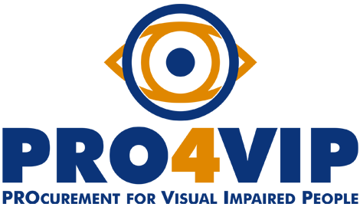

Definition of uncovered common needs

FG report

Slovenia
Status: Final
Issue date: 17.05.2016
Organisation name: Union of the Blind and Partially
Sighted of Slovenia
Author: Polona Car

TABLE OF CONTENTS

1 Introduction 3
2 Summary of the focus group 4
3 Participant profiles 5
4 Methodology 7
5 List of topics 8
Topic 1 – Indoor and outdoor orientation and mobility 8
Topic 2 – Reading and writing 12
Topic 3 – Personal care 16
Topic 4 – Access to information, goods and services 20
6 Findings 24
7 Recommendations 31

Introduction
PRO4VIP held a series of focus groups across EU, involving low-vision people, who are the primary target of this analysis phase, for which their feedbacks are considered paramount. Through the focus groups, the consortium gathered information to help decision makers, procurers and (potential investors) to analyse and define hierarchy between partially-sighted (PS) persons’ unfulfilled needs in terms of assistive devices, to scan the market and assess the technology state-of-the-art and to design prospective procurement models and approaches to solve the innovation gap between actual needs and solutions currently available on the market.
This document describes the activities performed and the evidences emerged during the focus group held in Izola, Slovenia, the 7th of May 2016 aimed at problem domain and uncovered needs analysis.

Summary of the focus group
Union of the Blind and Partially Sighted of Slovenia (UBPSS) held a focus group discussion with 23 participants on 7th May on the premises of UBPSS. The focus group was conducted as part of the involvement of the European Blind Union in PRO4VIP. Participants provided information in two ways: written responses (questionnaires) and group discussion.
The discussion was designed to gather information from the PS persons’ in regard to the following common outcomes, emerged as statistically relevant from the questionnaires:
- Indoor and outdoor orientation and mobility
- Reading and writing
- Personal care
- Access to information, goods and services

Participant profiles

23 participants took part in the focus group:
- 9 persons between 25 and 50 years old, 14 persons over 50.
- 11 participants identified themselves as having moderate low vision and 12 as severe;
- 5 participants – albinism; 1 participant - uveitis; 5 injury; 2 participants - multiple sclerosis (MS); 2 participants - glaucoma; 2 participants – age-related macular degeneration; 1 participants myopia plus bleeding of optic nerve; 1 participant - achromatopsia (ACHM); 4 participants – other (from birth/childhood, unknown cause);
- 16 of the 23 participants are retired; 4 participants are employed; 2 participants are students and 1 participant unemployed (able to work and currently work seeking).

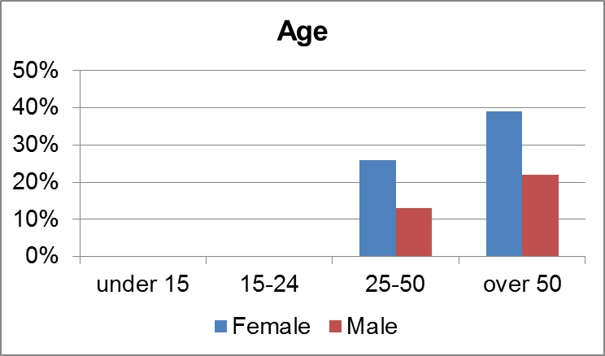

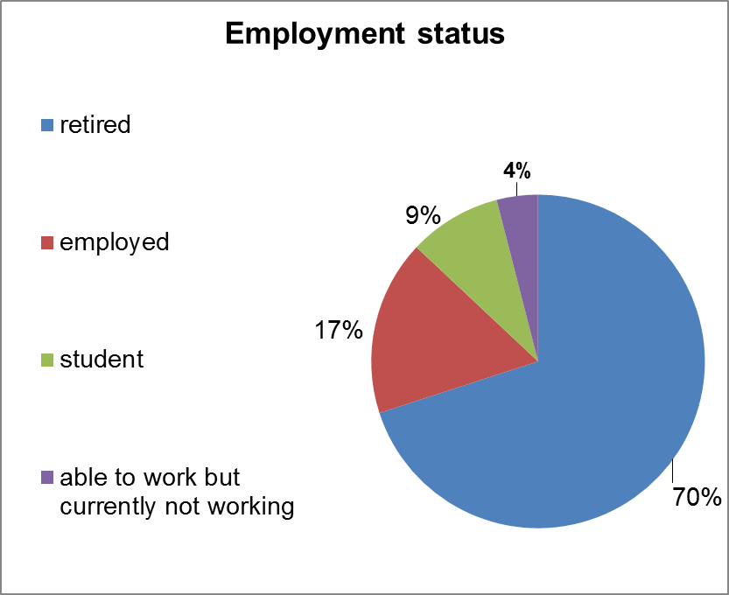

Methodology
The method used to identify innovation needs, validating them against their end-user relevance is the WIBGI developed by the English National Health Service (NHS UK). It uses collective brainstorm exercises with end-users to complete the sentence “Wouldn’t It Be Great If….”
In this setting, focus groups ought to be made by end-users: as they work and interact with a process on a daily basis, they are best-placed to see its problems or inefficiencies and identify possible areas of improvements.
WIBGI’s basic concept is to make time to take end-users out of their usual environment, group them and ask them to finish the sentence “Wouldn’t It Be great If....?” and, as a second step, to provide guide to collaboratively describe the problem to be solved, defining clear outcomes that are required (functionality / performance / efficiency improvements) rather than prescribing technologically how the solution for the problem should be built.

List of topics

Topic 1 – Indoor and outdoor orientation and mobility
In general, all participants were extremely reactive and passionate when talking about orientation and mobility. Both, indoor and outdoor orientation is high priority for most of them as ability to get out-and-about is one of the indicators of individual’s independent live.
- Wouldn’t it be great if….?
23 of the 23 participants outlined as very important to orientate and navigate independently in familiar and unfamiliar environment. For speakers is crucial to walk safely from certain starting point (e.g. home) to chosen destination. They want to be given exact and accurate information about the current location, distance to the final point, alert about obstacles on the route and information about other hazards such as construction site, overhanging branches etc. 10 of 23 participants pointed out the importance of clear announcements about staircases upwards or downwards, traffic lights or safe crossing points where there is no traffic light. All participants agreed that pedestrian crossings should be detected accurately and users should receive information in appropriately and efficient time manner. 5 participants especially addressed the need about other relevant information that they would like to gain from the environment: house numbers, names of the streets, points of interests or desired information about the nature in the vicinity of walking route. 3 participants also exposed indoor navigation for instance in the hospitals, bank, post office or administrative office where person have to read the signs and names of the personnel, departments, floors etc.
The PS persons offered a number of reasons for their evaluations:
- People with low vision struggle to walk confident in built environment, designed of buildings, sidewalks and other elements composing of inappropriate materials that cause glittering, glancing or low contrast with surroundings.
- Names of the streets, house numbers, information billboards and other signs are impossible to read as they are located to high.
- Down slopes, ramps, stairs, entrances into the buildings are inappropriately marked and could therefore be cause for an injury.
- Partially Sighted persons could bump into glass, walls or doors made of glass, as well as having difficulties using revolving or sliding doors as not knowing into which direction are they going to open or even can’t detect them.
- Direct sunlight or very bright light reduce usability of remaining sight.
- Train and bus stations are not properly marked with tactile and contrast surface indicators. It’s hard to find the right platform, bus (Quote: “There out of 10 buses at certain bus stop, how do I know which is the one I am looking for? I cannot read the numbers.”). Signs, information billboards and timetables are positioned to high and not in appropriate contrast. Letters are too small.
- On the sidewalks are too many static and moving obstacles.
- Frequent cause for difficulties indoors are: the size of the room, glittering surfaces, too bright or too dark room, no orientating points to rely on, difficulties to read signs, background noise or music.

- What are the main shortcomings of available solutions on the market?
All the participants agreed that in the area of orientation and mobility there are significant weaknesses and shortcomings, including:
- Mainly the solutions are available only for smartphones or tablets which are not friendly to use for elderly.
- Too complicated to use.
- Speech synthesis for Slovenian language operating on android has been developed only recently. Consequently, not everybody has opportunity to acquire it and try it yet.
- Systems are not stable. Information are not always accurate and also frequently delayed. Some application detects pedestrian crossing but not traffic lights. Obstacle detection is not precise – mostly unable to distinguish among sort of different obstacles (moving or static).
- Limited choice of contrast schemes and font sizes.
- Devices are unable to read signs, timetables and bus numbers.
- Awareness what is available on the market is insufficient.
They cited a number of the shortcomings of actual technologies and assistive devices, including:
- Solutions are depending on GPS signal, mobile or internet signal which is often bad or has bugs. Signal is too often dependent on weather conditions.
- When turning on the application battery is exhausting faster.
- Lack of backups in case when there is no signal.
- User interface adjusted for people with low vision makes application or the whole system work slow.
- Special settings are needed in order to get application working (sometimes you have to change mobile network settings or enable different system settings which are then overlapping with other phone functions).
They had specific needs for having reliable assistance that could substitute a sighted guide when navigating in familiar and unfamiliar environment. They used various words to describe their needs: “Wouldn’t it be great if there was device that would safely guide me on the route; for instance from home to the doctor or pharmacy.” “Wouldn’t it be great if there was application that would deliver me adequate information about timetables on command without inserting several details?” Wouldn’t it be great if there would be device that would recognize house numbers or street names and deliver me information about it? Then I would not be depended on passers-by and their feedback depending on their current mood.” Wouldn’t it be great if there would be reliable and accurate system telling me which bus number is coming or which bus is ready to go?” “Wouldn’t be great to have application that alerts you about construction-site or traffic information? Detects obstacle and recognize the difference between bicycle and humans? “Wouldn’t be great if device would guide me safely around trash bins, pillars car park barrier?”
Topic 1 – Indoor and outdoor orientation and mobility
Need 1.1 | The need for sustainable mobility aid for outdoor and indoor orientation.
Need 1.2 | The need for device which accurately detects and recognition of different obstacles and ability of providing information to the user.
Need 1.3 | The need for device that provides information about current position, distance, bus number, ability to read signs and names of streets and house numbers.

Topic 2 – Reading and writing
In general, PS persons assess reading and writing as very important. Again, being able to read and writing efficiently and without difficulties means better individual literacy.
- Wouldn’t it be great if….?
18 of the 23 participants outlined as very important to have aid that would help them with reading and writing. The remaining 5 participants mentioned that they do not face with many difficulties in this area as they always find the way how to overcome the barriers. For example, when they are in situation that they can’t read something, especially labels, user instructions etc., they take photo of the product or billboard and enlarge image on the smartphone. This enables them to read and get desired information. However, 2 participants pointed out that this takes too much time and effort. “Wouldn’t be great to have device that would read information without taking picture and enlarging the image?” “Wouldn’t be great to have device to read books in black print without converting them in other formats?”
The PS persons offered a number of reasons for their evaluations:
- Reading information is impossible for low vision person when signs, billboards are too high; labels in small print or bad contrast and instruction for devices, medicine not attached in proper version or available only online.
- TV subtitles and settings bar menu are for low vision difficult to read and use as color contrast is bad and font size to small.
- Particular low vision requires various adaptations for various circumstances. 11 participants mentioned they would need more than one aid for reading.
- Spectacles, lenses and glasses for reading do not have sufficient magnification.
- Majority of people with sight loss would require electronic magnifying system aid for reading but only people who have 5 % or less sight remaining can acquire aids through public health insurance.

- What are the main shortcomings of available solutions on the market?
All the participants agreed that in the area of reading and writing there are significant weaknesses and shortcomings, including:
- Limited choice of available products on the market: glasses, lenses or aids for near or far distance reading and watching do not meet the need of all low vision as magnification is not sufficient.
- Electronic magnifying systems lack of enough choice of contrast schemes and font sizes. They are robust and not handy for use, especially when used for writing (while writing picture blurs and it’s not clear).
- Inconvenient and not esthetic frames for glasses.
- Mono-oculars (or other aids for far distance) require from user to have hands still and in one particular position which cause pain and makes individual tired.
- Portable magnifying glasses are on the one hand too fragile and on the other too robust and heavy. There is not enough choice of adequate magnification.
- Prices of the products are unreasonably high.
They cited a number of the shortcomings of actual technologies and assistive devices, including:
- Screen readers (ZoomText etc.) are not compatible with the system – often makes computer work slow or causes collapse or other bugs.
- Portable electronic magnifying aids have too small screen (too narrow). Users can often choose only among 3-4 color (contrast) schemes and 4 font size, which does not meet the needs of many people with low vision. 3 participants pointed out that they would like to use them as aid for writing as well “but there is a problem with positioning and handling with aid while writing at the same time”.
- Picture on small portable magnifying screens are a bit delayed and text is twitching.
- Not enough memory on small portable magnifying devices to scan and store desired quantity of material.
- Aids for distance have limitations with zooming-in option and yet does not have option to adjust contrast.
- Battery not powerful enough.
They had specific needs for adequate glasses and lenses that would meet diverse needs of different low vision conditions. They used various words to describe their needs, “I would like to have an aid that helps me read efficiently in all light conditions and enables me to read all different font sizes”. “Wouldn’t it be great if there was a device to read all distant and near information at once, so I wouldn’t need to use two or more aids. In one minute I would be able to read a newspaper and in the next one I would be able to recognize my friend approaching from a distance”. “Wouldn’t it be great if there would be a small magnifying glass that would enlarge enough all types of text and look nice at the same time.”
Topic 2 – Reading and writing
Need 2.1 | The need for a high performance device that would combine “zoom-in, zoom-out” functions and enable users to read near and far information with the option of adjusting desirable settings.
Need 2.2 | The need for different types of glasses that would have better magnification and users would be able to choose the one that suits her/him best.

Topic 3 – Personal care
In general, PS persons were extremely reactive when talking about daily living activities that they are difficult to perform due to sight loss.
- Wouldn’t it be great if….?
23 of the 23 participants outlined as very important to be able to take care of themselves in their household. 10 participants expressed need for various devices with voice speech output, tactile buttons and large font size on the product’s commands (microwave, modern types of stoves, ovens, washing machine and dishwasher). 3 participants asked for solution that would help them clip the nails and apply make-up. 1 participant would need feedback on color of clothes. 6 participants emphasized the need for detecting dirt stains on their clothes, impurities and other spots in their homes. The remaining 6 participants also stressed out the need for personal care aids such us thermometer, digital pressure gauge, blood sugar meter etc. that would provide reliable and accurate information and have voice output in Slovenian language. Moreover, the need for large print and tactile buttons is essential for all products. 2 users addressed the need for assistance with sewing, knitting and crocheting.
The PS persons offered a number of reasons for their evaluations:
- When doing housework help of other person is often required. Cleaning takes a lot of effort as person with low vision is not sure if work is done properly.
- Limited choice of scales: not enough contrast and big marks on the screen.
- Labels on the products for personal care, food and cleaning fluids are not suitable as font size is far too small. Sometimes they are hard to read even with magnifying aid.
- With goods are not equipped with appropriate programmes, which would be easy to use and do not have tactile commands or large print signs.
- Instructions are not available in suitable format – sometimes they are only available online, which is problem for many users who do not use computers.
- For users is hard to distinguish products, especially when they are purchasing goods in the supermarket.
- Manufactures change paper wrapping or packing too often – users find difficult to recognize desired product.
- Clipping nails is extremely awkward situation as users struggle to hold clipper with one hand and magnifying glass in the other.

- What are the main shortcomings of available solutions on the market?
All the participants agreed that in the area of personal care there are significant weaknesses and shortcomings, including:
- Solutions on the market are too expensive – for high price person with low vision does not acquire desired effect of the product.
- Main problem remains not enough reliable feedback. Existing color detector does not always provide accurate information about the color.
- White goods and electronic device are equipped with inappropriate commands in small fonts and poor contrast.
- Modern materials that goods are made of are reducing the usability of remaining sight as it’s hard to tell where is the control panel with all programs and other components.
They cited a number of the shortcomings of actual technologies and assistive devices, including:
- Poor quality of speech output. Information is delayed or not accurate (e.g. user receives wrong information about the shade of the color or is given false information about the color as it is in reality).
- Contemporary devices have touch screen commands which are hard or impossible to operate for persons with low vision.
- Solutions, especially applications for smartphones that enables support and assistance are still very much dependent on sighted guide. Audio labelers require pre-recorded contents which takes time, effort and help of other person.
They had specific needs for the aid that would help them with purchasing food, accessories, cosmetic products. They used various words to describe their needs: “Wouldn’t be great if there would be a device that would help me find the product I am looking for? Once I hold the product, I need the detailed information about it, the device could read the label content for me. “I need information if product is gluten-free, because I have allergy.” Wouldn’t be great, if this device would warn me about the harmful ingredients or dangerous effects on body and environment?” “Wouldn’t be great to have an aid that informs me when my clothes are dirty or when my apartment is not clean or there are cobwebs?”
Topic 3 – Personal care
Need 3.1 | The need for device that would recognize products in the supermarket and in the household that would read labels, measure different measurements and provide user feed accurate feedback.
Need 3.2 | The need for the device detects spots on clothes and impurities within the household.
Need 3.3 | The need to have glasses with adequate magnification which would enable users to perform precise tasks such as sewing.

Topic 4 – Access to information, goods and services
In general, PS persons were extremely reactive when talking about access to information, good and services.
- Wouldn’t it be great if….?
23 of the 23 participants outlined as very important to access to all sort of information. 11 participants special focused on web accessibility. The remaining 12 participants pointed out that even basic services or goods are not accessible. For example: prescriptions, personal documents are written by doctor or public personnel in small font and in hard paper only. “Wouldn’t be great if there was device that would fast recognize different handwritings and tell me what is written on the paper?” “Wouldn’t be great if the device would simply transfer visual information (picture caught by camera) into audio descriptive information?” Wouldn’t it be great if computer or application would enable contrast and font size in default settings?” “Wouldn’t be great there would be an aid that would read me signs, billboards, street names, house numbers and help me allocate desired bus stop?”
The PS persons offered a number of reasons for their evaluations:
- Many times access to information is denied for VI persons.
- People receive document in format, they couldn’t read.
- Websites or applications remain inaccessible as they are not designed inclusively (it’s not possible to properly enlarge image or set suitable color contrast and choose font size).
- Forms, ballot papers are not possible to read nor to fulfill them as letters and brackets are too small and narrow.
- ATMs are not possible to use without help of a sighted guide. Only a few are adjusted for people with visual impairments.
- High contrast and big font size are missing.
- Announcements on passenger’s terminals, signs, timetables on the bus or train stations and electronic billboards are located to high so person with low vision can’t see or read them. In administrative office there is no voice announcements that would make procedure easier for VI people.

- What are the main shortcomings of available solutions on the market?
All the participants agreed that in the area of accessibility of information there are significant weaknesses and shortcomings, including:
- Certain solution that is provided by the manufactures of designers only applies on one particular area (e.g. website, app). Moreover, the program or application is then overlapping with other settings or is not compatible with the whole system. Thus consequence is poor responses of the programs, bugs or system stops working.
- On most websites there are no adjustments available for people with low vision. User can’t choose desired color contrast or font size.
- The basic structures of websites is more or less complex and design varies from site to site which makes users hard to navigate on internet as he/she is forced to adapt to different layout, structure every time.
- ATMs are not equipped with voice/speech output. Color contrast is poor and there is no option to change font size. Many ATMs have different keyboards which results into difficulties with inserting pin. Also card slot is positioned variously what users find extremely annoying.
They cited a number of the shortcomings of actual technologies and assistive devices, including:
- Experience show that some adjustments for VI people bug the system sustainability which results in collapse of the device.
- Currently available settings for TV do not allow VI people to adjust menu bars, subtitle in efficient contrast and desirable font size. Furthermore, there is no voice output.
- Available solutions are not sufficiently reliable for VI people. They are suitable for sighted people. Sometimes even as “computer games”, but lack of accuracy and frequent bugs prevent people with low vision to use them efficiently.
They had specific needs for easy access to all sorts of information. 4 participants particularly emphasized the need to be treated under equal circumstances which means “we need equal access to goods, service and information”. They used various words to describe their needs: “Wouldn’t be great to simply switch on handy device that would “translate visual into audio output”; that would provide me with information from my personal documentation, forms that I need to fulfill, device that would be reliable to that extent that would allow me to perform activities safely (bank business, payments, cash withdrawal, form in post office etc.” Also, “wouldn’t be great if there would be the device that would recognize faces and expression of persons approaching or persons who are present in the same room”.

Topic 4 – Access to information goods and services
Need 4.1 | The need for program or application that would run on computers, smartphones and other devices (ATM, ticketing machines, check-in machines), that would enable color and contrast adjustments, font size and audio output. Plus, that would be compatible with the whole system (bugs would be totally eliminated).
Need 4.2 | The need for a device that translates visual information into audio information (that would help users to read signs, gain various and crucial information from the environment (outdoors and indoors) that are essential for understanding particular room and that are basic for safe functioning.

Findings

The need 1.1: The need for mobility tool is due to the evidences that today orientation and mobility is hazardous for people with sight loss. To navigate from starting point to the final destination safe and sound, passing all the barriers on the way, crossing busy and noise streets with or without traffic lights could be risky not only for VI people but for sighted as well. The challenge is to provide users who have low vision with sustainable and reliable solution that would run on smartphone, “smart” glasses or smart watch and would offer them assistance when out and about. In this way they would be more independent and their self-esteem would be improved.
For most participants the indoor navigation is also very important since they find difficulties with orientating themselves throughout indoor public buildings.

Need 1.1 - The need for sustainable mobility aid for outdoor and indoor orientation.
Function 1 | Device should be easy to use.
Function 2 | It should be portable and lite.
Function 3 | Must have integrated color and contrast adjustments, different font size settings.
Function 4 | Speech output in Slovenian language.
Function 5 | Device should have backup when bad or no GPS, mobile or internet signal.
Function 6 | Device should have strong battery.
Function 7 | Device should be affordable.
Function 8 | Should have also tactile and convex buttons (at least for basic commands).
Function 9 | Good quality screen which improves usability in strong brightness (screen should not glitter).
Function 10 | System or application should provide accurate and reliable information about the location, about the direction where to user should walk, about nearby vicinity if required by user.
Function 11 | Precise obstacle detection and alerts about other hazards on the route (overhanging branches, construction site, ramps, pillars, slopes).

Use case #1
Need 1.1 - Sustainable mobility aid for outdoor and indoor orientation.
Use-case today | Today, without efficient solution, I have to prepare myself for the route. I have to plan the journey in advance. While walking, I often bump into the barriers and harm myself. Therefore, I don’t feel comfortable walking on my own. Sometimes I get completely lost. I’m forced to ask for help which is not always pleasant as I don’t want to explain to strangers I have sight loss. I spent more time on the way then I would like to. For longer journeys I ask sighted guide to assist me on the way.
Use-case tomorrow | Tomorrow with new device I will be able to navigate myself in familiar and unfamiliar environment, outdoors and indoors. I won’t need to ask for help people on the street nor my family or friends. I will receive all crucial information about the chosen route, direction of walking, potential hazards and my personal points of interest. I will now exactly on which street I’m on at certain moment. I will spend less time on the way. Walking will become more pleasant activity.

Need 2.1: Participants agreed reading is crucial activity in their lives. Reading is essential in performing daily activities, work related activities and learning. Aids for near and far reading are various but too expensive. Moreover, not in every country the same products are available. End-users don’t receive what is available on the market. Also, low vision requires many aid and technical equipment: e.g. mono-ocular/binocular for far reading, magnifying glasses and lenses for near reading. It’s not handy for users to carry all this aids always with themselves. Sometimes it’s difficult to change aid for far distance reading with aid for reading newspapers. The need to have one aid, that would efficiently combine far and near distance reading is one of the most frequent mentioned user’s requirements.
Need 2.1 - The need for a high performance device that would combine “zoom-in, zoom-out” functions and enable users to read near and far information with the option of adjusting desirable settings.
Function 1 | Device combine adjustable zoom for near and far reading.
Function 2 | It’s portable, lite and handy – easy to use.
Function 3 | Device It’s affordable.
Function 4 | It has settings for different color high contrasts and font size.
Function 5 | It has efficient system.
Function 6 | Strong battery.
Function 7 | Screen is not glittering or glaring.
Function 8 | It has simple and easy to use commands – convex buttons.
Function 9 | Fast and responsive.
Function 10 | It has speech synthesis in Slovenian language.

Use case #2
Need 2.1 – Device for far and near distance reading
Use-case today | Today I have to use 2 different glasses for reading. For small letters I need also magnifying glasses. I can’t choose suitable between suitable color contrast nor font size. 1 aid means one magnification. Electronic portable magnifier offers 3-4 magnification but still not enough for all conditions. When I am trying to read signs in the distance I have to change my glasses and binoculars. I spent too much time on adjusting the right zoom and thus I can’t catch certain details. Therefore, I miss potential important and interesting information.
Use-case tomorrow | Tomorrow I will have a device that would enable near and far reading with any difficulties. Device will have functions which will be easy to change. I won’t bother with settings and desired adjustments as device will do it by itself. I will be able read books in black print whenever I want, with speed I want and with qualitative voice synthesis.

Need 2.2: The need for different types of glasses that would have better magnification and users would be able to choose the one that suits her/him best. Participants discussed about the aids with various technical functionalities. But in overall, they would also like to have improvement on “classical” magnification aids such as glasses and magnifying lenses. Some of participants particularly emphasized they would still be able to perform many tasks if only lenses would have better and appropriate magnification. Lack on the market and limitations is however significant.
Need 2.2 - The need for different types of glasses that would have better magnification and users would be able to choose the one that suits her/him best.
Function 1 | Magnification lenses are small and lite.
Function 2 | Desired and suitable magnification available.
Function 3 | Lenses are not fragile.
Function 4 | Portable solution.
Function 5 | Magnification lenses available in tasteful design - as jewellery (for instance as neckless that woman can always carry it around the neck).

Use case #3
Need 2.2 – Glasses and lenses with better and improved magnification
Use-case today | With magnifiers I am using today I can’t read small fonts and perform precise tasks at home. I have to ask my husband every time I need to read or to do something.
Use-case tomorrow | Tomorrow I will find on the market suitable magnifier for me. I will be able to read and do things on my own and I won’t be depended on husband’s help.

Recommendations
Participants in Slovenia welcomed the initiative of PRO4VIP project. Early in the beginning they expressed warm support for approach taken in organizing FG which resulted into high number of participation – 23 participants in total (21 plus EBU observer and national coordinator, both also making comments during the discussion). For majority of the participants this was rare opportunity to take part in international projects. They were pleased to share their own opinions, ideas, experience.
During the session, a special bond was developed within the group. After initial excitement and brief presentation of participants and main goals of the workshop, they spontaneously started to give advices to each other. Progression of the debate encouraged them with further exchange of experience, knowledge and sources of beneficial information. Mostly, they were interested in efficient navigational aid that would assist them when walking on busy street or indoor public buildings. They want accurate information and feedback about the route, obstacles, location and directions. Furthermore, all of them showed interest in accessible devices such as ATMs, ticketing machines and accessible information on bus/train stops: timetables, announcements, billboards, signs, bus numbers etc. It was emphasized that devices for household should meet criteria of universal design as much as possible. Participants expressed that they wanted to be heard and taken into consideration. Additionally, aids and equipment for reading were prioritized high. For users is frustrating when they have to use more devices for reading or have to change aids for reading and aids for distance really fast. They would like to have all in one; aid, that combines far and distance modifications.
Regarding the date: we decided to organize FG in the beginning of May, what was proven as right decision. We tried to give participants enough time to plan ahead. We choose venue that was suitable and comfortable for work. The only shortcoming of this was not enough time to draft report.
In terms of moderation, it was beneficial to have introduction. Presented examples during the Skype calls were important for understanding of what were the expectations and desired outcomes of FG. Sent templates in advance were good guidance for work, except draft report template was at first a bit confusing. We took into account that debate should be good balance of structure and guidance on one hand and spontaneous on the other. Every user had opportunity to talk and share opinions. To break the ice initially everybody was invited to talk about general things and then continued with more specific discussion. Occasionally, we had to kindly interrupt speaker in order not to go far away from the topic or to prevent two or more would talk one over another.
Several times participants pointed out the need to have presentation or demonstration of available aids and devices on the market prior initial end-user questionnaire. It would be easier to propose suggestions, if knowing what is already developed and available. However, this seemed difficult to conduct, but at the same time this is strong supported end-user requirement for potential future project. All participants expressed the need for individual training about how to use and handle with technical aids.
To conclude, FG was challenging but very interesting to organize and moderate. For users, observer and moderator it was important that we share the same personal experience – sight loss. This allowed us to develop closer bond and gain better mutual understanding. Thank you for giving us the opportunity. We will eagerly wait for developers to response.

