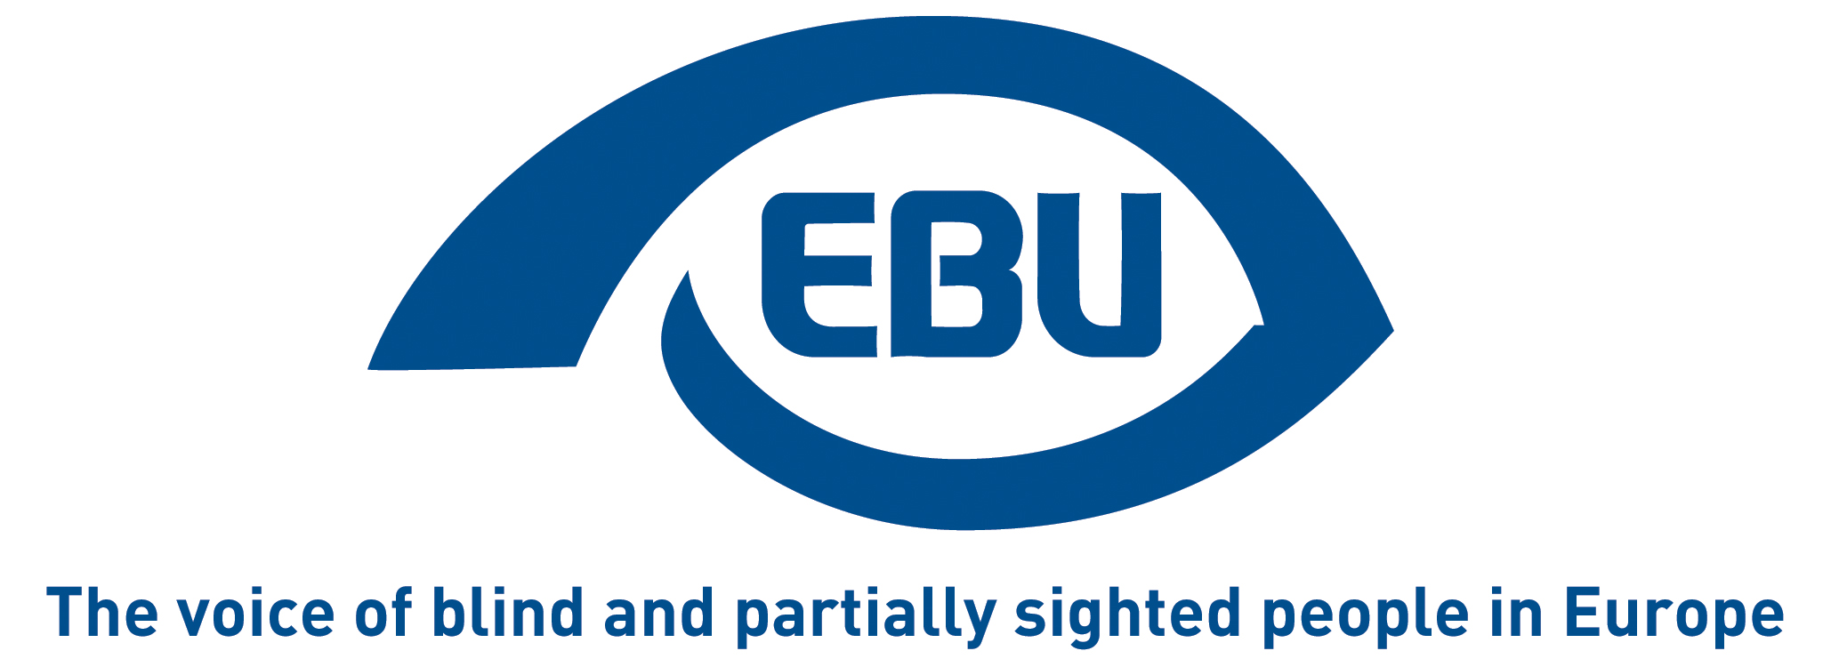

European Blind Union response to Commission call for evidence on Citizens’ Omnibus Initiative to simplify travel and tourism

EBU Position Paper | June 2026

Object of the call for evidence
The call for evidence indicates: “The Citizens Omnibus aims to set up a process to reduce administrative burdens in EU legislation which have a direct impact on the daily lives of people legally residing in the EU. The goal is to ensure they can fully benefit from the single market without facing disproportionate administrative or legal barriers, especially in cross-border situations. It will provide an opportunity for targeted amendments to EU legislation that cut red tape and make rules simpler.”
The EU Tourism Platform further indicates: “The European Commission has introduced the Citizens’ Omnibus Initiative to cut down on administrative hurdles and make daily cross-border interactions within the EU easier. This initiative is particularly important for sectors like tourism, mobility, and hospitality, as it seeks to enhance digital services, streamline bureaucracy, and facilitate smoother travel experiences across Europe. Stakeholders in tourism are invited to share their insights to help build a more connected and visitor-friendly Europe.”

Our response
EBU would like to take this opportunity to make the case for accessible tourism in the EU for blind and partially sighted travellers, building on the principle of design for all in legislation, public policies, and tourism industry. The European Commission should ensure that any simplification of tourism and travel procedures is based on accessible-by-default digital systems and consistent requirements across the travel and tourism ecosystem. There can be no seamless travel without accessible information
In practice, even in most performing EU countries, the accessibility chain is not always complete, especially when it comes to information for travel planning, digital services, European-level standardisation, and information about accessibility – let alone consistent implementation of existing laws.
There is a growing use of digital interfaces in travel and tourism. While digitalisation offers significant advantages, it can also create new, often greater barriers than traditional alternatives if accessibility of websites and digital services of transport, hotels, museums and other tourist attractions, tourism portals, and other tourism-related service providers, is not considered from the outset. If these are not accessible, visually impaired persons face uncertainty and dependence on others even before the actual journey begins.
All digital travel and tourism services should comply with recognised accessibility standards and be fully usable with screen readers and other assistive technologies. Effective enforcement mechanisms and penalties for non-compliance should ensure equal access.
Booking platforms and tourism service providers should provide clear, reliable, accessible and easy-to-find information whether a destination, accommodation, or service is accessible for blind or partially sighted persons, including any potential environmental barriers that may affect independent mobility. This would enable informed decision-making and significantly reduce negative travel experiences. Common standards for presenting accessibility information should be promoted.
Tourism providers should be encouraged to offer accessible navigation tools, such as audio-guided routes, accessible digital maps, and detailed textual description of routes between key locations, to improve safety, increase confidence, and promote independent travel.
Also to be taken into account is that information in the event of disruptions during a journey (delays, line closures, route changes, change of stops etc.) should be provided in real time and in an accessible format. Tourism and accommodation providers should provide accessible multi-channel customer support, including telephone support – often a faster and more efficient means of communication than chatbots, online forms, or email, especially when travelling.
The matter is broader than the European Accessibility Act, the EU Directive on accessibility of the websites and mobile applications of public sector bodies, and the accessibility provisions contained in passenger rights legislation. By ensuring that accessibility is integrated into the simplification of travel and tourism services, the EU can make travel more inclusive, independent, and enjoyable for millions of blind and partially sighted travellers.

About EBU
The European Blind Union (EBU) – Interest Representative Register number 42378755934-87 – is a non-governmental, non-profit making European organisation founded in 1984. It is one of the six regional bodies of the World Blind Union, and it promotes the interests of blind and partially sighted people in Europe. It currently operates within a network of 40 national members including organisations from 26 European Union member states, candidate countries and other countries in geographical Europe.
European Blind Union
6 rue Gager Gabillot - 75015 Paris
+33 1 88 61 06 60 | ebu@euroblind.org | www.euroblind.org
Contact: Antoine Fobe, Head of Advocacy and Campaigning
ebucampaigning@euroblind.org | +33 1 88 61 06 64

