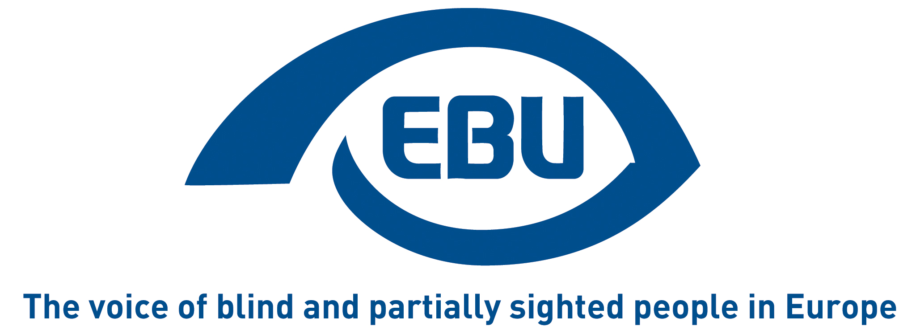

European Blind Union response to Commission call for evidence for evaluation and impact assessment of Audiovisual Media Services Directive

EBU Position Paper | December 2025

Object of the call for evidence
The call for evidence indicates:
“The evaluation of the AVMSD will assess its effectiveness, efficiency, relevance, EU added value, and (internal and external) coherence. It will look at a wide range of important areas of the Directive, including its scope, prominence of media services of general interest, audiovisual commercial communications, protection of minors rules applicable to video-sharing platforms and promotion of European works.
The Commission will consider the relevance of the current rules of the Directive and assess whether its provisions are still fit for purpose, taking into account the developments in the EU audiovisual media market and the new technological realities. This evaluation will help the Commission identify potential shortcomings in the existing framework.”
We regret that under “Problem the initiative aims to tackle”, no reference is made to the accessibility requirements of Article 7, the object of our present response.

Response
Audio description and audio subtitling are effective measures to implement accessibility for visually impaired persons.
Despite the slow and challenging transposition, the revised Audiovisual Media Services Directive (AVMSD) brought positive points in terms of accessibility. For the first time, Member States were obliged to put in place measures on media accessibility and to create a contact point for media accessibility information and complaints (Article 7).
However, to-date, the AVMSD has failed to make audio description and audio subtitling largely available for blind and partially sighted persons.
This is because, compared to other EU accessibility laws, which provide specific accessibility requirements that are harmonised across the EU, the AVMSD gives a lot of flexibility to Member States. The general wording of Article 7, with no specific targets on percentage of accessible audiovisual content, no clear timelines, no definitions of access services (beyond the general and vague reference in recital 23) nor standards for such services, and no obligation to involve persons with disabilities, has led to different approaches to media accessibility which are limiting the impact of the Directive for the disability community.
Other reasons of concern are:
- The AVMSD is not adapted to market developments and changing viewer habits (e.g. growth of online platforms, on-demand services, influencers’ activities, and shifts in consumer-viewing behaviour), with legal clarity that the provision on accessibility (Article 7) covers new relevant media players, notably influencers.
- The AVMSD is not fully aligned with the European Accessibility Act (EAA)—which also fails to clarify and specify how to implement the accessibility obligations of the AVMSD—and the Digital Services Act—which also fails to regulate the accessibility of online platforms, including video-sharing platforms, social media and newspapers. Online platforms and digital services should comply with the same accessibility requirements of EU accessibility harmonised legislation, particularly the Web Accessibility Directive and the EAA.
Some of these fears were already evident in 2021 European Regulators Group for Audiovisual Media Services (ERGA) report on Article 7.1, and they have been confirmed by recent reports, including that of the Commission (2024) and the European Audiovisual Observatory (2023). More recently, in its concluding observations, the UNCRPD Committee concluded that the AVMSD lacks timelines and targets for implementation and does not ensure the accessibility of video-sharing platforms, social media and the audiovisual sections of news websites.
For all these reasons, EBU calls for a revision of the AVMSD that will ensure that it truly advances accessibility.
We fully support the demands of our umbrella group, the European Disability Forum, for this revision, namely the call for:
- Updated definitions of accessibility requirements and a clear reference to these in Article 7, with concrete targets indicating, with clear timelines, what percentage of audiovisual content should be made accessible and for what type of access service.
- Addressing the lack of accessibility obligations for video-sharing platforms and social media, the lack of cooperation of Member States with organisations representing persons with disabilities, the lack of appropriate points of contact at national level for information and complaint on accessibility, and the lack of special attention to providing emergency information in an accessible manner.
We would also like to echo the following two important by-the way demands:
- ERGA should analyse the intellectual property challenges, identified in the Audiovisual Observatory Report, of creating audio descriptions without the authorisation of the copyright holder and request the extension of the Marrakesh Treaty copyright exceptions to access services in audiovisual content (i.e., beyond the adaptation of printed works).
- No audiovisual content that received public funding should be inaccessible, and the Creative Europe programme for instance should leverage its funding to promote good practices to guarantee access to culture for persons with disabilities.

About EBU
The European Blind Union (EBU) – Interest Representative Register number 42378755934-87 – is a non-governmental, non-profit making European organisation founded in 1984. It is one of the six regional bodies of the World Blind Union, and it promotes the interests of blind and partially sighted people in Europe. It currently operates within a network of 40 national members including organisations from 26 European Union member states, candidate countries and other countries in geographical Europe.
European Blind Union
6 rue Gager Gabillot - 75015 Paris
+33 1 88 61 06 60 | ebu@euroblind.org | www.euroblind.org

Contact: Antoine Fobe, Head of Advocacy and Campaigning
ebucampaigning@euroblind.org | +33 1 88 61 06 64

