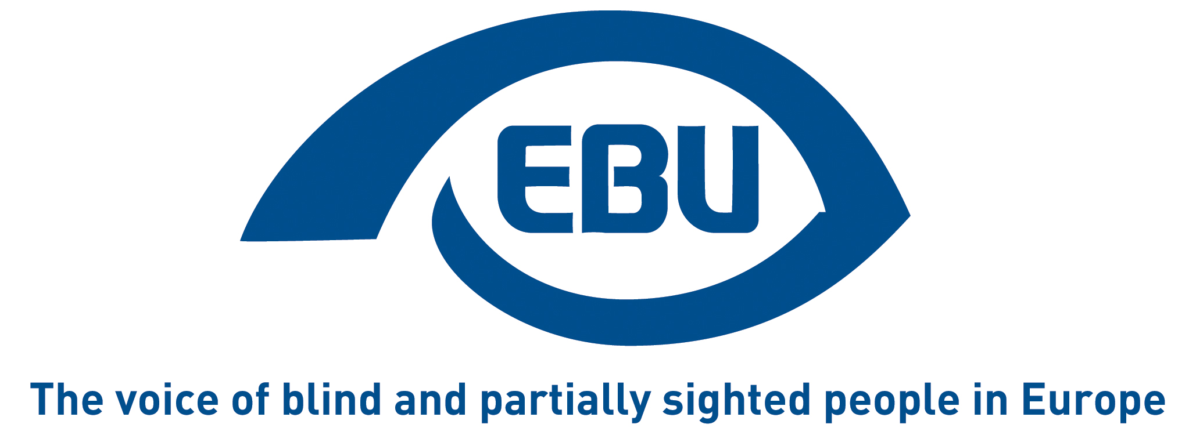

European Blind Union response to Commission’s call for evidence:

“A strategic vision for sport in Europe: reinforcing the European Sport Model”

EBU Position Paper | November 2025

Object of the call for evidence
The call for evidence indicates:
“Sport is not just for leisure or entertainment. It also contributes to public health, education, inclusion, European integration, and competitiveness.
With these benefits for society, sport is seen both as a public good and an increasingly valuable European asset in economic, social, political and cultural terms. To ensure people can reap all the benefits of sport, action must be taken to strengthen, safeguard and promote the distinct way sport is organised in Europe (European Sport Model).”
Inclusion is a key word for EBU and it inspires our response below.

Response
Despite growing attention to inclusion in EU sport policy, blind and partially sighted people continue to face structural barriers to accessing mainstream sport. These include inaccessible venues, a lack of adapted sport materials, and the digital inaccessibility of club websites, registration systems, and sport finders. Coaches and volunteers are often not trained to support athletes with specific needs, and young people with disabilities remain underrepresented in grassroots and competitive sport pathways. There are also safety issues attached to these concerns.
The European Commission’s announced public consultation should examine to what extent national and local sport ecosystems apply principles of universal design and accessibility, including physical access, adapted materials, affordability, and mobility to and from venues. It should also explore how digital websites and tools enable or exclude participation, and whether personal data and privacy are safeguarded.
In addition, the consultation should address the training and awareness of coaches, as well as the safety aspects related to the accessibility and clarity of information. To ensure lasting change, the roles and responsibilities of federations and municipalities should be examined across all these dimensions.
With reference to the EU Council Resolution of 2019 on access to sport for persons with disabilities (2019/C 192/06), EBU expects a communication on inclusive sport to address the barriers mentioned above and what is needed to create socially inclusive and safe sport environments for persons with disabilities, including visually impaired people.
Particular attention should be paid in the communication, at root level, to ensuring that information about sport opportunities, registration procedures and safety guidelines are available in accessible digital and alternative formats (such as audio, large print or easy language), along the principles of the European Accessibility Act and the Digital Services framework.
Also crucial is the monitoring of progress, which should measure not only participation rates but also the accessibility of communication, facilities, and training offers at local club level. This monitoring should be carried out regularly and with enough detail to track meaningful progress over time. Data collected through federations and municipalities could feed into an EU-wide “Sport Inclusion Index”, helping to measure progress on accessibility and participation for persons with disabilities in a consistent and transparent way.
In line with Article 31 of the UN Convention on the Rights of Persons with Disabilities, data collection and monitoring should include disability-disaggregated information to ensure evidence-based policymaking across Member States.
Embedding accessibility as a transversal value in the European Sport Model will help ensure that inclusion is not treated as a separate pillar, but as a defining characteristic of sport governance, funding and participation at every level.
EBU remains ready to support the European Commission in this work, for instance within the future EU Sport Forum process.

About EBU
The European Blind Union (EBU) – Interest Representative Register number 42378755934-87 – is a non-governmental, non-profit making European organisation founded in 1984. It is one of the six regional bodies of the World Blind Union, and it promotes the interests of blind and partially sighted people in Europe. It currently operates within a network of 40 national members including organisations from 26 European Union member states, candidate countries and other countries in geographical Europe.

European Blind Union
6 rue Gager Gabillot - 75015 Paris
+33 1 88 61 06 60 | ebu@euroblind.org | www.euroblind.org

Contact: Antoine Fobe, Head of Advocacy and Campaigning
ebucampaigning@euroblind.org | +33 1 88 61 06 64

