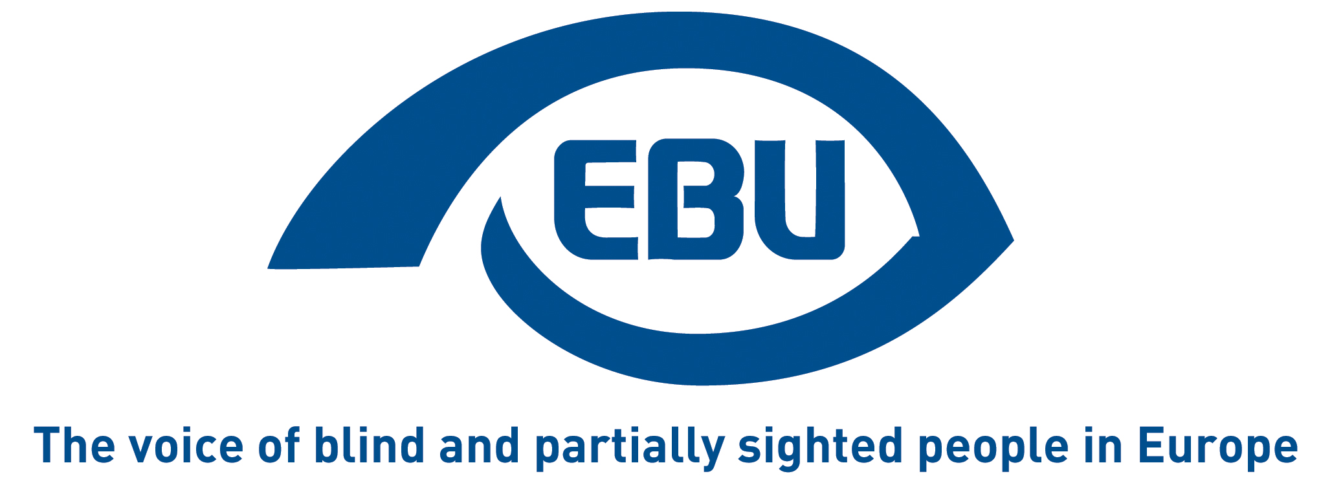

European Blind Union response to Commission call for evidence on enhancing the Strategy for the rights of persons with disabilities up to 2030

EBU Position Paper | January 2026

Object of the call for evidence
The call for evidence indicates:
“This strategy contributes to building a Union of equality by providing an EU framework for disability policies that can be built along with EU countries. It supports implementation of the European Pillar of Social Rights and the UN Convention on the Rights of Persons with Disabilities.
Although the strategy’s objectives are still relevant, ongoing challenges highlight the need for renewed action to advance the rights and autonomy of persons with disabilities and their participation in society.”

Response
In the continuity of the existing priorities – to which we refer – we would like to signal the following key areas for action for the second phase of the Strategy for the rights of persons with disabilities up to 2030:
ACCESSIBILITY (priority 1):
- Revised Audiovisual Media Services Directive, namely of its Article 7 (Accessibility) to introduce clear targets and allow the benchmarking of progress.
- Review of the Marrakesh Treaty Directive, where it allows Member States to provide for “compensation” of right-holders when authorised produce accessible-format copies of books or works for the print-disabled.
- Ambitious agreement on a revised Air Passenger Rights Regulation, namely to uphold the right of persons with disabilities to travel without needing approval or prenotification and to travel with an assistance dog.
- Awareness-raising about the key impact of inaccessible household appliances – especially with the widespread use of touchpad-operated systems – on the autonomous living of visually impaired users.
- Strengthened European accessibility resource centre AccessibleEU, through the creation of a dedicated permanent regulatory agency.
ENJOYING EU RIGHTS (priority 2):
- Continued efforts to improve the freedom of movement of persons with disabilities throughout the European Union, to organise the mutual recognition of their disability status when they move their residence to another Member State, at least during the transition to the competence of the new country of residence.
- Legislative initiative to ensure, at least in European Parliament elections, the equal political participation of persons, based on accessible elections covering the right to vote as well as the right to stand for election.
DECENT QUALITY OF LIFE AND LIVING INDEPENDENTLY (priority 3): To complement the Disability Employment Package:
- Guidance to Member States to support reforms of social protection that ensure that access to employment is not disincentivised by loss of disability benefits in cash (“disability benefits trap”).
- EU-funded Employment and Skills guarantee for persons with disabilities, as part of an inclusive and ambitious multi-annual financial framework and drawing inspiration from the Youth Guarantee.

About EBU
The European Blind Union (EBU) – Interest Representative Register number 42378755934-87 – is a non-governmental, non-profit making European organisation founded in 1984. It is one of the six regional bodies of the World Blind Union, and it promotes the interests of blind and partially sighted people in Europe. It currently operates within a network of 40 national members including organisations from 26 European Union member states, candidate countries and other countries in geographical Europe.
European Blind Union
6 rue Gager Gabillot - 75015 Paris
+33 1 88 61 06 60 | ebu@euroblind.org | www.euroblind.org

Contact: Antoine Fobe, Head of Advocacy and Campaigning
ebucampaigning@euroblind.org | +33 1 88 61 06 64

