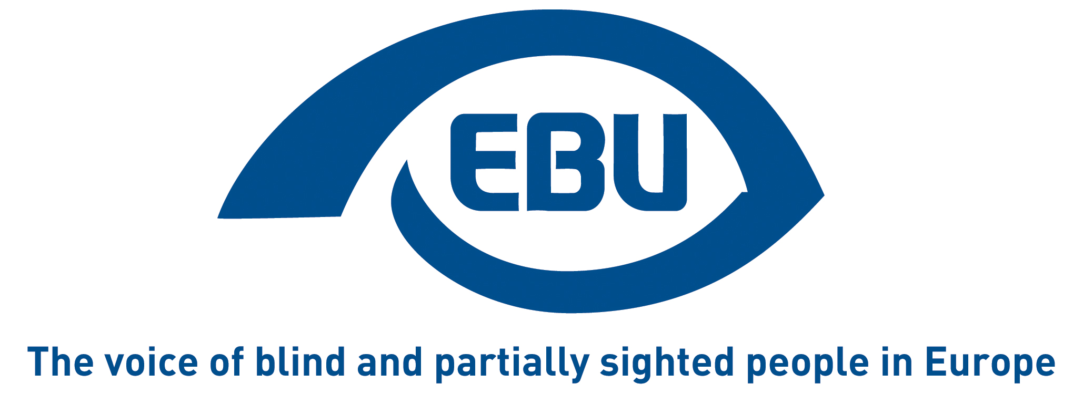

European Blind Union response to Commission call for evidence on ESSPASS initiative

EBU Position Paper | January 2026

Object of the call for evidence
The call for evidence indicates:
“ The European Social Security Pass (ESSPASS) will simplify how EU citizens moving to or working in other EU countries interact with relevant authorities or service providers in the context of social security. By enabling the secure and quick verification of social security rights and documents via a digital solution, it will cut paperwork and the risk of errors and fraud.
This initiative will establish a standardised digital solution to streamline processes for citizens, businesses and public authorities.”

Response
The European Blind Union sees a potential for the ESSPASS initiative to address the following indirect barrier to the mobility in the European Union of persons with disabilities: when they move their residence to another Member State, in can take a long time before they have their disability status re-assessed in the host country, which results in a period of legal limbo between the moment you stop residing a member state and the moment when your new member state of residence has reassessed your disability.
We would like to underline that the recently adopted Directive establishing a European Disability Card – a significant but only partial progress – only covers travelling to another Member State, i.e., on a short stays, and therefore does not cover access to residence-based social security and social welfare benefits. It was acknowledged by the European Commission that recognition of the disability status when changing country of residence should be addressed in a separate, social security-related legal instrument.
The ESSPASS, as a stand-alone instrument or in complementarity with another legal instrument, could provide a solution by organising the recognition of the disability status at least in the transition to another country’s competence.

About EBU
The European Blind Union (EBU) – Interest Representative Register number 42378755934-87 – is a non-governmental, non-profit making European organisation founded in 1984. It is one of the six regional bodies of the World Blind Union, and it promotes the interests of blind and partially sighted people in Europe. It currently operates within a network of 40 national members including organisations from 26 European Union member states, candidate countries and other countries in geographical Europe.
European Blind Union
6 rue Gager Gabillot - 75015 Paris
+33 1 88 61 06 60 | ebu@euroblind.org | www.euroblind.org

Contact: Antoine Fobe, Head of Advocacy and Campaigning
ebucampaigning@euroblind.org | +33 1 88 61 06 64

