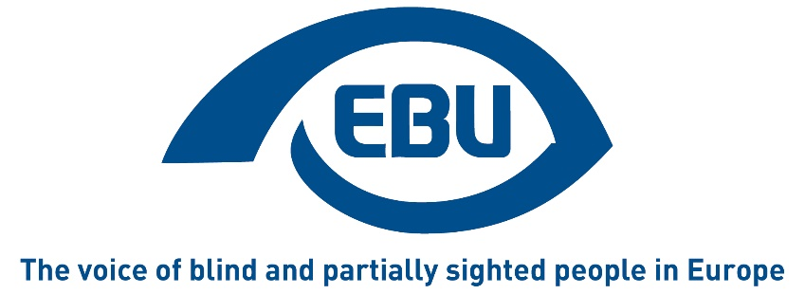

Wake up call for the European Accessibility Act to become a reality for consumers with a visual impairment
EBU Statement | June 2025
Saturday 28th June 2025 marks the date from which the obligations set by the European Accessibility Act (EAA) have to be respected. This directive establishes a series of binding accessibility requirements for a number of products and services offered in the EU, ensuring their access on an equal basis with others for 87 million people with disabilities in the EU.
Among others, the EAA sets obligations for payment terminals, computers and laptops, electronic communication services or platforms giving access to audio-visual media services. Although EBU welcomes the minimum standards set by the directive (see press release), our organisation has always underlined the limited coverage of the Act due to its focus on digital products and services. Even so, monitoring and enforcement of the EAA remains crucial as far from all businesses are ready to comply with it.
Bearing in mind the context described above and as part of our commitments to underscore the rights of blind and partially sighted people in the EU, EBU calls:
- On private companies to put their act together to quickly adapt their products and services to conform with the EAA.
- On national governments to remember that the EAA doesn’t prevent them from going beyond the scope of the Act, for instance to also provide for the accessibility of household appliances, the built environment, and public transport services.
- On the EU to set up an agency to support and guide Member States, public authorities and businesses in the implementation of the EAA.
Ends
The European Blind Union (EBU) – Interest Representative Register number 42378755934-87 – is a non-governmental, non-profit making European organisation founded in 1984. It is one of the six regional bodies of the World Blind Union, and it promotes the interests of blind and partially sighted people in Europe. It currently operates within a network of 42 national members including organisations from 26 European Union member states, candidate countries and other countries in geographical Europe.
European Blind Union
6 rue Gager Gabillot - 75015 Paris
+33 1 88 61 06 60 | ebu@euroblind.org | www.euroblind.org
Contact: Antoine Fobe, Head of Advocacy and Campaigning
ebucampaigning@euroblind.org | +33 1 88 61 06 64
Facebook - LinkedIn- X

