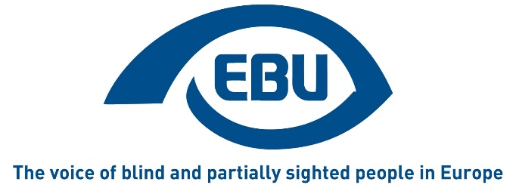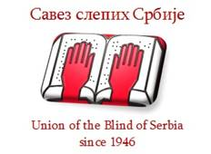

"Employment of Blind and Partially Sighted People - a Key to Inclusion"

Belgrade, October 21-22, 2021

Programme

Wednesday, October 20, 2021
Arrival of participants and dinner

Thursday, October 21, 2021
09.00 - 09.30: Introductory speeches and opening: President of the Republic of Serbia Aleksandar Vučić (TBC), EBU President, Rodolfo Cattani and President of the Union of the Blind in Serbia, Milan Stosic.
09.30 - 10.15: Presentation of the activities of the Ministry for Labour, Employment, social and veterans' affairs regarding the employment of blind and visually impaired persons in Serbia (the speech by the Minister) followed by discussion. Moderation by a representative from Serbia (TBC).
10.15 - 11.00: The active measures of the employment of persons with disabilities in Serbia (the Director of the National Employment Service). Followed by discussion. Moderation by a representative from Serbia (TBC).
11.00 - 11.30: Coffee break
11.30 - 13.00: The examples of good practice - Presentation of a public institution or company which has employed blind and partially sighted persons.
The presentation of the research of the Union of the Blind of Serbia on the employment of blind and visually impaired persons in Serbia.
13.00 - 15.00: Lunch
15.00 - 17.00: The experiences of 4 EBU member countries, Montenegro, Hungary, Germany and Spain (TBC) in the employment of blind and partially sighted persons. Followed by Discussion.
17.00 - 17.30: Coffee break
17.30 - 18.30: The impact of Covid 19 on the employment of blind and partially sighted persons. Speech by Stefan Trömel, ILO Senior Disability Specialist (online), followed by discussion. Moderation by Rodolfo Cattani.
20.00: Dinner.

Friday, October 22, 2021
09.00 - 10.30: The examples of good practice and challenges in the employment of blind and partially sighted physiotherapists - report of the Research by CFPSAA (EBU member from France). Followed by Discussion. Moderation by Lars Bosselmann.
10.30 - 11.00: Coffee break
11.00 - 12.00: Presentation by EBU Second Vice-President Bárbara Martín Muñoz of the report on the situation of blind and partially sighted persons regarding employment in Europe after 10 years of the United Nations Convention on the Rights of Persons with Disabilities: challenges and opportunities, focussing on 5 countries, Sweden, Italy, UK, Portugal and Belgium. Followed by Discussion. Moderation by Lars Bosselmann.
12.00: Reading and adoption of the resolution.
12.30: Conclusions and closing ceremony.
13.00: Lunch.
Afternoon: Departure of participants.
END OF DOCUMENT

