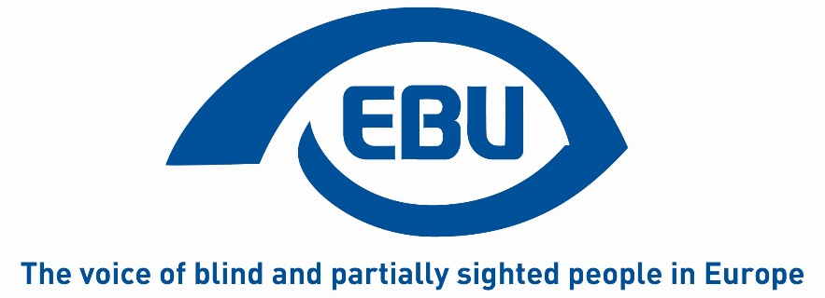
European Blind Union

Action Plan 2022
Notes:
This document sets out actions to be conducted in 2022 to implement the Strategic Orientation Plan agreed by the 11th EBU General Assembly (Rome, 28-30 October 2019). In cases where the actions are directly taken from the Orientation Plan, they are numbered in the same way as in the original document. In addition, it contains other key actions to be conducted in 2022, all in line with the Orientation Plan. This is in a view to show the links between different areas of EBU’s work which are part of a coherent agenda. The document also tries to identify the bodies responsible for implementing the action, as well as the source of their funding. The lead body identified for implementing the various actions will obviously consult other EBU sources such as our sectorial and thematic networks. For the project-supported activities, more detailed work plans do exist. It should be noted from the outset, that 2022 is the first year of a new 4-year operating grant with the European Commission. So, some activities are new and require to be set in motion in 2022.

Objective 1: Promoting Braille and Braille literacy
Description: Braille means for generations of blind people accessibility in so many areas of life and a key to independent living. In times of new technologies, learning, promoting and using Braille undergoes significant changes. Against that backdrop, EBU will:
- produce a good practice video targeting sighted learners and parents.
Resources: CERV T2.1, T1.3
Led by: Braille project team

Objective 2: Employment
Description: While we are still lacking reliable, comparable and disaggregated data on the employment situation of blind and partially sighted people, we know that they are disproportionately represented amongst the unemployed population and, when employed, often in precarious jobs. The consequences of the COVID-19 crises will probably worsen that situation. Though employment is not only a right, but also a formidable means of inclusion of blind and partially sighted people in society. Against that backdrop, EBU will:
- Contribute to the Possible revision of the EU Equality in Employment Directive or better implementation of it.
- contribute to the EU package to improve labour market outcomes of persons with disabilities.
- Implement ADVISE in new countries (action 4).
- Ensure follow-up to the 2021 EBU annual conference by establishing a working group on physiotherapy.
Resources: CERV T1.3, T3.2, T3.3 and T3.4.
Led by: ADVISE Project team, LC and Board for the topic of physiotherapy

Objective 3: Access to Technology
Description: Access to technology is more than ever a key to inclusion in literally all areas of life. For blind and partially sighted people, technology has already opened-up so many possibilities unthinkable a few years ago. At the same time, when designed in an inaccessible way, technology can also lead to further exclusion. Against this backdrop EBU will:
- Co-organise and support ICC camps (International Camp on Communication and Computers).
- Provide information on ICTs through EBU Access Cast, or the revised version of the podcast. (Action 8).
Resources: CERV T1.4 and T4.2.
Led by: EBU Youth Network for ICC and new podcast tbc

Objective 4: Participation in public life
Description: Equal participation by blind and partially sighted people in public life is one of the most powerful means of inclusion, and at the same time a prerequisite for it. Today, there are still many barriers to participation, e.g. when it comes to voting. Against that backdrop, EBU will:
- contribute to the consultation process for future EC electoral guidelines.
- Promote the AVA report on the Accessibility of Elections for Blind and Partially Sighted Voters in Europe (action 9).
- - Lobby for fully accessible EP Elections in 2024 through the electoral reform. (Action 10).
- Organise a de-centralised public awareness event on May 9th on the topic of political participation.
Resources: CERV T2.2, T2.3, T1.3 and PARVIS
Led by: AVA Project team, PARVIS consortium/SRF and OVN, and LC on the EP Elections and EC election guidelines

Objective 5: Non-Discrimination
Description: While there is a growing body of legislation in the field of anti-discrimination, including on grounds of disability, many blind and partially sighted people are still facing discrimination in their daily lives. This can be exacerbated by discrimination on other grounds such as gender. Against this backdrop, EBU will:
- Lobby for an efficient EU Disability Card (Action 12).
- Hold the PARVIS concluding event themed around non-discrimination.
- Map-out social security and disability benefits in different countries.
Resources: CERV T1.3, T3.5, T4.3 and PARVIS
Led by: LC and PARVIS consortium

Objective 6: Accessible goods and services
Description: In the vast area of accessible goods and services, often linked with new technologies, the very daily needs of blind and partially sighted people are concerned. Working towards fully accessible goods and services therefore can have such a direct and positive impact on concrete life situations. Unfortunately, the opposite is also true. Against that backdrop, EBU will:
- Push the EU and Member States to use their financial leverage to promote the production of accessible audio-visual productions, including productions for children (Action 15).
- To collect and publish good practice at the national level on audio-description for videos, museums, theatres and sports.
- To pursue our advocacy for accessible lifts.
- Continue to advocate for an effective implementation of the Marrakesh Treaty by helping the Commission to assess its progress and by pushing more countries to join.
- Consider other goods and services such as payment and self-service terminals.
- Through the UPowerWAD project, help to develop tools for blind and partially sighted users to monitor the implementation of the European Web Accessibility Directive
- And promote that directive in non-EU countries.
Resources: CERV T1.3, T2.4, T2.5 and PARVIS
Led by: LC and PARVIS consortium

Objective 7: Mobility
Description: It is obvious that mobility is an area in which many spectacular changes can be observed, and this trend will continue. The challenges, obstacles, but also the aids and means to overcome them, are constantly changing. This requires a constant effort to adapt and develop by e.g. urban planners, public authorities, the industry, and, of course, blind and partially sighted people themselves. Against that backdrop EBU will:
- Pursue our engagement with developments regarding Connected and Autonomous Vehicles (CAVs) so that the user perspective of blind and partially sighted people is taken into consideration from the outset (Action 19).
- Launch a working group to examine the topic of shared spaces and new forms of mobility.
Resources: PASCAL and CERV T1.3 and T3.7.
Led by: RSAT network, PASCAL project team and LC.

Objective 8: EBU has improved governance and working processes.
Description: EBU strives to become even more diverse and representative of its constituency at all levels of the organisation and recognises that this requires further action. In parallel, EBU endeavours to constantly improve its working processes and methods in a view to increase member’s participation. Against that backdrop, EBU will:
- Continue its work towards balanced representation in terms of gender, age, and type of visual impairment (Action 20) through the respective CERV activities.
- Work of the Gender Equality WG is strengthened.
- Enhance cohesion amongst the membership (Action 21).
- Conduct a first face-to-face meeting by the Leadership Forum.
- Start preparations of the 12th General Assembly to be held in autumn 2023.
- Promote the EBU Solidarity Fund amongst members.
- Stimulate an increased use of virtual communication between meetings.
- With the support of an external resource, start to build an EBU monitoring, evaluation and learning system.
Resources: CERV T1.5, T1.6, T1.7.
Led by: Board, the respective project teams under CERV.

Objective 9: EBU and its organisations have improved communication and campaigning capacity.
Description: It is widely acknowledged that effective campaigning and advocacy go hand in hand with effective communication, and that communication has both an internal and external dimension. For EBU, the link between campaigning and communication is made further complex by our nature as a European umbrella organisation having to deal with the language barrier and multi-level communication. Taking stock of where we have reached and how to improve requires ongoing attention. Against that backdrop, EBU will:
- Recruit an external Communication’s Officer.
- Follow-up on the internal communications review (Action 26).
- Improve its tracking and statistics to measure our coms outreach.
- Set up an automatic translation feature on EBU website.
Resources: CERV T1.1, T4.1 and T4.2.
Led by: Board

Objective 10: EBU and its organisations have improved fundraising capacity.
Description: Growing and diversifying our funding resources, in order to implement and sustain our ambitious agenda is an obvious goal for EBU and its members. In this competitive, fast-changing and complex market, facilitating exchange of good and bad practice is really important. Against that backdrop, EBU will:
Provide an overview of the new EU funding programmes during an online presentation (Action 28).
Resources: no extra resources required.
Led by: Project Manager

End of document

