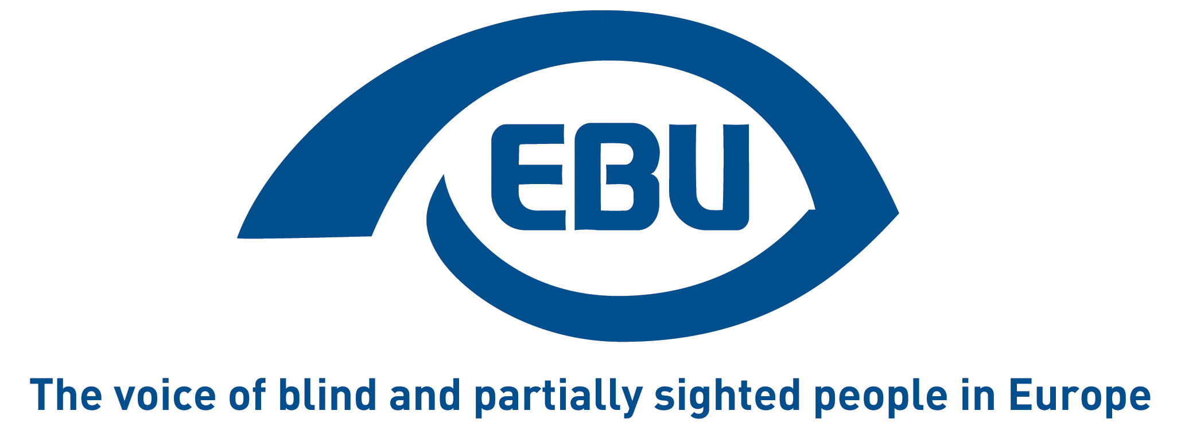

European Blind Union response to the European Commission’s request for feedback on its roadmap for improving access to emergency communications through single number 112

EBU Position Paper | October 2021

Aim of the consultation

Throughout the EU, people should be able to quickly contact emergency services through the single European emergency number ‘112’.
The Commission’s roadmap aims to account for technological developments in emergency communications and address any gaps that may exist across the EU.
It aims to ensure that emergency communication systems are effective as regards:
- information on caller location
- access for disabled people
- directing communications to the most appropriate public safety answering point (PSAPs)

Feedback

EBU supports the response of its umbrella group, the European Disability Forum, to this consultation and the emphasis therein on ensuring total conversation and real time text communication by PSAPs.

We would like to add or highlight some elements of particular interest to visually impaired persons, especially given that the European Accessibility Act will require the above result on from 2027 at latest:
- There should be quick access to the emergency number, without having to go through extra steps (e.g. press 1 for ambulance, 2 for police, 3 for firefighters, etc.), especially since such features are difficult to manage for visually impaired people using a smartphone.
- Transmission of the user’s location is crucial, as visually impaired people might not be able to describe their surroundings or their location with enough accuracy. This should happen automatically (subject to consent in line with the GDPR) and with the highest accuracy possible.
- It should be possible to initiate a video call between the user and the emergency services, to allow the operator to gather additional information through the user’s phone camera.
- Subject to consent in line with the GDPR, the user should be allowed to automatically share an ‘emergency profile’ of their medical record, indicating critical medical conditions, including disability.
- Subject to consent in line with the GDPR, a user’s personal health monitoring device should be able to automatically communicate to emergency services crucial information on their health.
- The emergency profile should also include relatives or friends to be alerted. Ideally it should also provide the option to allow these persons to be the ones to call the emergency number about their old, ill or disabled relative and, with the help of digital identification, still be able to share that person’s medical information.
- All or as many as possible of the above features should be available across the EU, both in the user’s home country and when roaming.
- Apps or websites have a special role to play in respect of the above possibilities—whether to collect prior consent, to organise the information and to share it with the operator in an emergency call—but also, more generally, for easy-to-find emergency information. They should be accessible in line with the European Accessibility Act and the Web Accessibility Directive, and they should be pan-European, with EU-wide technical specifications. Moreover, it would be useful if calling the emergency number would automatically open the relevant app, to help users with disabilities face situations of stress.
- How country-specific emergency numbers connect to 112 should also be carefully considered, as some national numbers automatically switch to 112 when roaming in other EU countries. Indeed, EU Member States still tend to prioritise national numbers in the information to the public.

About EBU
The European Blind Union (EBU) – Interest Representative Register number 42378755934-87 – is a non-governmental, non-profit making European organisation founded in 1984. It is one of the six regional bodies of the World Blind Union, and it promotes the interests of blind and partially sighted people in Europe. It currently operates within a network of 41 national members including organisations from 25 European Union member states, candidate countries and other countries in geographical Europe.

European Blind Union
6 rue Gager Gabillot - 75015 Paris
+33 1 88 61 06 60 | ebu@euroblind.org | www.euroblind.org

Contact: Antoine Fobe, Head of Advocacy & Campaigning
ebucampaigning@euroblind.org | +33 1 88 61 06 64

