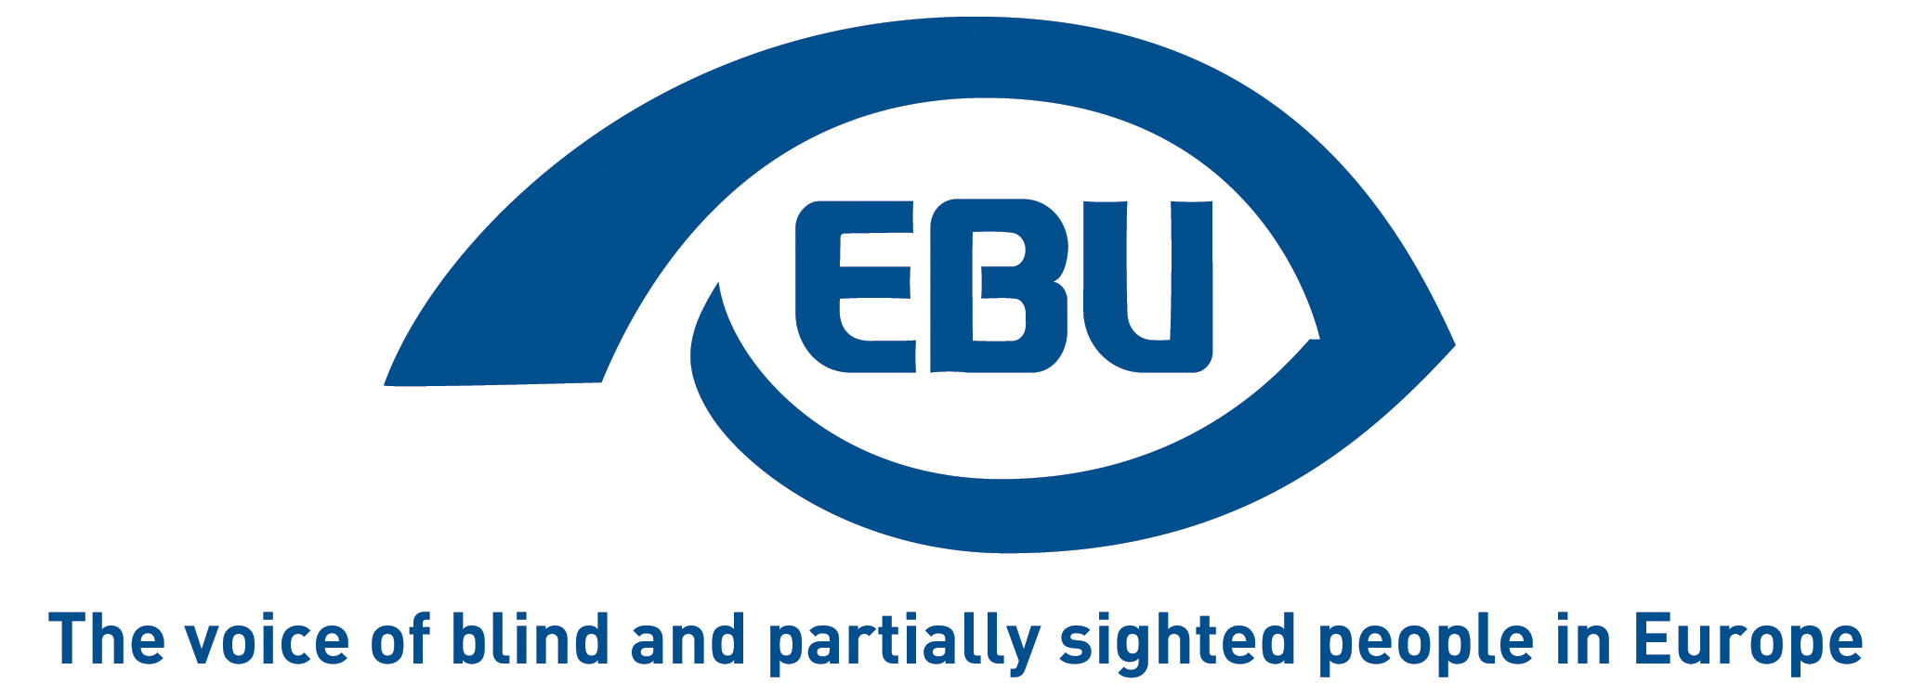

EBU response to consultation on European Democracy Action Plan
EBU Position Paper | September 2020

Questions on election integrity and political advertising:

iii) European Political Parties:
Q1: Is there scope to further give a stronger European component to the future campaigns for EU elections?
Reply “12. Other”.
Explanation: “We are generally in favour of any measure that will make European elections more a vote on EU (not national) affairs, and on what the EU should be and do (not for or against the EU), none of the initiatives listed correspond to the EBU mission.”

(iv) European Elections:
Q2. In your opinion what initiatives at European level could strengthen monitoring and enforcement of rules relevant to the electoral context?
Reply “5. Other”.
Explanation: “European elections should aim to be exemplary as fully inclusive for voters with disabilities. This concerns the act of voting itself as well as the electoral information (manifestos) at least for European elections. We refer here to our work in the framework of our Accessible Voting Awareness-raising project and the very first point of our Statement on European Elections 2019. In writing this, we don’t ignore that electoral procedures are essentially a competence of the Member States, even for European elections; however, we feel that pressure at EU level about European elections would have a beneficial effect for electoral practices at all levels.

Questions on supporting civil society and active citizenship:
Q1. Do you think civil society is sufficiently involved in shaping EU policies, notably through consultation?
Reply “1. Yes”.

Q2. Do you think civil society should be more involved in concrete EU-level actions to promote democratic debate?
Reply “1. Yes”.
Explanation: “We would have liked to nuance our reply to Q1 but there is no field for that; so we use the free text field here to add the following: online consultation on the “Have Your Say” portal are often in the form of online questionnaires that complicate the participation of persons with visual impairment, resulting in deadlines being often too short for these persons and their organisations. Moreover, the questionnaire format does not lend itself to European umbrella organisations collecting and compiling feedback from national member organisations and individual stakeholders.”

Q3. Do you think actions should be taken at EU level to strengthen cooperation among civil society actors across borders?
Reply “1. Yes”.
Explanation: “A dynamic and genuinely European civil society is necessary for European democracy, just as the development of EU-level political parties for instance. It is therefore essential that the EU continue to provide financial support to NGOs representing the views of stakeholders across Europe, and to European platforms fostering debate at European level – See the reply to Q4 below.”

Q4. Do you think the EU should provide more financial support for civil society (for example under the ‘Rights, equalities and citizenship’ programme)?
Reply “1. Yes”

Q6. Do you think that more participatory or deliberative democracy at the European level, with more possibilities for public deliberation and citizen engagement, beyond public consultations, would be:
Reply 1. A good thing.
Explanation: “There is arguably already considerable effort to involve civil society in EU decision-making, certainly in our direct area of interest, and this even outside formal consultations (conferences, dialogue meetings etc.). However still not visibly enough, within the Member States, to counter – often unfair – criticism of a distant and disconnected EU administration.”

Q6.1 If given the opportunity, would you take part in a European participatory or deliberative democracy event?
Reply “1. Yes, absolutely”.

Q7. Are you familiar with the European Citizens’ Initiative?
Reply “2. Yes, but I have not taken part in one before”.

About EBU
The European Blind Union (EBU) – Interest Representative Register number 42378755934-87 – is a non-governmental, non-profit making European organisation founded in 1984. It is one of the six regional bodies of the World Blind Union, and it promotes the interests of blind and partially sighted people in Europe. It currently operates within a network of 41 national members including organisations from 27 European Union member states, candidate countries and other countries in geographical Europe.
European Blind Union
6 rue Gager Gabillot - 75015 Paris
: +33 (1) 88 61 06 60 | ebu@euroblind.org | www.euroblind.org

Contact: Antoine Fobe, Head of Campaigning
ebucampaigning@euroblind.org | +33 1 81 61 06 64

