Good practices on blind and partially-sighted persons’ employment in Europe

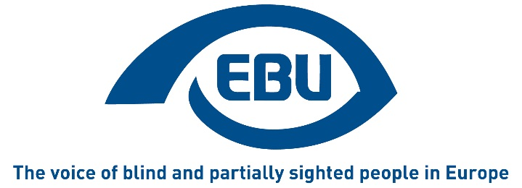

First edition (September 2018)

Co-authors:
- Katarina BIGOVIC (Union of the Blind of Montenegro)
- Philippe CHAZAL (CFPSAA - Confédération Française pour la Promotion Sociale des Aveugles et Amblyopes)
- Goran MACANOVIC (Union of the Blind of Montenegro)
- Bárbara MARTÍN (ONCE - Organizacion Nacional de Ciegos Españoles)
- Martin O'KANE (RNIB - Royal National Institute of Blind People)
- Lena SODERBERG (SRF - Swedish Association of the Visually Impaired)

CONTENTS

PARTICIPATING COUNTRIES 3

INTRODUCTION 4

1. Accessibility of the environment 5
2. Booklets 6
3. Disability Allowance 6
4. Empowerment through coaching 6
5. Financial Support for Employers 7
6. Internships 8
7. Online Accessible Platforms 8
8. Matching employers and job seekers 9
9. Measuring distance to labour market 10
10. Open Job Opportunities 11
11. Peer mentoring and role models 11
12. Pre-Employment Training 12
13. Quota Systems 14
14. Retraining Centres 15
15. Self-employment 16
16. Supported Employment 16
17. Support in education to improve employment 17

LIST OF POSITIONS 19

PARTICIPATING COUNTRIES

- ALBANIA - Albanian Blind Association - shvsh@shvsh.org.al
- FRANCE - Confédération Française pour la Promotion Sociale des Aveugles et Amblyopes - contact@cfpsaa.fr
- GERMANY - German Federation of the Blind and Partially Sighted - b.vandenboom@dbsv.org
- HUNGARY - Hungarian Federation of the Blind and Partially Sighted - international@mvgyosz.hu
- IRELAND - National Council for the Blind of Ireland - denis.daly@ncbi.ie
- ISRAEL - The Center for the Blind in Israel - zohar@ibcu.org.il
- ITALY - Unione Italiana dei Ciechi e degli Ipovedenti - inter@uiciechi.it
- MONTENEGRO - Union of the Blind of Montenegro - savezslijepihcg@gmail.com
- NETHERLANDS - Eye Association Netherlands - dennis.dondergoor@oogvereniging.nl
- POLAND - Polish Association of the Blind - pzn@pzn.org.pl
- RUSSIA - All Russia Association of the Blind - oms6236160@yandex.ru
- SPAIN - Organizacion Nacional de Ciegos Españoles - BMMU@once.es
- SWITZERLAND - Swiss Federation of the Blind and Visually Impaired / Swiss Union of the Blind - rahel.escher@sbv-fsa.ch
- UNITED KINGDOM - Royal National Institute of Blind People - martin.okane@rnib.org.uk

INTRODUCTION

With financial support from the Rights, Equality and Citizenship (REC) Programme of the European Union, the European Blind Union (EBU) undertakes every year to collect, summarise and disseminate the best practices in Europe related to a specific area of accessibility. In 2018, EBU has collected national best employment practices for blind and partially-sighted persons. Fourteen countries, EBU members and partners, have produced detailed contributions which were carefully examined by a jury on the following criteria: originality, transferability and report clarity. The winners of the competition this year are UK (89 points), Germany (86) and Italy (81).
This brochure, available in several languages, groups and summarises the 17 most important themes included in the contributions, classified in alphabetic order.
We know that economic levels, legislation and awareness of visual impairment are very different within EBU’s member countries, but we are convinced that good practice which is demonstrated in one country can be used to help shape good practice in other countries too. That is the aim of this brochure. Due to financial constraints, we are limited in the amount of detail that we can share within this brochure. However, if you would like further information on any of the themes contained within, please don’t hesitate to contact the EBUoffice at ebu@euroblind.org where you can find out more or we can put you in touch with the country who provided the information.
We hope this brochure will be useful for you and will increase the employment prospects of blind and partially-sighted job-seekers and help improve their access to the labour market.

Philippe CHAZAL (France)
Jury Chairman

Accessibility of the environment
In order for a person with sight loss to work independently, it is of great importance that the work environment is designed towards inclusion for all – both in relation to the necessary adapted technology and the physical environment.
The People´s Advocate Institution is the only public institution in Albania that has managed to adapt the entire building to the needs of people with sight loss and can now function as a best practice example for others. The building has been designed in collaboration with expertise offered by the Albanian Blind Association and has managed to create a warm, non-discriminating and barrier-free building for all employees with or without sight.
Features within the building include:
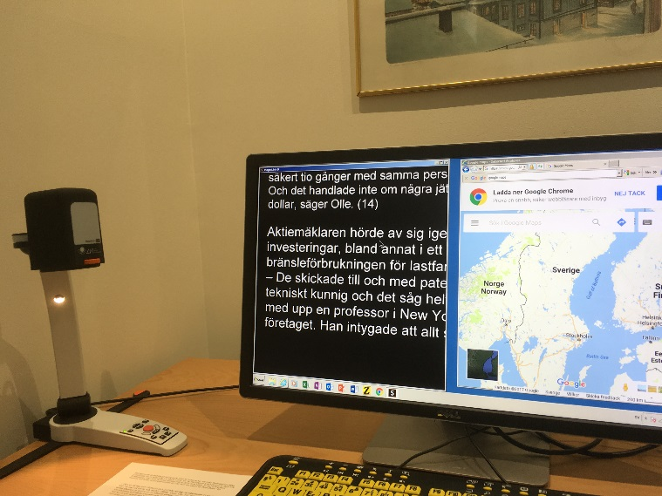
- Camera at the entrance providing audio information to people arriving at the building.
- Yellow and blue contrast painting on the pavement leading towards the building.
- Tactile identifications strips on external and internal doors.
- Tactile map in the hallway providing an overview of the building.
- Information on alternative print formats.

The accessibility of the building provides an important statement which will hopefully lead to other more accessible buildings and ultimately to making it easier for people with sight loss to work.
One member of staff who works at the building has been quoted as saying:
“I feel not only satisfied for my personal and professional achievement, but also for the entire community of blind and partially sighted persons and feel accomplished in my accessible working place, in which I can independently perform all my duties”.

Booklets
The French Federation of the Blind has published a booklet entitled "Working together! Good practices with a visually impaired co-worker".
The booklet describes the basic rules of well-being at work, describing topics like: what it means to be partially sighted, how to guide a person who is blind or partially sighted and how helpful the white cane is. It is an easy to use guide for everyone to use.

Disability Allowance
Disability Allowance schemes are a way of providing benefits to both employees with disabilities and their employers. The French Disability Allowance system is a good example of this. Since 2005, all disabled people in France can obtain this allowance which aims to compensate for the additional costs related to the disability (for example, assistance of a third party, acquiring aids for independent living, upkeep of a guide dog). This allowance is given to blind people, independent of any other income received by the disabled persons or their family. This allowance is a great incentive to work for disabled people.
In Switzerland, Invalidity Insurance offers people the opportunity to demonstrate their skills in the open labour market. For the first three to six months, the insured person receives a daily allowance. During this training or familiarisation period, employers who engage the insured person through the public employment agency receive financial support which is paid for a maximum of 180 days and amounts to as much as 100 swiss francs per day.

Empowerment through coaching
In the Netherlands in 2015, Oogvereniging developed a coaching project called “Working together to find work”, where blind and partially sighted participants learn to use their own strengths to find a job.

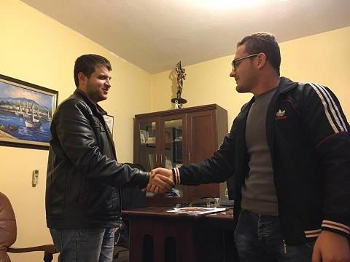
In the programme, visually impaired people who have a job (coaches) help visually impaired job seekers (coachees) to find a job. Both coach and coachee are matched, based on criteria such as similar training or work experience, type of visual impairment or personality type. For a year, coach and coachee consult once every two weeks. The coach assists the coachee in finding out what sort of job he or she wants, how to build a useful network, how to apply for a job, how to communicate about their visual impairment during job interviews and how to learn to accept their disability.
Over the course of one year, all participants share their experiences in four meetings where they learn to use social media tools when looking for a job; inform employers about the subsidies that are available when hiring them; and find assistive (technology) tools that suit their needs in the working environment. A total of 95 job seekers participated in the programme, 80% of which found a job.

Financial Support for Employers
Funding is available in many European countries for the employment of disabled workers. In France, for example, associations representing disabled people are represented on a funding board alongside trade unions and employers. Funds made available through this system can then used to pay for:
- Workspaces and the working environment to be adapted to the needs of disabled workers.
- Training / apprenticeships and professional integration of people with sight loss into the workplace.
- Awareness-raising amongst employers.
- Attribution of start-up grants enabling disabled people to create their own jobs;

Internships
In Italy, the Italian Union of the Blind and Partially Sighted identify companies willing to accept interns with disabilities, drawing managers’ attention to the opportunities offered by such internships schemes and the interns themselves.
Applicants who fulfill the requirements for the scheme are introduced to various companies. Managers then interview applicants in order to select the most suitable interns for their needs. More than 40 visually impaired people took part in a recent internship scheme and some of them stayed on in the company at the end of their internship and got a permanent job.
The internships covered a large range of work activities such as administrative tasks, digital media work, travel and tourism, legal practice, training centres and call centres.
In several cases, host companies needed advice and support at the beginning of the internship and, at a later stage, expressed very positive feedback about the progress of the interns.

Online Accessible Platforms
In Germany, iBoB provides a comprehensive database of lifelong learning opportunities for blind and partially sighted professionals. On a dedicated website, 86 accessible courses are listed for interested participants, with or without disabilities.
The website, through a fully accessible interface, is sorted by topic (for example IT, Finance etc.), method (users can choose between “face-to-face” meetings, e-learning and long-distance learning or blended learning, which mixes those two approaches) and provider.
In terms of providers, there are so far nine partners in the project. Most of the courses are offered by specialist institutes that have been part of the low vision community for years. These institutes are focusing on first-level opportunities.
In Russia, VOS has set up the website www.trudvos.ru. which translates as "Work for the Visually Impaired”. This web site has dedicated resources on the employment of people with visual impairment and lists available vacancies for job seekers with sight loss, agreed with employers.

Matching employers and job seekers
EMPLOYPWD.ME, ZAPOSLIOSI.ME- Montenegro
The ‘Union of the Blind of Montenegro’ have created a portal ‘employPWD.me’, with the aim of connecting and enabling effective communication between employers and unemployed people with disabilities.
The portal has a rich content focused on the promotion of employment of people with disabilities. In addition to employment opportunities for unemployed people looking for work, there is information on Employment Rights and financial benefits and incentives for getting into work.
The portal also allows employers to connect with unemployed people with disabilities through reading biographies of unemployed people, and watching short video presentations where job seekers highlight their skills and qualifications. The video presentations are brief, lasting up to 60 seconds. According to research, one minute is sufficient time for observers to get an impression of the person. The portal is an innovative and original concept which could be easily transferred to other countries and encourage more employers to employ people with sight loss.
Since 2015, in Russia, VOS has been an active participant of regional, national and international championships among people with disabilities, known as 'Abilympics'.
Just two national Abilympics helped hundreds of visually impaired people to find outlets for their professional skills. For these participants, the competitions meant self-fulfillment and a path to independent living, while employers were provided with access to excellent candidates.

Measuring distance to labour market
RNIB (Royal National Instititute of Blind People) support people with sight loss throughout the UK. They have created a toolkit to help employment professionals plan the actions that need to be taken to support blind and partially sighted persons towards employment.
The toolkit involves asking questions to the clients concerning different areas such as work experience, access to information, level of computer skills, orientation & mobility, vison status and other health related issues, career aspirations and current job search activities.
Based on the response from the questions, the clients are given a rating:
- Level 1 - Work ready
- Level 2 - Nearly work ready (closer to the labour market)
- Level 3 - Nearly work ready (further from the labour market)
- Level 4 - Longer term support needed
- Level 5 - Foundation work required before employment services

The toolkit helps increase the understanding for both the client and the advisor of the skills, aspirations and barriers to employment for the client. The rating gives guidance on where to start to plan the actions needed to increase the client’s work and employment possibilities.
The assessment tool gives a baseline to start out from and can be used to measure results of progress towards employment after a period of interventions.
The toolkit serves as a useful diagnostic tool for planning the steps necessary to progress towards work and employment for clients
By using the toolkit, RNIB now delivers better services to help blind and partially sighted people find employment. It provides employment advisers with an accurate profile of the client to help identify and prioritise interventions and encourages designing them together. Clients find it useful to be clear on the challenges ahead, and the path towards employment can be broken down into achievable steps. The assessment tool can be used to show progress after a period of support. Since the toolkit clearly identifies and shows the different levels of need for different clients, it can be used to influence the way support services are organised and financed.
RNIB has found the assessment tool very useful, and, since their aim is to make society more inclusive for people with sight loss, they are promoting the use of the assessment toolkit to the wider employment sector for any organisation who supports people with sight loss. The toolkit and related documents can be downloaded from the RNIB website at the following address:
https://www.rnib.org.uk/services-we-offer-advice-professionals-employment-professionals/employment-assessment-toolkit

Open Job Opportunities
In Russia, VOS carries out research work to identify the most popular professions and find jobs in the open market that would suit people with visual impairments. A specially designed database, “VOS Human Resources”, is used to identify professions suited to their needs. They also build relationships with private companies and non-for-profit organisations to secure employment opportunities for its members.
VOS regularly monitors the presence of visually impaired workers in the open job market.

Peer mentoring and role models
Albania is showing us the importance of having strong role models to aspire to. Through acknowledging the talents and achievements of a person, looking beyond the disability or impairment, it can be of great influence and provide inspiration to others to know that career goals can be reached.
The Albanian Parliament voted to have a totally blind person at the top of senior administration for the first time in history when hiring a blind lawyer at the People´s Advocate Office four years ago. During these four years, more than 3000 issues and complaints from people with disabilities in various fields such as human rights, legalisation, health, education and others have been dealt with through this office.
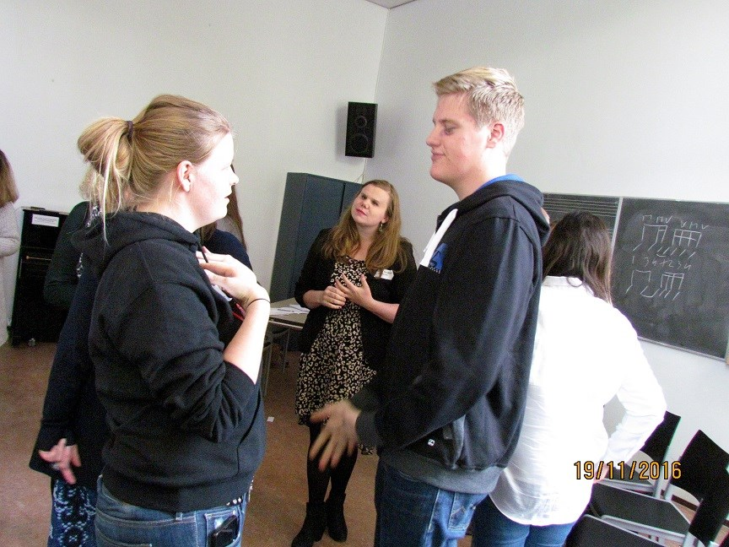
The lawyer’s rise to this position is an inspiring one. It was his dedication and determination that enabled him to succeed. For many years he did not think he could do the same job as other people because of his sight loss. “That feeling prevented me from looking for a job. But thanks to the development of technology, the support of the blind association in my country and the effort People's Advocate Office put in to making the workplace accessible and free of barriers, I now feel the same as those who can fully see” he says.
In Gemany, iBoB follows a peer-centred mentorship program, where both the mentor, an experienced facilitator and councillor; and the mentee, come from the low vision community.
The iBoB staff are readily available to advise interested professionals regarding their lifelong learning opportunities, including funding and accessibility. This is initiated by making phone or online contact. The aim is to transfer interested professionals into mentoring relationships- these can be one-on-one or group-based mentorship arrangements. The design of the relationship is left to the mentors but is always based on sharing common experiences of their sight loss.

Pre-Employment Training
The Employment Service of the NCBI (The National Council for the Blind of Ireland) strives to increase participation in the labour market and to achieve greater retention outcomes with the onset of vision impairment. This is achieved by an intensive multidisciplinary collaboration across NCBI services, especially mobility and technology trainers. The employment advisor (who is an Organisational Psychologist) conducts a comprehensive assessment of need with the service user. The assessment process recognises that, with the loss of sight or deterioration in vision, many interventions often are required that will empower and enable an individual to achieve the best outcome in employment.
The service has two main aims:
- To equip motivated service users with targeted industry guided job- seeking skills:
Courses have been designed around preparing and empowering individuals in their job seeking efforts including CV prep, confidence building, interview skills and technology awareness. To ensure that the course is on topic and industry led, guest speakers such as Fujitsu and Robert Walters Recruitment have led workshops and carried out mock interviews with feedback at the end of the course.
Feedback to date from running the courses has been very positive and individuals feel more confident in their job seeking efforts.
“Thank you for the opportunity, I really appreciate it. I enjoyed the course, especially the chance to meet real vision impaired people who actually made it and found a real job”.

“Whole course was very good and did enjoy it. As a result, my CV has definitely improved, and I will now definitely work towards putting it up online”

- To eliminate the factors that restrict employers from hiring a person with a vision impairment:
NCBI addresses the issue of barriers to work for people with sight loss by attempting to anticipate them and to remove some of the misconceptions which commonly include:
- Cost of equipment
- Can they do the work?
- How will they get around the workplace?
- What types of jobs can they do?

Information on barriers and how to overcome them has been promoted to over 150 HR executives representing 100 different companies in Ireland.
In light of these barriers, it is little surprise that the longer an individual remains outside of the labour force, the less likely they are to re-enter employment. This highlights a need for interventions that are designed to increase the skills that promote employability and, from the other side, to minimise the obstacles and perceived barriers from employers to give a person with a vision impairment a chance.
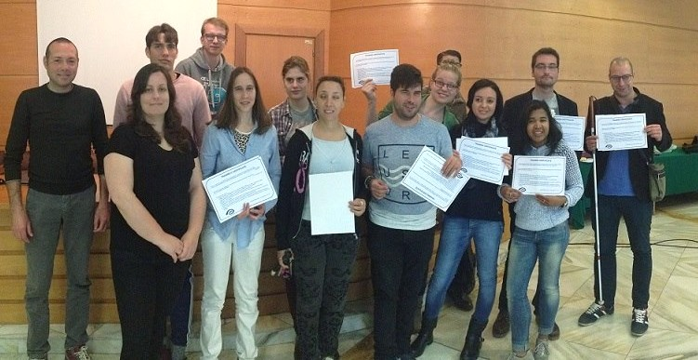

Quota Systems
Several countries in Europe have a quota system which compels employers (private companies or public administrations) to engage a certain percentage of disabled persons in their workforce. For example, in France : to fulfil the legal obligation, the employers can choose between four possibilities : a) actually employing disabled staff ; b) the provision of work, by subcontracting to protected centres by helping disabled people into work or to blind or visually impaired people who are self-employed, within the limit of 50% of the legal obligation ; c) payment of a lump sum contribution to a fund for the employment of disabled workers, the amount of which is calculated according to the size of the company and the number of disabled people employed ; d) reaching an agreement with a relevant trade union organisation around recruitment, training or job retention where there is a risk of dismissal for incapacity. The choices given to employers enable them to diversify their means of fulfilling their obligations.

Retraining Centres
Even though the integration of blind and partially sighted people in to schools, further education, university, and business is so important, there is still a place for Vocational Retraining Centres in supporting people. This is especially relevant to people who are newly diagnosed with sight loss after illness or an accident. Ten specialist centres catering for approximately 500 trainees each year are currently runnning in France.
Before begining their training, people are offered an ‘adaptation’ course which allows them, if necessary, to learn braille, mobility techniques, and how to use adaptative computer technology.
The training courses provided can vary from physiotherapy to admin and telecommunications and manual work. The running costs of the centres are covered by the Social Security system which also pays the accomodation costs of the trainees. Trainees receive a salary paid by the State which is equal to 80% of that which they received before losing their sight, or an amount of some 650 euros if they have never been in employment.
In these centres, trainees receive the psychological help that they so often need and also benefit from social services, sight specialists and employment specialists who work together as part of a multi-disciplinary team. Teaching methods are adapted to individual needs: for example documents are produced in braille or large print and accessible software and hardware is available for trainees who need magnification or audio.

Self-employment
In Spain, the Spanish National Organisation of the Blind (ONCE) supports self-employment as an alternative that allows its entrepreneurial members to start up self-employment projects.
ONCE provides advice and support to those wishing to embark on self employment projects. They also provide help with accessing a range of financial aids to assist with the development of projects. In 2016, the ONCE employment support service supported 328 self-employed persons.

Supported Employment
Some people with sight loss do not have the capacity to find work in the open labour market. As a result many countries have in place specific structures to allow people with limited capacity to find and retain employment.
In France two different levels of structures are accessible:
- ESAT is a network of employers who offer work and also social, medical, psychological and/or educational assistance to the disabled people they cater for. ESAT is not made up of ordinary companies in terms of employment legislation but are part of a protected sector and are considered as medical-social establishments. Support activities that are offered include learning to use Braille, Daily Living activities, Mobility Training and Sport. Participants do receive a salary of between 5 and 35% of the minimum wage which is complemented by a grant paid by the State.
- Adapted Companies (EA). 80% of workers in this structure have to be disabled, ten EAs receive around 300 visually impaired people. The EAs are real companies within the open labour market; their employees have the same rights as all other workers. They receive a salary of at least the minimum wage. In this arrangement, workers enter into a three-year contract with State services, which, once approved, offers them State assistance to compensate for additional costs relating to the employment of disabled people with reduced efficiency.

Support in education to improve employment
The Aleh Society promotes the academic education of VI young people in Israel. Its operation began with five students and now accommodates over 450 at present. The model of the Aleh society that developed to help VI students to overcome difficulties in education has been acknowledged by relevant government agencies and adopted by all universities as well as by colleges in Israel. The model has several components: a human facet, a technological aspect, a joint technological-human facet, and a rehabilitation aspect, all of which facilitate the VI students' independence.
When a VI student enrolls in a University, orientation and mobility is given primary emphasis. Simultaneously, students begin learning how to search for academic sources - getting the student acquainted with his/her specific course materials.
To ensure independent learning, the VI student must master the process of computer navigation.
Social workers are also available to provide any assistance needed on an emotional and social level.
Stage 1 of the model is the student’s arrival at the University, during which time he depends on human assistance for mobility and reading, to a greater degree than he depends on technology. Through an ongoing process of instruction, the use of human assistance and the use of technological assistance balance out over the course of stages 2 and 3, based on the student’s rate of progression. In stage 4, the tables are reversed, and the VI student becomes independent in using technology over human assistance. However, the human aspect continues to remain relevant because fast-paced technological advancements require tutorials for almost every new innovation.
The Aleh Society provides computer equipment to the students, making it accessible for use at the educational establishments and at home. In addition, the student may use human assistance for personal readings and tutorials. A digital talking books library with over 5,000 titles is available as well as a library of Braille and large-print books.
As part of its efforts in promoting higher education among VI high school graduates, Aleh operates preliminary courses for the Psychometric Exams. The courses are offered in a few languages, most often in Hebrew and Arabic. The classes are held in small groups of 7 to 15 students.
A longitudinal survey spanning more than 10 years of VI University graduates throughout Israel reveals that the majority of graduates (80%) had completed their bachelor’s degree in three to four years. About 73% of the VI graduates supported by Aleh programs are working in the open market, while among the general blind population, only 26% are employed. These findings point out the change in attitude by both the VI graduates themselves, as well as by the community toward them, and highlight their self-empowerment.

LIST OF POSITIONS
Below a list of positions occupied by visually impaired persons:
- Social worker
- Sales staff
- Lawyer
- Librarian
- Perfume designer
- Diplomat
- Public writer
- Farmer
- Museum guide
- Innkeeper
- Sound engineer
- IT engineer
- Conference interpreter
- Radio journalist
- Magistrate
- Mayor
- Osteopath
- Wellness practioner
- University Law Professor
- University Mathematics Professor
- Psychiatrist
- Insurance teleoperator

This is a non-exhaustive list. For more information, please contact the EBU office at ebu@euroblind.org.

This publication has been co-funded by the "Rights, Equality and Citizenship" Programme of the European Union

END OF DOCUMENT

