THE HIDDEN MAJORITY – a ‘how to’ guide

Reviewing economic inactivity of blind and visually impaired people

By
Philippa Simkiss and Fred Reid

2013

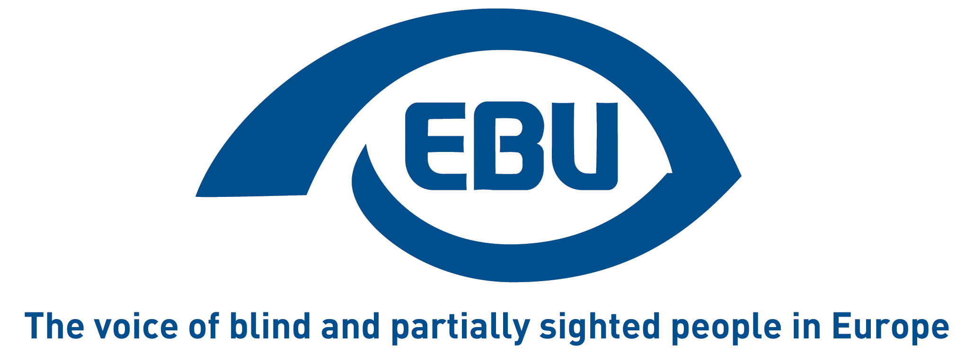

Who are the Hidden Majority?
People who are either in work or unemployed and actively seeking work are ‘economically active’. Those who fall outside these two groups are ‘economically inactive’.
Blind and visually impaired people carry out a wide range of occupations throughout the EU but EBU has gathered evidence of high levels of economic inactivity amongst this group in member states of the European Union, ranging from about 40 to about 80 percent. EBU commissioned a series of in depth reports, supported by PROGRESS, the Community programme for Employment and Social Solidarity and the Royal National Institute of Blind People.
These reports, available on the EBU website, present evidence that throughout the EU as a whole this group of economically inactive blind and visually impaired people constitute a ‘hidden majority’.

Who needs to know about the hidden majority?
As this group makes up the largest proportion of working age blind and visually impaired people it is important that policy makers and service providers understand how to engage economically inactive blind and visually impaired people and how to adapt provision to meet their needs.
EBU members can use information about the rate of economic inactivity among blind and visually impaired people of working age in their work to drive up the quality of services for blind and visually impaired people.

Finding the Hidden Majority

How?
Semi- structured interviews with questions sent in advance to the interviewees

Who with?
- People responsible for delivering the state employment service for blind and visually impaired people
- Officials responsible for labour activation measures.
- Well informed observers including people from major organisations representing blind people themselves
Tip: EBU members gave valuable assistance in finding key contacts to interview.
Important: Everyone was given a guarantee of anonymity – none of the comments made were attributable to any individuals.

Questions to ask
To investigate labour activation measures, employment support services and to gather evidence of the hidden majority your questions should be structured around a series of topics as follows:

- A legal definition of blindness and/or visual impairment which qualifies a person to access special labour activation programmes.
- Number of blind and visually impaired people in employment, broken down by age, gender and additional impairments
- Range of occupations in which blind and visually impaired people are employed together with any indication of clustering in one dominant occupation

- Number of blind and/or visually impaired people actively seeking work, broken down by age and gender and additional impairments
- Number of blind and/or visually impaired people who are economically inactive, broken down by age, and gender
- Number of blind and visually impaired people close to the labour market
- Number of blind and visually impaired people distant from the labour market
- Types of social security benefit paid to blind and visually impaired people who are economically inactive, distinguishing between income substitution and compensation for the costs of disability
- Level of the above expressed as a percentage of average annual earnings
- Labour activation programmes specially provided for blind and visually impaired people aimed at employment in mainstream occupations and at employment in special centres e.g. sheltered factories, social enterprises, social firms, etc.
- Legislation aimed at influencing employers to employ blind and visually impaired people, e.g. Quotas, reserved occupations.

Making sure the report is accurate
Send all participants a first draft of the report to give them chance to make corrections, send supplementary evidence and comment.
This way you will achieve broad agreement and a balanced account of the employment services and their impact on blind and visually impaired people, and you will be able to draw conclusions about the hidden majority.
Important: Any remaining differences of emphasis and occasionally of interpretation should be disclosed in the report.

Publishing your Hidden Majority report
EBU would be pleased to receive your report especially if it highlights good practice, which might be disseminated throughout the European Union by EBU and its member organisations.
EBU can publish your report on its website along other Hidden Majority reports:
http://www.euroblind.org/working-areas/rehabilitation-vocational-training-and-employment/

Using your Hidden Majority report
There are case studies on the EBU website which show how member states have used their Hidden Majority reports to influence policy and change practice. EBU would welcome feedback on how you use yours .

This manual is supported by the European Union Programme for Employment and Social Solidarity - PROGRESS (2007-2013).
This programme is implemented by the European Commission. It was established to financially support the implementation of the objectives of the European Union in the employment, social affairs and equal opportunities area, and thereby contribute to the achievement of the Europe 2020 Strategy goals in these fields.
The seven-year Programme targets all stakeholders who can help shape the development of appropriate and effective employment and social legislation and policies, across the EU-27, EFTA-EEA and EU candidate and pre-candidate countries.
For more information see: http://ec.europa.eu/progress

The information contained in this publication does not necessarily reflect the position or opinion of the European Commission.

